Lab assignment 1

**Q1.** Run the demo to see if the output is same with the sample picture below ?If not please find the reason

and modify it.

print_string("it is an odd number (0:

.include "macro_print_str.asm"

false,1:true) : ")

li $v0,1

.text

main:

syscall

print_string("please input an integer : ")

li $v0,5

syscall

end

move

nor

$t0, $v0

$t1, $zero, $zero

sra

$t2, $t1,

$a0, $t2,

31

$t0

and

please submit the modified asm file(**LabA1Q1_*yourID*.asm**) and “macro_print_str.asm” in Sakai site, write

down the reasons which mentioned in the Q1 to the report (**LabA1_*yourID*.pdf** ).

**Q2.** We have already introduced three addressing methods of memory before winter holidays, they’re direct

addressing, indirect addressing and baseline addressing, and we have also known how to move an immediate

value to general purpose registers (we can call this as immediate value addressing, it is a kind of register

addressing method, but not a kind of memory addressing method, please note this), so four kinds of

addressing method are represented.

In this homework, please accomplish addition, subtraction, multiplication and division operations of **two**

**integers** at least once, and the operands sent to registers are fetched by **different** **addressing** **method** for each

operation, and the **results** **are** **expected** **to** **store** **in** **memory** (when storing the results, you can choose any

kind of addressing method). After storing the results, please **print** **the** **equations** in screen. And **detailed**

**comments** are also expected.

Please run the codes in QtSpim or Mars, and capture the **screenshot** **of** **data** **segment** both before and

after the code running, and **point** **out** **where** **the** **operands** **and** **results** **are** in data segment as Fig. 1 and Fig. 2

showed.

At last, please submit two files in Sakai site, one is source code file(**LabA1Q2_*yourID*.asm**), and the other

is screenshot of data segment(**LabA1_*yourID*.pdf** ).

1) Tips1: You can design your code as the comments showed

**#.data**

#distribute two integers for immediate value addressing method

#define all the labels of address in memory in which operands and results are stored

**#.text**

**#immediate** **value** **addressing**

#fetch the operands

#calculate

#store the result at address 0x********

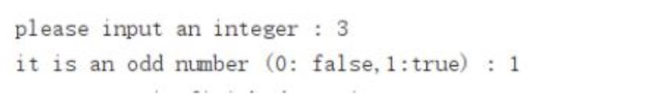

#print the equation on screen in the form of A + B = C

**#direct** **addressing**

#......

**#indirect** **addressing**

#......

**#baseline** **addressing**

#......

2) Tips2: screenshots of data segment

Fig.1. screenshot of data segment before running

Fig.2. screenshot of data segment after running

