1. In the below elements which of them are values or an expression? eg:- values can be integer or string and expressions will be mathematical operators.

\* 🡪 It is a mathematical operation(Multiplication Operation)

'hello' 🡪 It is a Expression (String)

-87.8 🡪 It is an decimal value with negative sign

- 🡪 It is a Mathematical operation (subtraction Operation)

/ 🡪It is a Mathematical operation(Division Operation)

* 🡪 It is a Mathematical operation (Addition Operation)

6 🡪 It is a Integer value

2. What is the difference between string and variable?

🡪 A variable is used to store the information where as string is a information or sentence (enclosed with double quoted )that store in the variable

Example : x = “hello world”

Here x is a variable that stores the information - >hello world(string)

3. Describe three different data types.?

🡪 The three different data types are

1.String

2.List

3. Tuple 🡪are the three different data types

4. What is an expression made up of? What do all expressions do?

🡪An expression is a combination of operators and operands

Expressions represents the values example string is an expression variable that represents a sentence or an information which is stored in string variable

5. This assignment statements, like spam = 10. What is the difference between an expression and a statement?

Expression 🡪 expression is a combination of variables and operators

Statement 🡪 Statements is a commands like print statement, assignment statement

6. After running the following code, what does the variable bacon contain?

bacon = 22

bacon + 1

After running the given code the bacon variable contains the value 🡪22

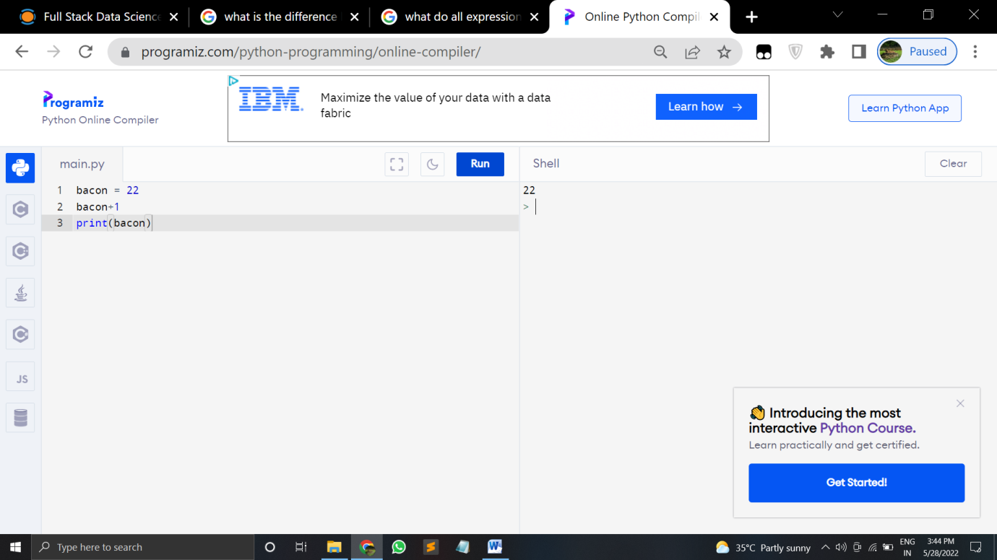

7. What should the values of the following two terms be?

'spam' + 'spamspam'

'spam' \* 3

The result of 1st one is = “spamspamspam

The 2nd result = spamspamspam (repeats 3 times)

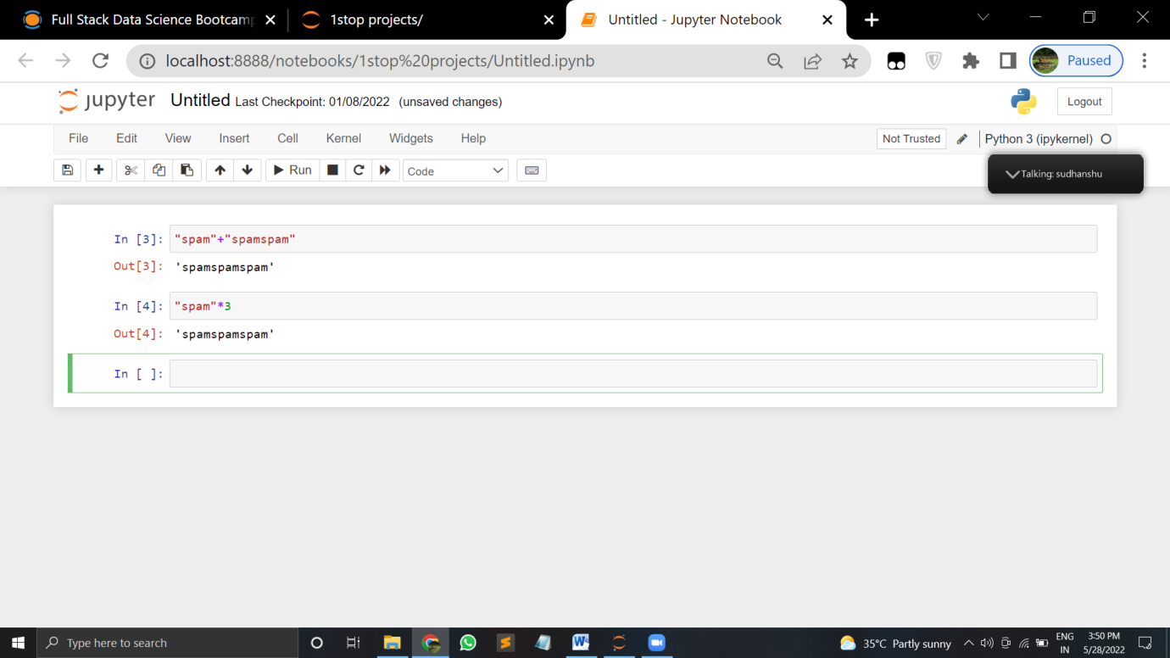

8. Why is eggs a valid variable name while 100 is invalid?

🡪here 100 is valid because a variable name can not be a number

Where the variable should be with a alphabet

9. What three functions can be used to get the integer, floating-point number, or string version of a value?

🡪The function used to get integer is : int()

🡪The function used to get floating-point number is : float()

🡪The function used to get string value is : string()

10. Why does this expression cause an error? How can you fix it?

'I have eaten ' + 99 + ' burritos.'

🡪This expression fails because of sting quotes

We can fix it by changing the quotes

The first one is failed to run

The second one is modifiend and runned successfully

