**API TESTING**

**Introduction:**

API testing is a type of software testing that analyzes an application programming interface (API) to ensure it meets expectations for functionality, reliability, performance.

API testing involves sending requests to the API and checking the responses to ensure they match the expected results. Some types of API testing include:

* Validation testing: Ensures the API returns the correct results and in the expected format
* UI testing: Validates that the API works correctly within the application's user interface

**API Testing using Postman:**

Postman tool used by developers and testers for API testing and development. It simplifies the process of sending requests to APIs and inspecting responses, allowing for comprehensive testing and debugging.

**GET:** Retrieve data from a server.

**POST:** Send data to a server to create or update a resource.

**PUT:** Send data to a server to update or create a resource (entirely).

**DELETE:** Delete a resource on the server.

**Test report for searching fish:**

<https://jpetstore.aspectran.com/catalog/searchProducts?keyword=fish>



**Post-Response:**

pm.test("Response status code is 200", *function* () {

    pm.response.to.have.status(200);

});

pm.test("Response time is less than 400ms", *function* () {

    pm.expect(pm.response.responseTime).to.be.below(400);

});

pm.test("Presence of 'Search Results for' text in the HTML response", *function* () {

    pm.expect(pm.response.text()).to.include("Search Results for");

});

pm.test("Verify the presence of Product ID, Name, and Description", *function* () {

*const* responseData = pm.response.text();

    pm.expect(responseData).to.include("Product ID");

    pm.expect(responseData).to.include("Name");

    pm.expect(responseData).to.include("Description");

});

**Response status code is 200**

Result: PASS

Observation: The API responded with a status code of 200, indicating a successful request.



**'Search Results' text in the HTML response**

Result: PASS

Observation: The response body contains the text "Search Results for", confirming that the API response likely includes search results.



**Verify the presence of Product ID, Name, and Description**

Result: PASS

Observation: The response body includes references to "Product ID", "Name", and "Description".



**Response time is less than 400ms**

Result: FAIL

Error: AssertionError: expected 682 to be below 400



**HTML response:**

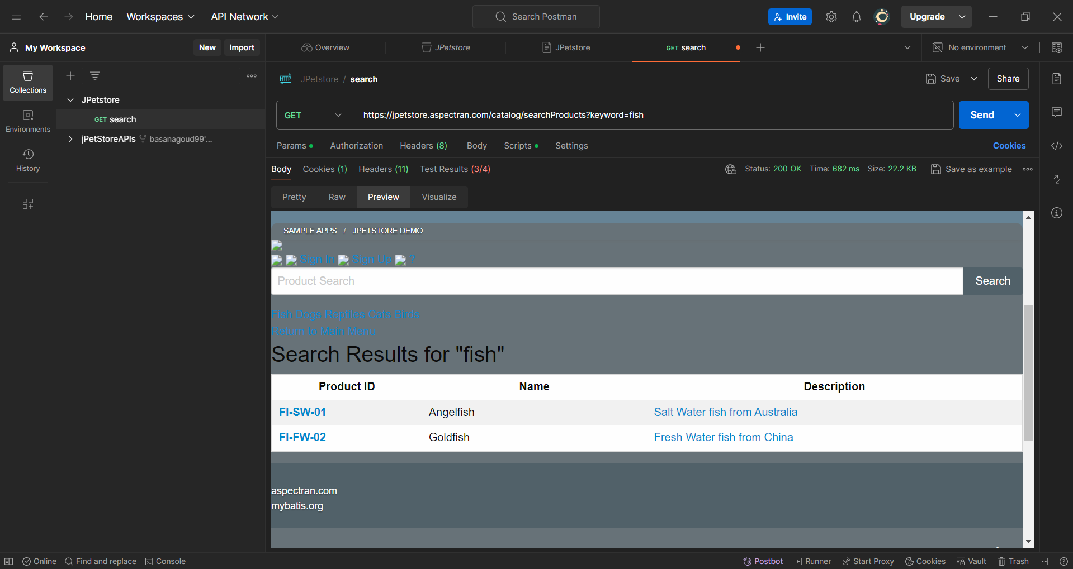

**API Test result:**

