- GitHub URL : https://github.com/Kondemahesh/k8s-network-troubleshooting/tree/main
https://github.com/Kondemahesh/k8s-network-troubleshooting.git
for Local setup we are getting error so i have tried in GCP Cloud for error attached screenshot below
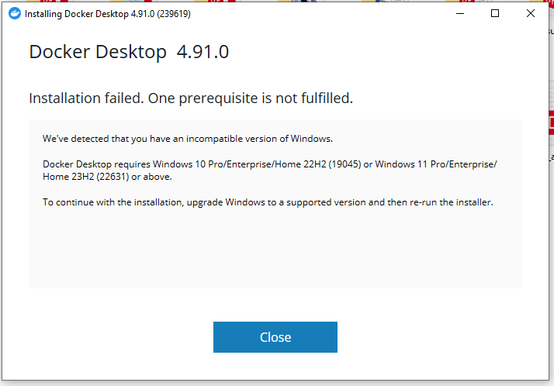

- Created GKE Cluster with 3 nodes
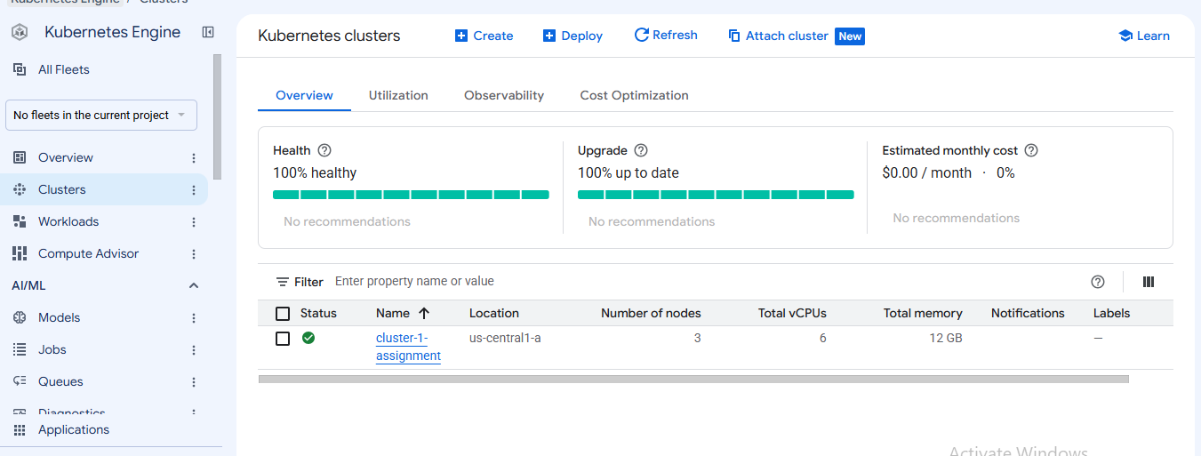
- And created Jump Server and connected the GKE cluster through Jump server
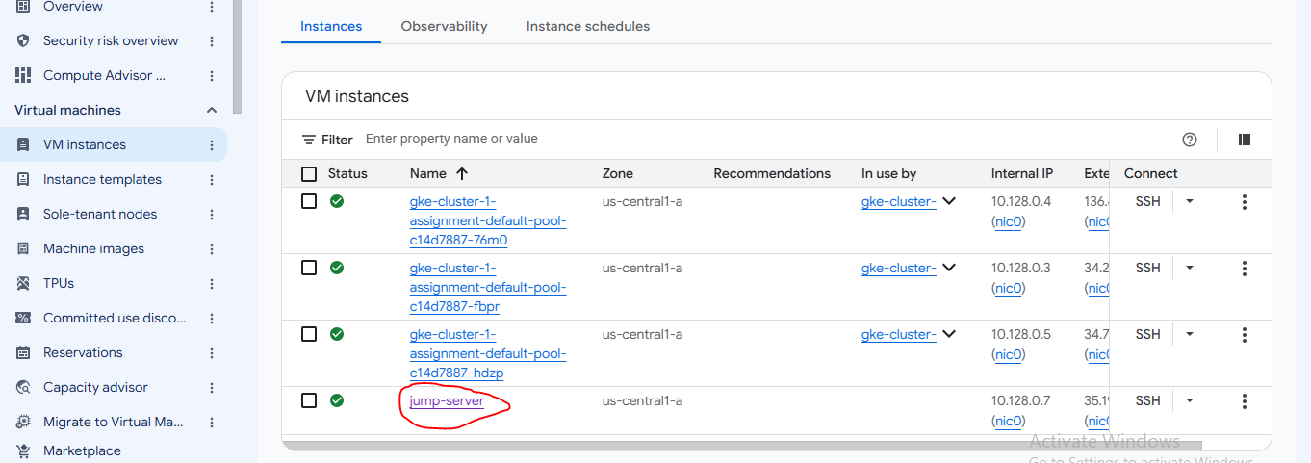
- For connecting Cluster through Jump Server used command
gcloud container clusters get-credentials cluster-1-assignment --zone us-central1-a

- Created a Folder in Jump server name: k8s-network-troubleshooting

- And created folde inside k8s-network-troubleshooting name manifeast

I created the manifest files in the manifest folder: namespace.yaml, frontend.yaml, frontend-service.yaml, backend.yaml, backend-service.yaml, and Client.yaml. I have also attached the GitHub URL below: https://github.com/Kondemahesh/k8s-network-troubleshooting.git

- And please check the Deployments of Client.yaml, frontendand backend
Kubectl get deployments –n network-lab
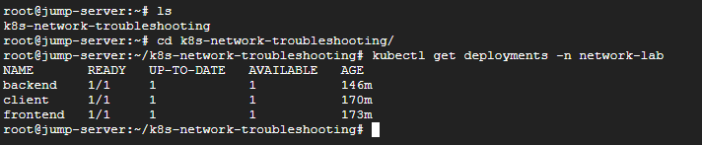

- And please check services I have deployed
Command: kubectl get svc –n network-lab
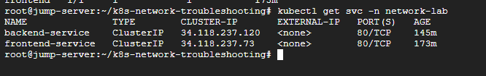

- Also check the end points
Command: kubectl get endpoints –n network-lab
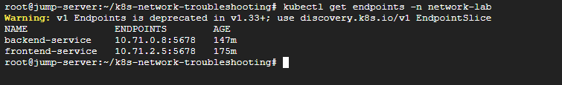

- We are checking connectivity from Clients to Frontend
Command: kubectl exec -it deployment/client -n network-lab – sh
curl http://frontend-service
- Verify Frontend and Backend Connectivity
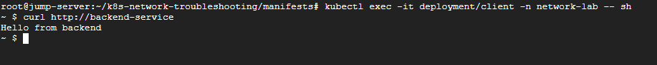

client → frontend SUCCESS
client → backend SUCCESS
12. Introduce Network Problem
we are intentionally changed the backend service labels
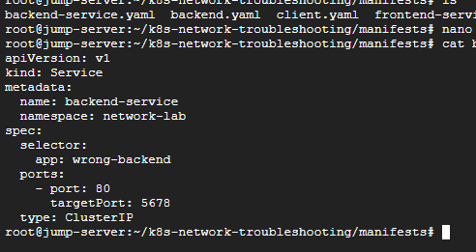

- Applied the same file
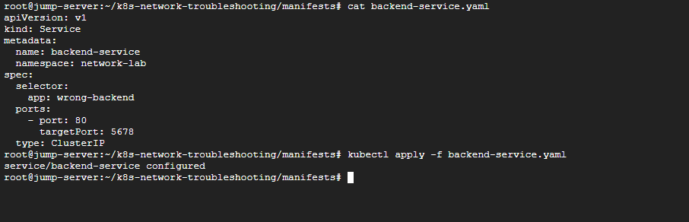

- Check the end point its not showing the backend end point
we are unable to connect the services

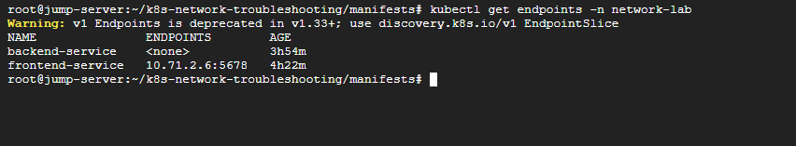

- Pods are running

15.Test The DNS
command: kubectl exec -it deployment/client -n network-lab – sh
We are used the nslookup command in screenshot
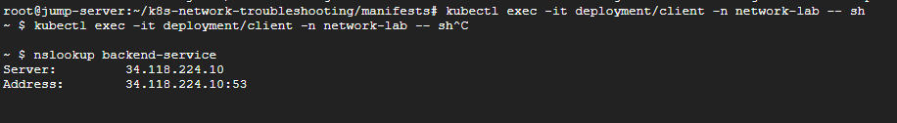

Curl command Failed
INVESTIGATE THE ISSUE
Observe
↓
Investigate
↓
Identify
↓
Fix
↓
Verify
15. Check the pods
Pods are working No pod crash issue

- Check the End points
command: kubectl get endpoints -n network-lab
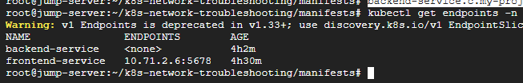

After issue backend Service NO End points in screen shot observe
16. Describe the Pod Services
Command: kubectl describe svc backend-service -n network-lab
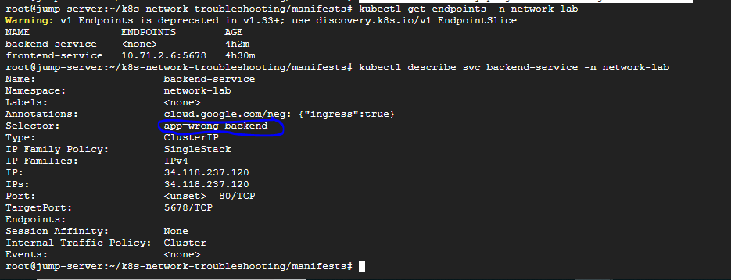

Look for your service Selector labels app: wrong-backend
and your pod Label app:backend
show below screenshot
17. Check Pod Labels:

Command: kubectl get pods -n network-lab --show-labels

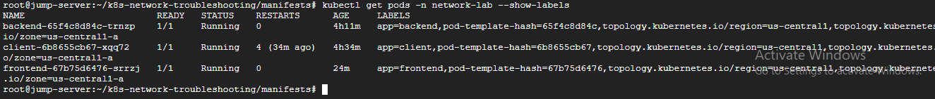

18. FIX THE ISSUE
In Backend Service.yaml file Update Below Selector
Change
selector:
app: wrong-backend
Update To
selector:
app: backend
and deploy the Backend Service
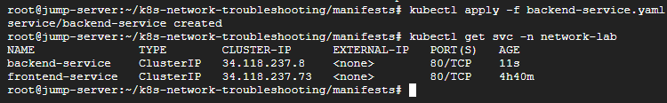

18. Verify Connectivity:

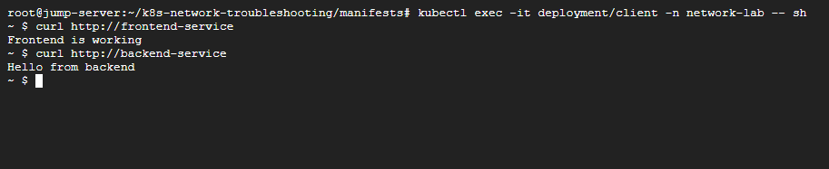
Frontend and Backend Connectivity Working
client → frontend
client → backend

You should see correct Selector in below Screenshot
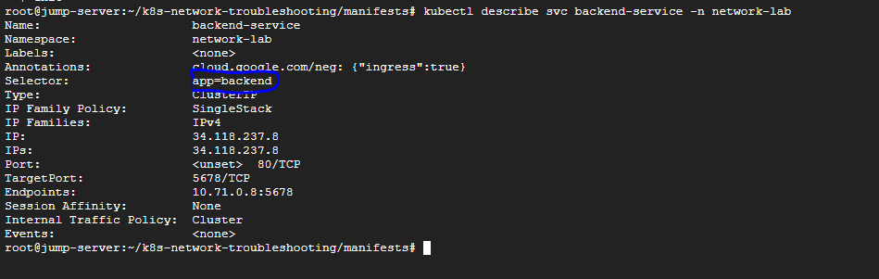

Root Cause: The Service selector did not match the backend Pod label. As a result, Kubernetes did not add the backend Pod to the Service endpoints.

