Reversible Data Hiding in Encrypted Images Based on Edge-Directed Prediction and
Multi-MSB Self-Prediction
ABSTRACT:
This paper proposes a high-capacity reversible data hiding in encrypted images (RDH-EI) method that combines edge-directed prediction (EDP) and multi-MSB self-prediction. The system aims to securely embed additional data within encrypted grayscale images without compromising the original image quality. The proposed method involves two main participants: the data owner and the data user, with an admin responsible for authorizing user access. The data owner encrypts the image, while the data user can request the image and retrieve it only after OTP verification. The method utilizes advanced algorithms, such as MSB prediction and adaptive error embedding, to enhance data embedding capacity and improve encryption security. Experimental results demonstrate that the method achieves high embedding rates, security, and lossless image recovery, outperforming state-of-the-art RDH-EI techniques. This technique ensures confidentiality and integrity while providing a reversible process for image recovery and data extraction.
Keywords
Reversible Data Hiding, Encrypted Images, Edge-Directed Prediction, Multi-MSB Self-Prediction, Data Embedding, Image Encryption, Data Security, OTP Verification, Image Recovery, Reversible Data Hiding in Encrypted Domain (RDH-EI).
STATEMENT ABOUT THE PROBLEM
As cloud storage and encrypted communication become more prevalent, ensuring the security and privacy of image data is crucial. Traditional data hiding methods cannot be applied to encrypted images due to the loss of spatial redundancy, limiting data embedding capacity. Existing Reversible Data Hiding in Encrypted Images (RDH-EI) techniques struggle with achieving high embedding capacity while ensuring secure, reversible image recovery. This work aims to develop a high-capacity, secure RDH-EI method that allows data embedding in encrypted images and guarantees lossless image recovery, with an effective user authorization system to prevent unauthorized access.
WHY IS THE PARTICULAR TOPIC CHOSEN?
With the rise of cloud computing and increasing concerns over data privacy, protecting sensitive data, especially in images, has become a major priority. Traditional data hiding techniques struggle with encrypted images due to the loss of spatial redundancy after encryption. Reversible Data Hiding in Encrypted Images (RDH-EI) addresses this challenge, allowing additional data to be embedded in encrypted images while ensuring the original image can be perfectly restored.
The motivation for this work is to enhance both the security and capacity of RDH-EI methods. By incorporating Edge-Directed Prediction (EDP) and Multi-MSB Self-Prediction, this method provides higher embedding capacity and greater accuracy compared to existing techniques. Additionally, the inclusion of an admin role for user authorization and OTP verification ensures that only authorized users can access and recover the original image, adding a layer of security critical for applications in fields like medical imaging and secure communications.
This approach aims to improve the efficiency, security, and reversibility of data hiding in encrypted images, contributing to the ongoing effort to safeguard sensitive data in cloud-based environments.
SCOPE:
The scope of this project encompasses the development of a high-capacity Reversible Data Hiding in Encrypted Images (RDH-EI) method that enables secure and efficient data embedding in encrypted grayscale images. It focuses on utilizing advanced prediction techniques like Edge-Directed Prediction (EDP) and Multi-MSB Self-Prediction to optimize embedding capacity while ensuring lossless image recovery. The project also integrates a robust user authorization system with OTP verification to prevent unauthorized access and safeguard data privacy. The solution is designed for applications in cloud storage and secure communication where both data security and image integrity are critical.
OBJECTIVE OF THE PROJECT:
The objective of this project is to develop a high-capacity Reversible Data Hiding in Encrypted Images (RDH-EI) method that enables efficient embedding of additional data into encrypted grayscale images while ensuring the lossless recovery of the original image. The project aims to implement advanced data embedding techniques using Edge-Directed Prediction (EDP) and Multi-MSB Self-Prediction to enhance embedding capacity and accuracy. It also focuses on ensuring secure and reversible image recovery through encryption and data extraction processes. Furthermore, the project incorporates a user authorization system with OTP verification to prevent unauthorized access and maintain data privacy, ultimately achieving high embedding capacity without compromising image quality or security.

EXISTING METHOD
Existing Reversible Data Hiding in Encrypted Images (RDH-EI) systems primarily focus on embedding data into encrypted images while ensuring the original image can be accurately restored. However, these methods often face limitations in embedding capacity due to the loss of spatial redundancy after encryption. Techniques like Least Significant Bit (LSB) prediction and prediction-error expansion, though widely used, struggle to balance high embedding capacity with image quality and security. These methods also lack robust user authorization systems, leading to potential security risks, and often require substantial computational resources for data embedding and recovery.
DISADVANTAGES
• Limited embedding capacity due to the loss of spatial redundancy after encryption.
• Inability to maintain high image quality while embedding large amounts of data.
• Lack of robust user authorization systems, leading to potential unauthorized access.
• High computational complexity for data embedding and image recovery.
• Security vulnerabilities in data extraction and recovery processes.
PROPOSED SYSTEM:
The proposed system aims to enhance existing RDH-EI methods by using advanced techniques like Edge-Directed Prediction (EDP) and Multi-MSB Self-Prediction, which improve pixel prediction accuracy and increase the embedding capacity. Additionally, it integrates a user authorization system with OTP verification to ensure that only authorized users can access and download the embedded data, further securing the data. The proposed system ensures a higher embedding rate, improved image recovery, and enhanced security, making it more suitable for cloud storage and secure communication applications where both data integrity and confidentiality are essential.
ADVANTAGES
- Improved embedding capacity using Edge-Directed Prediction (EDP) and Multi-MSB Self-Prediction.
- Secure data embedding with lossless image recovery.
- Integration of a user authorization system with OTP verification for enhanced security.
- Higher accuracy in pixel prediction, ensuring better image quality.
- More efficient and secure for applications in cloud storage and encrypted communication.

PROJECT FLOW:

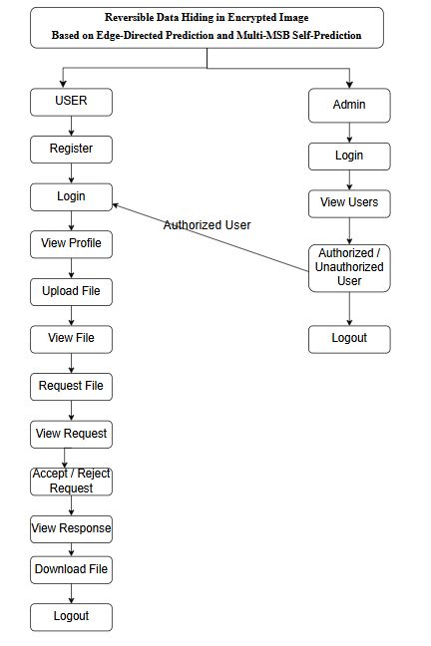
SOFTWARE FRONT END REQUIREMENTS

H/W CONFIGURATION:

Processor - I3/Intel Processor
- Hard Disk -160GB
- Key Board - Standard Windows Keyboard
- Mouse - Two or Three Button Mouse
- Monitor - SVGA
- RAM - 4Gb
S/W CONFIGURATION:
- Operating System : Windows 7/8/10
- Server side Script : Python, HTML, MYSQL, CSS, Bootstrap.
- Libraries : Django, Smtlib, Numpy
- IDE : VScode
- Technology : Python 3.10+
MODULES/IMPLEMENTATION
User Module
Functionality:
- Manages user registration, login, and profile management.
- Users can view, update their profile, and track their activities.
- Allows users to upload encrypted grayscale images (if data owners) and request data (if data users).
- Handles unauthorized access checks and allows only authorized users to perform specific actions based on admin approval.

Admin Module
Functionality:

- Admin is responsible for logging in and viewing a list of users.
- Admin can approve or deny user access, marking them as authorized or unauthorized.
- Manages the overall system security by controlling user permissions.
File Upload Module (Data Owner)
Functionality:
- Data owners can upload grayscale images and other relevant data.
- The files are encrypted using the RDH-EI method before being stored.
- Ensures that both the image and associated data are securely encrypted, preserving confidentiality.
File Request Module (Data User)
Functionality:

- Data users can browse available images and make requests for specific files.
- Requests are sent to the data owner for review and approval.
- Enables data users to select which image or both image and text they wish to download.
Request Approval and OTP Verification Module
Functionality:
- Data owners review file requests from data users.
- After approving a request, an OTP is sent to the data user's email.
- Ensures that data users can only access requested files after OTP verification.
Data Embedding and Encryption Module
Functionality:
- Embeds additional data securely into the encrypted image using Edge-Directed Prediction (EDP) and Multi-MSB Self-Prediction.
- Ensures high embedding capacity while maintaining the ability to perfectly recover the original image.
- Uses encryption techniques to secure the data embedding process.
Data Extraction and Image Recovery Module
Functionality:
- Enables authorized users to extract embedded data and restore the original image.
- Only users with proper decryption keys can access the hidden data or recover the original image.
- Ensures the integrity of both the embedded data and the recovered image.

OTP Verification for File Download Module
Functionality:
- Verifies the OTP entered by the data user before allowing file downloads.
- Ensures that only the authorized data user can download the requested file.
- Provides a secure method of file access by checking the OTP validity.

