Reversible Data Hiding in Encrypted Images
Based on Edge-Directed Prediction and
Multi-MSB Self-Prediction

CONTENT
Abstract
1.INTRODUCTION
1.1 Motivation
1.2 Problem Statement
1.3 Objective of the Project
1.4 Scope
1.5 Project Introduction
2.LITERATURE SURVEY
2.1 Related Work
3. SYSTEM ANALYSIS
3.1 Existing System
3.2 Disadvantages
3.3 Proposed System
3.4 Advantages
3.5 work Flow of Proposed system
4. REQUIREMENT ANALYSIS
4.1 Function and non-functional requirements
4.2 Hardware Requirements
4.3 Software Requirements
4.4 Architecture
5. SYSTEM DESIGN
5.1 Introduction of Input design
5.2 UML Diagram(class, use case, sequence, collaborative, deployment, activity, ER diagram and Component diagram)
5.3 Data Flow Diagram
6. IMPLEMENTATION AND RESULTS
6.1 Modules
6.3 Output Screens
- METHODOLOGY
- SYSTEM STUDY AND TESTING
8.1 Feasibility study
8.2 Types of test & Test Cases
9. CONCLUSION
10. FUTURE ENHANCEMENT
11. REFERENCES

ABSTRACT:
This paper proposes a high-capacity reversible data hiding in encrypted images (RDH-EI) method that combines edge-directed prediction (EDP) and multi-MSB self-prediction. The system aims to securely embed additional data within encrypted grayscale images without compromising the original image quality. The proposed method involves two main participants: the data owner and the data user, with an admin responsible for authorizing user access. The data owner encrypts the image, while the data user can request the image and retrieve it only after OTP verification. The method utilizes advanced algorithms, such as MSB prediction and adaptive error embedding, to enhance data embedding capacity and improve encryption security. Experimental results demonstrate that the method achieves high embedding rates, security, and lossless image recovery, outperforming state-of-the-art RDH-EI techniques. This technique ensures confidentiality and integrity while providing a reversible process for image recovery and data extraction.
Keywords
Reversible Data Hiding, Encrypted Images, Edge-Directed Prediction, Multi-MSB Self-Prediction, Data Embedding, Image Encryption, Data Security, OTP Verification, Image Recovery, Reversible Data Hiding in Encrypted Domain (RDH-EI).

- INTRODUCTION
1.1 Motivation:
With the rise of cloud computing and increasing concerns over data privacy, protecting sensitive data, especially in images, has become a major priority. Traditional data hiding techniques struggle with encrypted images due to the loss of spatial redundancy after encryption. Reversible Data Hiding in Encrypted Images (RDH-EI) addresses this challenge, allowing additional data to be embedded in encrypted images while ensuring the original image can be perfectly restored.

The motivation for this work is to enhance both the security and capacity of RDH-EI methods. By incorporating Edge-Directed Prediction (EDP) and Multi-MSB Self-Prediction, this method provides higher embedding capacity and greater accuracy compared to existing techniques. Additionally, the inclusion of an admin role for user authorization and OTP verification ensures that only authorized users can access and recover the original image, adding a layer of security critical for applications in fields like medical imaging and secure communications.
This approach aims to improve the efficiency, security, and reversibility of data hiding in encrypted images, contributing to the ongoing effort to safeguard sensitive data in cloud-based environments.

1.2 Problem Statement:
As cloud storage and encrypted communication become more prevalent, ensuring the security and privacy of image data is crucial. Traditional data hiding methods cannot be applied to encrypted images due to the loss of spatial redundancy, limiting data embedding capacity. Existing Reversible Data Hiding in Encrypted Images (RDH-EI) techniques struggle with achieving high embedding capacity while ensuring secure, reversible image recovery. This work aims to develop a high-capacity, secure RDH-EI method that allows data embedding in encrypted images and guarantees lossless image recovery, with an effective user authorization system to prevent unauthorized access.
1.3 Objective of the project:
The objective of this project is to develop a high-capacity Reversible Data Hiding in Encrypted Images (RDH-EI) method that enables efficient embedding of additional data into encrypted grayscale images while ensuring the lossless recovery of the original image. The project aims to implement advanced data embedding techniques using Edge-Directed Prediction (EDP) and Multi-MSB Self-Prediction to enhance embedding capacity and accuracy. It also focuses on ensuring secure and reversible image recovery through encryption and data extraction processes. Furthermore, the project incorporates a user authorization system with OTP verification to prevent unauthorized access and maintain data privacy, ultimately achieving high embedding capacity without compromising image quality or security.
1.4 Scope:
The scope of this project encompasses the development of a high-capacity Reversible Data Hiding in Encrypted Images (RDH-EI) method that enables secure and efficient data embedding in encrypted grayscale images. It focuses on utilizing advanced prediction techniques like Edge-Directed Prediction (EDP) and Multi-MSB Self-Prediction to optimize embedding capacity while ensuring lossless image recovery. The project also integrates a robust user authorization system with OTP verification to prevent unauthorized access and safeguard data privacy. The solution is designed for applications in cloud storage and secure communication where both data security and image integrity are critical.
1.5 Project Introduction:
With the growing reliance on cloud storage and encrypted communication for safeguarding sensitive data, ensuring the security and privacy of image files has become a significant concern. Traditional data hiding techniques, which embed additional data into images, are not suitable for encrypted images due to the loss of spatial redundancy caused by encryption. This limitation restricts the capacity to embed data while maintaining the original image quality.
Reversible Data Hiding in Encrypted Images (RDH-EI) has emerged as a solution to this problem, enabling the embedding of data within encrypted images while ensuring that the original image can be perfectly restored. However, existing RDH-EI methods face challenges in achieving high embedding capacity and maintaining secure, lossless recovery of the image.
This project aims to address these challenges by proposing a high-capacity RDH-EI method that leverages advanced techniques such as Edge-Directed Prediction (EDP) and Multi-MSB Self-Prediction. These techniques enhance the accuracy of pixel prediction and increase the available space for data embedding, ensuring both high embedding capacity and secure image recovery. Additionally, the project integrates a user authorization system with OTP verification to ensure that only authorized users can access and download the embedded data. The proposed method targets applications in cloud storage and secure communication where both data security and image integrity are crucial.

- LITERATURE SURVEY
2.1 Related Work:
1. "Reversible Data Hiding and Authentication Scheme for Encrypted Images Based on Prediction Error Compression"
Authors: Fang Ren, Zhelin Zhang, Kai Jiang, Peiyang Zhang, Tengfei Yang
Date: July 2025
Summary: This paper proposes a scheme that combines reversible data hiding with content authentication. It utilizes a new predictor, ISGAP, to generate accurate predictions, compresses errors using adaptive Huffman coding, and embeds authentication information to ensure both data confidentiality and integrity.
2. "A Survey of Reversible Data Hiding in Encrypted Images"
Authors: Pauline Puteaux, Simying Ong, Koksheik Wong, William Puech
Date: March 2021
Summary: This comprehensive survey reviews the evolution of RDH-EI over the past 12 years, categorizing various techniques and highlighting significant methods that balance embedding capacity, security, and image quality.
3. "Reversible Data Hiding in Encrypted Images Using Adaptive Classification Embedding Mechanism"
Authors: Not specified in the provided information
Date: March 2025
Summary: This study presents an RDH-EI approach that enhances embedding capacity by employing an adaptive classification embedding mechanism, addressing challenges in balancing embedding rate and image quality.

4. "Reversible Data Hiding in Encrypted Image Using Multiple Data-Hiders Sharing Algorithm"
Authors: Weng, C.Y.; Yang, C.H.
Date: 2023
Summary: The paper introduces a method where multiple data-hiders collaboratively embed data into encrypted images, enhancing embedding capacity and security by distributing the embedding process.

5. "Reversible Data Hiding in Encrypted Images Based on Secret Sharing and Hybrid Coding"
Authors: Yu, C.; Zhang, X.; Qin, C.; Tang, Z.
Date: 2023
Summary: This research combines secret sharing techniques with hybrid coding to propose an RDH-EI method that improves embedding capacity and ensures data confidentiality and reversibility.
6. "Reversible Data Hiding in Encrypted Images Using Chaos Theory and Histogram Shifting"
Authors: Wang, Y.; Xiong, G.; He, W.
Date: 2023
Summary: The authors propose an RDH-EI technique that leverages chaos theory for encryption and histogram shifting for data embedding, aiming to enhance security and embedding capacity.

3. SYSTEM ANALYSIS

3.1 Existing System
Existing Reversible Data Hiding in Encrypted Images (RDH-EI) systems primarily focus on embedding data into encrypted images while ensuring the original image can be accurately restored. However, these methods often face limitations in embedding capacity due to the loss of spatial redundancy after encryption. Techniques like Least Significant Bit (LSB) prediction and prediction-error expansion, though widely used, struggle to balance high embedding capacity with image quality and security. These methods also lack robust user authorization systems, leading to potential security risks, and often require substantial computational resources for data embedding and recovery.
3.2 Disadvantages
- Limited embedding capacity due to the loss of spatial redundancy after encryption.
- Inability to maintain high image quality while embedding large amounts of data.
- Lack of robust user authorization systems, leading to potential unauthorized access.
- High computational complexity for data embedding and image recovery.
- Security vulnerabilities in data extraction and recovery processes.

3.3 Proposed System
The proposed system aims to enhance existing RDH-EI methods by using advanced techniques like Edge-Directed Prediction (EDP) and Multi-MSB Self-Prediction, which improve pixel prediction accuracy and increase the embedding capacity. Additionally, it integrates a user authorization system with OTP verification to ensure that only authorized users can access and download the embedded data, further securing the data. The proposed system ensures a higher embedding rate, improved image recovery, and enhanced security, making it more suitable for cloud storage and secure communication applications where both data integrity and confidentiality are essential.
3.4 Advantages
- Improved embedding capacity using Edge-Directed Prediction (EDP) and Multi-MSB Self-Prediction.
- Secure data embedding with lossless image recovery.
- Integration of a user authorization system with OTP verification for enhanced security.
- Higher accuracy in pixel prediction, ensuring better image quality.
- More efficient and secure for applications in cloud storage and encrypted communication.

3.5 work Flow of Proposed system:

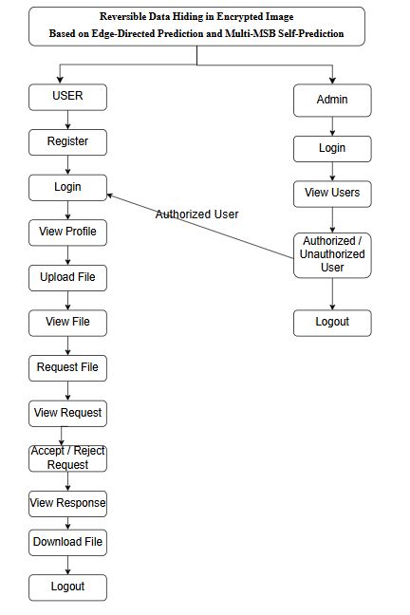

4. REQUIREMENT ANALYSIS
4.1 Functional and non-functional requirements
Requirement’s analysis is very critical process that enables the success of a system or software project to be assessed. Requirements are generally split into two types: Functional and non-functional requirements.
Functional Requirements: These are the requirements that the end user specifically demands as basic facilities that the system should offer. All these functionalities need to be necessarily incorporated into the system as a part of the contract. These are represented or stated in the form of input to be given to the system, the operation performed and the output expected. They are basically the requirements stated by the user which one can see directly in the final product, unlike the non-functional requirements.
Examples of functional requirements:
- Authentication of user whenever he/she logs into the system
- System shutdown in case of a cyber-attack
- A verification email is sent to user whenever he/she register for the first time on some software system.
Non-functional requirements: These are basically the quality constraints that the system must satisfy according to the project contract. The priority or extent to which these factors are implemented varies from one project to other. They are also called non-behavioral requirements.
They basically deal with issues like:
- Portability
- Security
- Maintainability
- Reliability
- Scalability
- Performance
- Reusability
- Flexibility
Examples of non-functional requirements:
- Emails should be sent with a latency of no greater than 12 hours from such an activity.
- The processing of each request should be done within 10 seconds
- The site should load in 3 seconds whenever of simultaneous users are > 10000
  - Hardware Requirements

Processor - I3/Intel Processor
Hard Disk - 160GB
Key Board - Standard Windows Keyboard
Mouse - Two or Three Button Mouse
Monitor - SVGA
RAM - 8GB
  - Software Requirements:
Operating System : Windows 7/8/10
Server side Script : HTML, CSS, Bootstrap & JS
Programming Language : Python
Libraries : Django, Os, Smtplib, Numpy
IDE/Workbench : VS code
Technology : Python 3.6+

  - Architecture: 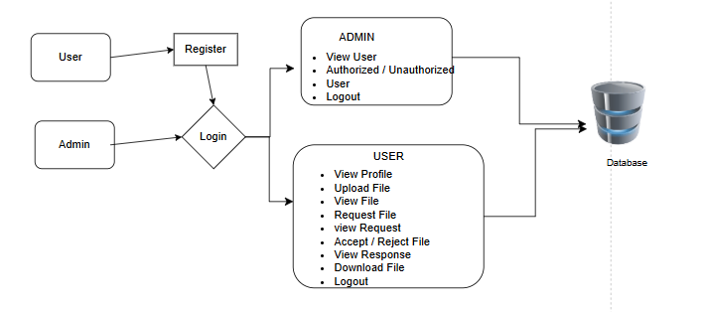

5. SYSTEM DESIGN
5.1 Introduction of Input Design:
In an information system, input is the raw data that is processed to produce output. During the input design, the developers must consider the input devices such as PC, MICR, OMR, etc.
Therefore, the quality of system input determines the quality of system output. Well-designed input forms and screens have following properties −
- It should serve specific purpose effectively such as storing, recording, and retrieving the information.
- It ensures proper completion with accuracy.
- It should be easy to fill and straightforward.
- It should focus on user’s attention, consistency, and simplicity.
- All these objectives are obtained using the knowledge of basic design principles regarding −
  - What are the inputs needed for the system?
  - How end users respond to different elements of forms and screens.

Objectives for Input Design:
The objectives of input design are −
- To design data entry and input procedures
- To reduce input volume
- To design source documents for data capture or devise other data capture methods
- To design input data records, data entry screens, user interface screens, etc.
- To use validation checks and develop effective input controls.

Output Design:
The design of output is the most important task of any system. During output design, developers identify the type of outputs needed, and consider the necessary output controls and prototype report layouts.

Objectives of Output Design:
The objectives of input design are:
- To develop output design that serves the intended purpose and eliminates the production of unwanted output.
- To develop the output design that meets the end user’s requirements.
- To deliver the appropriate quantity of output.
- To form the output in appropriate format and direct it to the right person.
- To make the output available on time for making good decisions.
5.2 UML Diagrams:
5.2.1 Use Case Diagram:
A use case diagram in the Unified Modeling Language (UML) is a type of behavioral diagram defined by and created from a Use-case analysis. Its purpose is to present a graphical overview of the functionality provided by a system in terms of actors, their goals (represented as use cases), and any dependencies between those use cases. The main purpose of a use case diagram is to show what system functions are performed for which actor. Roles of the actors in the system can be depicted.
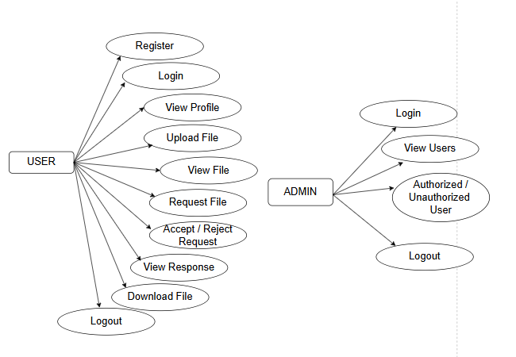
CLASS DIAGRAM:
In software engineering, a class diagram in the Unified Modelling Language (UML) is a type of static structure diagram that describes the structure of a system by showing the system's classes, their attributes, operations (or methods), and the relationships among the classes. It explains which class contains information.
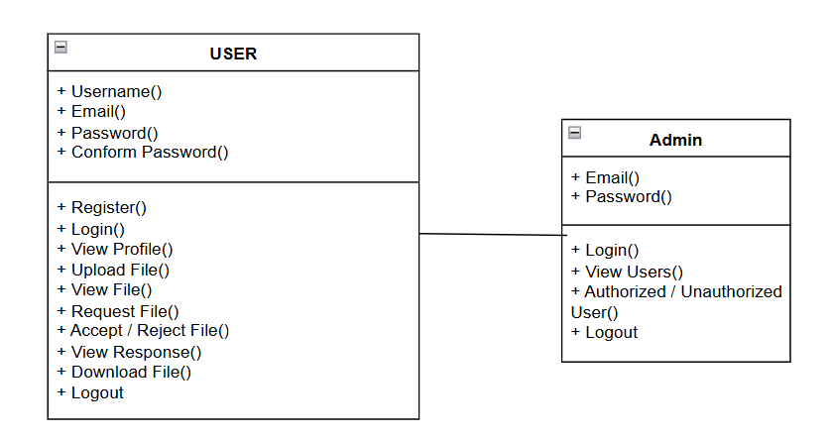
SEQUENCE DIAGRAM:
A sequence diagram in Unified Modelling Language (UML) is a kind of interaction diagram that shows how processes operate with one another and in what order. It is a construct of a Message Sequence Chart. Sequence diagrams are sometimes called event diagrams, event scenarios, and timing diagrams.
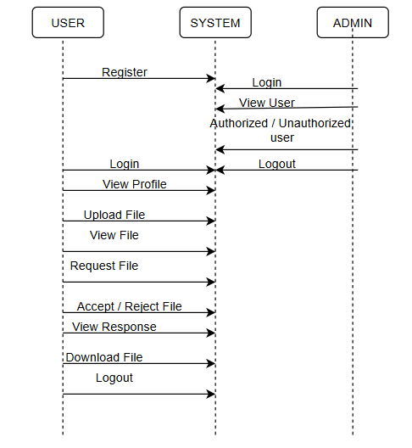
COLLABORATION DIAGRAM:
In collaboration diagram the method call sequence is indicated by some numbering technique as shown below. The number indicates how the methods are called one after another. We have taken the same order management system to describe the collaboration diagram. The method calls are similar to that of a sequence diagram. But the difference is that the sequence diagram does not describe the object organization whereas the collaboration diagram shows the object organization.
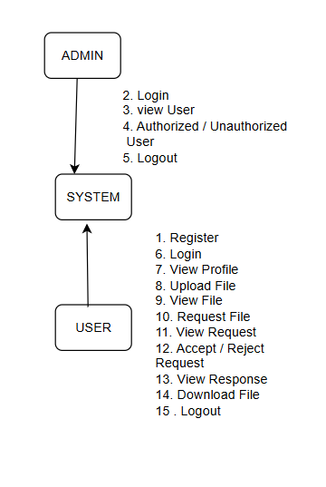
DEPLOYMENT DIAGRAM
Deployment diagram represents the deployment view of a system. It is related to the component diagram. Because the components are deployed using the deployment diagrams. A deployment diagram consists of nodes. Nodes are nothing but physical hardware’s used to deploy the application.
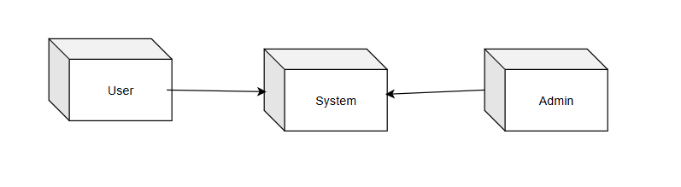
ACTIVITY DIAGRAM:
Activity diagrams are graphical representations of workflows of stepwise activities and actions with support for choice, iteration and concurrency. In the Unified Modelling Language, activity diagrams can be used to describe the business and operational step-by-step workflows of components in a system. An activity diagram shows the overall flow of control.
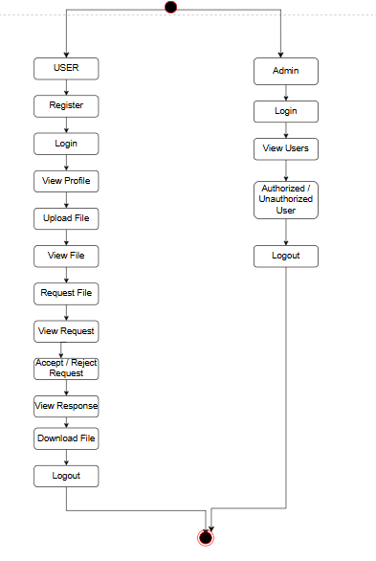
COMPONENT DIAGRAM:
A component diagram, also known as a UML component diagram, describes the organization and wiring of the physical components in a system. Component diagrams are often drawn to help model implementation details and double-check that every aspect of the system's required functions is covered by planned development.
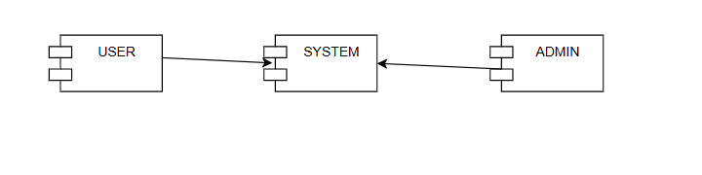

ER DIAGRAM:
An Entity–relationship model (ER model) describes the structure of a database with the help of a diagram, which is known as Entity Relationship Diagram (ER Diagram). An ER model is a design or blueprint of a database that can later be implemented as a database. The main components of E-R model are: entity set and relationship set.
An ER diagram shows the relationship among entity sets. An entity set is a group of similar entities and these entities can have attributes. In terms of DBMS, an entity is a table or attribute of a table in database, so by showing relationship among tables and their attributes, ER diagram shows the complete logical structure of a database. Let’s have a look at a simple ER diagram to understand this concept.
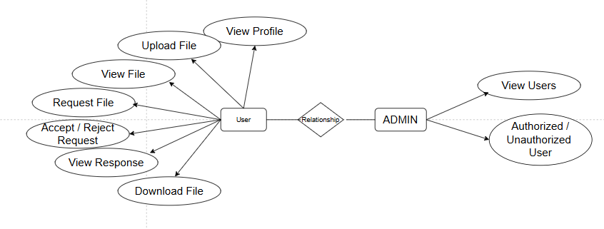
DFD DIAGRAM:
A Data Flow Diagram (DFD) is a traditional way to visualize the information flows within a system. A neat and clear DFD can depict a good amount of the system requirements graphically. It can be manual, automated, or a combination of both. It shows how information enters and leaves the system, what changes the information and where information is stored. The purpose of a DFD is to show the scope and boundaries of a system as a whole. It may be used as a communications tool between a systems analyst and any person who plays a part in the system that acts as the starting point for redesigning a system.
Level 0 Diagram:
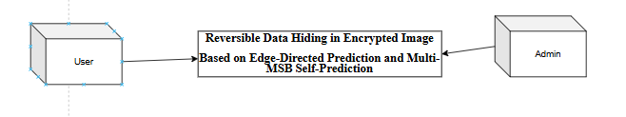

Level 1 Diagram:

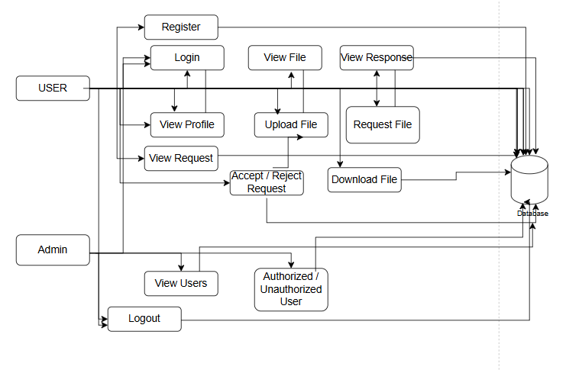
Level 2 Diagram:
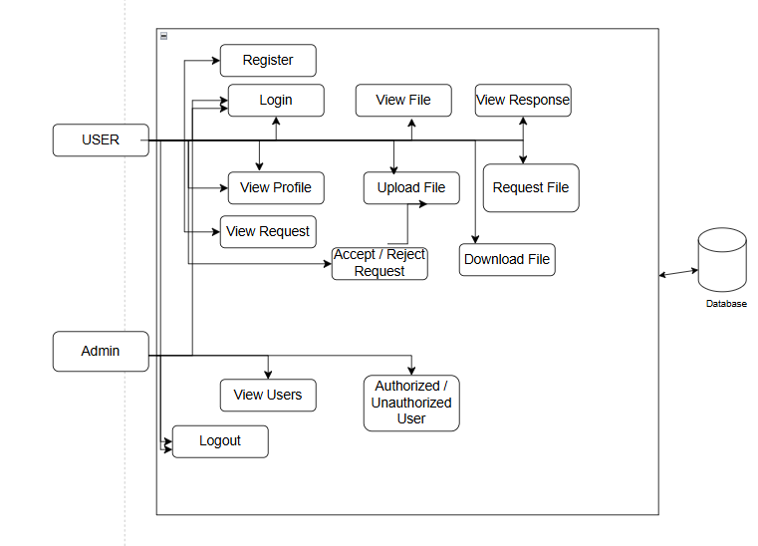

MODULES/IMPLEMENTATION
6.1MODULES:
User Module

Functionality:

- Manages user registration, login, and profile management.
- Users can view, update their profile, and track their activities.
- Allows users to upload encrypted grayscale images (if data owners) and request data (if data users).
- Handles unauthorized access checks and allows only authorized users to perform specific actions based on admin approval.

Admin Module
Functionality:

- Admin is responsible for logging in and viewing a list of users.
- Admin can approve or deny user access, marking them as authorized or unauthorized.
- Manages the overall system security by controlling user permissions.
File Upload Module (Data Owner)
Functionality:

- Data owners can upload grayscale images and other relevant data.
- The files are encrypted using the RDH-EI method before being stored.
- Ensures that both the image and associated data are securely encrypted, preserving confidentiality.

File Request Module (Data User)

Functionality:

- Data users can browse available images and make requests for specific files.
- Requests are sent to the data owner for review and approval.
- Enables data users to select which image or both image and text they wish to download.
Request Approval and OTP Verification Module

Functionality:

- Data owners review file requests from data users.
- After approving a request, an OTP is sent to the data user's email.
- Ensures that data users can only access requested files after OTP verification.

Data Embedding and Encryption Module
Functionality:

- Embeds additional data securely into the encrypted image using Edge-Directed Prediction (EDP) and Multi-MSB Self-Prediction.
- Ensures high embedding capacity while maintaining the ability to perfectly recover the original image.
- Uses encryption techniques to secure the data embedding process.
Data Extraction and Image Recovery Module
Functionality:

- Enables authorized users to extract embedded data and restore the original image.
- Only users with proper decryption keys can access the hidden data or recover the original image.
- Ensures the integrity of both the embedded data and the recovered image.

OTP Verification for File Download Module
Functionality:
- Verifies the OTP entered by the data user before allowing file downloads.
- Ensures that only the authorized data user can download the requested file.
- Provides a secure method of file access by checking the OTP validity.

6.2 Results:

Home Page: This is the home page.
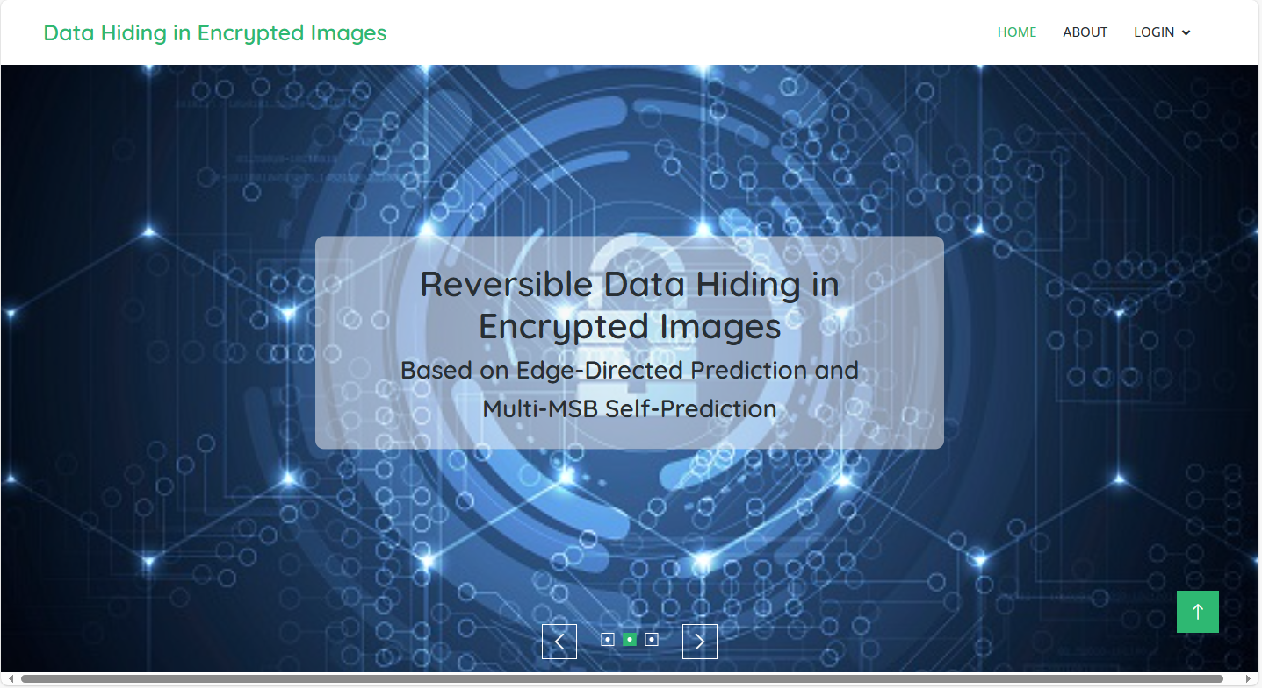

About page: here some details about project.
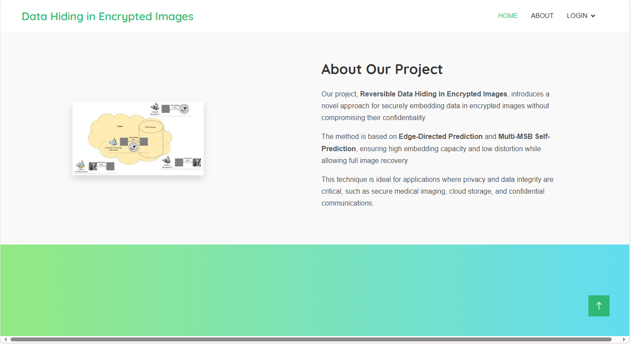
Registration Page: Here user can register by providing required details.
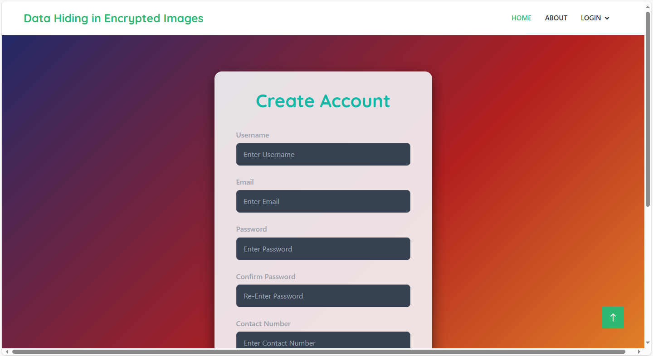

Login Page: here user can login by giving their registered email and password.
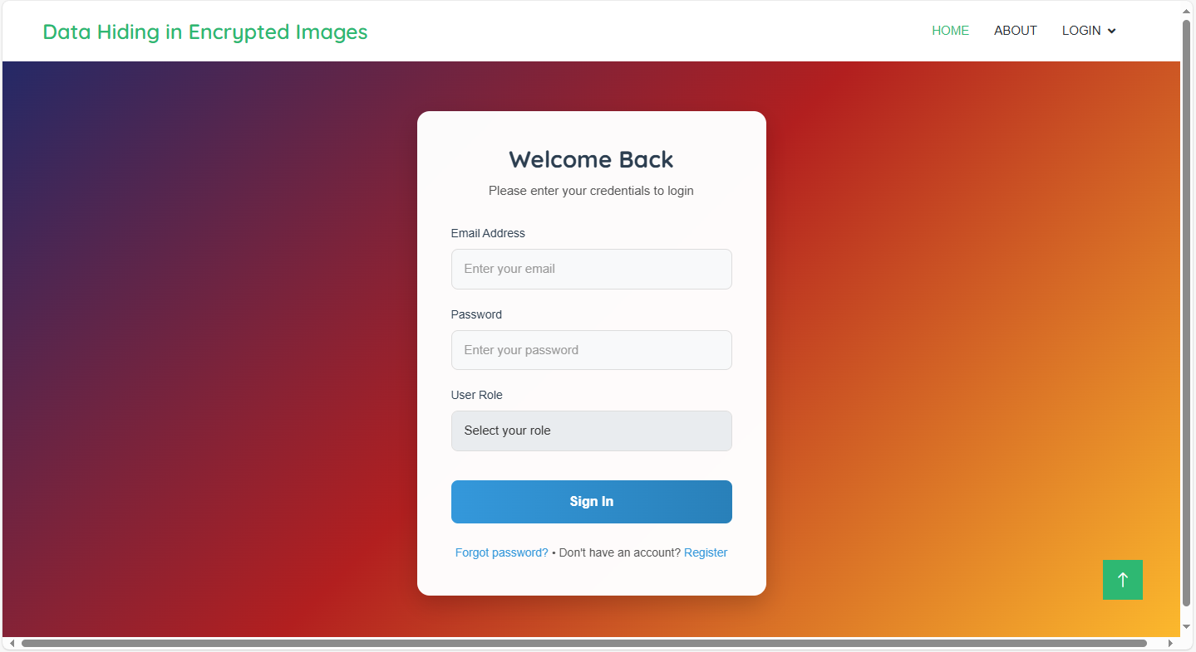

Home page: here user will redirect to home page of user when they successfully login.
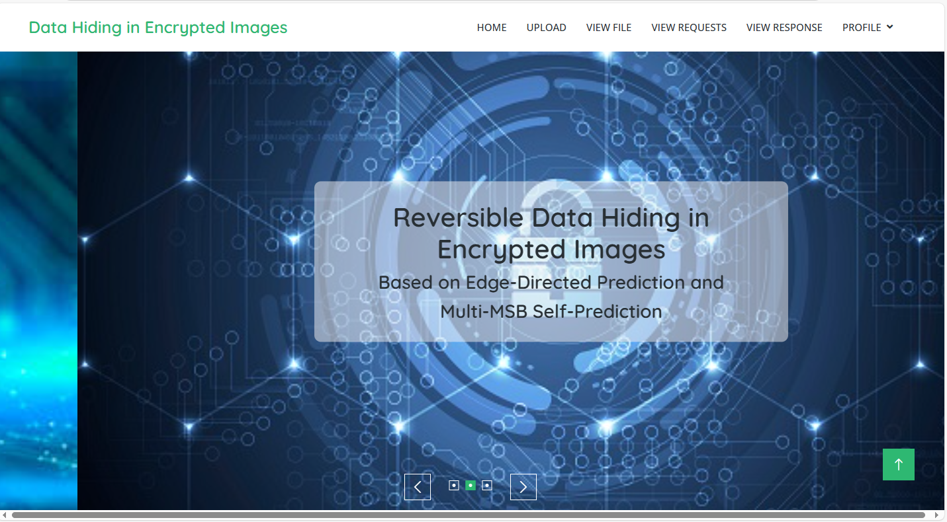
Upload File: here user can upload file with providing key and data.
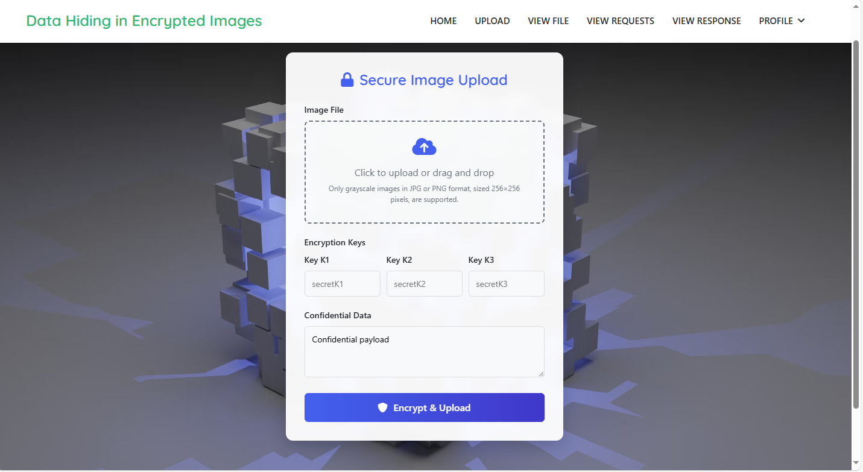
View File: here user can view their file which are uploaded.
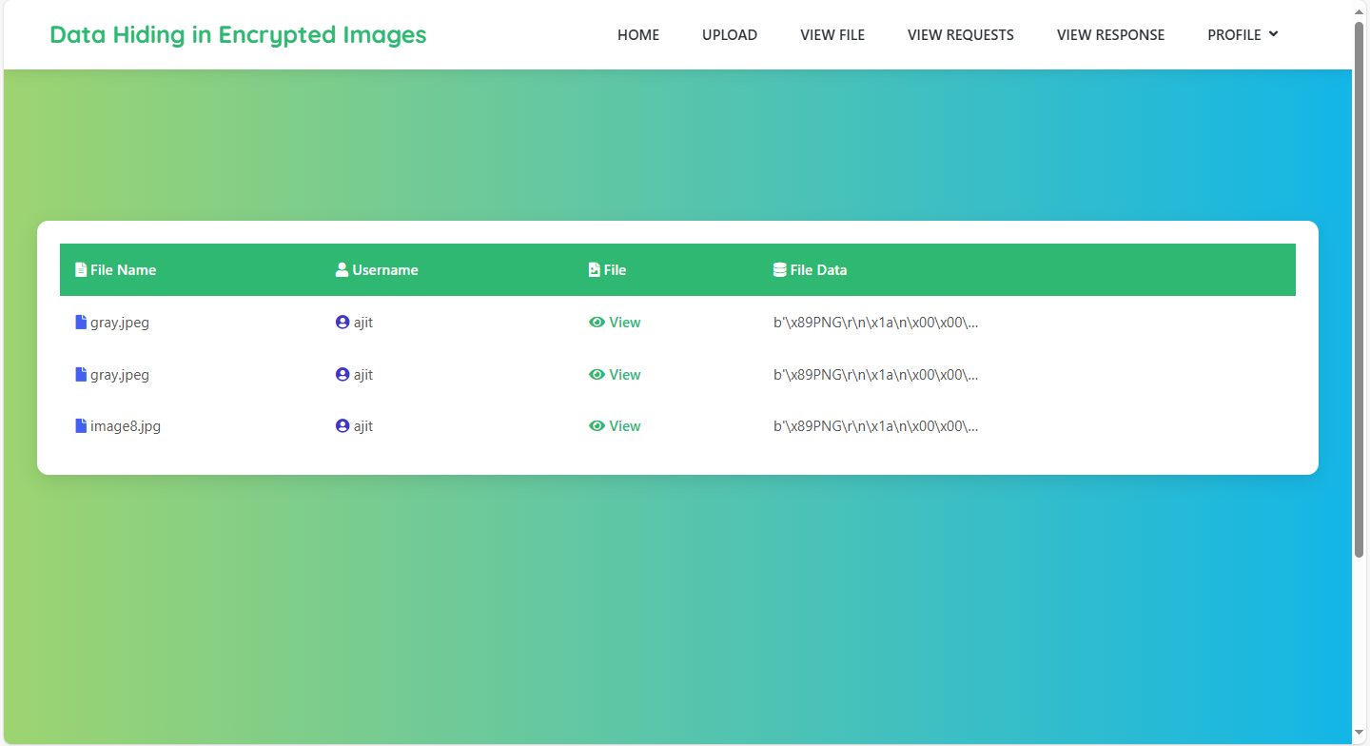

View Request: here user can view requests then they will decide accept or reject.
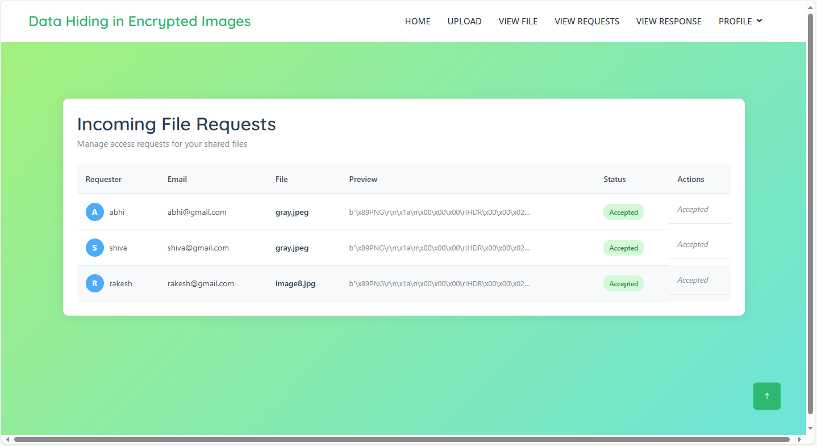
View Response: Here user can view response of requested file.
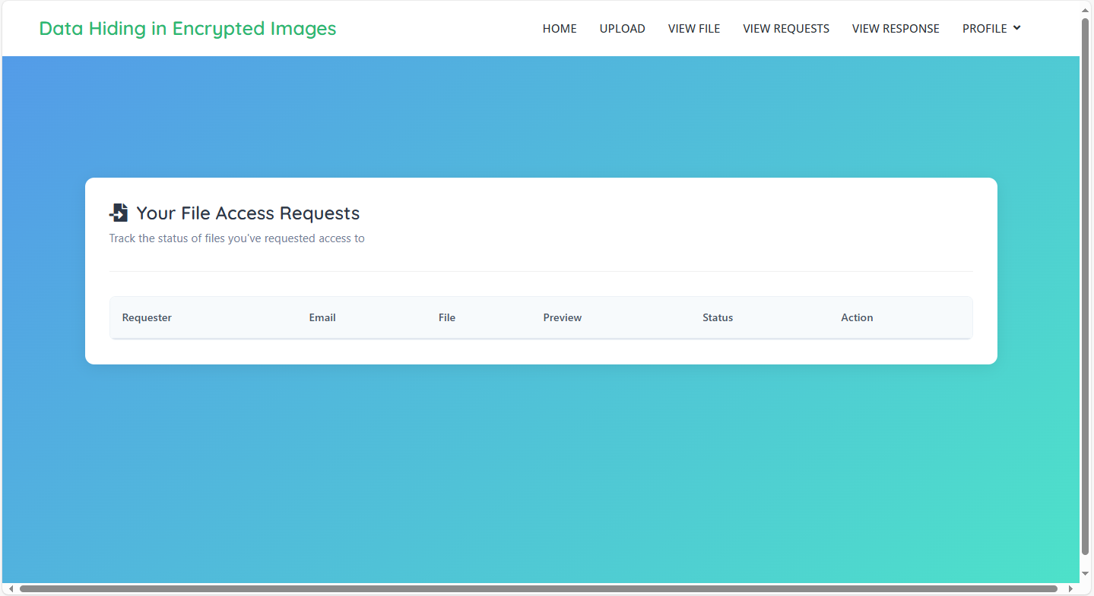

Profile: here user can view their profile later they can update.
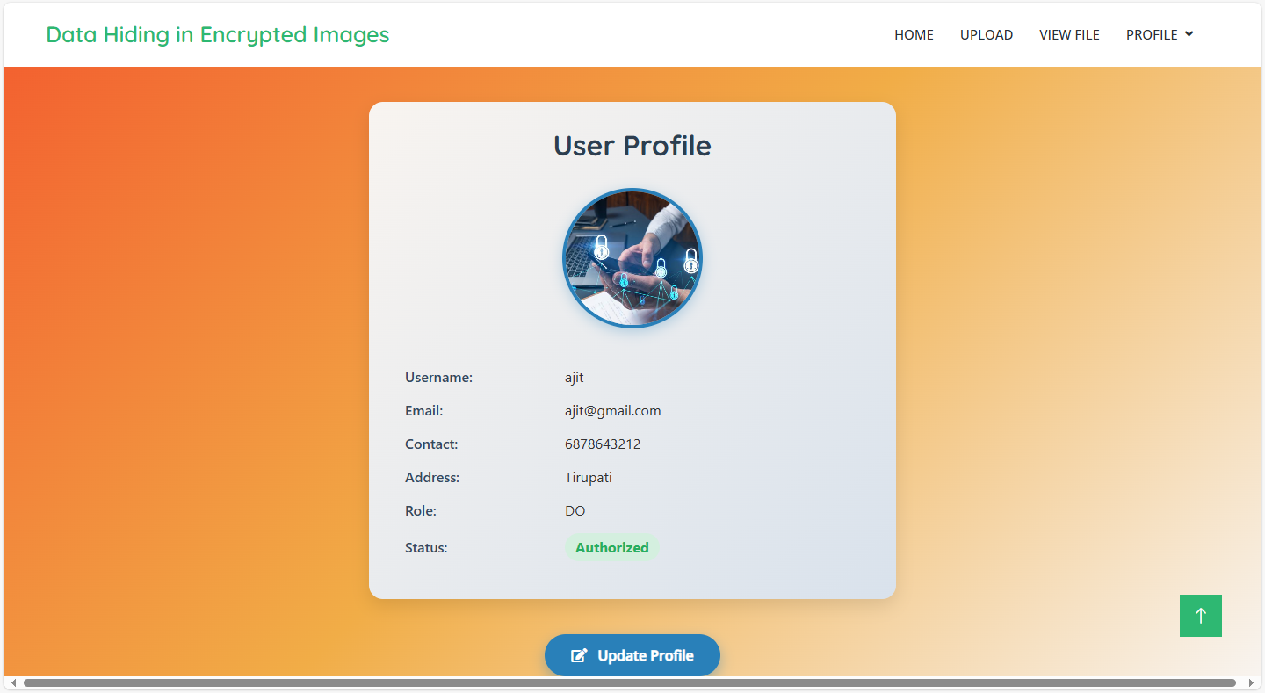
Request file: here user can request the file.
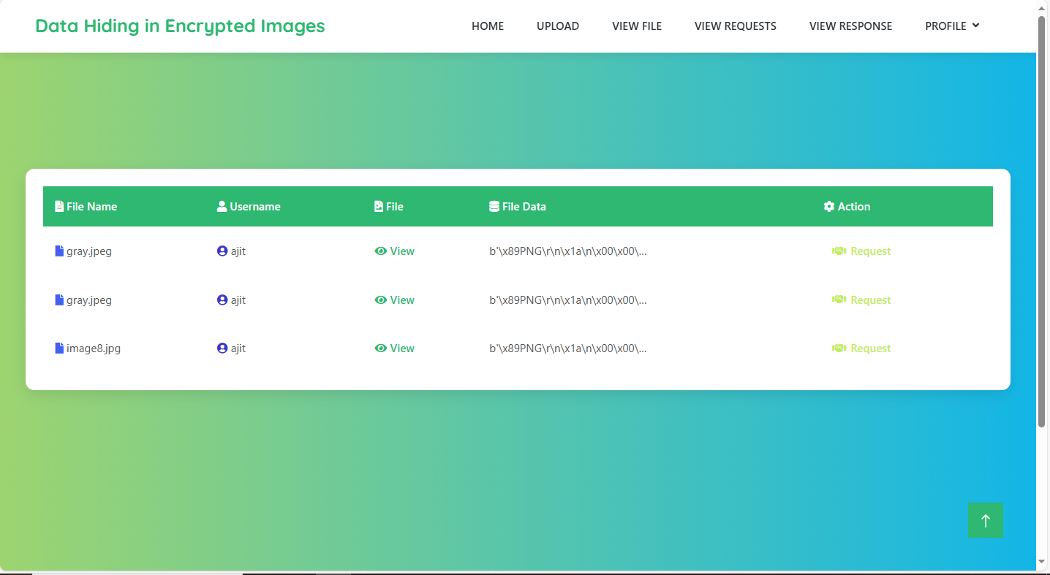

Download page: here user can download file.


Admin login: here admin can login by providing details.
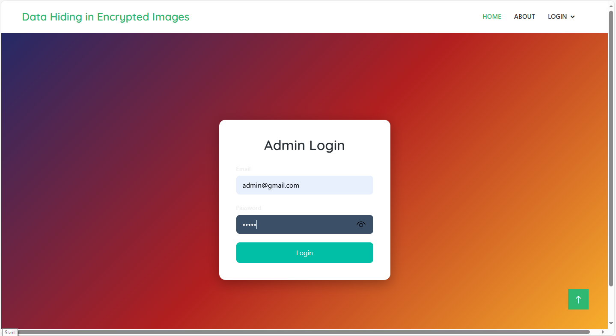

View user: here admin can view users then admin can give access to user to login to the website.
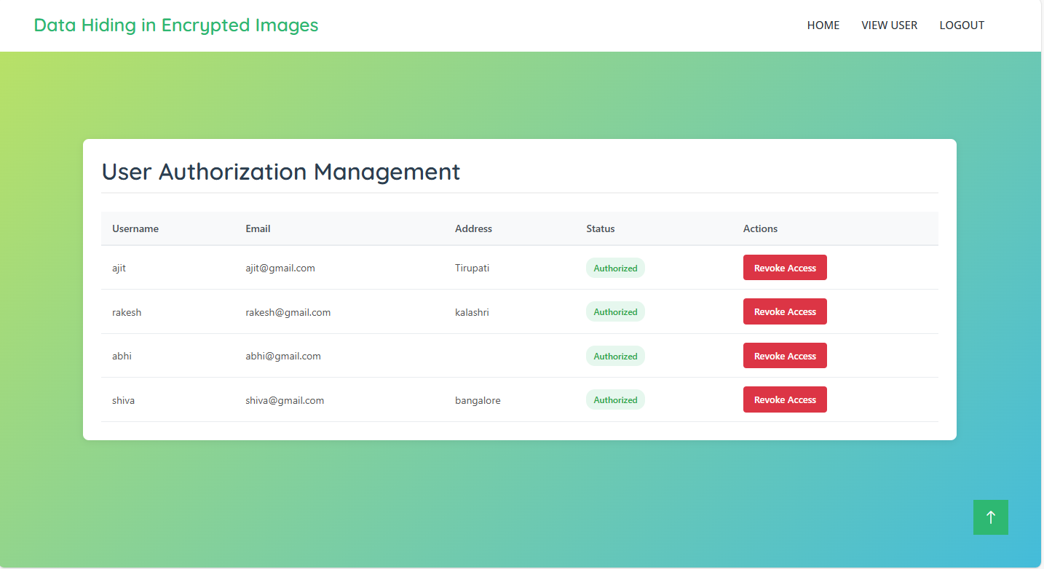

8. SYSTEM STUDY AND TESTING
8.1 Feasibility Study
The feasibility of the project is analysed in this phase and business proposal is put forth with a very general plan for the project and some cost estimates. During system analysis the feasibility study of the proposed system is to be carried out. This is to ensure that the proposed system is not a burden to the company. For feasibility analysis, some understanding of the major requirements for the system is essential.
Three key considerations involved in the feasibility analysis are
- Economical feasibility
- Technical feasibility
- Social feasibility
Economical Feasibility
This study is carried out to check the economic impact that the system will have on the organization. The amount of fund that the company can pour into the research and development of the system is limited. The expenditures must be justified. Thus the developed system as well within the budget and this was achieved because most of the technologies used are freely available. Only the customized products had to be purchased.

Technical Feasibility
This study is carried out to check the technical feasibility, that is, the technical requirements of the system. Any system developed must not have a high demand on the available technical resources. This will lead to high demands on the available technical resources. This will lead to high demands being placed on the client. The developed system must have a modest requirement, as only minimal or null changes are required for implementing this system.
Social Feasibility
The aspect of study is to check the level of acceptance of the system by the user. This includes the process of training the user to use the system efficiently. The user must not feel threatened by the system, instead must accept it as a necessity. The level of acceptance by the users solely depends on the methods that are employed to educate the user about the system and to make him familiar with it. His level of confidence must be raised so that he is also able to make some constructive criticism, which is welcomed, as he is the final user of the system.
System Testing
The purpose of testing is to discover errors. Testing is the process of trying to discover every conceivable fault or weakness in a work product. It provides a way to check the functionality of components, sub-assemblies, assemblies and/or a finished product It is the process of exercising software with the intent of ensuring that the
Software system meets its requirements and user expectations and does not fail in an unacceptable manner. There are various types of test. Each test type addresses a specific testing requirement.

8.2 Types of Tests

8.2.1 Unit testing
Unit testing involves the design of test cases that validate that the internal program logic is functioning properly, and that program inputs produce valid outputs. All decision branches and internal code flow should be validated. It is the testing of individual software units of the application .it is done after the completion of an individual unit before integration. This is a structural testing, that relies on knowledge of its construction and is invasive. Unit tests perform basic tests at component level and test a specific business process, application, and/or system configuration. Unit tests ensure that each unique path of a business process performs accurately to the documented specifications and contains clearly defined inputs and expected results.

8.2.2 Integration testing
Integration tests are designed to test integrated software components to determine if they actually run as one program. Testing is event driven and is more concerned with the basic outcome of screens or fields. Integration tests demonstrate that although the components were individually satisfaction, as shown by successfully unit testing, the combination of components is correct and consistent. Integration testing is specifically aimed at exposing the problems that arise from the combination of components.
Software integration testing is the incremental integration testing of two or more integrated software components on a single platform to produce failures caused by interface defects.
The task of the integration test is to check that components or software applications, e.g. components in a software system or – one step up – software applications at the company level – interact without error.
Test Results: All the test cases mentioned above passed successfully. No defects encountered.

Acceptance Testing
User Acceptance Testing is a critical phase of any project and requires significant participation by the end user. It also ensures that the system meets the functional requirements.
Test Results: All the test cases mentioned above passed successfully. No defects encountered.

8.2.3 Functional testing
Functional tests provide systematic demonstrations that functions tested are available as specified by the business and technical requirements, system documentation, and user manuals.
Functional testing is centered on the following items:
Valid Input : identified classes of valid input must be accepted.
Invalid Input : identified classes of invalid input must be rejected.
Functions : identified functions must be exercised.
Output : identified classes of application outputs must be exercised.
Systems/Procedures: interfacing systems or procedures must be invoked.
Organization and preparation of functional tests is focused on requirements, key functions, or special test cases. In addition, systematic coverage pertaining to identify Business process flows; data fields, predefined processes, and successive processes must be considered for testing. Before functional testing is complete, additional tests are identified and the effective value of current tests is determined.

8.2.4 White Box Testing
White Box Testing is a testing in which in which the software tester has knowledge of the inner workings, structure and language of the software, or at least its purpose. It is purpose. It is used to test areas that cannot be reached from a black box level.

8.2.5 Black Box Testing
Black Box Testing is testing the software without any knowledge of the inner workings, structure or language of the module being tested. Black box tests, as most other kinds of tests, must be written from a definitive source document, such as specification or requirements document, such as specification or requirements document. It is a testing in which the software under test is treated, as a black box. you cannot “see” into it. The test provides inputs and responds to outputs without considering how the software works.
Test objectives
- All field entries must work properly.
- Pages must be activated from the identified link.
- The entry screen, messages and responses must not be delayed.
Features to be tested
- Verify that the entries are of the correct format
- No duplicate entries should be allowed
- All links should take the user to the correct page.
- TEST CASES:
Input | Output | Result
Input text files | Reversible Data Hiding in Encrypted Images  Based on Edge-Directed Prediction and  Multi-MSB Self-Prediction | Success

- Test cases Model building:

S.NO | Test Case | I/O | Expected O/T | Actual O/T | P/F
1 | Register Data Owner | Enter valid name, email, password, address | Registration successful. | Registration successful. | P
2 | Register Data User | Enter valid name, email, password, address | Registration successful. | Registration successful. | P
3 | Login Before Authorization | Enter valid credentials before admin approval | “Unauthorized: Contact admin.” | “Unauthorized: Contact admin.” | P
4 | Admin Login | Enter admin email, password | Admin login successful. | Admin login successful. | P
5 | Authorize User | Admin selects user → clicks “Authorize” | “User authorized successfully.” | “User authorized successfully.” | P
6 | Login After Authorization | Enter valid user credentials after approval | Login successful. | Login successful. | P
7 | Update Profile | Change name/phone → click “Update Profile” | “Profile updated successfully.” | “Profile updated successfully.” | P
8 | File Upload (Data Owner) | Select grayscale image + metadata → click “Upload” | “File uploaded & encrypted successfully.” | “File uploaded & encrypted successfully.” | P
9 | View Available Files | Click “View Files” | List of uploaded files displayed. | List of uploaded files displayed. | P
10 | Request File (Data User) | Select file → click “Request” | “Request sent to owner.” | “Request sent to owner.” | P
11 | Approve Request & Send OTP | Owner views request → clicks “Approve” | “OTP sent to user’s email.” | “OTP sent to user’s email.” | P
12 | Download File with Correct OTP | Enter received OTP → click “Download” | “File decrypted and downloaded.” | “File decrypted and downloaded.” | P
13 | Download File with Incorrect OTP | Enter wrong OTP → click “Download” | “Error: Invalid OTP.” | “Error: Invalid OTP.” | P
14 | Logout (User or Admin) | Click “Logout” | Logout successful. | Logout successful. | P

- CONCLUSION:

This project presents an advanced Reversible Data Hiding in Encrypted Images (RDH-EI) method designed to efficiently and securely embed data in encrypted grayscale images while maintaining the integrity of the original image. By employing Edge-Directed Prediction (EDP) and Multi-MSB Self-Prediction, the system enhances embedding capacity without compromising image quality or recovery accuracy. Additionally, the integration of a user authorization system with OTP verification ensures that only authorized users can access and download the data, adding an extra layer of security. Compared to existing RDH-EI techniques, this system achieves superior embedding capacity, security, and image recovery, making it well-suited for applications in cloud storage and secure communications.

10. FUTURE ENHANCEMENT
Future improvements to the system could focus on optimizing the data embedding algorithms, such as further enhancing EDP and Multi-MSB Self-Prediction techniques to achieve higher embedding capacities while preserving image quality. Real-time processing capabilities could also be introduced to facilitate dynamic environments like live streaming or real-time communication. Moreover, expanding the system to support multiple data owners and users concurrently would enhance scalability for larger datasets in cloud-based applications. Further strengthening security by incorporating additional encryption methods and multi-factor authentication could provide even more robust protection for data access. Finally, making the system compatible across various platforms and devices would ensure broader accessibility and deployment, enhancing its usability in diverse environments. These future enhancements will improve the system’s efficiency, security, and versatility, making it a more powerful solution for secure data embedding and retrieval applications.
11. REFERANCES
- Yingqiang Qiu, “Reversible Data Hiding in Encrypted Images Based on Edge‑Directed Prediction and Multi‑MSB Self‑Prediction,” 7 April 2025
- Fang Ren; Zhelin Zhang; Kai Jiang; Peiyang Zhang; Tengfei Yang, “Reversible Data Hiding and Authentication Scheme for Encrypted Images Based on Prediction Error Compression,” July 2025
- Huan Zhou; Guanghui Chen, “Reversible Data Hiding in Encrypted Image with Local‑Correlation‑Based Classification and Adaptive Encoding Strategy,” 2023
- Yiming Wang; Guoqiang Xiong; Wei He, “High‑Capacity Reversible Data Hiding in Encrypted Images Based on Pixel‑Value‑Ordering and Histogram Shifting,” 2023
- R. Anushiadevi; R. Amirtharajan, “Separable Reversible Data Hiding in an Encrypted Image Using the Adjacency Pixel Difference Histogram,” 2023
- Qingfeng Feng; Lihua Leng; Chun‑Chieh Chang; Jun‑Hong Horng; Meng‑Hsuan Wu, “Reversible Data Hiding in Encrypted Images with Extended Parametric Binary Tree Labeling,” 2023
- Princy Jeena; R. Shreelekshmi, “High Capacity Reversible Data Hiding in Encrypted Images Using Block Labeling,” 2023
- P. V. Deshmukh; A. S. Kapse; V. M. Thakare; A. S. Kapse, “High Capacity Reversible Data Hiding in Encrypted Images Using Multi‑MSB Data Hiding Mechanism with Elliptic Curve Cryptography,” 2023
- C. Y. Weng; C. H. Yang, “Reversible Data Hiding in Encrypted Image Using Multiple Data‑Hiders Sharing Algorithm,” 2023
- Shao‑Ying Xu; Chun‑Chieh Chang; Jun‑Wei Horng, “A Steganography Based on Optimal Multi‑Threshold Block Labeling,” 2022
- Zehua Hua; Yuxuan Wang; Shengyi Yi; Yong Zhou; Xin Jia, “Reversible Data Hiding in Encrypted Images Using Cipher‑Feedback Secret Sharing,” August 2022
[12] Zehua Hua; Yuxuan Wang; Shengyi Yi; Yichen Zheng; Xiaoyue Liu; Ying Chen; Xiaobo Zhang, “Matrix‑Based Secret Sharing for Reversible Data Hiding in Encrypted Images,” September 2023

