**RAILWAY RESERVATION SYSTEM**

**PROJECT REPORT**

Submitted in partial fulfillment of the requirements for the award of the

Degree of Bachelor of Technology

In

COMPUTER SCIENCE AND ENGINEERING

BY

| **S.No** | **Roll No** | **Name of the students** | **Project Batch** | **Projects Assigned (Descriptions attached)** |
| --- | --- | --- | --- | --- |
| 1 | 21331A0576 | KANDI SANJAY | 3 | RAILWAY RESERVATION SYSTEM |
| 2 | 21331A0577 | KANDI VASUNDHARA |
| 3 | 21331A0580 | KARRI ANITHA |
| 4 | 21331A0582 | KARROTHU SASIDHAR |
| 5 | 21331A0592 | KONDU TANOOJ |

UNDER THE SUPERVISION OF

Mr.M. VAMSI KRISHNA

Assistant Professor

DEPARTMENT OF COMPUTER SCIENCE AND ENGINEERING

MVGR COLLEGE OF ENGINEERING(Autonomous)

VIZIANAGARAM-535005, AP(INDIA), MAY-2023

**CERTIFICATE**

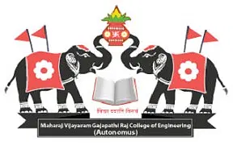

This is to certify that the project report entitled **RAILWAY RESERVATION SYSTEM** being submitted by SANJAY , VASUNDHARA , ANITHA, SASIDHAR and TANOOJ bearing registered Numbers 21331A0576 , 21331A0577, 21331A0580, 21331A0582, 21331A0592 respectively, in partial fulfillment for the award of the degree of Bachelor of Technology in Computer Science and Engineering is a record of bonafide work done by them under my supervision during the academic year 2023

Dr. P RAVI KIRAN VARMA Mr. M VAMSI KRISHNA

Head of the Department Assistant Professor

Dept. of Computer Science & Eng., Dept. of Computer Science & Eng.,

# 

# 

# **ACKNOWLEDGEMENT**

We place on record and warmly acknowledge the continuous encouragement, invaluable supervision, timely suggestions and inspired guidance offered by our guide Mr M Vamsi Krishna Sir, Asst. Professor, Department of Computer Science and Engineering MVGR College of Engineering in bringing this report to a successful completion.

We consider it out privilege to express our deepest gratitude to Dr. P Ravi Kiran Varma Sir, Head of the Department for his valuable suggestions and constant motivation that greatly helped the project work to get successfully completed.

We are privileged to express our profound gratitude to Dr. K. V. L. Raju Sir, Professor and Principal for extending his utmost support and cooperation in providing all the provisions for the successful completion of the project. We sincerely thank all the members of the staff in the Department of Computer Science & Engineering for their sustained help in our pursuits. We thank all those who contributed directly or indirectly in successfully carrying out this work.

**INDEX**

CONTENTS PAGE NO

1. AIM 4

2. CLASS DIAGRAM 4

3. SOURCE CODE 5 - 6

4. OUTPUT 6 - 7

5. OUTPUT SCREENSHOT 8 - 12

6. OUTCOMES 13

7. REFERENCE LINKS 13

**AIM:**

To construct different classes based on Railway reservation system by using packages.

**CLASS DIAGRAM:**

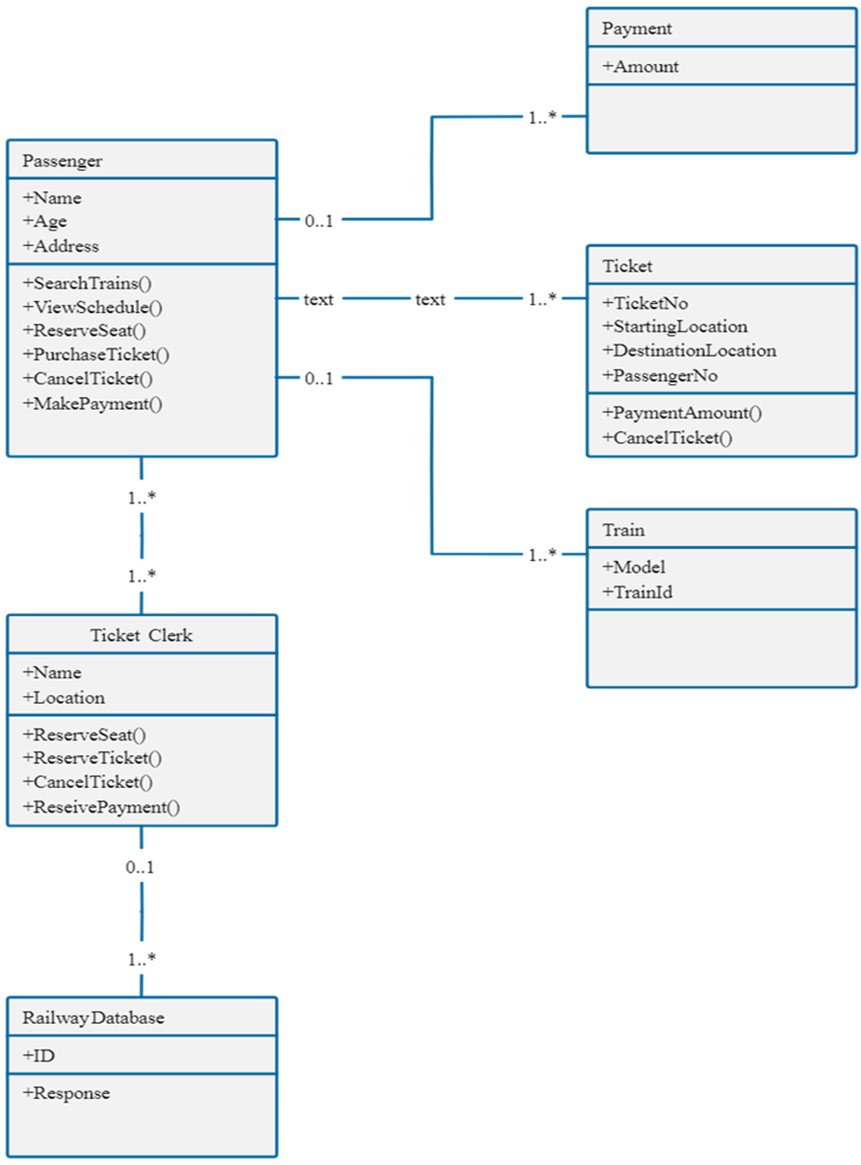

**SOURCE CODE:**

**1) Repository Link - Railway Reservation System :**

| * <https://gitlab.com/kondutanooj/railwayreservationsystem/-/blob/c076bc3cef6f90bd37dda8a5a54a72de2a2f49ee/RailJava3.java> * [Rail3.jpeg · 92463fd3fd3a101c923e5b79ca30867331175e5e · Kondu Tanooj / RailwayReservationSystem · GitLab](https://gitlab.com/kondutanooj/railwayreservationsystem/-/blob/92463fd3fd3a101c923e5b79ca30867331175e5e/Rail3.jpeg) |
| --- |

**2) Repository Link - Train Details :**

| <https://gitlab.com/kondutanooj/railwayreservationsystem/-/blob/a406aab0c212ba880d9d3a8c61c0bca4624eb851/traindetails.txt> |
| --- |

* Here, The **Repository Link - 1 & 2** are mandatory for the program.
* Remaining links are used only if the user is not supposed to submit new details then he/she can use them for verification of program.

**3) Repository Link - CreditMoney Details :**

| <https://gitlab.com/kondutanooj/railwayreservationsystem/-/blob/a406aab0c212ba880d9d3a8c61c0bca4624eb851/Creditmoney.txt> |
| --- |

**4) Repository Link - CreditPayment Details :**

| <https://gitlab.com/kondutanooj/railwayreservationsystem/-/blob/a406aab0c212ba880d9d3a8c61c0bca4624eb851/Creditpayment.txt> |
| --- |

**5) Repository Link - DebitMoney Details :**

| <https://gitlab.com/kondutanooj/railwayreservationsystem/-/blob/a406aab0c212ba880d9d3a8c61c0bca4624eb851/Debitmoney.txt> |
| --- |

**6) Repository Link - DebitPayment Details :**

| <https://gitlab.com/kondutanooj/railwayreservationsystem/-/blob/a406aab0c212ba880d9d3a8c61c0bca4624eb851/Debitpayment.txt> |
| --- |

**7) Repository Link - Employee Details :**

| <https://gitlab.com/kondutanooj/railwayreservationsystem/-/blob/a406aab0c212ba880d9d3a8c61c0bca4624eb851/employeedetails.txt> |
| --- |

**8) Repository Link - EmployeeLogin Details :**

| <https://gitlab.com/kondutanooj/railwayreservationsystem/-/blob/a406aab0c212ba880d9d3a8c61c0bca4624eb851/employeelogin.txt> |
| --- |

**9) Repository Link - Offline Reserved Tickets Details :**

| <https://gitlab.com/kondutanooj/railwayreservationsystem/-/blob/a406aab0c212ba880d9d3a8c61c0bca4624eb851/offlinereserveticket.txt> |
| --- |

**10) Repository Link - Online Reserved Tickets Details :**

| <https://gitlab.com/kondutanooj/railwayreservationsystem/-/blob/a406aab0c212ba880d9d3a8c61c0bca4624eb851/reserveticket.txt> |
| --- |

**11) Repository Link - User Details :**

| <https://gitlab.com/kondutanooj/railwayreservationsystem/-/blob/a406aab0c212ba880d9d3a8c61c0bca4624eb851/userdetails.txt> |
| --- |

**OUTPUT:**

By following the below steps, you can understand the way this application works. If you read these instructions and steps it will be easier to use this application.

1. Compile the Java file **~ javac RailJava3.java** and execute it **~ java RailJava3**.
2. After opening the Application **SignUp**  if you are not, else continue with **SignIn** with your login details.
3. In the new window we can observe 3 Buttons : 1) Passenger.

2) Employee.

3) Train.

1. Click the **Train** Button , In this we can see that schedule of the trains and their details. In this frame we can Search the train details by entering the data of the info we know in the text field.Click the **Back** to go back to the main window
2. Click the Passenger Button, we get a new window which consists of 3 Buttons are 1) Reserve Seat , 2) View Ticket 3) Payment.
3. In Reserve Seat, we can reserve Seat ticket of a particular train from the trains present.
4. In View Ticket, we are able to see the tickets which are booked by the user.
5. In the Payment Button, We can add money to your user account. This works as a wallet like in other applications. User is able to see his Credit History and Debit History. In Debit History, it consists with the PNR number of the particular ticket of a Passenger.

**NOTE : Make sure that user must verify his/her account balance before they do transactions. If Balance is less than the price of the Ticket, then it is must and should add money to his/her account.**

1. Use the Back Button to go back to the previous window. Now come back to the main window.
2. Click Employee Button, An Employee must login and if he/she was not registered in the application then it is mandatory to SignUp.
3. After opening the application, we can observe 2 buttons with 1) Ticket Clerk, 2) Railway DataBase.
4. In Ticket Clerk, the employee can do 1) Reserve Seat 2) Reserved Ticket. In the Reserve Seat , it is as like as in the Passenger but this reservation was done offline by the ticket clerk.
5. In Reserver Ticket, it is for General Tickets that only need the starting and ending location.
6. Come Back to the window after employee login. In the RailWayDataBase Button ,We can have the data of 1)Userdetails, 2) Employee details, 3)add Trains and 4)Tickets List.
7. In Userdetails and Employee Details Button , we can have the details of the users and employees who have registered this application in table format. In the Add Trains Button, employees can add new trains to the application.
8. In the Tickets List Button, We can see a table consisting of all the passengers and their PNR and train details and booking status as by online or offline.

**OUTPUT - SCREENSHOTS:**

**1) After compiling — LOGIN page**

|  |
| --- |

**2) After clicking the “SignUp” Button — SignUp Page**

|  |
| --- |

**3) After “SignIn” — Railway Reservation System Frame**

|  |
| --- |

**4) Train Details —- “Train” Button. Use “ Search ” Button for search by Entering data in TextField.**

|  |
| --- |

**5) Click “ Back ” Button in Train details frame , frame in setp 3 will displayed. Then Click “ Passenger ” Button .**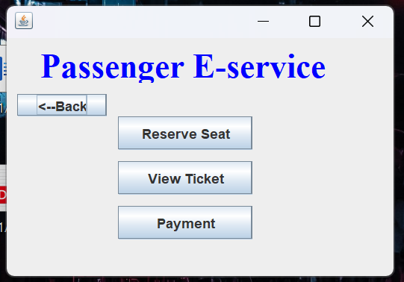

**6) Click on the “ payment ” Button for your Account payment details .**

* **“ Add Money ” Button – For Adding money to your Account.**
* **“ View Debit History ” – For viewing Debited history.**
* **“ View Credit History ” – For viewing Credited history.**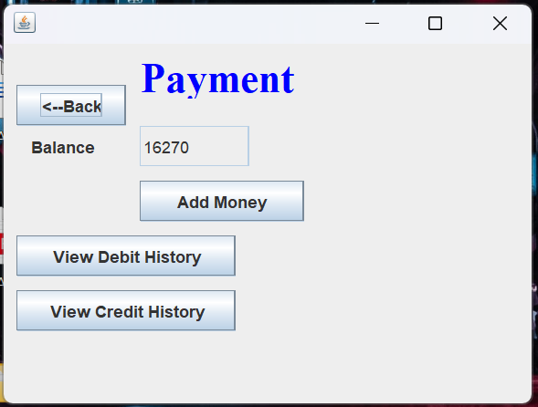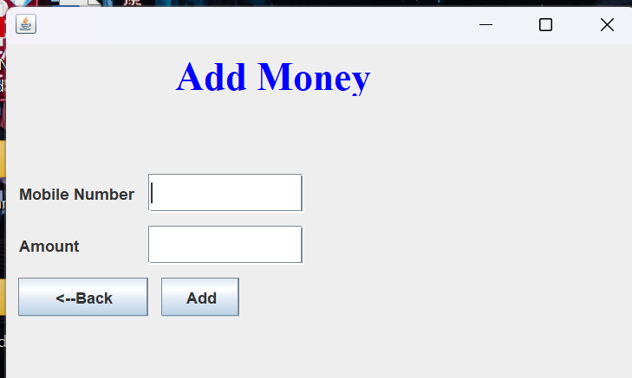

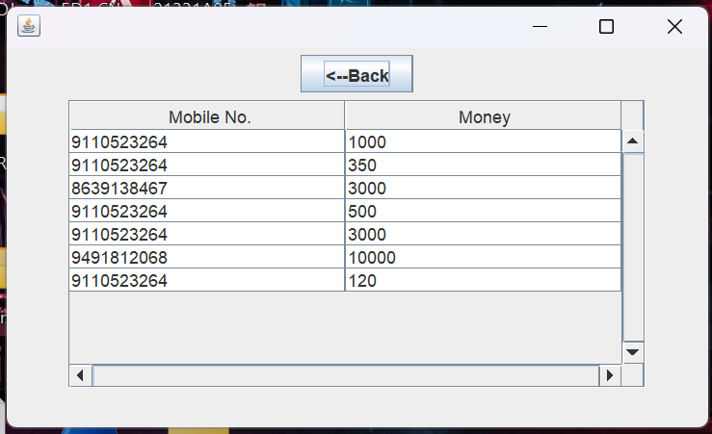

**—> Credit Details**

**—> Debit Details**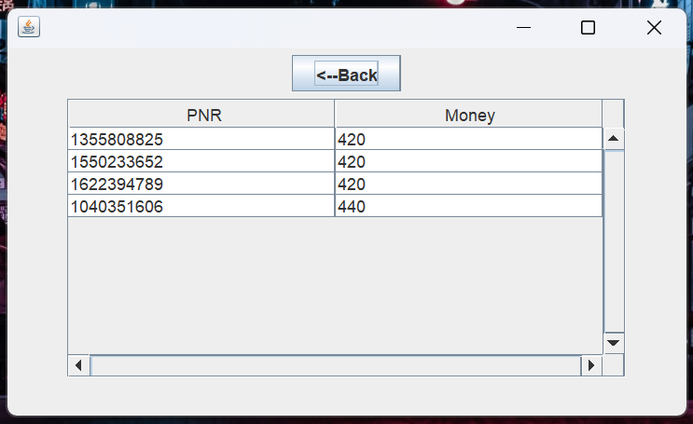

**7) Use the “ Back ” Button to go to the previous Frame. Come to the Passenger Frame in Step - 5. Click on the “ Reserve Seat ” Button to reserve the seat(online). After entering the valid details :**

* **“ Confirm Ticket ” – To Confirm the Ticket.**
* **“ Cancel Ticket ” – For not Confirm the Ticket and Go to previous Frame.** 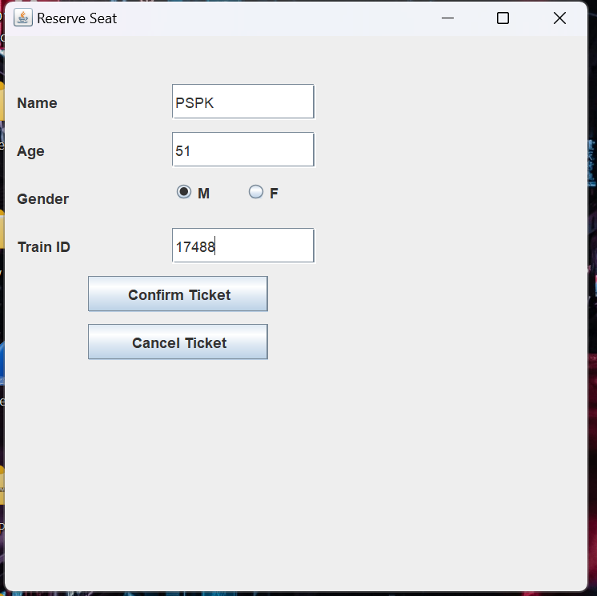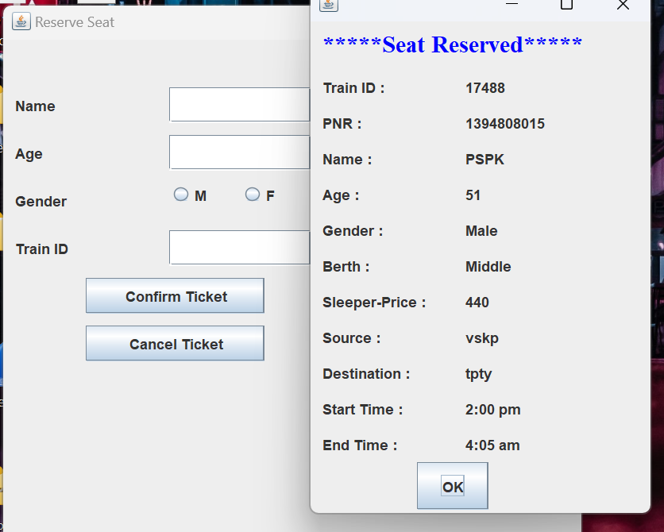

**8) Come back to the Frame Passenger in step - 5. Click on the “ View Ticket ” Button for viewing the Ticket details. We can use the “ Search ” button for searching.**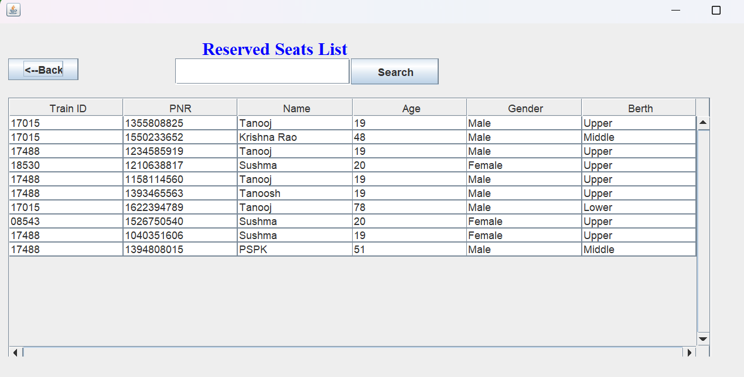

**9) Come back to the Railway Reservation System Frame in step - 3. Click on the “ Employee ” Button for employee access. SignIn by inserting the details and new employee get SignUp.**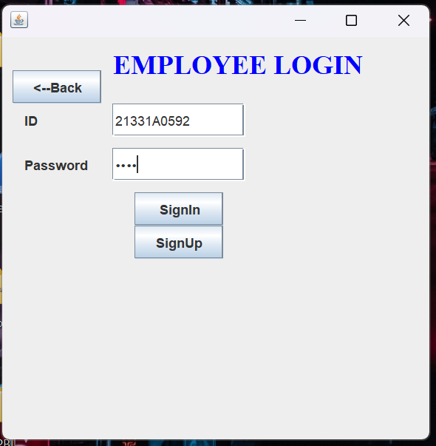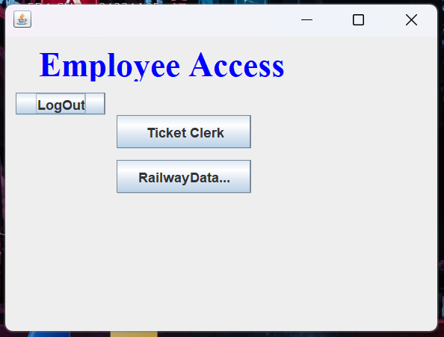

* **“ Ticket Clerk ” – For Ticket counter, used for offline Tickets.**
* **“ RailwayDataBase ” – For Accessing the Railway Data Center.**

**10) After opening of the Ticket Counter Frame :**

* **“ Reserve Seat ” – For reserve Seat in offline source.**
* **“ Reserve Ticket ” –For General Ticket.**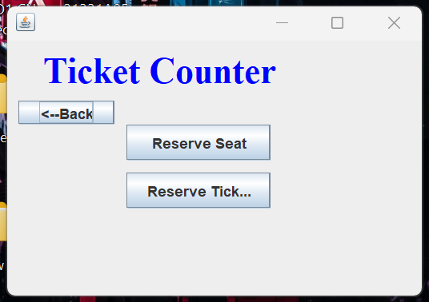

**—> Reserve Ticket – General Ticket.**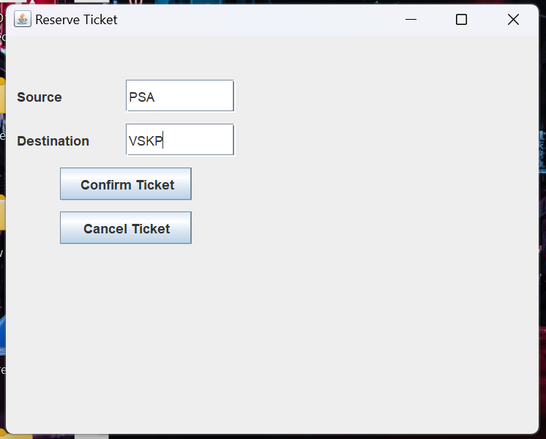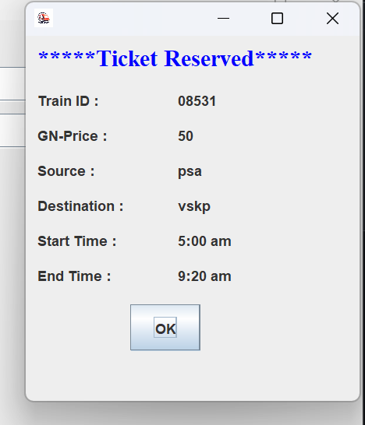

**11) Come to the Employee Access Frame and Click on the “ RailwayDataBase ” Button :**

* **“ User Details ” – For the details of users registered in the Application.**
* **“ Employee Details ” – For the details of Employees registered in the Application.**
* **“ Add Train Details ” – For adding new trains in the application.**
* **“ Ticket List ” – For the details of all the Tickets booked using this Application.**

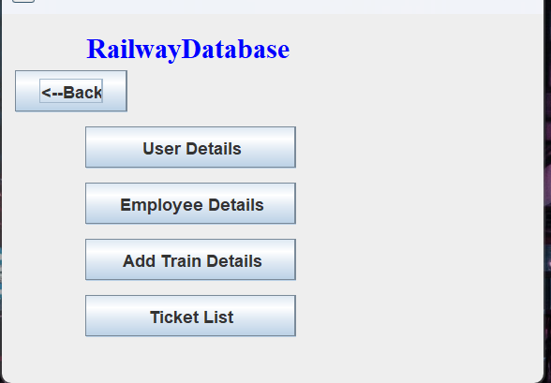

**—> User Details**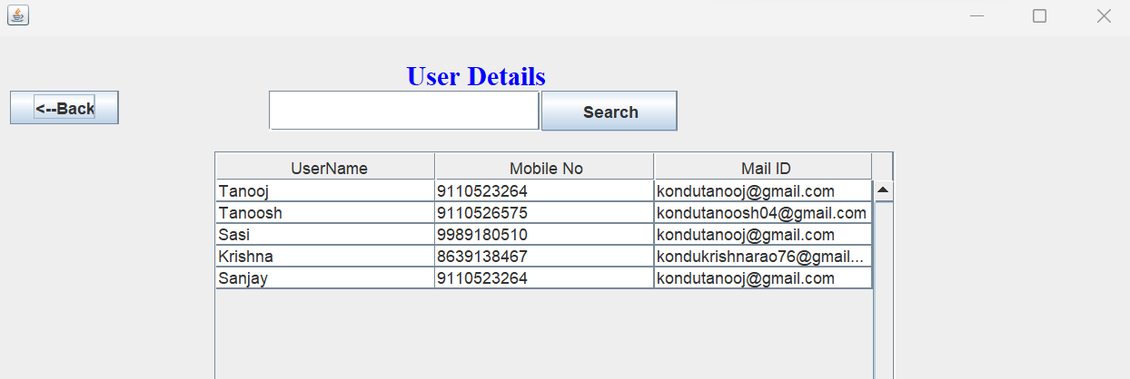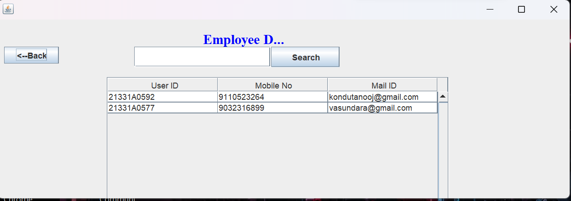

**—> Employee Details**

**—> Add Train Details**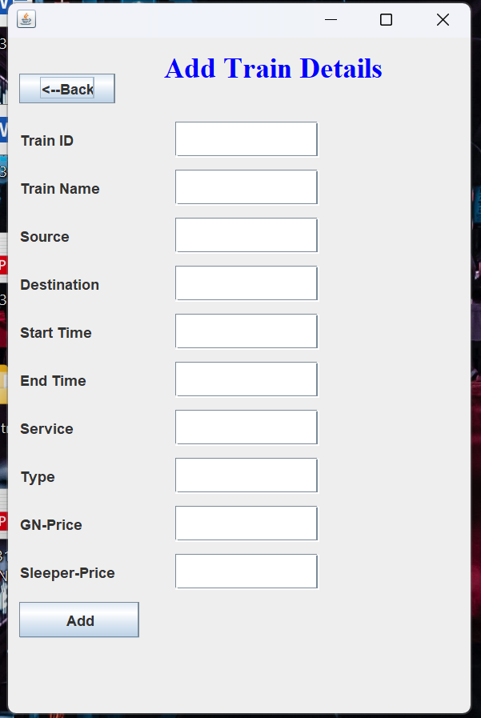

**—> Add Train Details**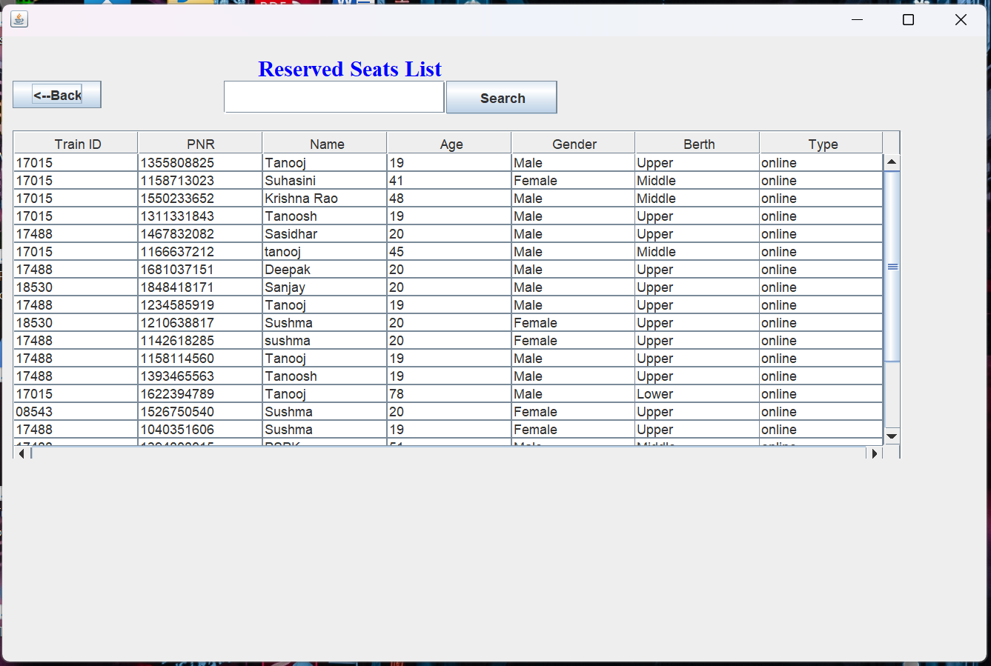

**OUTCOMES:**

In this Project, We are able to create a program that is used in the Railway Reservation System. This application will produce tickets to the passenger according to the Trains scheduled. While logging from the Employee, we can add new Trains and schedule new Trains.

**REFERENCE LINKS:**

**1) Oracle Java - for packages:**

| <https://docs.oracle.com/javase/8/docs/api/overview-summary.html> |
| --- |

**2) JavatPoint.com - for examples:**

| * <https://www.javatpoint.com/java-swing> * <https://www.javatpoint.com/java-awt> * <https://www.javatpoint.com/java-io> |
| --- |

**3) Geeks for Geeks - for demonstrations:**

| <https://www.geeksforgeeks.org/tag/java-swing/> |
| --- |