Hive

create table movie(movie_id int,movie_name varchar(30),year_of_release int,rating float,duration int) row format delimited fields terminated by ',';

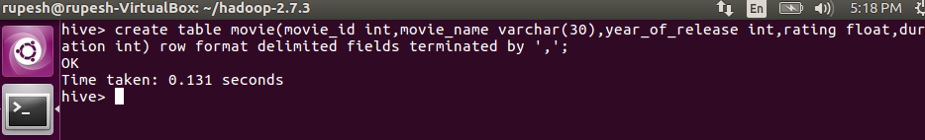

load data local inpath '/home/rupesh/Downloads/movies dataset for pig (2).txt' into table movie;

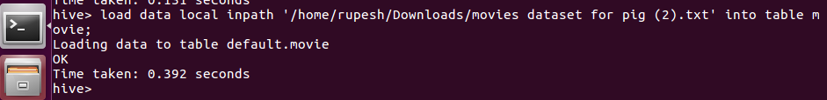

select * from movie;

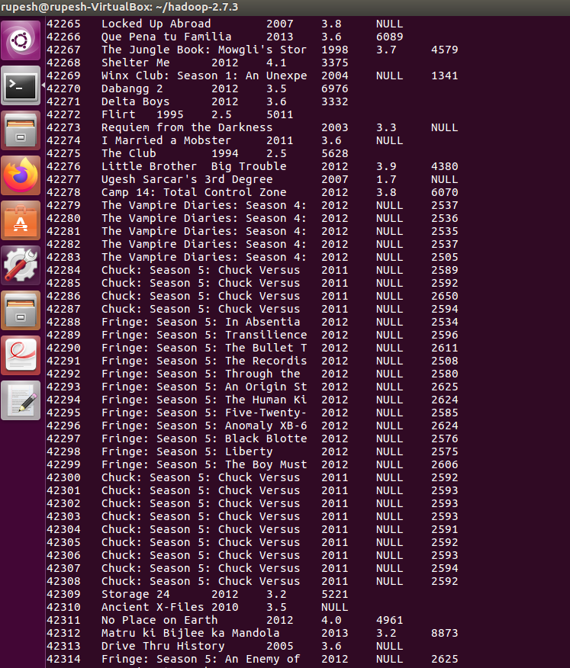

1. select * from movie where year_of_release >=1950 and year_of_release<=1960;

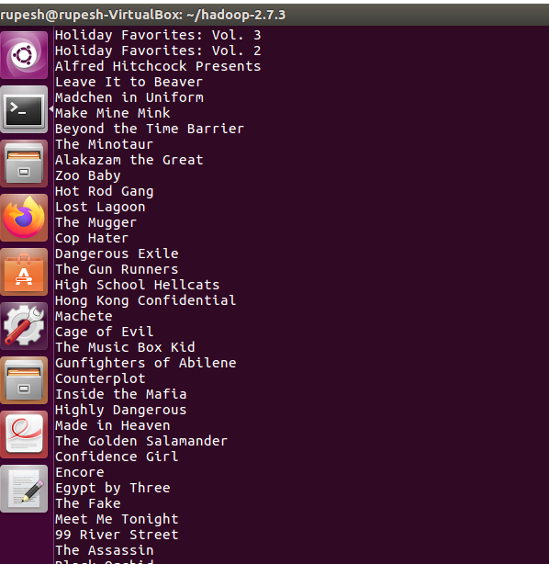

1. select count(movie_name) from movie where rating>4.0;

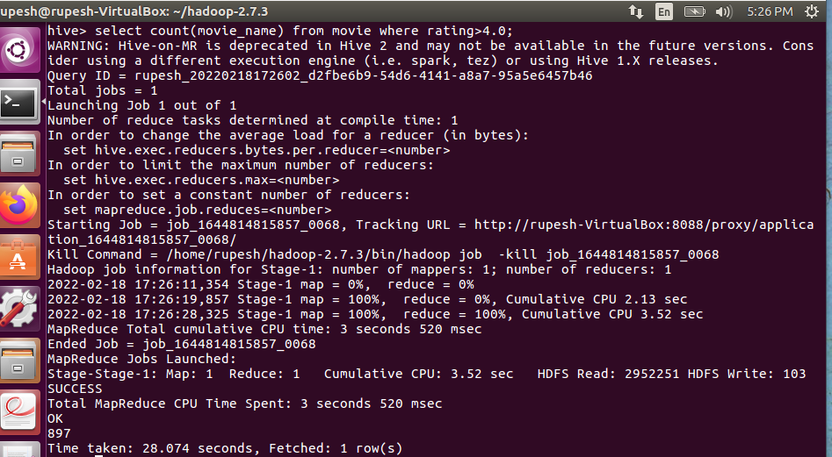

c) select * from movie where rating>3.0 and rating<4.0;

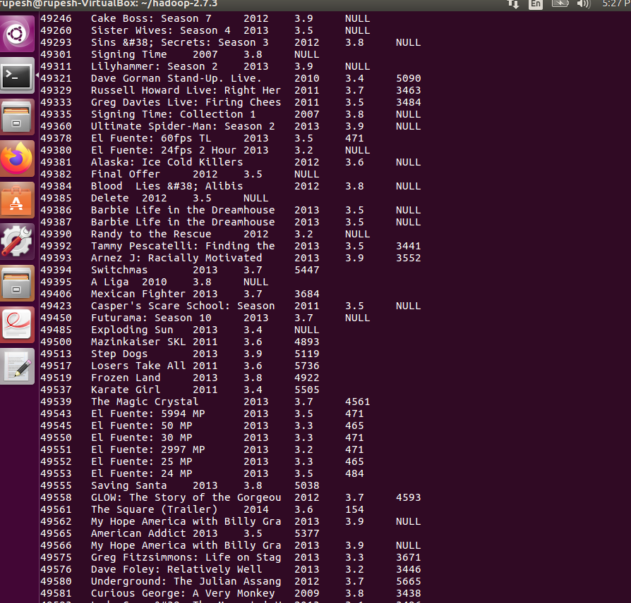

d) select count(movie_id) from movie where duration>7200;

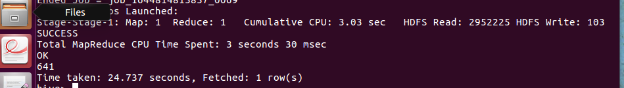

E) select year_of_release,count(movie_id) from movie group by year_of_release;

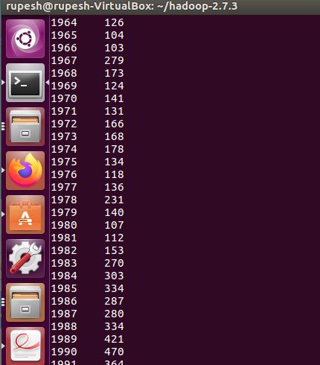

F) select count(movie_id) from movie;

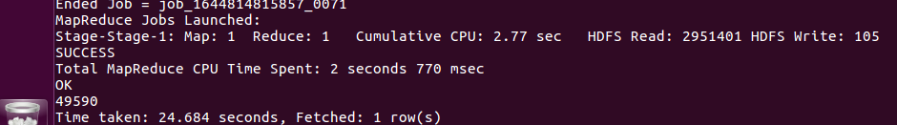

PIG

bin/hdfs dfs -put /home/rupesh/Downloads/movies.txt /assignment;



movie = LOAD '/assignment/movies.txt' using PigStorage (',') AS (Movie_ID:long,Movie_name:chararray,Yr_of_Release:int,Mov_rating:float,mov_duration:long);



describe movie;



illustrate movie;

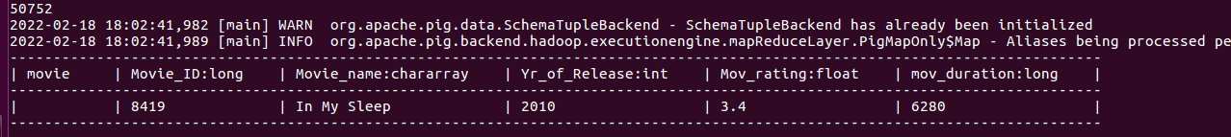

B = FILTER movie by Yr_of_Release >= 1950;

C = FILTER B by Yr_of_Release <= 1960;

Mov_count1 = GROUP C All;

count = FOREACH Mov_count1 GENERATE COUNT(C);

DUMP count;



B = FILTER movie by Mov_rating > 4.0;

Mov_count2 = GROUP B All;

Count2 = FOREACH Mov_count2 GENERATE COUNT(B);

DUMP count2;



B = FILTER movie by Mov_rating >= 3.0;

C = FILTER B by Mov_rating <= 4.0;

Mov_list = FOREACH C GENERATE Movie_name;

DUMP Mov_list;

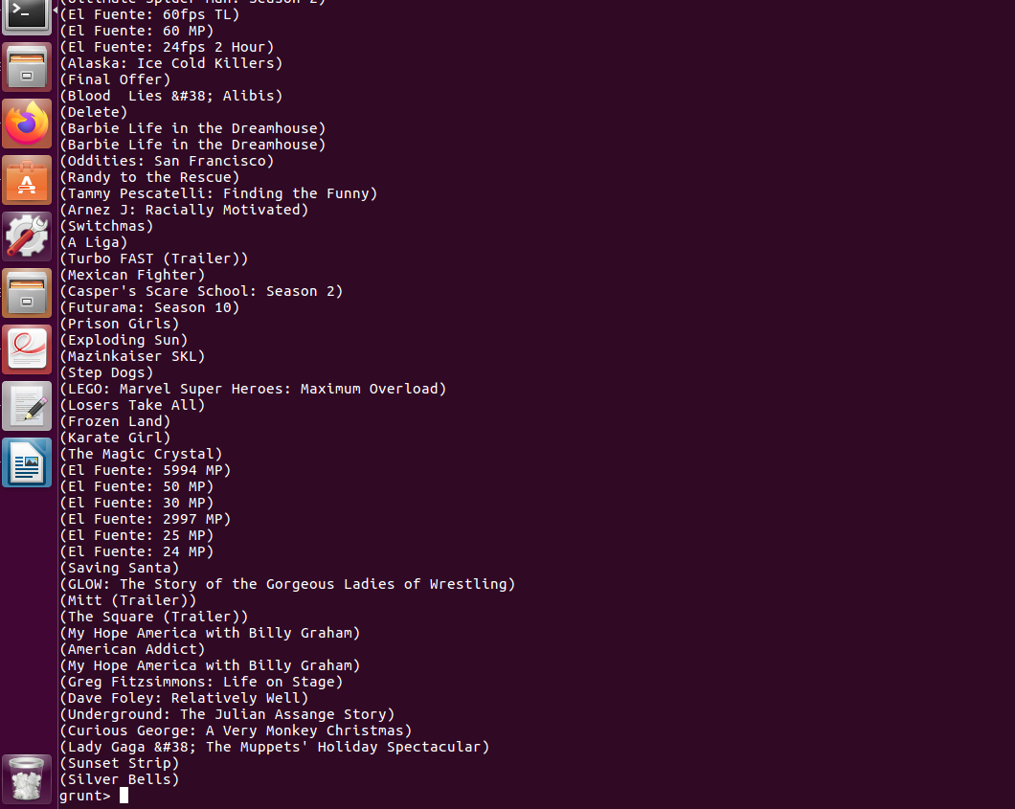  
B = FILTER movie by mov_duration > 7200;

Mov_count3 = GROUP B All;

count3 = FOREACH Mov_count3 GENERATE COUNT(B);

DUMP count3;



B= FOREACH movie GENERATE Yr_of_Release;

Yr_list = GROUP B by Yr_of_Release ;

List = FOREACH Yr_list GENERATE group, count(B) AS Num_Movies;

DUMP List;

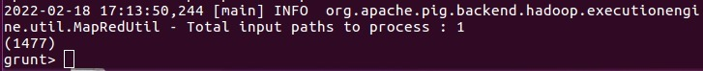

Mov_count4 = GROUP A All;

count4 = FOREACH Mov_count4 GENERATE COUNT(A);

DUMP count4;

