The Teenager Who Won an Apple Development Award and his 5 no’s.

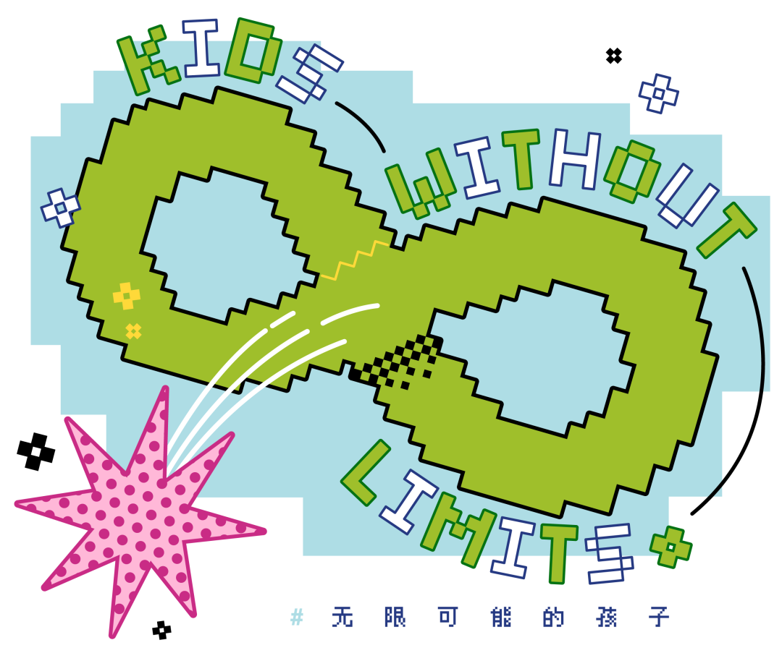

If winning a world-class app design competition gives a 12-year-old an aura of distinction, does this teenager, who used to annoy his mother with his games, have a different mindset or is he bold and constantly experimenting? Or does he come from an international family that benefits from the clash of cultures? In fact, the experience of this teenager named Zhuang Mingxuan is the same as many children, but also different.

The "Kids with Infinite Possibilities" series reports on kids who may be a bit "different" and full of possibilities from different angles, and this time, it's Zhuang Mingxuan, a boy who hopes to change the world with his programming.



First "no." I'm not a genius.

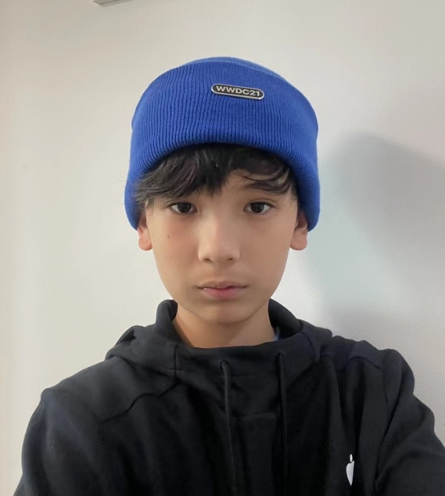

" You know what? The race lanes are closing in two hours and I'm still tuning the program." Gage's tone reveals a hint of mischievousness, disinterest, and mixed with a rare maturity of a twelve-year-old who is about to enter the eighth grade.

The competition Gage Hakim was talking about was the Apple Developer Challenge 2021. And the decision to enter was made only a month and a half before the deadline. The bigger challenge was that it was Gage's first exposure to Swift, the programming language mandated by the competition.

" I'm not the child prodigy or genius that people make me out to be, mainly because I've learnt the Python language for over two years before, so it was easy to get to grips with databases and things like that." For Gage, mastering the programming language was only the most basic part, what was more challenging was "what exactly is the core logic?"

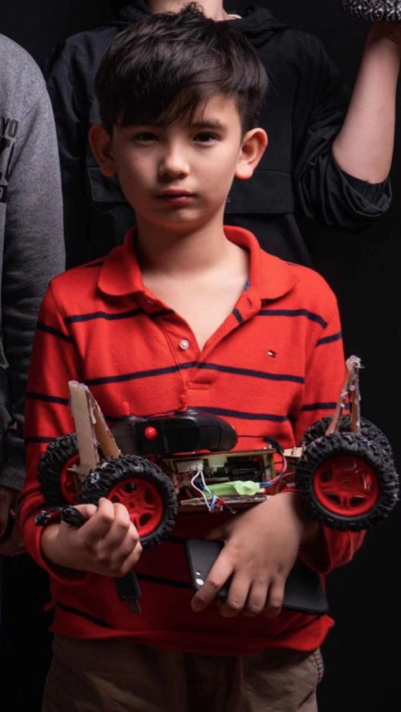

The WWDC Apple Developer Challenge (WWDC Swift Student Challenge) is a competition for school student developers launched by Apple since 2016. Every year, participants from all over the world are required to submit their projects through Swift Playground (Apple's APP design platform). This year, there were 350 winners worldwide, and Gage Hakim, whose Chinese name is Zhuang Mingxuan, set a new record for winning, which was previously set by a 14-year-old winner from the Greater China region, with an app that solves the problem of learning the periodic table of chemical elements.

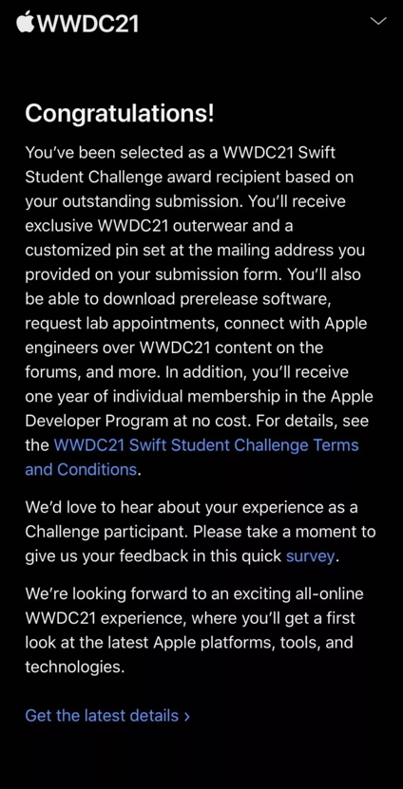



Second "no."

I didn't just prepare for a month and a half.

Gage, who enters the eighth grade on 30 August 2021, surprisingly chose "learning about the periodic table" as his "core logic" for the competition. But with a father who is an entrepreneur in the medical-biological field and a mother who is a psychologist, there was no one in the family who dealt with "chemistry". In 7th grade science class, the introductory chemistry unit, "The Periodic Table of Elements," drove Gage crazy: "It's hard to memorize, it's boring, you have to remember a lot of the elements in English, and you have to know where each element is on the periodic table. ...... "



Gage designed four levels: the first level slightly explains to the user what the periodic table of elements is, with the emphasis on "no need to memorise"; the second level is to make the user remember the classification of the elements, Gage designed a jigsaw puzzle, so that the different classification of the elements "fall"; the third level is to help the user to memorise by filling in. The second level is for users to remember the classification of elements, Gage designed a jigsaw puzzle where different elements are "dropped" to help users memorise them by filling in the blanks; the third level randomly "drops" elements from the periodic table, and users put them together manually; and the fourth level randomly combines the elements, like a chemistry experiment.

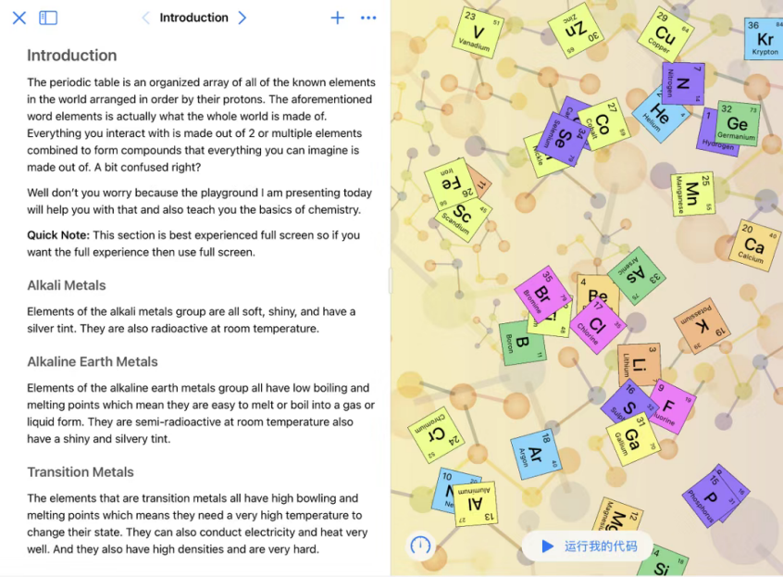

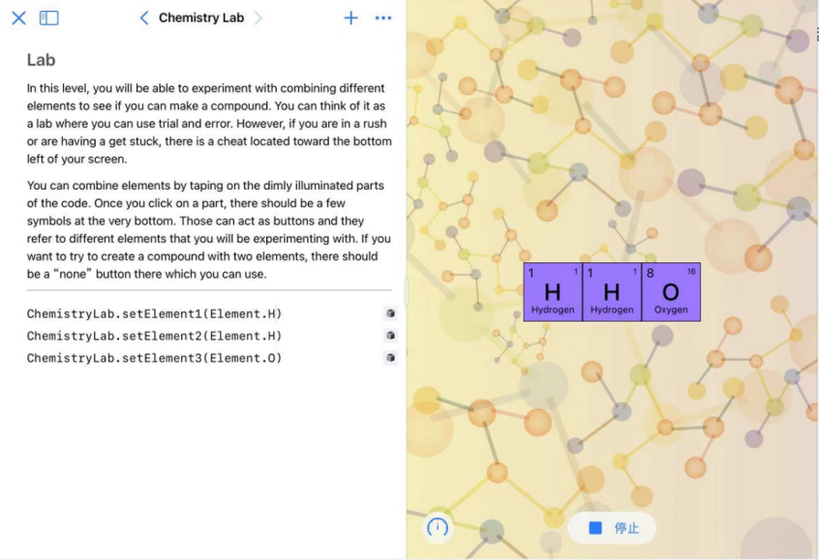

While the programming database has a selection of modules that already exist, it didn't allow for what Gage wants to express. In fact, Gage had to program three separate game levels while learning the Swift language. "The hardest part was the puzzle pieces falling randomly and then putting them together, and there was a lot of stuff to do: firstly to be able to fall, secondly to recognize if they were falling in the appropriate area, and finally how to put them on." The good thing is that the Apple system provides a programming database so I did not need to design the "falling" trajectory, "as if I was given a motor, I can control. But how to control, I had to think for myself."

Gage, who originally thought it would take 2022 or a little longer to win the award, reveals the same restraint and calmness as the programmer, "My biggest difference should be that I made an educational PLAYground, which is fun and at the same time lets the user learn, which is probably the reason for the award." Then he used a famous saying he heard from his mom and dad, "Pigs can fly even in the wind. It's not the pig that's powerful, it's the wind."

During a month and a half of preparation for the competition, Gage was only programming four hours a week, with a lot of time spent gathering information after school. "There was actually too much chemistry that I didn't know. It hasn't been taught in school yet. For example, 'silicon', which is a material used to make glass in the twentieth century." So with his dad's help, Gage went to ask a good friend of her dad's, "who was a chemistry professor at the university. But I had to gather more information from the Internet."

When designing the program, Gage still hid his favorite colors, "I chose white for the background because I liked it so much. Also picked a lot of elements floating around and on an orange background."

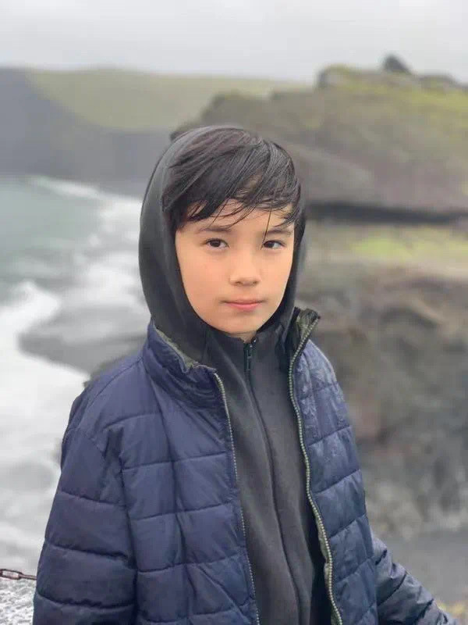



The third "no."

I'm not trying to program.

Gage started out learning Scratch, MIT's introductory programming language, "It's not a language that requires typing, but rather squares, each with its own meaning. Just to help beginners to learn." After all, Gage was still in third grade at the time, and once he got home from school each day, he would spend over an hour playing games, "My classmates were playing 'Plants vs. Zombies' and 'Tribal Warfare', and they even made me captain, so I just went with everyone and to Play together!"

And with his mom's introduction, Gage met a great programming teacher and started learning the programming language. "This language can only do some basic games, not the more complicated ones." Gage, who was less than ten years old, thought it would be nice to be able to make his own games.

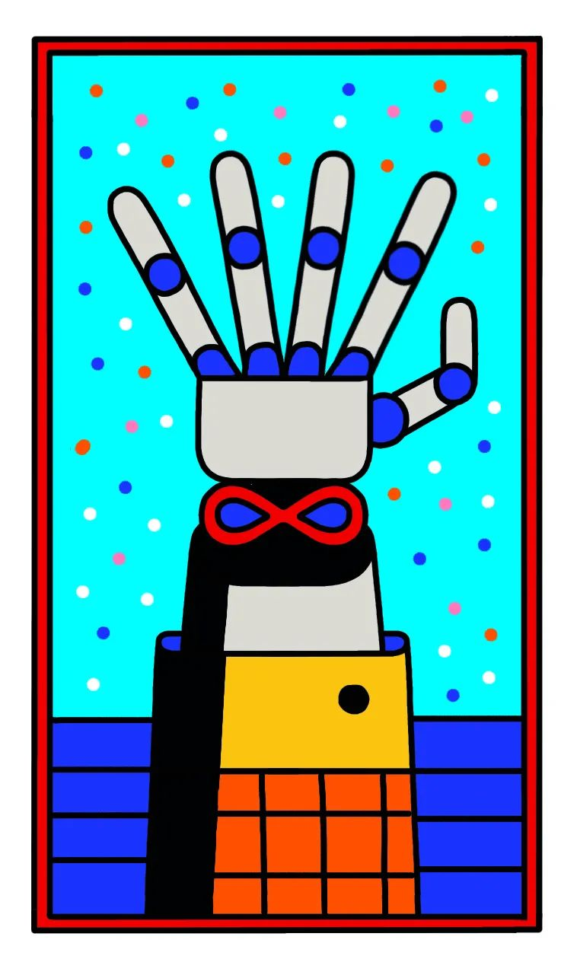

"Programming was very fun because there was no rote memorization." Gage started out by borrowing the logic and rules of games in the arcade, "It was only a year into the program, and even if it didn't work, I learned something." The result was more than a dozen projects in one sitting, including Space Pinball, Saving Private, and Whack-a-Mole. These are the games that stayed in his childhood, "I only got a computer when I was eight years old, and I used to use a tablet or cell phone and play very traditional games."

Gage's mom was anxious when she saw him playing games "like crazy", "We are an international family and we respect our children. Our philosophy is to respect the child's strengths and interests to stimulate the child's own internal motivation to learn on his own initiative. The result of this "respect" was that Gage came to his mom and encouraged her to play a game called "Minecraft". Mom didn't play because she was anxious and didn't want Gage to know.

It wasn't until Gage started learning to program that he completed his first project: a spiderweb-like game. "It was very rudimentary, but it was still exciting to finish." As a result, mom immediately went to play the game. She had a blast playing it.



The fourth "no. I'm not talking to the player.

Like a game that requires upgrades to fight monsters, when Gage, who was only in the fifth grade, was introduced to the more difficult language of Python, his mind was running as fast as light, and his progress in programmable learning inevitably fell short of his ability to keep up.

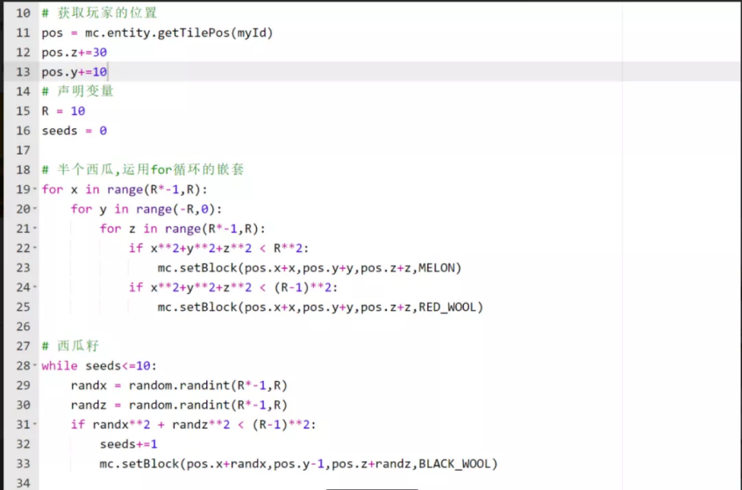

So Gage started practicing game design on Roblox, a platform that caters to players and users all over the world. "Roblox is a platform that can reach a lot of people, and it's easy to find a lot of interesting people when you're wandering around." Gage's practice started with designing the core logic of the game, and then slowly added details, "If I realized in the middle of the process that the game wasn't very fun, or the users didn't like it, I wouldn't add the small details and just figured out the core." The core logic of the game is definitely a challenge for children compared to traditional games - after all, it has to be fun, difficult, and not self-contradictory.

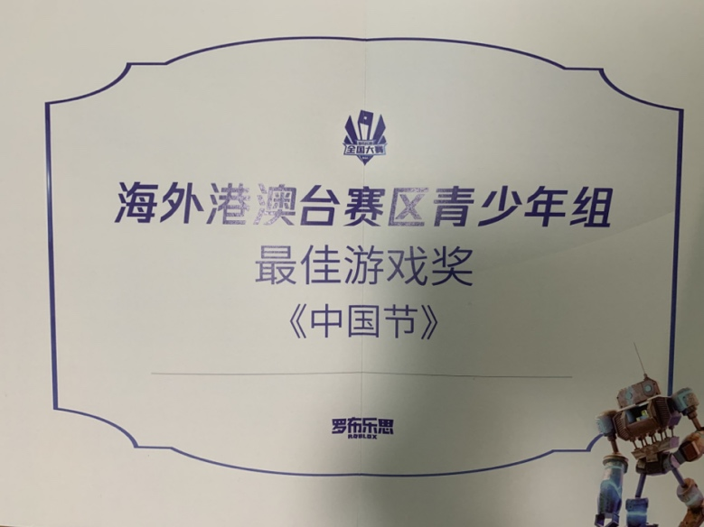

At the same time, Gage was no longer satisfied with what the programming language could say on the computer, and he began to experiment with more "conversational modes". He went to DDI DJI to assemble a drone: the drone had four motors and was put together with two wooden boards, and Gage wrote the core code to control the motors and propellers. He also in the "Makerspace" through the 3D printing design and production of robots: design software to control the laser cutter, the board cut into shape, good position of the screw holes, and finally assembled with hot melt adhesive joint, the finished product is about 1.5 times the height of a piece of A4 paper so high. "The first time I did it, I didn't consider the assembly margin, and the cutting size was too precise to complete the assembly."

Learning from his mistakes, Gage managed to make a robotic hand in the following days. "The activity of the human hand is parsed through pressure, compression and pressure sensors on the glove, which feed the movement into a program that ultimately controls the manipulator." Gage's original intention was to help people with disabilities, "like if you lose your left hand, you can make another one." Two months later, when he finally made a finished product with the help of skilled workers, he found that a company in South America had already done it, "and it was much, much better than mine, with motors inside each joint." Gage calmly brought up his shortcomings, "I still don't really understand Bluetooth or the AIRPOT transmission programs."

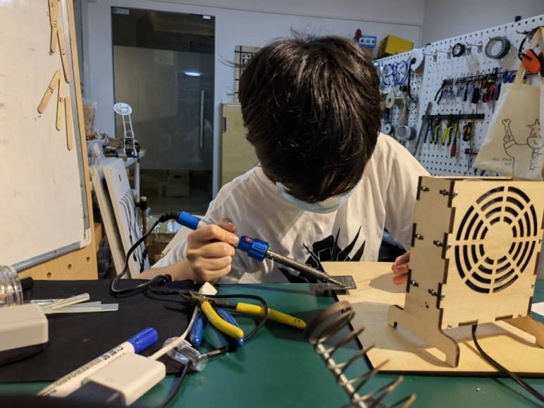

While making the robotic hand, Gage realized that conducting fine hand movements wasn't easy. "Originally, I wanted to use ordinary string, but it wasn't pretty or strong." Gage suddenly thought of fishing line and used it in the 3D model, "the fishing line is very strong and can reflect the pressure value to the model." Gage happily hid the program he designed, the fishing line, and the breadboard where he placed the program in the lower part of the wrist of the robot. "Maybe I won't need all this once I get Bluetooth, but the fishing line is really great."



The fifth "no." I'm not a foreigner.

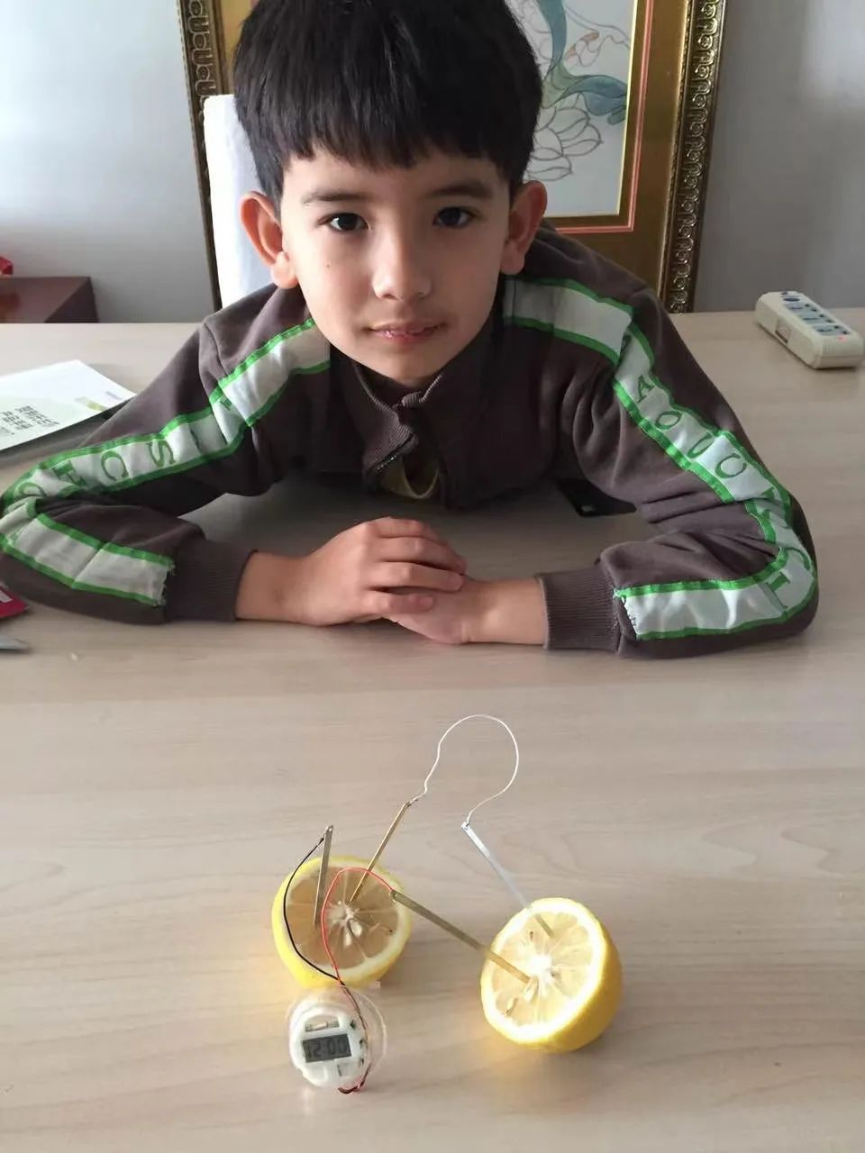

Gage is 1/4 Syrian, 1/4 American and half Chinese. With a family background that blends Eastern and Western cultures and an international school upbringing, Gage wanted his programming to help students in China, Syria, the U.S., and beyond.

Gage designed a game called "Chinese Festivals" "to help foreigners understand Chinese culture. Chinese festivals were put into the programming, including New Year, Lantern Festival, and Mid-Autumn Festival." Today, Gage is working on a new game. He will "add a lot of Chinese cultural things and also some American cultural elements to give it a more international flavor." He plans to finish it within the next semester, "which is a longer one for me."

Gage's idols are mom and dad. "Mom's language skills are very good, and she is a TEDx forum speaker. It was only when I read her WeChat circle that I realized it. Dad's social skills are awesome. He doesn't work in chemistry but can very easily reach out to college professors in chemistry to help me."

In the Gage household, whatever decisions are made are discussed together, including the learning of the Swift language, including the golf lessons he recently started. "I used to learn how to play basketball and always broke my foot." Even Gage, who is regarded as a "genius" by the outside world, has aspects he needs to consider making up for, "If you want to get into the famous American boarding high school that your dad used to go to, you need to be able to speak at least three languages, be good at a sport, etc. Golf is to fulfill this requirement. Learning golf is a way to fulfill that requirement. I've been teaching myself Spanish for a while now, but now I only speak Chinese and English."

Gage, who no longer specializes in basketball, "pretty much relaxed" before the start of the school year. Except for a late-night "robotics development class" from 10:30 to 11:30 p.m. every day, which "we decided on as a family, mainly because I'm interested in it.

The thirteen-year-old teenager is more interested in "the best way to design games to make some money. Mom and Dad must have spent a lot of money for me to learn programming." In the long run, Gage would like to set up a studio for making educational apps, "Learning is too boring, make it fun, kids and moms and dads are happier." Gage denies many of the definitions that the outside world has given him. But he has always been very firm on the matter of "play".