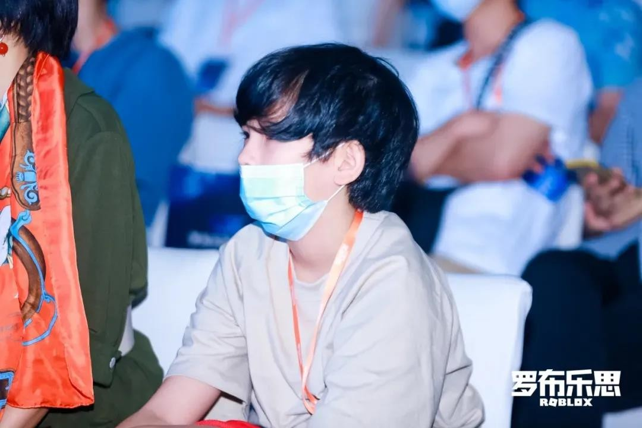

Gage's Development Journey, Love Makes Dreams Come True!

By Roblox Developer - Sharing game development related content

This developer interview introduces you to a 12-year-old boy named Gage.

You may be sceptical, but is he a developer at such a young age? But it's true, and there are a lot of other teens in the Robolux community who share Gage's love of development and interest in game making. We came across this young developer at the recently concluded Roblox National Awards.

The RNA Competition is a game development competition for developers who have the dream of making games nationwide, aiming to provide a platform for developers to

communicate innovatively and at the same time, it will also provide developers with millions in funds and support.

With his love for development and spirit of research, Gage submitted his work "China Festival" just two months after he got in touch with Roblox and learned Lua programming. He proved himself with practical actions and made his dream come true, and finally stood out in the "Teenager Group" of the RNA Competition and won the "Teenager Creation Award". Gage has brought us so many surprises, telling us never to define "teenager" so quickly.

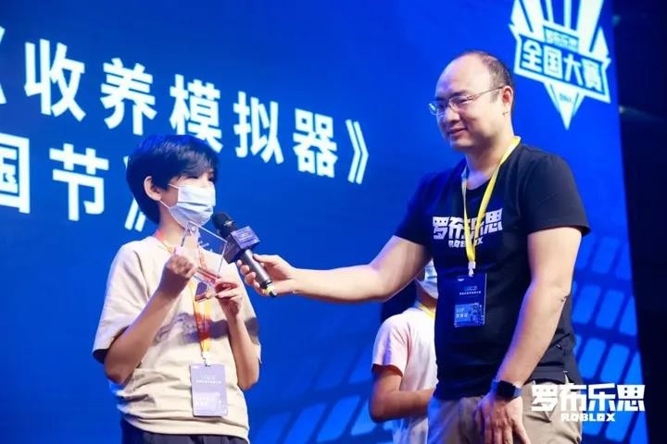

About Gage

Gage is a Roblox developer who will be 13 years old in November this year. Although he is still young and needs to be accompanied by his family for interviews, he can express his ideas clearly with the staff and even the staff is impressed.

In the "meta-universe" environment, more and more young people are turning from just playing to content creation and game development, and we were curious to see how Gage came across Roblox and decided to pursue the development path.

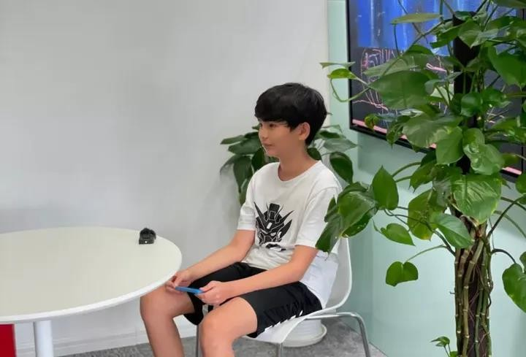

Gage said, "In fact, this is the first game I made with Roblox Studio, and I was quite surprised but very happy to win the award. At the very beginning, I was originally interested in

programming and intended to learn Lua as a programming language on my own. I then found this tool after checking on the Internet, and it just so happened that Roblox was holding a competition again, so I just I signed up without any hesitation. I made the game, "China Festival", while I was learning Lua in these two months."

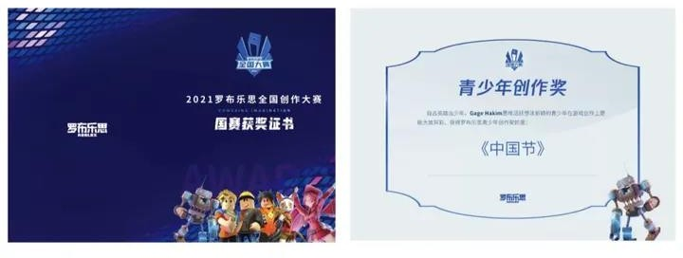

In just two months of exposure to Lua, Gage was able to create a creative game for us called "Chinese Festival" with Chinese characteristics, and took home the RNA competition trophy.

We then asked why he would think of making a game like this. He thought for a while and said, "Because I think many roblox games take a long time to play, so my idea was to simplify the process so the game can be played in 10-20 minutes. I wanted to keep the spirit of being responsible to the players, and not thinking about making a profit, so I made it so people can play my game in a short period of time."

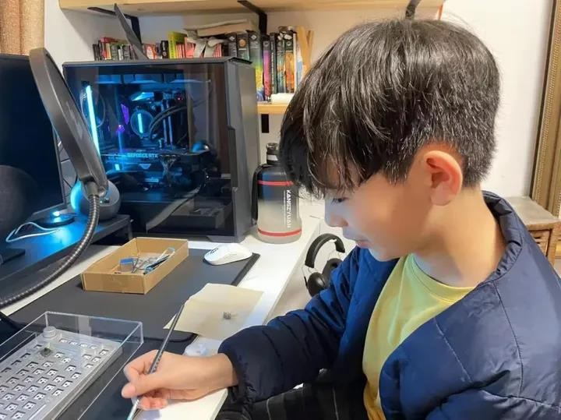

Gage's words reveal thoughts and reflections beyond his age, and although he hasn't been in contact with Roblox for very long, he has his own insights into the product and puts them inside the game.

"At the beginning I actually intended to do more small games with Chinese festivals, like Mario Party, but because of time constraints, this time the final completion of only seven, combined together to become the Chinese festival." Speaking of the work Gage, looked

more talkative than just now, "This process makes me enjoy it very much, being able to see my ideas presented on Studio step by step and being able to go from the very beginning of the framework to the completion of the game production, and finally being able to win the awards to be recognised by the officials is all great."

Roblox in my mind

Gage actually learned Unity before he got involved with Roblox, but found that the various aspects of the operation didn't suit him, so he quickly joined Roblox developers, and after that his skills in creating his work gradually improved.

So we also asked him why there is a more obvious improvement after the transformation.

He told us that this is probably because of the Roblox community: "In the construction of the scene of the work, not only do you need to build a little bit of manual construction, but also encounter a lot of buildings and triggers and other complex technical problems. This made me go to the forums to seek help. After finishing the construction, I also would seek players'

opinions on Roblox, fix the bugs listed by everyone, and do my best to complete the work in the best possible way."

Gage, did well to get both positive and negative feedback, but the biggest advantage was the atmosphere of mutual help within the community. When developers encounter problems that cannot be solved, everyone is very happy to lend a helping hand to help, which also

gives this part of the developers confidence to complete the development work. About the shortcomings

One of the things that makes Gage so impressive is that he did all the work by himself, but this is also something he sees as a weakness.

When we talked to Gage about the difficulties he encountered in completing the work independently, he suggested to us, "I actually want a team to complete more creations,

because everyone has their own strengths, and compared to me, the design ability is lacking. And, whenever the design of a game is a bit more complex, the team will definitely end up with a better presentation and higher playability than an individual."

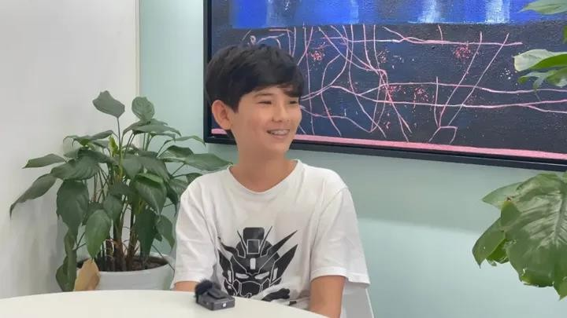

Teenager nurtured by internal drive education

For Gage, the process of game development and creation is also a process of continuous

learning. In the process of realising his own ideas, he has unconsciously learnt a lot of skills, and he himself aspires to be a creator at heart. Gage reveals to us that he can't wait to make his next game, and from this teenager we see his passion for development: "The real

development process, realising each function layer by layer, is what makes you realise what a fun and challenging world it is."

Winning the RNA National Competition may just be the beginning of his game development, but there is still a lot more to be done, and Gage says that he will continue to work towards his goal of making educational games that are recognised by a wider range of players. Let's stay excited about the teenager's development journey!

Roblox is the world's most popular 3D digital creative community, a family of 9 million active creators and hundreds of millions of players. Roblox Studio is a powerful, easy-to-

understand, one-click publishing tool for cross-platform game development that is free for anyone to use!