
UNIVERSITY OF BUEA

FACULTY OF ENGINEERING AND TECHNOLOGY
(FET)
PO BOX 63

REPUBLIC OF CAMEROON

PEACE-WORK-FATHERLAND
BUEA, SOUTH WEST REGION
Design and Implementation of a
Crowdsensed Drive Test Mobile Application for
Coverage Prediction
REPORT
MOBILE APP DEVELOPMENT PROCESS

COURSE TITLE: Internet Programming And Mobile Programming
COURSE INSTRUCTOR: Dr. Nkemeni Valery

SUBMITTED BY GROUP 3 MEMBERS

Name | Matricule
KONEH CATHERINE MBEH | FE23A076
MOFA DIVINE ESIMO | FE23A095
ETUBE NDIANG MARY SHARON | FE23A051
AGBORNJA BESONG AKPAK DIVINE | FE23A006
OBIOMA OBI FODJO CAREL | FE23A133

DEPARTMENT OF COMPUTER ENGINEERING
ACADEMIC YEAR 2025 - 2026

Contents
1
1 Introduction 4
2 Problem Statement 4
3 Objectives 5
4 Stakeholder Identification 5
4.1 End Users Smartphone Owners 6
4.2 Mobile Network Operators 6
4.3 University and Academic Supervisors 6
4.4 Backend and System Administrators 6
4.5 Regulatory Bodies 6
5 Requirement Gathering Methods 7
5.1 Survey 7
5.2 Brainstorming 7
5.3 Reverse Engineering 7
6 Data Collected 8
6.1 Demographics 8
6.2 Network Experience 9
6.3 6.3 User Willingness and Concerns 11
6.4 Desired Features 12
7 Data Cleaning 13
8 Requirement Analysis 16
8.1 Functional Requirements 16
8.2 Network Parameter Collection 16
8.2 GPS Based Geo-Location Tagging 16
8.3 Real-Time Signal Strength Display 17
8.4 Coverage Map Visualisation 17
8.5 Offline Data Storage and Synchronisation 17
8.6 Automatic Background Data Collection 17
8.7 Secure Data Transmission to Backend 17
8.8 User Consent and Permission Management 18
9 NonFunctional Requirements 18
9.1 Performance and Battery Efficiency 18
9.2 Low Data Consumption 18
9.3 Usability and Accessibility 19
9.4 Privacy and Security 19
9.5 Reliability and Availability 19
9.6 Scalability 19
10 Challenges Encountered 20
11 Conclusion 20
12 References 21

Introduction
Mobile communication networks are central to everyday life in Cameroon, enabling citizens to access digital services such as mobile banking, e-learning platforms, social media, e-government portals, and telecommunication services. As the demand for seamless connectivity continues to grow, the need for reliable and thorough network coverage assessment becomes increasingly important for both service providers and end users.
Traditionally, mobile network operators such as MTN and Orange Cameroon rely on physical drive testing a process that involves deploying specialized vehicles equipped with calibrated radio frequency (RF) measurement equipment along predefined routes. While this method produces accurate and detailed signal measurements including Reference Signal Received Power (RSRP), Signal-to-Interference-plus-Noise Ratio (SINR), and throughput, it is prohibitively expensive, time consuming, and logistically challenging, particularly in developing regions with difficult terrain and limited infrastructure.
Recent advances in smartphone sensor technology, mobile operating systems, and wireless APIs have opened an alternative pathway. Modern smartphones are capable of functioning as Class 2 IoT devices, able to collect georeferenced network performance data in real time as users move about their daily environments. This has given rise to the concept of mobile crowdsensing, wherein data collected passively from many ordinary users’ devices is aggregated to construct a comprehensive picture of network coverage across a geographic area.
This report documents the requirement gathering phase of the project titled “Design and Implementation of a Crowdsensed Drive Test Mobile Application for Coverage Prediction.” The process involved identifying key stakeholders, designing and distributing a structured survey instrument, collecting and cleaning the resulting data, and assessing user willingness to participate in crowdsensed data collection. A total of 63 valid responses were obtained and analysed to inform the requirements of the proposed mobile application.

Problem Statement
Mobile network operators in Cameroon such as MTN and Orange rely on traditional drive testing to monitor signal coverage. This method involves deploying expensive specialised vehicles along predefined routes to collect signal metrics such as RSRP and SINR. While accurate, it is costly, time-consuming, and impossible to scale across Cameroon's diverse terrain, causing coverage holes to go undetected for long periods and leaving citizens without reliable access to mobile banking, e-learning, and basic communication services.
Although modern smartphones are capable of functioning as passive network measurement devices, no dedicated application currently exists that is designed for the Cameroonian context, optimised for low-end Android devices, and capable of aggregating crowdsourced signal data for automated coverage prediction.
This project addresses this gap by designing and implementing a crowdsensed drive test mobile application that uses ordinary smartphones to continuously collect geo-referenced network measurements and transmit them to a backend platform for mobile network coverage prediction and coverage hole detection.

Objectives
The requirement gathering phase was guided by the following objectives:
- To identify all stakeholders associated with the proposed crowdsensed drive test mobile application and document their roles, interests, and expectations.
- To apply recognised requirement gathering techniques including surveys, brainstorming, and reverse engineering to elicit both functional and non-functional requirements from target users and domain experts.
- To collect, clean, and analyse primary data from prospective users in order to understand their experiences with mobile network coverage and their expectations of a monitoring application.
- To assess user willingness to install and operate a background network monitoring application, and to identify and document concerns related to privacy, battery usage, and data consumption.
- To derive a clear and prioritised set of user needs that will guide the system design, user interface development, and backend architecture of the proposed application.

Stakeholder Identification
Stakeholder identification is a foundational step in the requirement gathering process. A stakeholder is any individual, group, or organisation that has an interest in, or is affected by, the proposed system. For the crowdsensed drive test mobile application, the following stakeholders were identified.

End Users Smartphone Owners
End users represent the primary stakeholder group. These are everyday smartphone owners like students, professionals, and general members of the public who will use the platform on their devices. Their phones act as passive data collection instruments, gathering signal metrics such as RSRP, RSSI, SINR, and GPS coordinates as they go about their daily activities. Their willingness to use the application, their concerns about privacy and resource consumption, and their preferred features directly shape the application’s design requirements. The survey conducted for this task targeted this group specifically, yielding 63 responses.

Mobile Network Operators
Network operators such as MTN Cameroon and Orange Cameroon are indirect but critical stakeholders. They stand to benefit most from the crowdsourced coverage data generated by the application, as it can help them identify coverage holes, optimise antenna placement, and improve service quality in underserved areas at a significantly lower cost than traditional drive testing. Their technical standards for signal measurement parameters also inform the data schema used in the backend platform.

University and Academic Supervisors
The University of Buea and the project supervisor, Dr. Valery Nkemeni, serve as academic stakeholders. They define the scope, methodology, and evaluation criteria for the project. Their role is to ensure the project meets academic and engineering standards, and to guide the team through each phase of development from requirements to deployment.

Backend and System Administrators
The technical team responsible for managing the server infrastructure, database, and data processing pipelines form another important stakeholder group. Their requirements relate to system scalability, data security, API design, and the reliability of data transmission from mobile clients to the backend platform. These concerns directly influence non-functional requirements such as performance, security, and maintainability.

Regulatory Bodies
The Agence de Régulation des Télécommunications (ART), Cameroon’s telecommunications regulatory authority, represents a regulatory stakeholder. Any application that collects georeferenced signal data and transmits it to external platforms must comply with applicable data protection regulations and telecommunications laws. Their requirements influence the application’s privacy policies, data handling procedures, and consent mechanisms.

Requirement Gathering Methods
A combination of complementary requirement gathering techniques was employed to ensure a comprehensive and well-rounded understanding of user needs, technical feasibility, and system expectations.

Survey
A structured questionnaire was designed and administered digitally via Google Forms. The survey comprised twelve questions organised into four thematic sections: demographics, network experience, user willingness and concerns, and feature preferences. It was distributed through digital channels such as WhatsApp groups, and direct sharing among students at the University of Buea and other neighbouring persons around us. The survey was open for 1week 5days, from 13 April to 25 April 2026, and collected a total of 63 valid responses. The survey method was chosen for its efficiency in reaching a large number of respondents quickly, its ability to generate quantifiable data suitable for statistical analysis, and its low cost of administration.

Brainstorming
The project team conducted structured brainstorming sessions to identify the core functionalities, potential risks, and architectural decisions for the application. These sessions helped generate ideas for features not explicitly requested by survey respondents, such as offline data buffering, battery optimisation strategies, and data anonymisation before transmission. Brainstorming complemented the survey by adding depth and technical perspective to the requirements.

Reverse Engineering
Existing mobile applications with similar functionality were studied and analysed to identify standard features, design patterns, and shortcomings. Applications reviewed included OpenSignal, Network Cell Info Lite, TEMS Pocket, GNet Track, CellMapper, and Speedtest by Ookla. This reverse engineering exercise revealed that while many global tools exist for network monitoring, there is currently no dedicated crowdsensed network coverage prediction system that is specific to Cameroon. These gaps helped define the unique value proposition and specific requirements of the proposed application.

OpenSignal

OpenSignal is one of the most recognized crowdsourced mobile network intelligence platforms. Its primary functionality is to measure signal strength, internet speed, latency, video streaming quality, and network availability using data submitted by millions of users globally. The application works by collecting passive and active measurements from users’ smartphones. Passive measurements are gathered while users naturally use their devices, such as signal strength changes, network switching between 3G, 4G, and 5G, and GPS location updates. Active measurements occur when a user runs a speed test or video test. The collected information is uploaded to cloud servers, aggregated, processed, and converted into coverage maps and operator rankings. For your crowdsense drive test system, this demonstrates how community-generated measurements can replace expensive manual drive testing while still providing large-scale visibility into network quality.

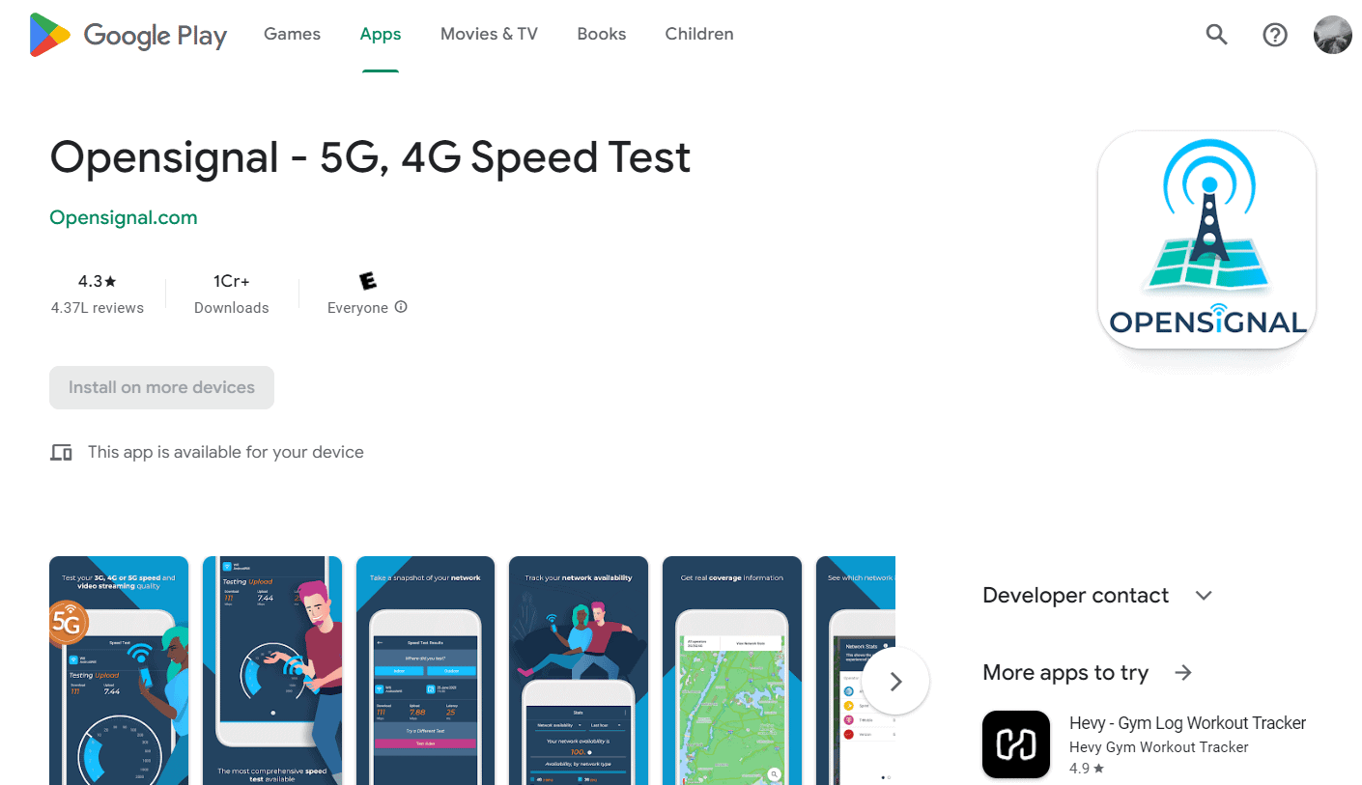

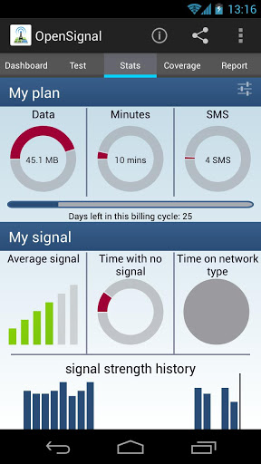

Network cell info Lite

Network Cell Info Lite focuses more on radio network diagnostics than public crowdsourcing. It provides real-time details about serving cell towers, neighboring cells, signal power levels, network generation, frequency bands, and cell identifiers. The software works by accessing the Android telephony APIs that expose cellular modem information. It continuously reads parameters such as RSRP, RSRQ, SINR, RSSI, PCI, TAC, and Cell ID, then displays them through gauges, charts, and maps. This application is highly useful for reverse engineering because it shows how technical radio parameters can be captured directly from mobile devices and visualized instantly. In your own system, similar functionality could be used to monitor signal degradation while users travel across urban roads.

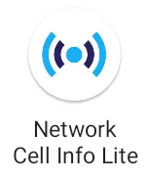

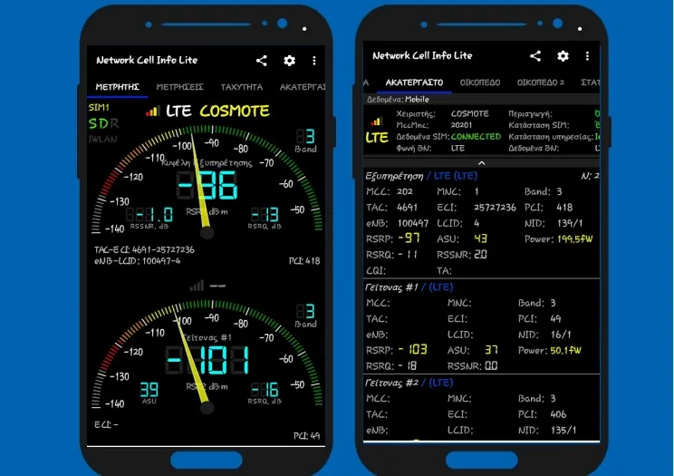

Speedtest by Ookla

Speedtest by Ookla specializes in measuring user data performance rather than radio diagnostics. Its core functions include download speed, upload speed, latency, jitter, and packet loss testing. The software works by connecting the device to the nearest or best-performing server, then transferring controlled packets of data to calculate throughput and responsiveness. Results are stored historically and can be compared across locations or operators. For your system, this illustrates the importance of combining radio-layer metrics with user experience metrics. Strong signal does not always mean good internet performance, so speed testing should complement signal measurements.

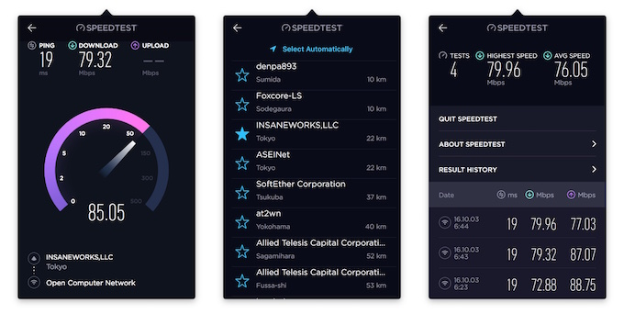

CellMapper

CellMapper is also highly precise for crowdsensing. Its entire value comes from users submitting cell IDs, GPS traces, and radio measurements while traveling. By combining data from many contributors, it estimates tower locations, sector directions, and coverage zones. This is a classic participatory sensing model where many individuals collectively build a telecom intelligence database.

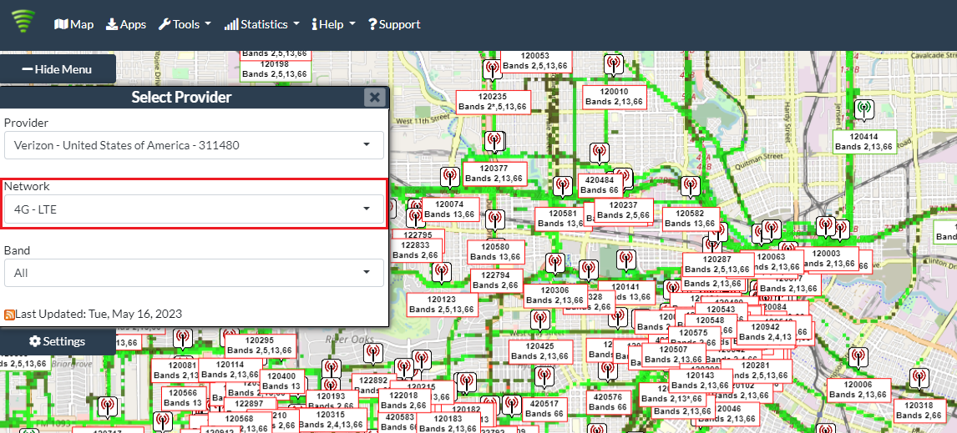

GNetTrack

GNetTrack can support crowdsensing if users upload logs to a central server, but by default it is more of a personal field testing and route logging tool. It is better described as a data collection tool that can be adapted into a crowdsensing ecosystem.

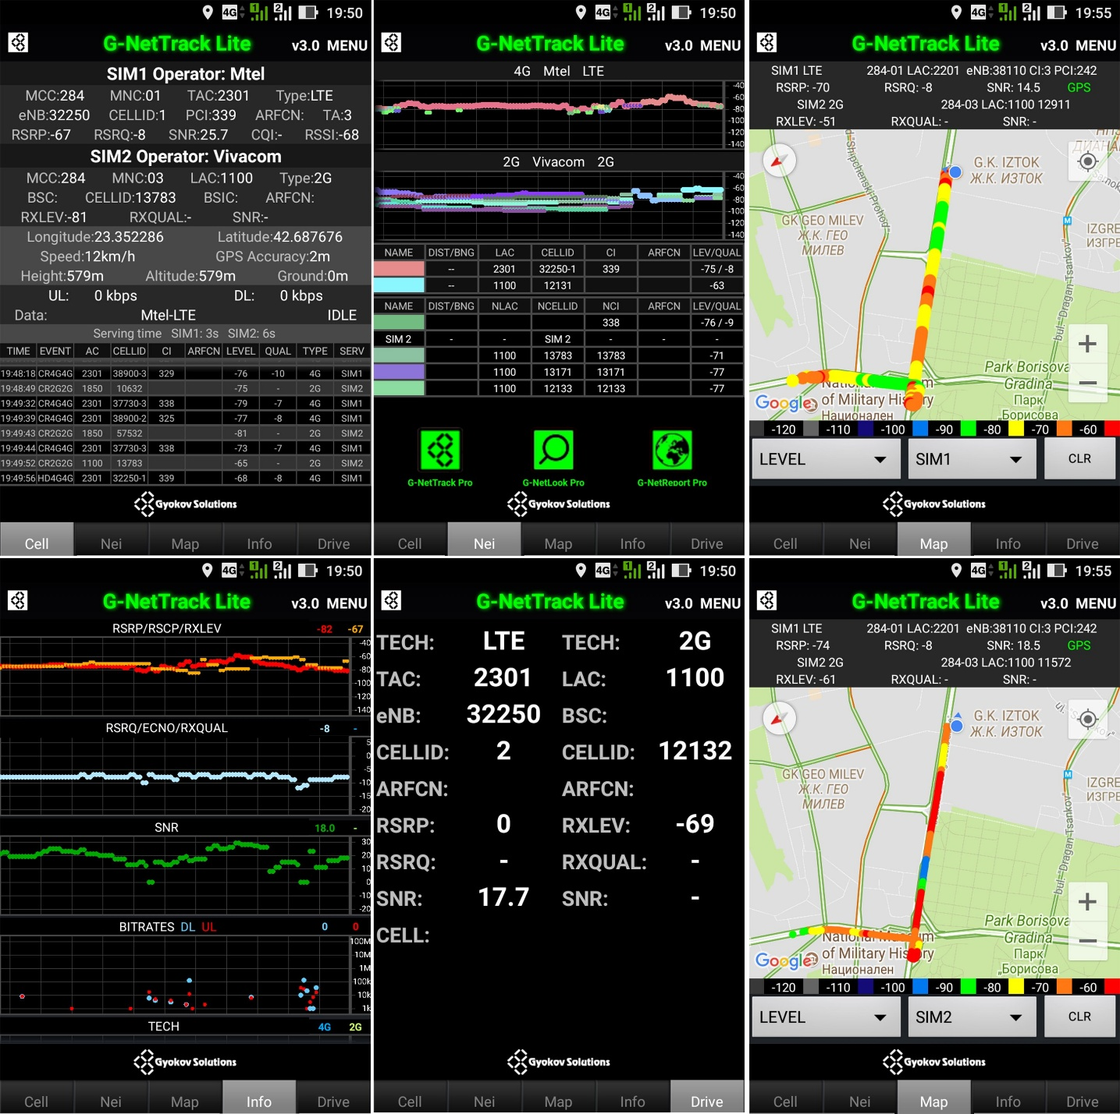
Although several crowdsensed mobile network applications such as OpenSignal, CellMapper, and Speedtest by Ookla are globally available and can be used in Cameroon, none of them is specifically designed to address the unique telecommunications challenges of the country. These platforms allow users in Cameroon to contribute signal strength, internet speed, and coverage data, but their services remain general and lack localized intelligence for Cameroon’s transport routes, urban congestion zones, rural coverage gaps, and dual SIM user behavior. The proposed crowdsensed drive test mobile application can therefore offer a unique solution by focusing specifically on Cameroon. Unlike existing systems, it can provide route based network performance analysis for major roads such as Douala–Yaoundé corridors, real-time comparison between operators like MTN, Orange, and Camtel, offline data collection for low connectivity areas, outage reporting linked to power interruptions, and bilingual support in English and French. It can also integrate AI to predict weak coverage zones ahead of travel routes and generate dashboards showing underserved communities. These localized innovations would make the system more practical, intelligent, and relevant than existing global platforms.

Data Collected
A total of 63 responses were collected from the survey. The data covered user demographics, network usage patterns, geographic areas of poor coverage, affected services, willingness to adopt the application, motivating factors, and desired features. The following subsections present a detailed narrative of the findings from each section of the survey.

Demographics
The survey respondents were predominantly young adults. An overwhelming 92.1 percent of respondents fell within the 18 to 25 age bracket, with the remaining 6.3 percent in the 26 to 35 range, and just one respondent aged 36 or above. This demographic profile is consistent with the target user base for a mobile crowdsensing application, as younger users tend to be more comfortable with mobile technology and more likely to adopt new applications.
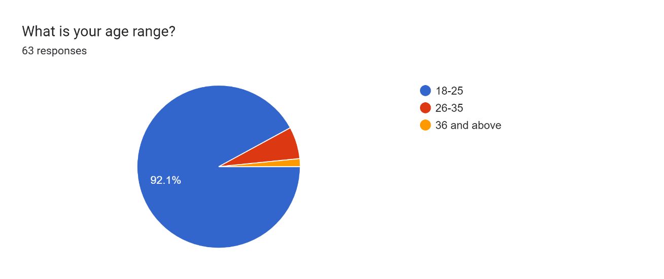
Figure: Distribution of respondents by age range
In terms of device type, 55.6 percent of respondents used iPhones while 44.4 percent used Android devices. This distribution is good because the application is initially being designed for the Android platform, given Android’s open API access to signal metrics such as RSRP and SINR. The significant proportion of iPhone users underscores a potential future requirement to extend the application to iOS, and also highlights a limitation in terms of API access on Apple devices, where signal data is more restricted.
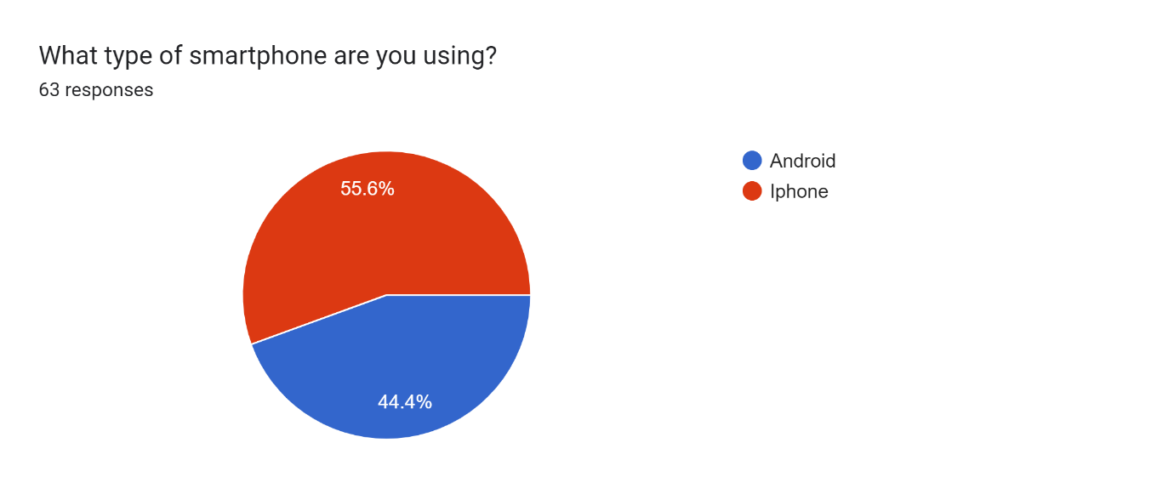
Figure: Distribution of respondents by smartphone type
Regarding mobile network providers, MTN was the most widely used network, with 69.8 percent of respondents using it as their primary provider. Orange followed at 17.5 percent, while 7.9 percent used other providers and 4.8 percent used Camtel. This distribution reflects the broader market reality in Cameroon, where MTN holds the dominant market share and thus is the most important network to monitor from a coverage prediction perspective.
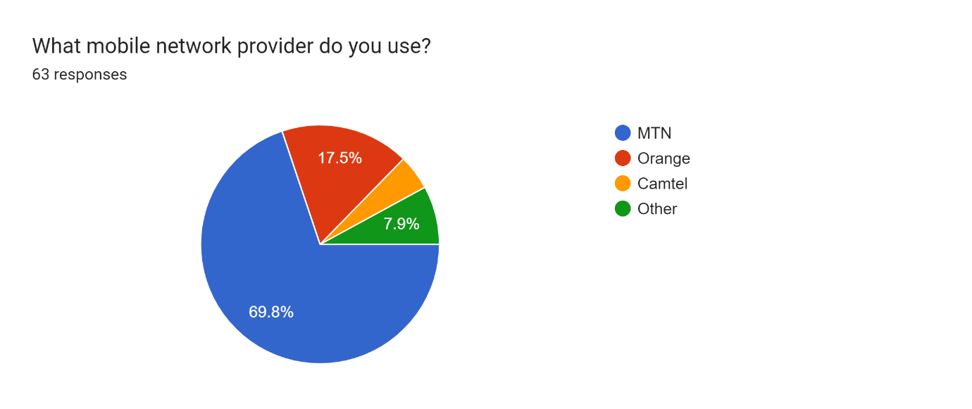
Figure: Distribution of respondents by mobile network provider

Network Experience
The survey results painted a stark picture of the extent of network coverage problems experienced by users. A total of 73 percent of respondents reported experiencing poor network coverage on a daily basis. A further 15.9 percent reported experiencing it weekly, bringing the total proportion of users who regularly encounter coverage issues to nearly 89 percent. Only 11.1 percent reported experiencing poor coverage rarely, and no respondent selected never. These findings strongly validate the problem statement of this project and confirm that mobile coverage deficiency is a persistent and widespread issue for the target user population.
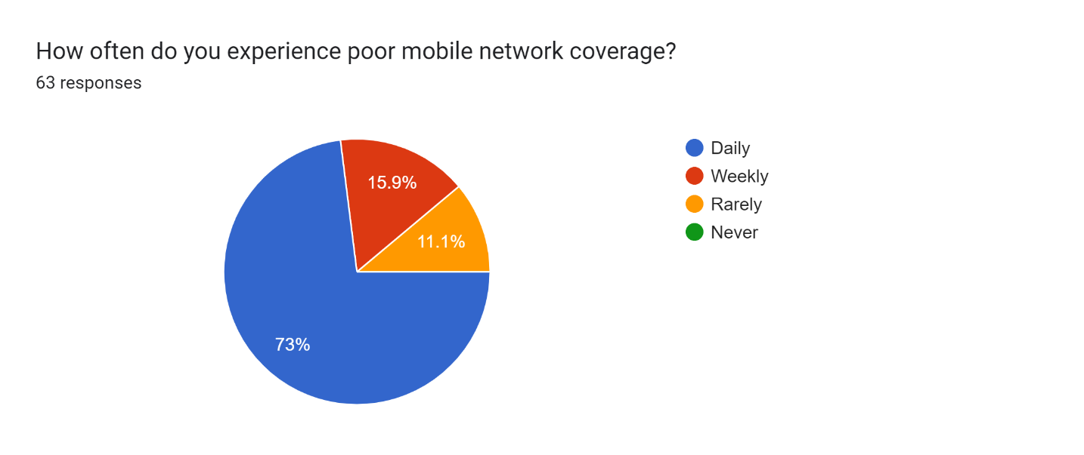
Figure: How often respondents experience poor mobile network coverage
When asked about the geographic areas in which poor coverage was most frequently experienced, respondents identified a wide range of locations. Commonly cited areas included Bomaka, Molyko, the University of Buea campus (specifically the FET building and UB Junction), Small Soppo, Idenau, Bafoussam, Mile 17 and Mile 18, Douala (particularly Makepe and around the Central Market), and Garoua. Many respondents simply stated everywhere or at home, suggesting that coverage problems are not confined to specific remote areas but affect both urban and residential environments. This geographic diversity reinforces the need for a crowdsensed approach, as no single measurement campaign could capture the full extent of coverage gaps.
Mobile data and browsing was by far the most affected service, cited by 90.5 percent of respondents. WhatsApp and messaging services were affected for 46 percent of respondents, while phone calls and live streaming were each cited by 25.4 percent of users. The predominance of mobile data issues as the primary pain point confirms that the application’s focus on monitoring data connectivity parameters is well-aligned with user needs.
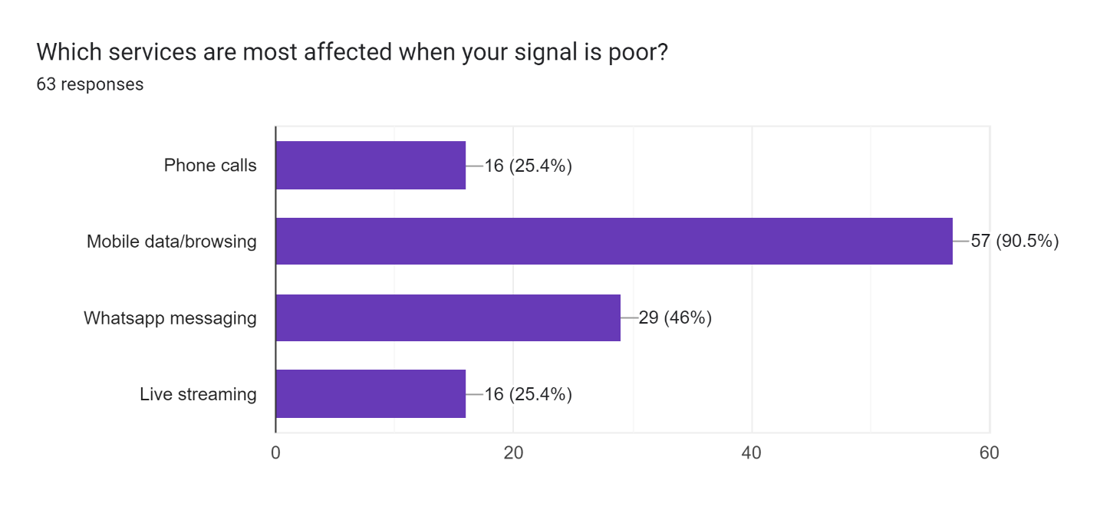
Figure: Services most affected by poor mobile network coverage

6.3 User Willingness and Concerns
On the question of whether respondents would install an application that automatically monitors signal quality in the background, 52.4 percent answered affirmatively, 42.9 percent responded with “maybe,” and only 4.8 percent declined outright. These results indicate a generally receptive target audience, with the vast majority of undecided users likely to convert if their concerns are adequately addressed through thoughtful application design.
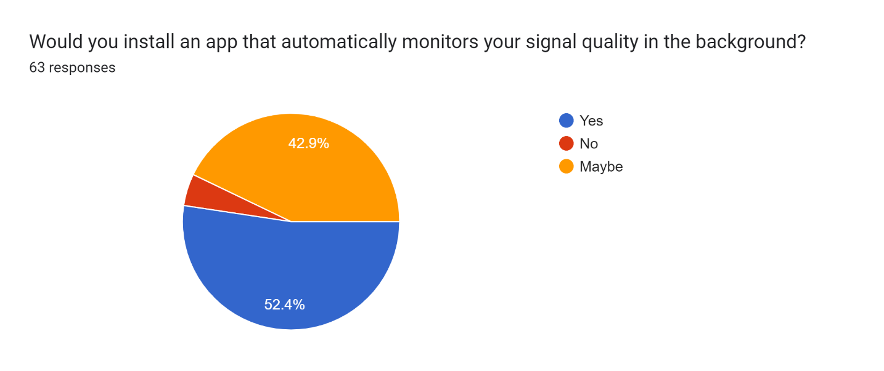
Figure: User willingness to install a background network monitoring application
When asked what would make them more willing to use such an application, the most commonly cited factor was knowing that the app would help improve the network, selected by 77.8 percent of respondents. This suggests that users are motivated by collective benefit and social impact rather than personal gain alone. A desire for a better personal internet connection was cited by 47.6 percent, while minimising mobile data consumption was a concern for 31.7 percent. These factors collectively define the motivational profile of the target user and should be reflected in the application’s onboarding messaging, privacy communication, and resource management strategy.
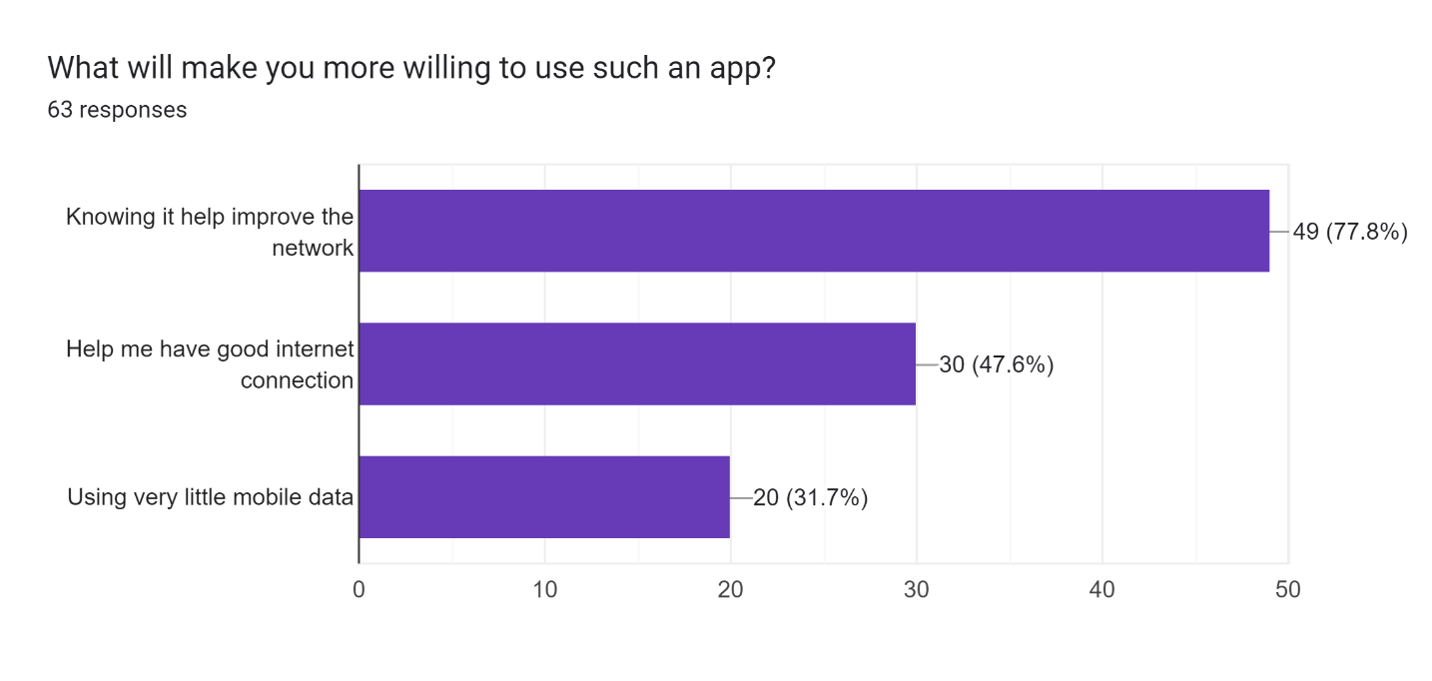
Figure: Factors that would motivate users to install the application

Desired Features
Respondents were asked to select the features they would find most useful in the application. Real-time signal strength display emerged as the most desired feature, selected by 76.2 percent of respondents. A coverage map of the user’s area was selected by 34.9 percent, while fully automatic background data collection was desired by 33.3 percent. These results confirm that users expect both passive collection capabilities and active informational displays, and that visibility into their own signal environment is a primary driver of adoption.
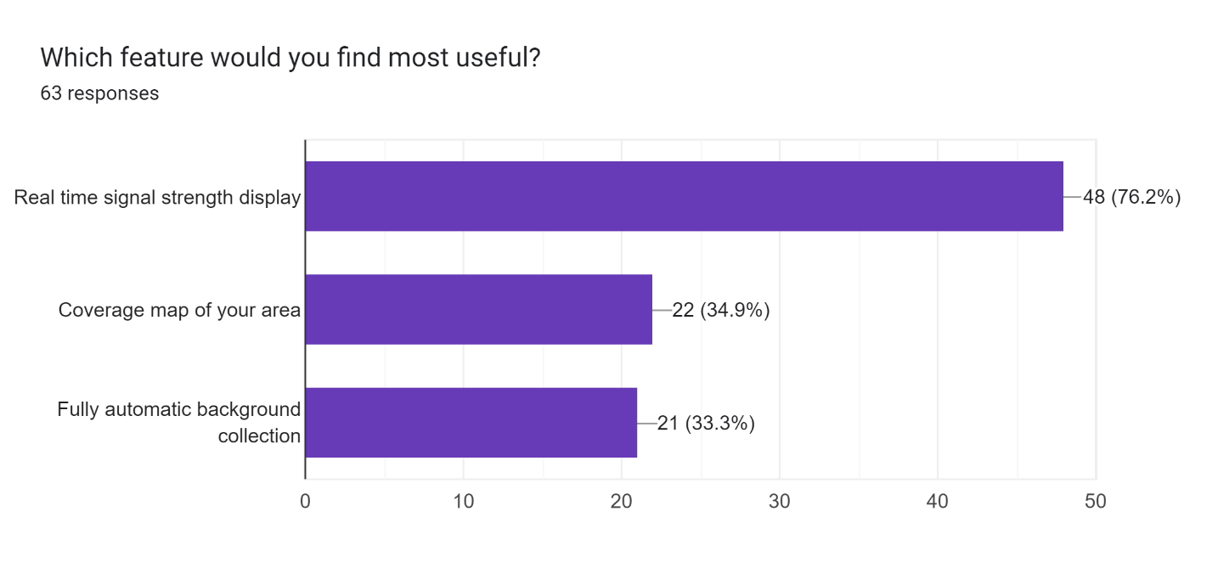
Figure: Features respondents would find most useful in the application

Data Cleaning
Following the collection phase, the raw survey data was reviewed and cleaned before analysis. The cleaning process involved three main steps. First, duplicate entries were identified by cross-referencing email addresses and timestamps. One respondent phinafuen@gmail.com submitted the form twice; the second submission was identified and excluded, resulting in a final dataset of 63 unique, valid responses.
Second, responses to open ended questions were reviewed for relevance and coherence. Entries in the area of poor coverage field that contained service names rather than geographic locations (such as “mobile data” or “browsing”) were noted as indicative of misunderstanding of the question but retained as evidence of the pervasiveness of data connectivity issues. Third, comments in the optional suggestions field were filtered to retain only substantive, constructive responses. Entries containing only “No,” “RAS,” or “None” were excluded from thematic analysis while being counted in total response tallies. The cleaned dataset was then used as the basis for all quantitative and qualitative findings reported as below.
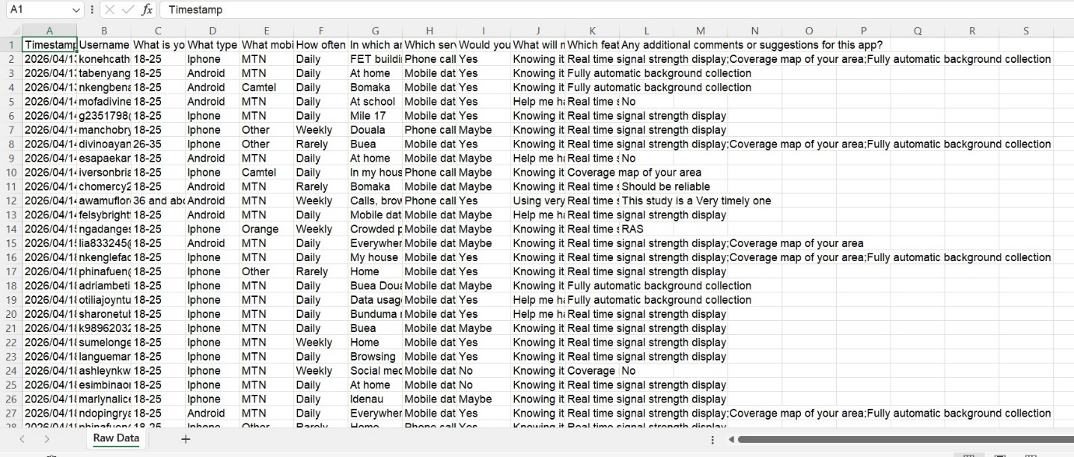
Figure 1:RAW DATA

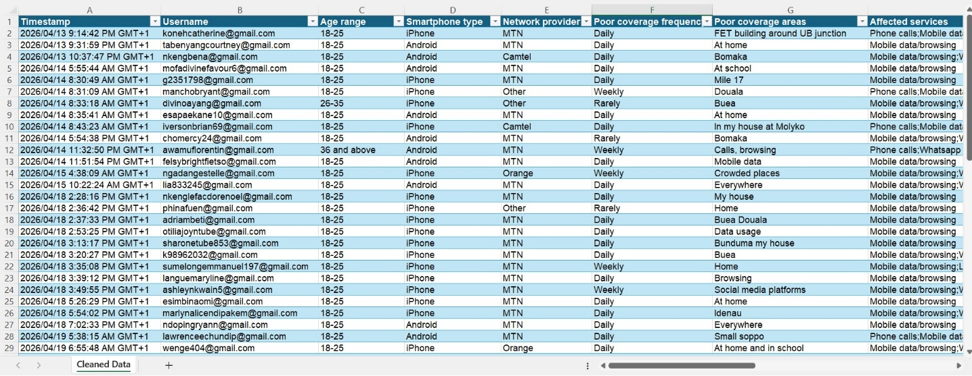

Figure 2:CLEANED DATA
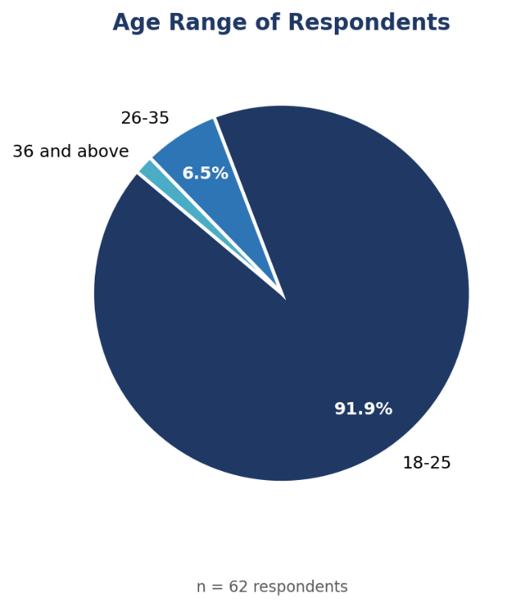
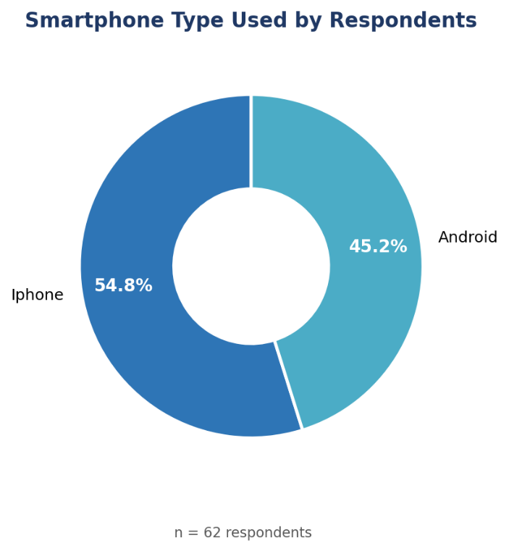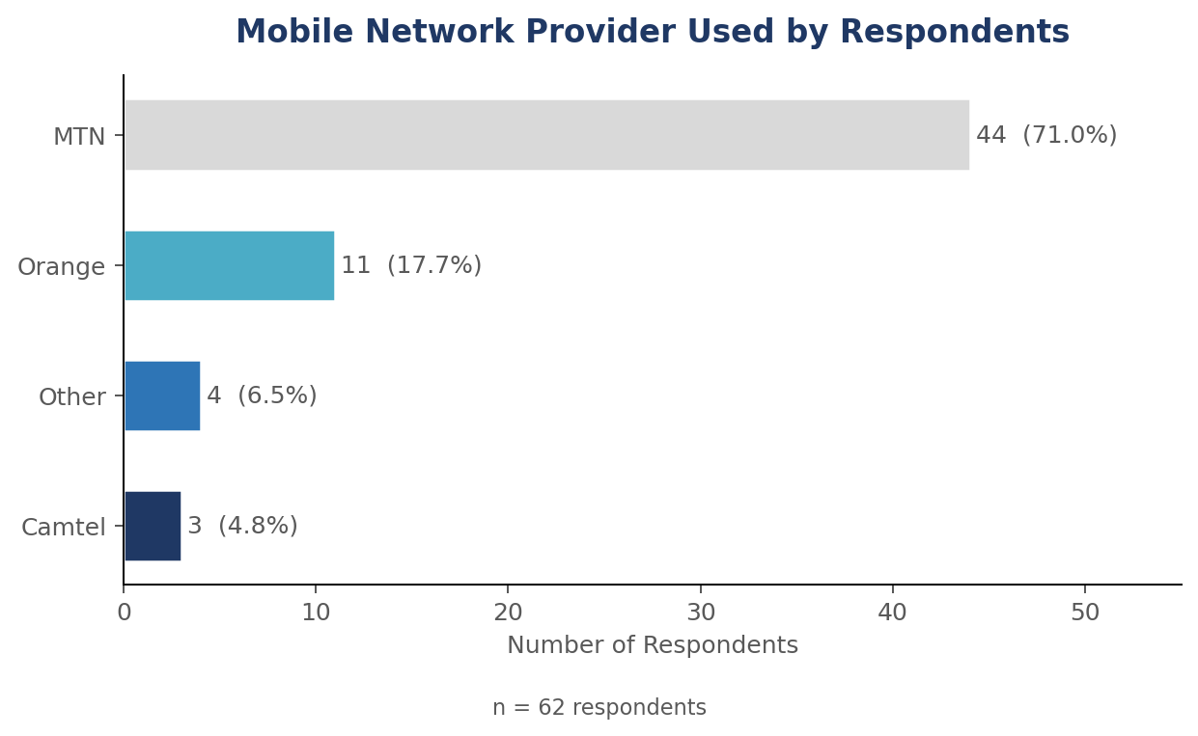
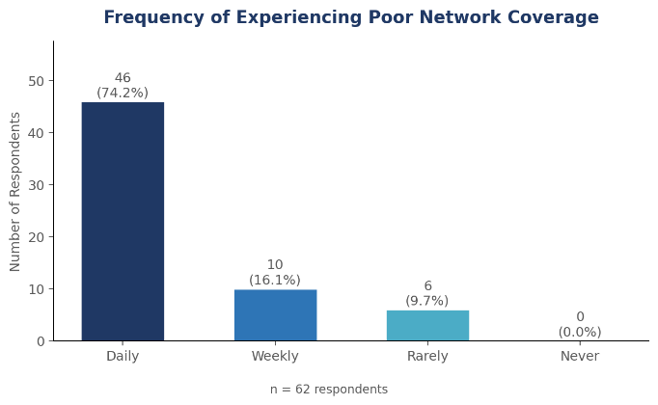
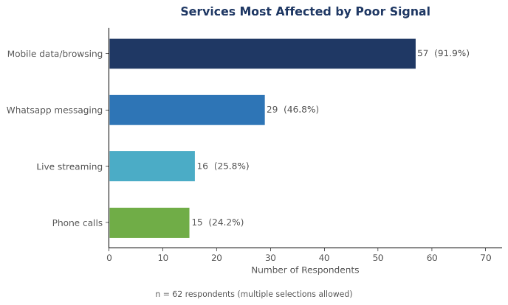
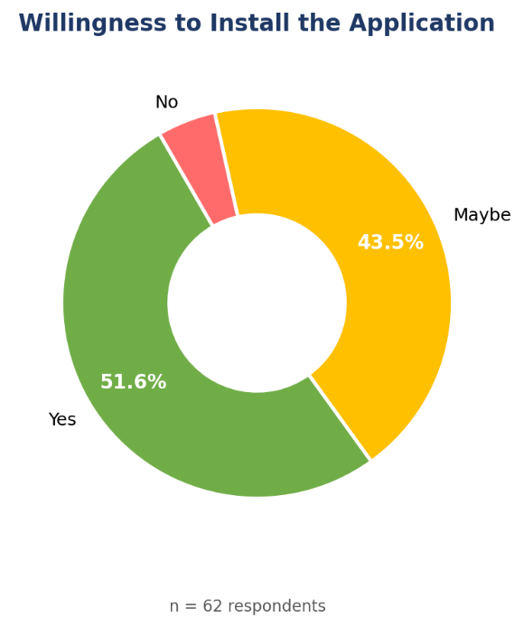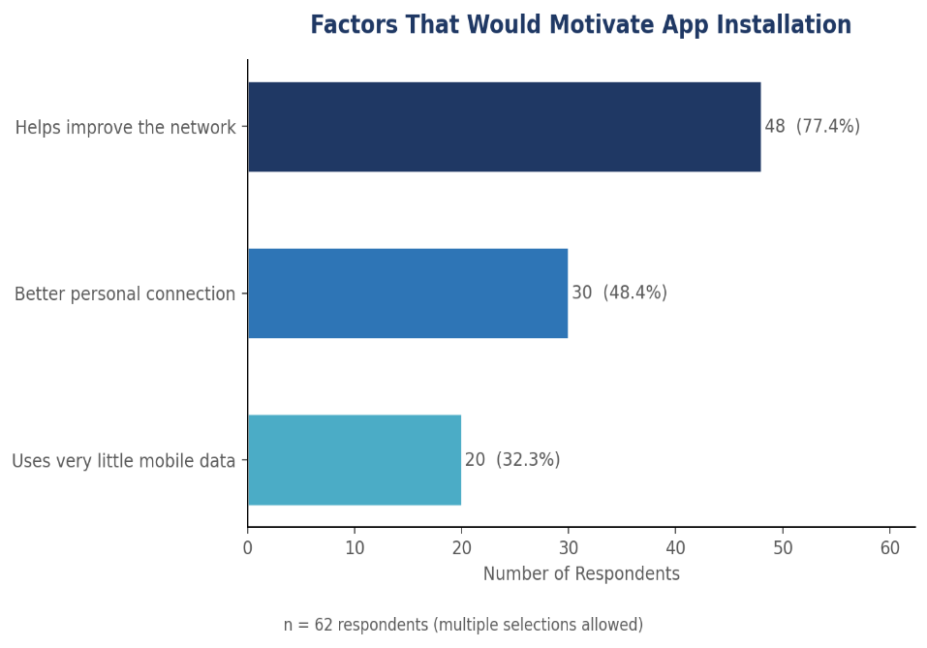
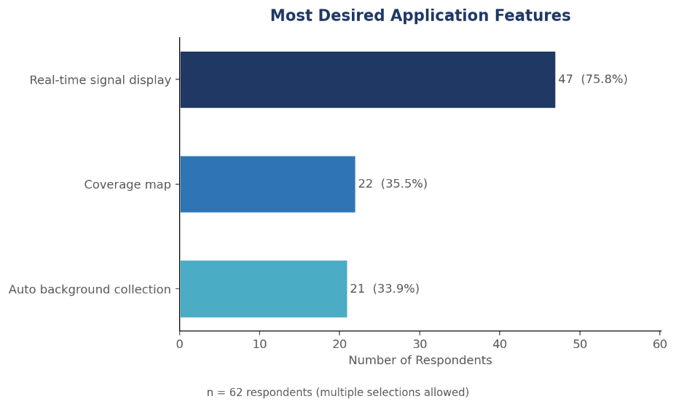

Challenges Encountered
Several challenges were encountered during the requirement gathering phase that are worth documenting for methodological transparency and future reference.
The first challenge concerned the representativeness of the survey sample. The majority of respondents were students aged 18 to 25 affiliated with the University of Buea, which limits the generalisability of findings to other demographic groups such as older users, rural inhabitants, or users in cities outside of Buea and Douala. A more geographically and demographically diverse sample would produce a richer and more complete picture of user needs.

Conclusion
The requirement gathering phase of this project has yielded a rich and detailed understanding of the needs, concerns, and expectations of the target user population for the proposed crowdsensed drive test mobile application. Through a combination of structured survey administration, brainstorming, and reverse engineering of existing applications, the team was able to collect and analyse data from 63 respondents, identify all relevant stakeholders, and derive a comprehensive set of functional and non-functional requirements.
The findings confirm that mobile network coverage deficiency is a pervasive and daily challenge for the majority of users in the target population, affecting primarily mobile data services and occurring across a wide range of geographic areas including residential, academic, and commercial environments. Users are broadly willing to adopt a background monitoring application, particularly if they are assured that it will consume minimal battery and data, and if they understand the collective benefit their participation generates.
The application must deliver real-time signal strength visibility and coverage map features as its primary user-facing value propositions, while implementing robust offline data buffering, secure transmission, and transparent consent mechanisms to address user concerns and regulatory requirements. The requirements identified in this report will form the foundation for the Software Requirements Specification (SRS) to be developed.
This project represents a meaningful contribution to the challenge of affordable and scalable mobile network monitoring in Cameroon, and the requirement gathering phase has established a solid empirical foundation upon which the remaining development work can confidently proceed.

References
- [1] A. Hezhe, "A Survey of Application and Key Techniques for Mobile Crowdsensing," Wireless Communications and Mobile Computing, vol. 2022, p. 3693537, 2022. https://doi.org/10.1155/2022/3693537
- [2] T. Wong, T. Freeman, and J. Feehily, "Mobile Coverage Analysis using Crowdsourced Geolocation Data," arXiv preprint, arXiv:2510.13459, 2025. https://arxiv.org/abs/2510.13459
- [3] M. F. Ahmad Fauzi et al., "Mobile Network Coverage Prediction Based on Supervised Machine Learning Algorithms," IEEE Access, vol. 10, pp. 55782–55797, 2022. https://doi.org/10.1109/ACCESS.2022.3176619
- [4] P. Koutroumpis and A. Leiponen, "Crowdsourcing Mobile Coverage," Telecommunications Policy, vol. 40, no. 6, pp. 532–544, 2016. https://doi.org/10.1016/j.telpol.2016.02.005
- [5] Business in Cameroon, "Cameroon Orders MTN, Orange, and Camtel to Improve Service Quality," Oct. 2024. [Online]. Available: https://www.businessincameroon.com/public-management/1410-14229

