SoB - Super outstanding Baller

Konsta Sinisalo, 506146, koossi@utu.fi

Pyry Vanamo, 506106, pyalva@utu.fi

Objective

We set out to make a non-competitive, relatively simple and harmless game to pass time on ones android phone. We decided to make a casual ball game (picture 1), in which the player tries to bounce small red balls to purple goals on each end of a play field. To achieve this, the player rotates a blue cube at the center of the field. When a goal is made, the ball pops and soon another appears. There is no scoreboard, so the game stays casual and relaxing.

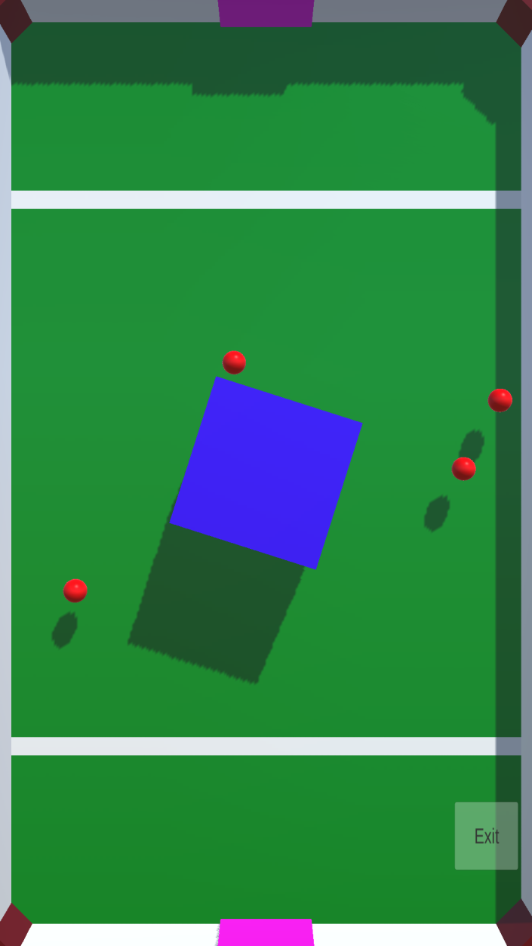

Development

We used Unity 3D -game development tool to make our game, because we have a very much experience working with it. Unity has a scene view that allows a game developer to construct a scene to which all the functional game mechanics are implemented linking code to assigned pieces (we used C# for game mechanics coding). With these tools the basic layout of the game was fast and easy to construct (picture 2).

Game layout

The final product ended up with a simplistic design: a simple main menu, with the options to start playing or exit the game. The game itself uses touch screen to control the turning of the cube. We also included another exit button to allow an easy transmission to the main menu.

1: The game scenario

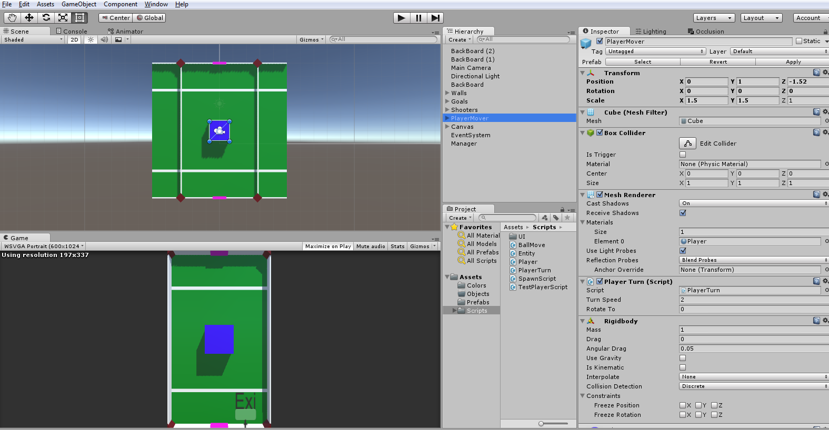

2: Our Unity-window

Outcome

Our game (Super outstanding Baller) achieved its purpose pretty well. Because the game was built as an android application some of the ball physics became a bit funky, but since both the purpose and the feel of the game weren’t too serious to begin with it didn’t bother the overall gaming experience. The most challenging part of the project were the game physics, which we were (in the end) both very happy. The final product realized our vision and was a complete success.