HW_DecisionTree

경제학과 2020110210 공소연

2022-11-06

## Q1-1

library(rpart)

## Warning: 패키지 'rpart'는 R 버전 4.2.2에서 작성되었습니다

data(stagec)  
data <- stagec  
str(data)

## 'data.frame': 146 obs. of 8 variables:  
## $ pgtime : num 6.1 9.4 5.2 3.2 1.9 4.8 5.8 7.3 3.7 15.9 ...  
## $ pgstat : int 0 0 1 1 1 0 0 0 1 0 ...  
## $ age : int 64 62 59 62 64 69 75 71 73 64 ...  
## $ eet : int 2 1 2 2 2 1 2 2 2 2 ...  
## $ g2 : num 10.26 NA 9.99 3.57 22.56 ...  
## $ grade : int 2 3 3 2 4 3 2 3 3 3 ...  
## $ gleason: int 4 8 7 4 8 7 NA 7 6 7 ...  
## $ ploidy : Factor w/ 3 levels "diploid","tetraploid",..: 1 3 1 1 2 1 2 3 1 2 ...

test.df <- data[145:146,-8]  
train.df <- data[1:144,]

## Q1-2

my_control <- rpart.control(xval = 10, cp = 0,   
 minsplit = 4)  
tree_model <- rpart(ploidy~.,method = "class",  
 control = my_control, data = train.df)  
tree_model

## n= 144   
##   
## node), split, n, loss, yval, (yprob)  
## * denotes terminal node  
##   
## 1) root 144 76 tetraploid (0.45138889 0.47222222 0.07638889)   
## 2) g2< 13.055 73 8 diploid (0.89041096 0.01369863 0.09589041)   
## 4) g2>=4.14 69 6 diploid (0.91304348 0.01449275 0.07246377)   
## 8) pgtime>=1.25 67 5 diploid (0.92537313 0.01492537 0.05970149)   
## 16) gleason< 7.5 60 3 diploid (0.95000000 0.01666667 0.03333333)   
## 32) pgtime< 12.45 56 2 diploid (0.96428571 0.00000000 0.03571429)   
## 64) age< 67.5 40 0 diploid (1.00000000 0.00000000 0.00000000) *  
## 65) age>=67.5 16 2 diploid (0.87500000 0.00000000 0.12500000)   
## 130) pgtime< 6.9 10 0 diploid (1.00000000 0.00000000 0.00000000) *  
## 131) pgtime>=6.9 6 2 diploid (0.66666667 0.00000000 0.33333333)   
## 262) pgtime>=8.3 3 0 diploid (1.00000000 0.00000000 0.00000000) *  
## 263) pgtime< 8.3 3 1 aneuploid (0.33333333 0.00000000 0.66666667) *  
## 33) pgtime>=12.45 4 1 diploid (0.75000000 0.25000000 0.00000000)   
## 66) pgtime>=13.3 3 0 diploid (1.00000000 0.00000000 0.00000000) *  
## 67) pgtime< 13.3 1 0 tetraploid (0.00000000 1.00000000 0.00000000) *  
## 17) gleason>=7.5 7 2 diploid (0.71428571 0.00000000 0.28571429)   
## 34) eet>=1.5 5 0 diploid (1.00000000 0.00000000 0.00000000) *  
## 35) eet< 1.5 2 0 aneuploid (0.00000000 0.00000000 1.00000000) *  
## 9) pgtime< 1.25 2 1 diploid (0.50000000 0.00000000 0.50000000) *  
## 5) g2< 4.14 4 2 diploid (0.50000000 0.00000000 0.50000000)   
## 10) g2< 3.67 2 0 diploid (1.00000000 0.00000000 0.00000000) *  
## 11) g2>=3.67 2 0 aneuploid (0.00000000 0.00000000 1.00000000) *  
## 3) g2>=13.055 71 4 tetraploid (0.00000000 0.94366197 0.05633803)   
## 6) pgtime>=5.5 36 0 tetraploid (0.00000000 1.00000000 0.00000000) *  
## 7) pgtime< 5.5 35 4 tetraploid (0.00000000 0.88571429 0.11428571)   
## 14) pgtime< 5.3 34 3 tetraploid (0.00000000 0.91176471 0.08823529) *  
## 15) pgtime>=5.3 1 0 aneuploid (0.00000000 0.00000000 1.00000000) *

library(rpart.plot)

## Warning: 패키지 'rpart.plot'는 R 버전 4.2.2에서 작성되었습니다

rpart.plot(tree_model)

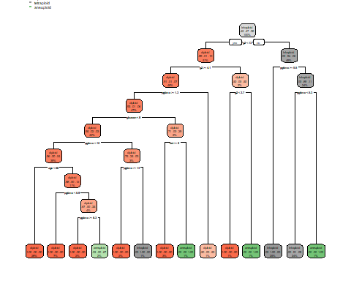

## Q1-3

printcp(tree_model)

##   
## Classification tree:  
## rpart(formula = ploidy ~ ., data = train.df, method = "class",   
## control = my_control)  
##   
## Variables actually used in tree construction:  
## [1] age eet g2 gleason pgtime   
##   
## Root node error: 76/144 = 0.52778  
##   
## n= 144   
##   
## CP nsplit rel error xerror xstd  
## 1 0.8421053 0 1.000000 1.18421 0.076440  
## 2 0.0131579 1 0.157895 0.15789 0.043640  
## 3 0.0087719 3 0.131579 0.18421 0.046778  
## 4 0.0065789 6 0.105263 0.19737 0.048233  
## 5 0.0043860 10 0.078947 0.23684 0.052219  
## 6 0.0000000 13 0.065789 0.26316 0.054605

pruned_model <- prune.rpart(tree_model, cp = 0.013)  
rpart.plot(pruned_model)

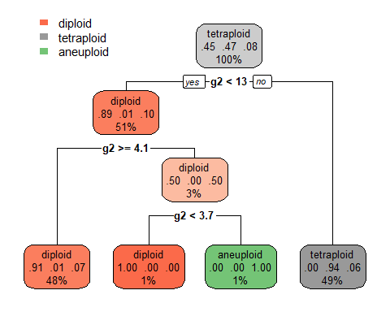

## Q1-4

predict(pruned_model, newdata = test.df, type = "class")

## 145 146   
## diploid diploid   
## Levels: diploid tetraploid aneuploid

## Q2-1

library("TH.data")

## Warning: 패키지 'TH.data'는 R 버전 4.2.2에서 작성되었습니다

## 필요한 패키지를 로딩중입니다: survival

## 필요한 패키지를 로딩중입니다: MASS

##   
## 다음의 패키지를 부착합니다: 'TH.data'

## The following object is masked from 'package:MASS':  
##   
## geyser

data(bodyfat)  
data2 <- bodyfat  
str(data2)

## 'data.frame': 71 obs. of 10 variables:  
## $ age : num 57 65 59 58 60 61 56 60 58 62 ...  
## $ DEXfat : num 41.7 43.3 35.4 22.8 36.4 ...  
## $ waistcirc : num 100 99.5 96 72 89.5 83.5 81 89 80 79 ...  
## $ hipcirc : num 112 116.5 108.5 96.5 100.5 ...  
## $ elbowbreadth: num 7.1 6.5 6.2 6.1 7.1 6.5 6.9 6.2 6.4 7 ...  
## $ kneebreadth : num 9.4 8.9 8.9 9.2 10 8.8 8.9 8.5 8.8 8.8 ...  
## $ anthro3a : num 4.42 4.63 4.12 4.03 4.24 3.55 4.14 4.04 3.91 3.66 ...  
## $ anthro3b : num 4.95 5.01 4.74 4.48 4.68 4.06 4.52 4.7 4.32 4.21 ...  
## $ anthro3c : num 4.5 4.48 4.6 3.91 4.15 3.64 4.31 4.47 3.47 3.6 ...  
## $ anthro4 : num 6.13 6.37 5.82 5.66 5.91 5.14 5.69 5.7 5.49 5.25 ...

?bodyfat

## httpd 도움말 서버를 시작합니다 ...

## 완료

# DEXfat is the dependent variable.

## Q2-2

set.seed(123)  
my_control2 <- rpart.control(xval = 10, cp = 0,  
 minsplit = 8)  
tree_model2 <- rpart(DEXfat~., method = "anova",  
 control = my_control2, data = data2)  
tree_model2

## n= 71   
##   
## node), split, n, deviance, yval  
## * denotes terminal node  
##   
## 1) root 71 8535.984000 30.78282   
## 2) waistcirc< 88.4 40 1315.358000 22.92375   
## 4) anthro3c< 3.42 13 145.993100 16.83692   
## 8) anthro3c< 3.165 5 11.818520 13.03600 *  
## 9) anthro3c>=3.165 8 16.792550 19.21250   
## 18) anthro3c>=3.31 3 3.139467 17.90667 *  
## 19) anthro3c< 3.31 5 5.468120 19.99600 *  
## 5) anthro3c>=3.42 27 455.819300 25.85444   
## 10) hipcirc< 101.35 16 120.142900 23.31937   
## 20) kneebreadth< 9.25 13 66.003320 22.49538   
## 40) kneebreadth>=8.85 3 13.596800 19.79000 *  
## 41) kneebreadth< 8.85 10 23.862010 23.30700   
## 82) waistcirc< 72.5 3 2.886667 22.00667 *  
## 83) waistcirc>=72.5 7 13.728770 23.86429 *  
## 21) kneebreadth>=9.25 3 7.065000 26.89000 *  
## 11) hipcirc>=101.35 11 83.287160 29.54182   
## 22) anthro3a< 4.09 8 12.389350 28.31250   
## 44) elbowbreadth>=6.45 4 3.575600 27.51000 *  
## 45) elbowbreadth< 6.45 4 3.661700 29.11500 *  
## 23) anthro3a>=4.09 3 26.568600 32.82000 *  
## 3) waistcirc>=88.4 31 1562.162000 40.92355   
## 6) kneebreadth< 11.15 28 615.525900 39.26036   
## 12) hipcirc< 109.9 13 136.296000 35.27846   
## 24) anthro3b< 4.605 6 19.088200 32.61000 *  
## 25) anthro3b>=4.605 7 37.862970 37.56571 *  
## 13) hipcirc>=109.9 15 94.469970 42.71133   
## 26) waistcirc< 113.5 12 30.609800 41.69000   
## 52) anthro3a< 4.155 5 16.973800 40.66000 *  
## 53) anthro3a>=4.155 7 4.542571 42.42571 *  
## 27) waistcirc>=113.5 3 1.272867 46.79667 *  
## 7) kneebreadth>=11.15 3 146.280300 56.44667 *

rpart.plot(tree_model2)

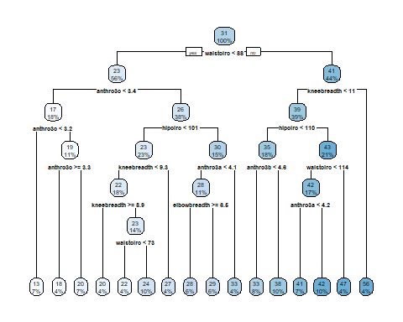

## Q2-3

printcp(tree_model2)

##   
## Regression tree:  
## rpart(formula = DEXfat ~ ., data = data2, method = "anova", control = my_control2)  
##   
## Variables actually used in tree construction:  
## [1] anthro3a anthro3b anthro3c elbowbreadth hipcirc   
## [6] kneebreadth waistcirc   
##   
## Root node error: 8536/71 = 120.23  
##   
## n= 71   
##   
## CP nsplit rel error xerror xstd  
## 1 0.66289544 0 1.000000 1.03108 0.169866  
## 2 0.09376252 1 0.337105 0.39741 0.091802  
## 3 0.08359261 2 0.243342 0.37083 0.070027  
## 4 0.04507506 3 0.159749 0.33000 0.066175  
## 5 0.02956768 4 0.114674 0.28050 0.057943  
## 6 0.01375143 5 0.085107 0.24686 0.066795  
## 7 0.00929533 6 0.071355 0.24186 0.066630  
## 8 0.00733217 7 0.062060 0.22636 0.063950  
## 9 0.00551484 8 0.054728 0.22152 0.063786  
## 10 0.00519322 9 0.049213 0.22133 0.063795  
## 11 0.00334402 10 0.044020 0.21419 0.063774  
## 12 0.00106531 11 0.040676 0.19240 0.053999  
## 13 0.00095888 12 0.039610 0.19004 0.053767  
## 14 0.00084894 13 0.038651 0.19072 0.053745  
## 15 0.00060357 14 0.037803 0.19072 0.053745  
## 16 0.00000000 15 0.037199 0.19122 0.053845

pruned_model2 <- prune.rpart(tree_model2, cp = 0.00096)  
rpart.plot(pruned_model2)

