TransE

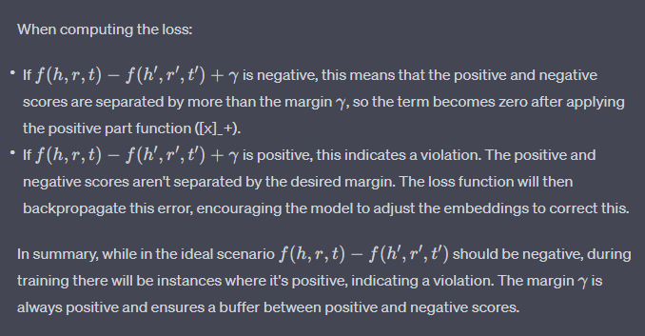

Q1: about margin

Q2: about normalization

