95140062UB_0000
8 ST
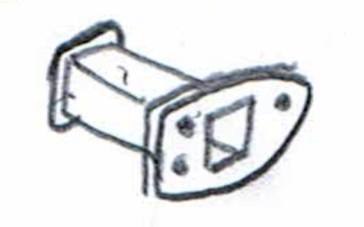

RON
60125181_0000
5 ST
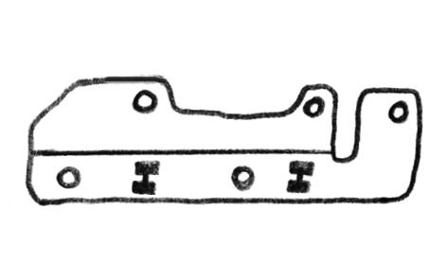

RON
60042067_0001
15 ST
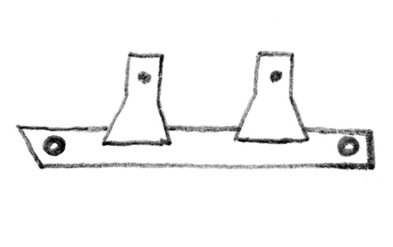

RON
24361400UB_0002
10 ST
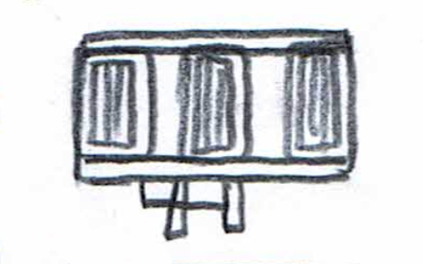

RON

34973400UB_A
2 ST
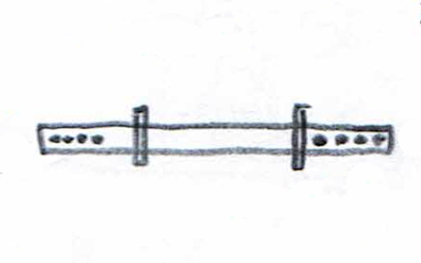

RON
60038918_0002
5 ST
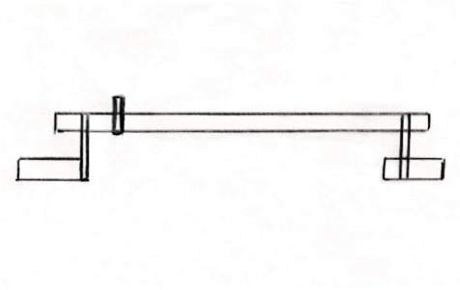

RON
23657100UB
2 ST
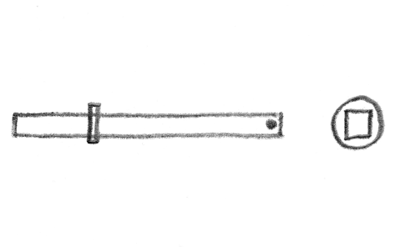

RON
28092400UB_A
1 ST
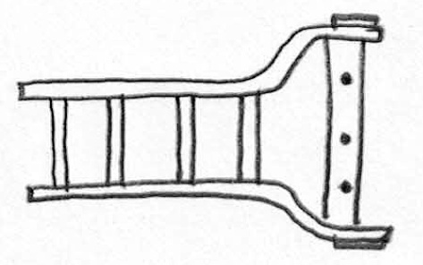

RON

37064600UB_0000
2 ST
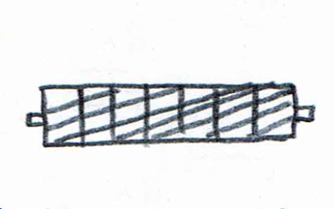

RON
60015018_0000
3 ST
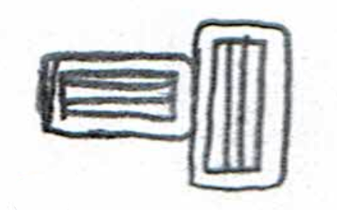

RON
60017654_0000
11 ST
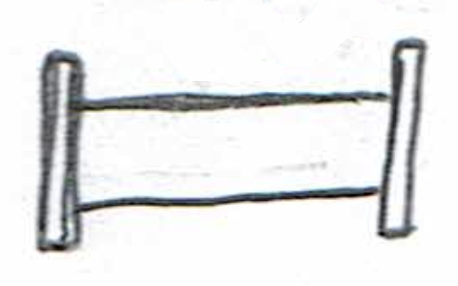

RON
60026471_0003
20 ST
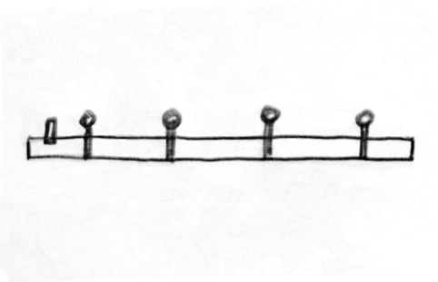

RON

60017696_0006
15 ST
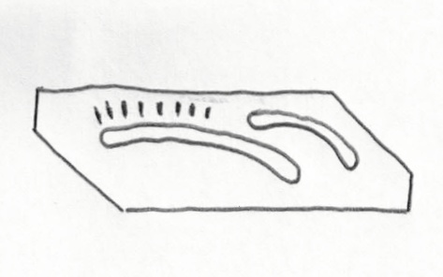

RON
60069789_0003
1 ST
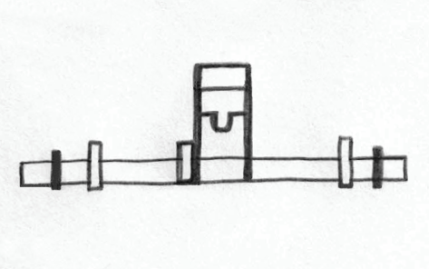

RON
60134355_0001
5 ST
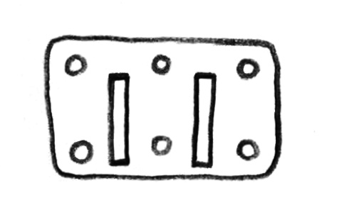

RON
60148666_0000
5 ST
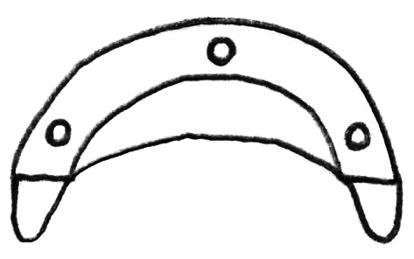

RON

60039098_0001
5 ST
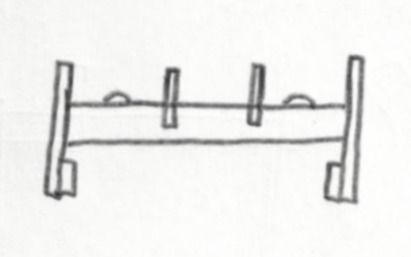

RON
60094638_0001
5 ST
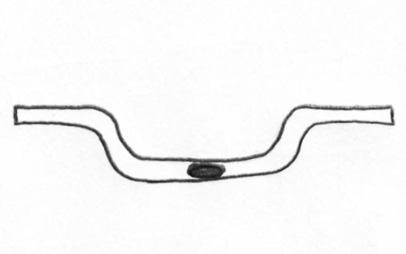

RON
28092200UB_B
1 ST
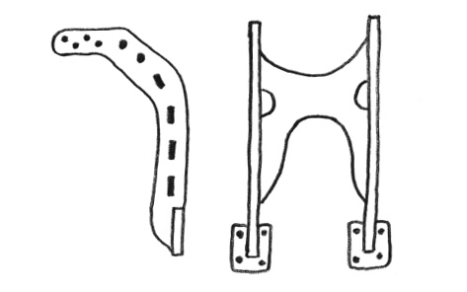

RON
28092500UB_A
1 ST
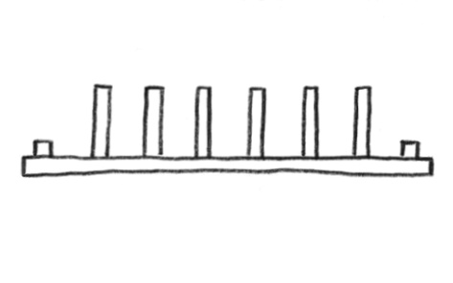

RON

28076600UB
2 ST
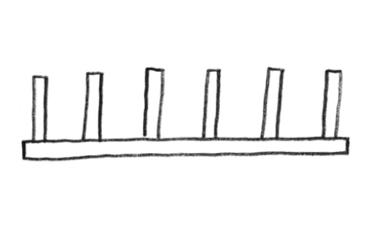

RON
60044145_0000
3 ST
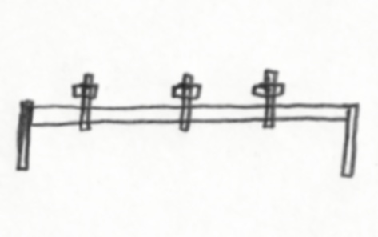

RON
28044500UB_A
1 ST
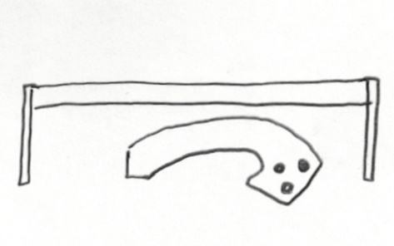

RON
ST

