Airlines

# Description of the project

The project implements the structure of airline companies. The main class company holds all their flights, planes, stewardesses, and pilots (crew members). Plane, flight, and crew member store company pointers to forbid assigning them to multiple airline companies.

Passengers, crew members and planes are stored in list outside any class, on the other hand flights are stored inside company they belong to in list. They are created and destroyed using function from company class, flight constructors are private.

Each flight consists of the plane, passenger, stewardess, pilots, company to which it belongs, and characteristic data for the flight: city of departure, arrival, and UTC of departure and arrival in milliseconds.

The class plane includes all of its flights, ID, name, company that belongs to, and parameters describing the plane, such as passengers, stewardesses, pilots capacity, and required number of stewardesses and pilots to operate the flight.

The next class is a person with ID, first and second name, birthday time (UTC in milliseconds), and gender. Class person is parent class for passenger and crew member classes.

The passenger class contains flights. The crew member class contains flights and the role of the crew member: pilot or stewardess. Separating these classes will allow the implementation of specific functions and parameters for these classes in the future.

# Case study

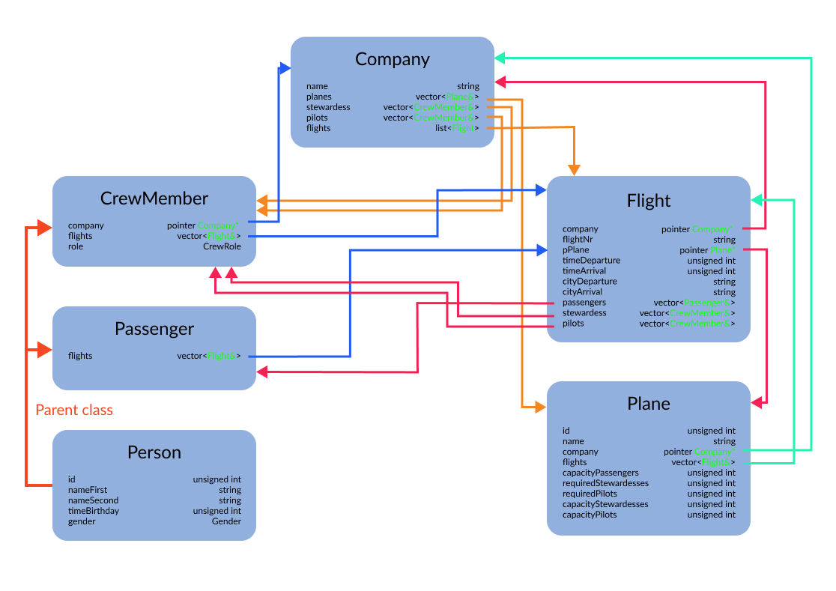

# Declaration of the classes

class Company {

   public:

    Company(std::string name);

    ~Company();

    void setName(std::string name);

    std::list<Flight>& getFlights();

    std::vector<std::reference_wrapper<Plane>>& getPlanes();

    std::vector<std::reference_wrapper<CrewMember>>& getStewardesses();

    std::vector<std::reference_wrapper<CrewMember>>& getPilots();

*// ADD PLANE TO COMPANY AND SET PLANE'S COMPANY*

    void addPlane(Plane& plane);

*// REMOVE PLANE FROM COMPANY AND REMOVES PLANE'S COMPANY*

    bool removePlane(Plane& plane);

    bool removePlanes();

*// ADD CREW MEMBER TO COMPANY AND SET CREW MEMBER'S COMPANY*

    void addCrewMember(CrewMember& crewMember);

*// REMOVE CREW MEMBER FROM COMPANY AND REMOVES CREW MEMBER'S COMPANY*

    bool removeCrewMember(CrewMember& crewMember);

    bool removeCrewMembers();

*// CRETE FLIGHT IN COMPANY*

    Flight& createFlight(std::string flightNr,

                         Plane& plane,

                         unsigned int timeDeparture,

                         unsigned int timeArrival,

                         std::string cityDeparture,

                         std::string cityArrival);

    Flight& createFlight(std::string flightNr,

                         unsigned int timeDeparture,

                         unsigned int timeArrival,

                         std::string cityDeparture,

                         std::string cityArrival);

*// REMOVE FLIGHT, DELETE FROM ALL CLASSES*

    bool removeFlight(Flight& flight);

    bool removeFlights();

   private:

    std::string name;

    std::list<Flight> flights;

    std::vector<std::reference_wrapper<Plane>> planes;

    std::vector<std::reference_wrapper<CrewMember>> stewardesses;

    std::vector<std::reference_wrapper<CrewMember>> pilots;

};

class Flight {

   public:

    ~Flight();

    Company*& getCompany();

    std::string getFlightNr() const;

    FlightStatus getStatus() const;

    Plane& getPlane() const;

    unsigned int getTimeDeparture() const;

    unsigned int getTimeArrival() const;

    std::string getCityDeparture() const;

    std::string getCityArrival() const;

    std::vector<std::reference_wrapper<Passenger>>& getPassengers();

    std::vector<std::reference_wrapper<CrewMember>>& getStewardesses();

    std::vector<std::reference_wrapper<CrewMember>>& getPilots();

    void setFlightNr(const std::string flightNr);

*// CHANGE PLANE FOR ANOTHER AND CHECK IF PASSENGERS, STEWARDESS, PILOTS ARE WITHIN RANGE*

    void setPlane(Plane& plane);

    bool removePlane();

*// CHANGE DATA TIME CALLED IN CONSTRUCTOR VALIDATING ARGUMENTS WITH THIS DATA PARAMETERS*

    void changeDataDeparture(const unsigned int time);

    void changeDataArrival(const unsigned int time);

    void changeDataDeparture(const unsigned int time, const std::string city);

    void changeDataArrival(const unsigned int time, const std::string city);

*// ADD PASSENGER TO FLIGHT,ADD FLIGHT TO PASSENGER*

    void addPassenger(Passenger& passenger);

*// REMOVE PASSENGER FROM FLIGHT, REMOVE FLIGHT FROM PASSENGER*

    bool removePassenger(Passenger& passenger);

    bool removePassengers();

*// ADD CREW MEMBER TO FLIGHT, ADD FLIGHT TO CREW MEMBER*

    void addCrewMember(CrewMember& crewMember);

*// REMOVE CREW MEMBER FROM FLIGHT, REMOVE FLIGHT FROM CREW MEMBER*

    bool removeCrewMember(CrewMember& crewMember);

    bool removeCrewMembers();

*// CHECK FOR FLIGHT TIME OVERLAP WITH TIME PERIOD*

    bool timeOverlap(const Flight& flight) const;

    bool timeOverlap(const unsigned int timeStart, const unsigned int timeEnd) const;

   private:

    Flight(

        Company* pCompany,

        std::string flightNr,

        Plane& plane,

        unsigned int timeDeparture,

        unsigned int timeArrival,

        std::string cityDeparture,

        std::string cityArrival);

    Flight(

        Company* pCompany,

        std::string flightNr,

        unsigned int timeDeparture,

        unsigned int timeArrival,

        std::string cityDeparture,

        std::string cityArrival);

    void setStatus();

    void setupCompany(Company* pCompany);

*// SET PLANE CALLED IN CONSTRUCTOR WITHOUT ANY CHECK ON CAPACITY LIMITS*

    void setupPlane(Plane& plane);

*// SET DATA TIME CALLED IN CONSTRUCTOR VALIDATING ARGUMENTS*

    void setDataTime(const unsigned int timeDeparture, const unsigned int timeArrival);

    void setDataTime(const unsigned int timeDeparture, const std::string cityDeparture, const unsigned int timeArrival, const std::string cityArrival);

    Company* pCompany;

    std::string flightNr;

    FlightStatus status;

    Plane* pPlane;

    unsigned int timeDeparture; *// time in miliseconds*

    unsigned int timeArrival; *// time in miliseconds*

    std::string cityDeparture;

    std::string cityArrival;

    std::vector<std::reference_wrapper<Passenger>> passengers;

    std::vector<std::reference_wrapper<CrewMember>> stewardesses;

    std::vector<std::reference_wrapper<CrewMember>> pilots;

    friend Company;

};

class Plane {

   public:

    static std::vector<unsigned int> usedIds;

    Plane(

        Company* pCompany,

        unsigned int id,

        std::string name,

        unsigned int capacityPassengers,

        unsigned int requiredStewardesses,

        unsigned int requiredPilots);

    Plane(

        unsigned int id,

        std::string name,

        unsigned int capacityPassengers,

        unsigned int requiredStewardesses,

        unsigned int requiredPilots);

    ~Plane();

    unsigned int getId() const;

    std::string getName() const;

    Company*& getCompany();

    std::vector<std::reference_wrapper<Flight>>& getFlights();

    unsigned int getCapacityPassengers() const;

    unsigned int getRequiredStewardesses() const;

    unsigned int getCapacityStewardesses() const;

    unsigned int getRequiredPilots() const;

    unsigned int getCapacityPilots() const;

    void setCompany(Company* pCompany);

    void changeId(const unsigned int id);

    void setName(const std::string name);

    void setCapacityPassengers(const unsigned int number);

    void setRequiredStewardesses(const unsigned int number);

    void setRequiredPilots(const unsigned int number);

    bool inRangePassengers(const unsigned int number) const;

    bool inRangeStewardesses(const unsigned int number) const;

    bool maximumStewardesses(const unsigned int number) const;

    bool inRangePilots(const unsigned int number) const;

    bool maximumPilots(const unsigned int number) const;

    bool inRangeCrew(const unsigned int stewardess, const unsigned int pilots) const;

*// INVOKE FUNCTION FROM FLIGHT TO ADD PLANE*

    void addFlight(Flight& flight);

*// INVOKE FUNCTION FROM FLIGHT TO REMOVE PLANE*

    bool removeFlight(Flight& flight);

*// INVOKE FOR ALL FLIGHTS FUNCTION removeFlight*

    bool removeFlights();

   private:

    void setId(const unsigned int id);

    unsigned int id;

    std::string name;

    Company* pCompany;

    std::vector<std::reference_wrapper<Flight>> flights;

    unsigned int capacityPassengers;

    unsigned int requiredStewardesses;

    unsigned int requiredPilots;

    unsigned int capacityStewardesses;

    unsigned int capacityPilots;

};

class Person {

   public:

    static std::vector<unsigned int> usedIds;

    Person(

        unsigned int id,

        std::string nameFirst,

        std::string nameSecond,

        unsigned int timeBirthday,

        Gender gender);

    ~Person();

    unsigned int getId() const;

    std::string getNameFirst() const;

    std::string getNameSecond() const;

    unsigned int getTimeBirthday() const;

    Gender getGender() const;

    void changeId(const unsigned int id);

    void setNameFirst(const std::string name);

    void setNameSecond(const std::string name);

    void setTimeBirthday(const unsigned int time);

   private:

    void setId(const unsigned int id);

    unsigned int id;

    std::string nameFirst;

    std::string nameSecond;

    unsigned int timeBirthday; *// time in miliseconds UTC*

    Gender gender;

};

class Passenger : public Person {

   public:

    Passenger(

        unsigned int id,

        std::string nameFirst,

        std::string nameSecond,

        unsigned int timeBirthday,

        Gender gender);

    ~Passenger();

    std::vector<std::reference_wrapper<Flight>>& getFlights();

*// INVOKE FUNCTION FROM FLIGHT TO ADD PASSENGER*

    void addFlight(Flight& flight);

*// INVOKE FUNCTION FROM FLIGHT TO REMOVE PASSENGER*

    bool removeFlight(Flight& flight);

*// INVOKE FOR ALL FLIGHTS FUNCTION removeFlight*

    bool removeFlights();

   private:

    std::vector<std::reference_wrapper<Flight>> flights;

};

class CrewMember : public Person {

   public:

    CrewMember(

        Company* pCompany,

        CrewRole role,

        unsigned int id,

        std::string nameFirst,

        std::string nameSecond,

        unsigned int timeBirthday,

        Gender gender);

    CrewMember(

        CrewRole role,

        unsigned int id,

        std::string nameFirst,

        std::string nameSecond,

        unsigned int timeBirthday,

        Gender gender);

    ~CrewMember();

    Company*& getCompany();

    std::vector<std::reference_wrapper<Flight>>& getFlights();

    CrewRole getRole() const;

*// INVOKE FUNCTION FROM COMPANY TO ADD CREW MEMBER*

    void setCompany(Company* pCompany);

*// INVOKE FUNCTION FROM FLIGHT TO ADD CREW MEMBER*

    void addFlight(Flight& flight);

*// INVOKE FUNCTION FROM FLIGHT TO REMOVE CREW MEMBER*

    bool removeFlight(Flight& flight);

*// INVOKE FOR ALL FLIGHTS FUNCTION removeFlight*

    bool removeFlights();

   private:

    Company* pCompany;

    std::vector<std::reference_wrapper<Flight>> flights;

    CrewRole role;

};