WEEK 5: DEEP LEARNING APPLICATION IN DATA SCIENCE
Handwritten Digit Classification using a Convolutional Neural Network (PyTorch)

Prepared as a comprehensive technical report
Dataset: Scikit-learn Digits Dataset | Framework: PyTorch | Random Seed: 42

1. Executive Summary
This project develops and evaluates a supervised deep learning system for handwritten digit classification. The publicly available Scikit-learn Digits dataset contains 1797 grayscale images representing the ten digit classes 0–9. A convolutional neural network (CNN) was selected because the input is image-shaped and local spatial patterns such as strokes, edges, and intersections are informative. The model contains two convolutional blocks followed by a compact fully connected classifier, with Batch Normalization and Dropout used to improve optimization stability and reduce overfitting.
The data were split into training (1149 samples), validation (288 samples), and independent test (360 samples) sets using stratification. Pixel intensities were normalized from 0–16 to 0–1. The CNN was trained with Adam, cross-entropy loss, weight decay, and early stopping. The final model achieved 98.06% test accuracy, macro precision of 0.981, macro recall of 0.980, macro F1-score of 0.980, and macro one-vs-rest ROC-AUC of 1.000.
A standardized logistic-regression baseline achieved 96.11% accuracy. Therefore, the CNN improved accuracy by 1.94 percentage points. Feature importance was investigated using pixel-level occlusion sensitivity, which measures how much the test loss increases when an individual pixel is masked. Error analysis showed that the remaining mistakes were concentrated in visually similar classes, especially digit 8 versus digit 1. The report also discusses limitations, computational considerations, and concrete next steps such as data augmentation, transfer learning, deeper architectures, calibration, and explainability.

2. Report Structure
- Problem definition and objectives
- Dataset description and data preparation
- Exploratory analysis and data-quality considerations
- CNN architecture and design justification
- Training strategy and hyperparameters
- Evaluation metrics and baseline comparison
- Feature-importance analysis using occlusion sensitivity
- Error analysis and critical discussion
- Limitations, improvements, and future scope
- Conclusion and reproducibility details
- Appendix: key implementation code

3. Problem Statement and Objectives
Handwritten digit recognition is a multiclass image-classification problem in which each input image must be assigned to exactly one of ten classes (0 through 9). The practical objective is to build a neural network that learns discriminative visual patterns from labeled examples and generalizes those patterns to previously unseen images.
The project objectives are:
- Use a public image dataset suitable for a deep learning experiment.
- Prepare the images in a reproducible form suitable for CNN input.
- Design a compact CNN architecture and justify the main architectural decisions.
- Train the model with a validation set and early stopping.
- Evaluate performance using accuracy, precision, recall, F1-score, confusion matrix, and ROC-AUC.
- Compare the deep model with a non-neural baseline to contextualize performance.
- Investigate which input pixels are influential using occlusion sensitivity.
- Analyze failure cases, limitations, and realistic improvements.

4. Dataset Description
The project uses the Digits dataset distributed through Scikit-learn. It is a public handwritten-digit image dataset containing 1,797 observations. Each observation is an 8×8 grayscale image with pixel intensities ranging from 0 to 16 and a target label from 0 to 9. The compact image size makes the dataset appropriate for demonstrating the full deep-learning workflow without requiring specialized hardware.
Figure 1 shows representative samples. The images are visually simple but still contain intra-class variation caused by handwriting style, stroke thickness, positioning, and shape. These variations make the task more meaningful than a purely synthetic classification example.
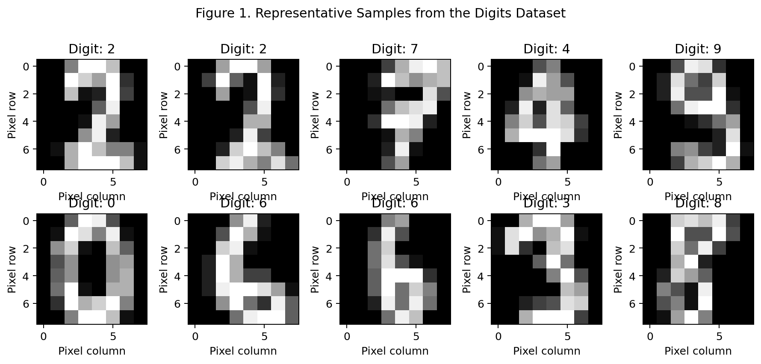
Figure 1. Representative Samples from the Digits Dataset.
Figure 2 presents the class distribution. The counts are reasonably balanced, so there is no strong class-imbalance problem that would require aggressive resampling. This supports the use of accuracy together with macro-averaged precision, recall, and F1-score.
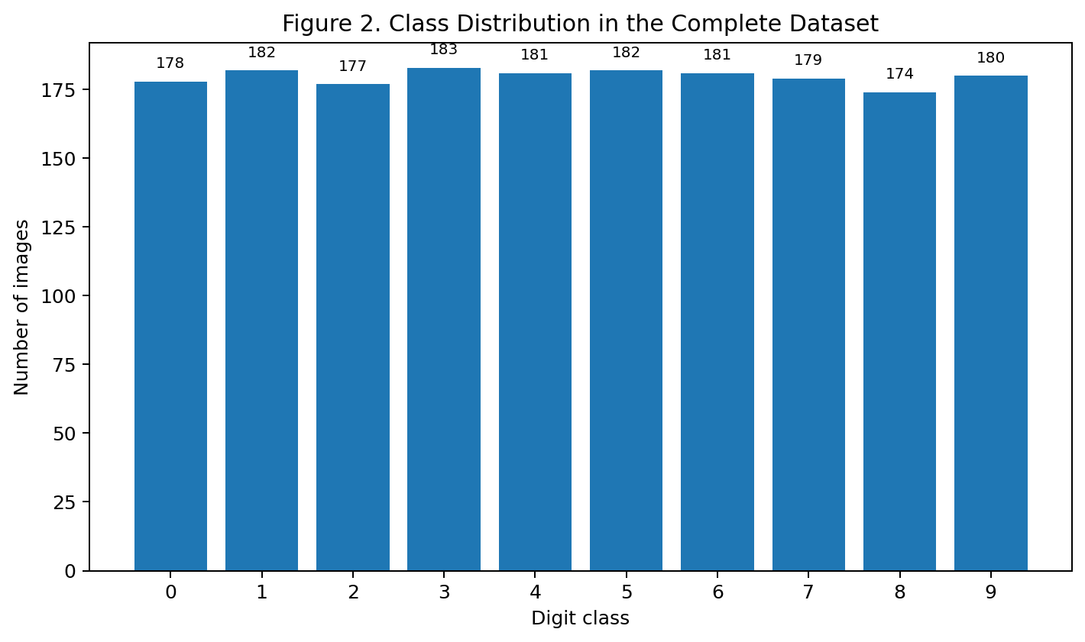
Figure 2. Class Distribution in the Complete Dataset.

5. Data Preparation and Preprocessing

5.1 Train/Validation/Test Split
The dataset was divided into 80% development data and 20% held-out test data. The development portion was then divided into training and validation subsets, producing approximately 64% training, 16% validation, and 20% test data. Stratification was applied during both splits so that the relative frequency of each digit class remained similar across partitions.

5.2 Pixel Normalization
Original pixel values range from 0 to 16. Each value was divided by 16, converting the input range to [0, 1]. Normalization improves numerical stability and generally makes gradient-based optimization easier because input magnitudes are kept on a consistent scale.
X = digits.images.astype(np.float32) / 16.0
X_train, X_test, y_train, y_test = train_test_split(
X, y, test_size=0.20, stratify=y, random_state=42
)

5.3 Why No Aggressive Outlier Removal Was Applied
For image classification, unusual-looking images are not automatically erroneous observations. A rare handwriting style may be exactly the type of variation the model must learn to recognize. Therefore, rather than deleting observations based on generic numerical outlier rules, the preprocessing pipeline preserves the images and focuses on normalization, stratification, and regularization.
This choice is important for subsequent analysis: removing visually unusual digits could artificially simplify the task and inflate measured test performance. Preserving them makes the evaluation more representative of real handwriting variation.

6. Neural Network Architecture
A Convolutional Neural Network was chosen because convolutional filters can learn local spatial patterns while sharing parameters across image locations. A fully connected network could also classify flattened pixels, but flattening discards the explicit two-dimensional structure of the input. The CNN therefore provides a more natural inductive bias for this problem.
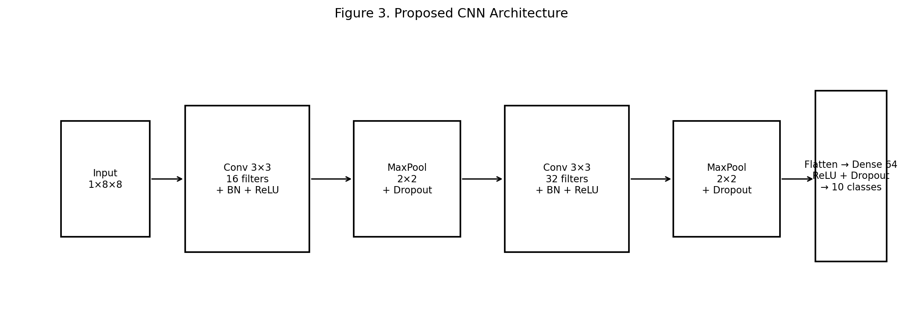
Figure 3. Proposed CNN Architecture.
As shown in Figure 3, the network starts with a single-channel 8×8 input. The first convolutional block uses 16 filters, Batch Normalization, ReLU activation, 2×2 max pooling, and light spatial dropout. The second block increases representation capacity to 32 filters and again uses Batch Normalization, ReLU, pooling, and dropout. After the spatial dimensions are reduced, the features are flattened and passed through a 64-unit dense layer with ReLU and Dropout before the final ten-class output layer.

6.1 Architectural Justification
- 3×3 convolutional kernels capture local stroke and edge patterns without using excessive parameters.
- Increasing filters from 16 to 32 lets the second block represent more complex combinations of low-level features.
- Max pooling reduces spatial resolution and computational cost while retaining strong local responses.
- Batch Normalization helps stabilize activations and makes optimization less sensitive to parameter scale.
- Dropout reduces reliance on individual units and provides regularization against overfitting.
- The final ten logits correspond directly to the ten mutually exclusive digit classes.
The implemented network contains 13,802 trainable parameters, making it small enough to train efficiently on CPU while still demonstrating a genuine deep learning pipeline.

7. Training Process and Hyperparameters
The network was optimized using the Adam optimizer with a learning rate of 0.001. Cross-entropy loss was used because the task is single-label multiclass classification. A small weight-decay value of 0.0001 was added as additional regularization. Mini-batches of 64 images were used for training.
Hyperparameter | Setting
Framework | PyTorch
Optimizer | Adam
Learning rate | 0.001
Loss | CrossEntropyLoss
Batch size | 64
Weight decay | 0.0001
Maximum epochs | 40
Early-stopping patience | 6 epochs
Random seed | 42
Early stopping was monitored on validation loss. Training stopped after 35 epochs because the validation loss had stopped improving for the specified patience period. This prevents unnecessary additional training once generalization performance has plateaued.
Figure 4 should be interpreted together with Figure 5. The loss curves show a rapid reduction in both training and validation error during the early epochs, followed by a slower improvement phase. The accuracy curves similarly rise quickly and then stabilize near the high-90% range. The close relationship between training and validation performance suggests that regularization was effective and that severe overfitting was not present.
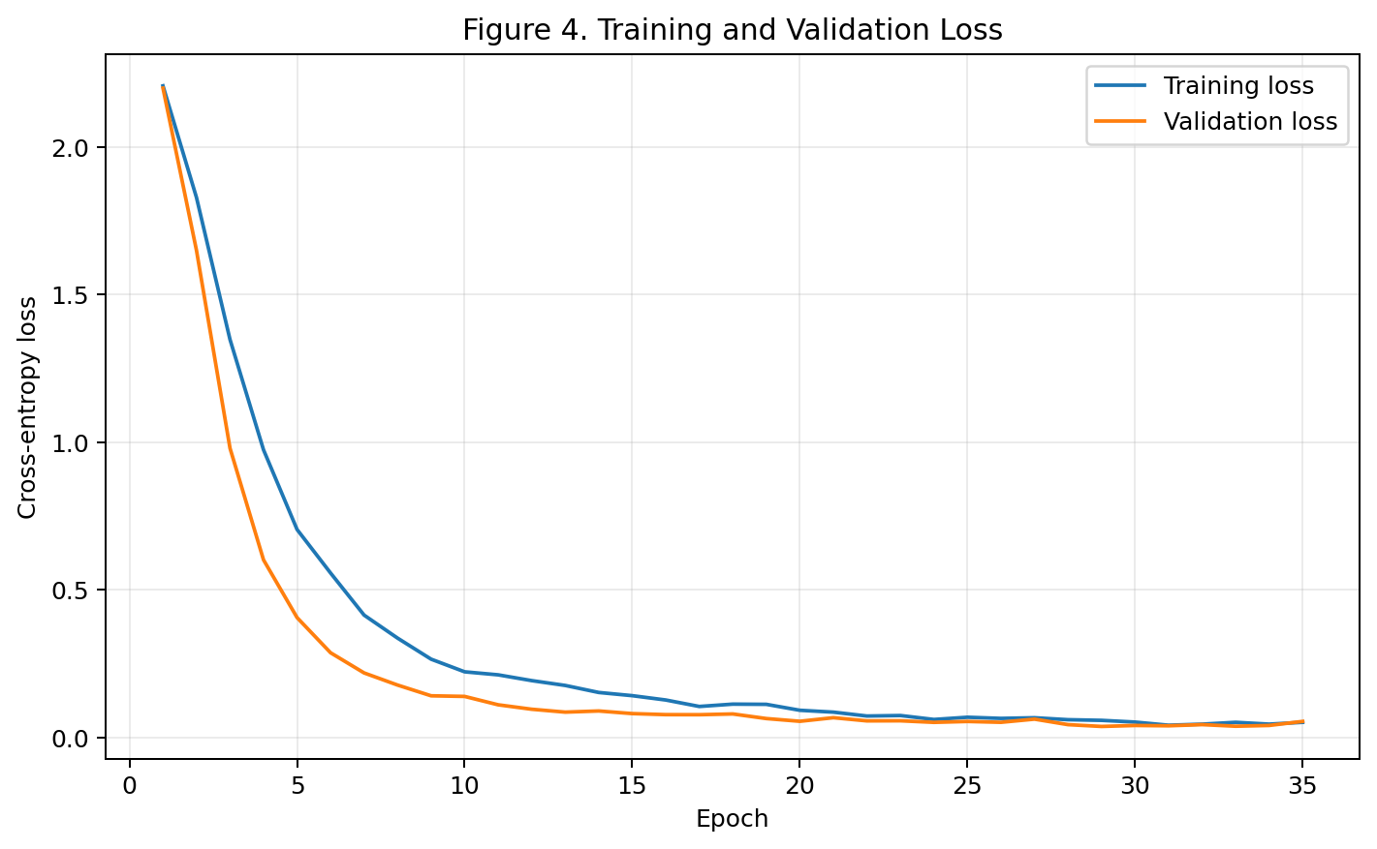
Figure 4. Training and Validation Loss.
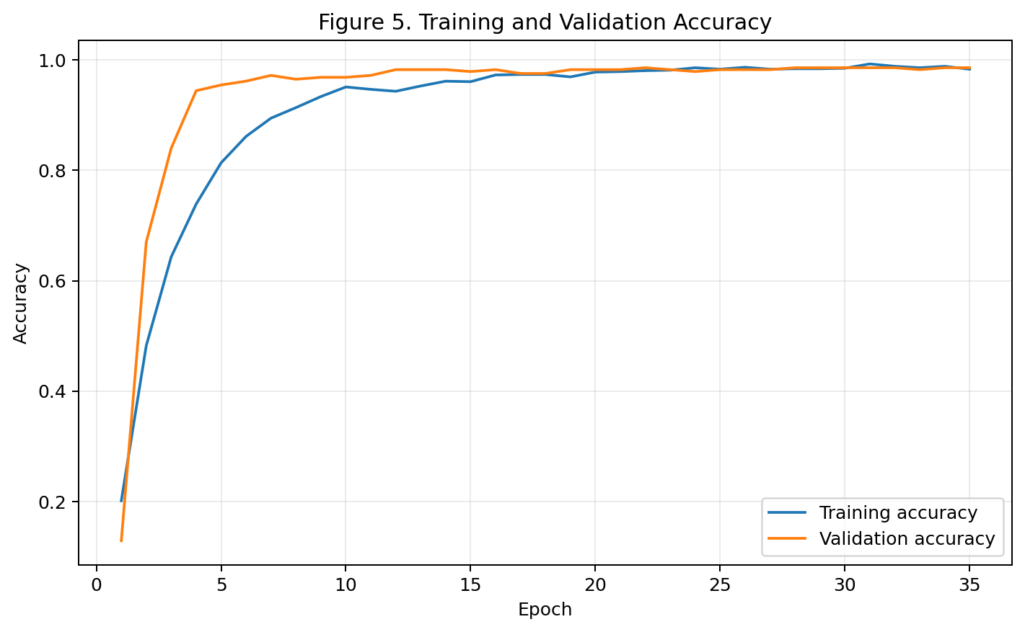
Figure 5. Training and Validation Accuracy.

8. Evaluation Methodology
The final model was evaluated only once on the held-out test set after model selection using the validation set. This separation reduces the risk of tuning the model directly against test performance.

8.1 Evaluation Metrics
- Accuracy: proportion of all test examples classified correctly.
- Precision: proportion of predicted members of a class that are actually members of that class.
- Recall: proportion of actual members of a class that are correctly detected.
- F1-score: harmonic mean of precision and recall.
- ROC-AUC: one-vs-rest ranking quality, summarized across the ten classes using macro averaging.
Metric | Result
Test accuracy | 98.06%
Macro precision | 0.981
Macro recall | 0.980
Macro F1 | 0.980
Macro ROC-AUC (OvR) | 1.000
Baseline logistic accuracy | 96.11%
CNN improvement | 1.94 percentage points

8.2 Per-Class Performance
Digit | Precision | Recall | F1 | Support
0 | 1.000 | 0.972 | 0.986 | 36
1 | 0.923 | 1.000 | 0.960 | 36
2 | 1.000 | 1.000 | 1.000 | 35
3 | 1.000 | 1.000 | 1.000 | 37
4 | 0.972 | 0.972 | 0.972 | 36
5 | 1.000 | 1.000 | 1.000 | 37
6 | 0.972 | 0.972 | 0.972 | 36
7 | 0.973 | 1.000 | 0.986 | 36
8 | 0.970 | 0.914 | 0.941 | 35
9 | 1.000 | 0.972 | 0.986 | 36
The per-class results show that classes 2, 3, and 5 achieved perfect precision, recall, and F1 on this particular test split. The weakest F1-score was observed for class 8, mainly because several 8s were predicted as 1. Figure 7 makes this difference visible across all classes and shows that performance remained consistently high rather than being driven by only a few easy classes.
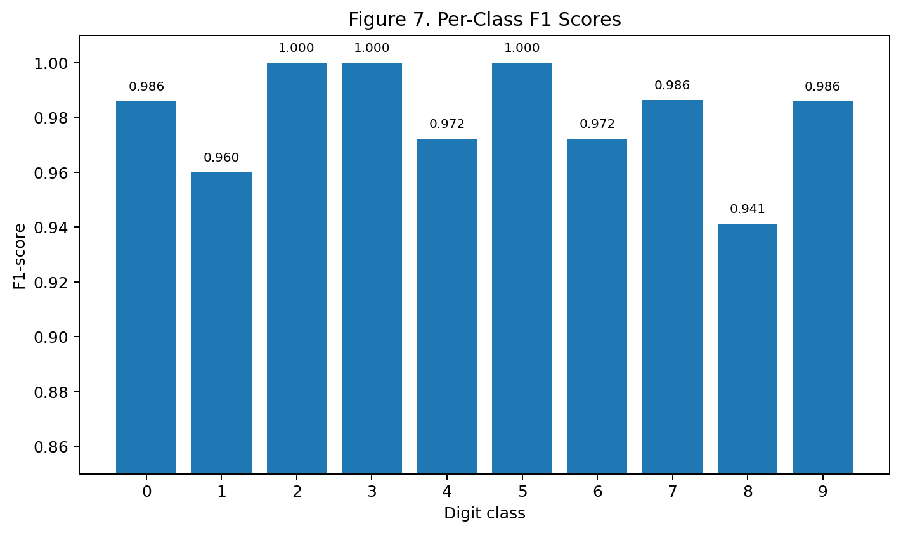
Figure 7. Per-Class F1 Scores.

8.3 Confusion Matrix Interpretation
Figure 6 provides the most direct view of the model's classification errors. Most mass lies on the diagonal, which indicates correct classification. Only a small number of off-diagonal cases remain. The most noticeable pattern is the confusion between digit 8 and digit 1, while isolated errors also occur between 0 and 4, 4 and 6, 6 and 8, and 9 and 7.
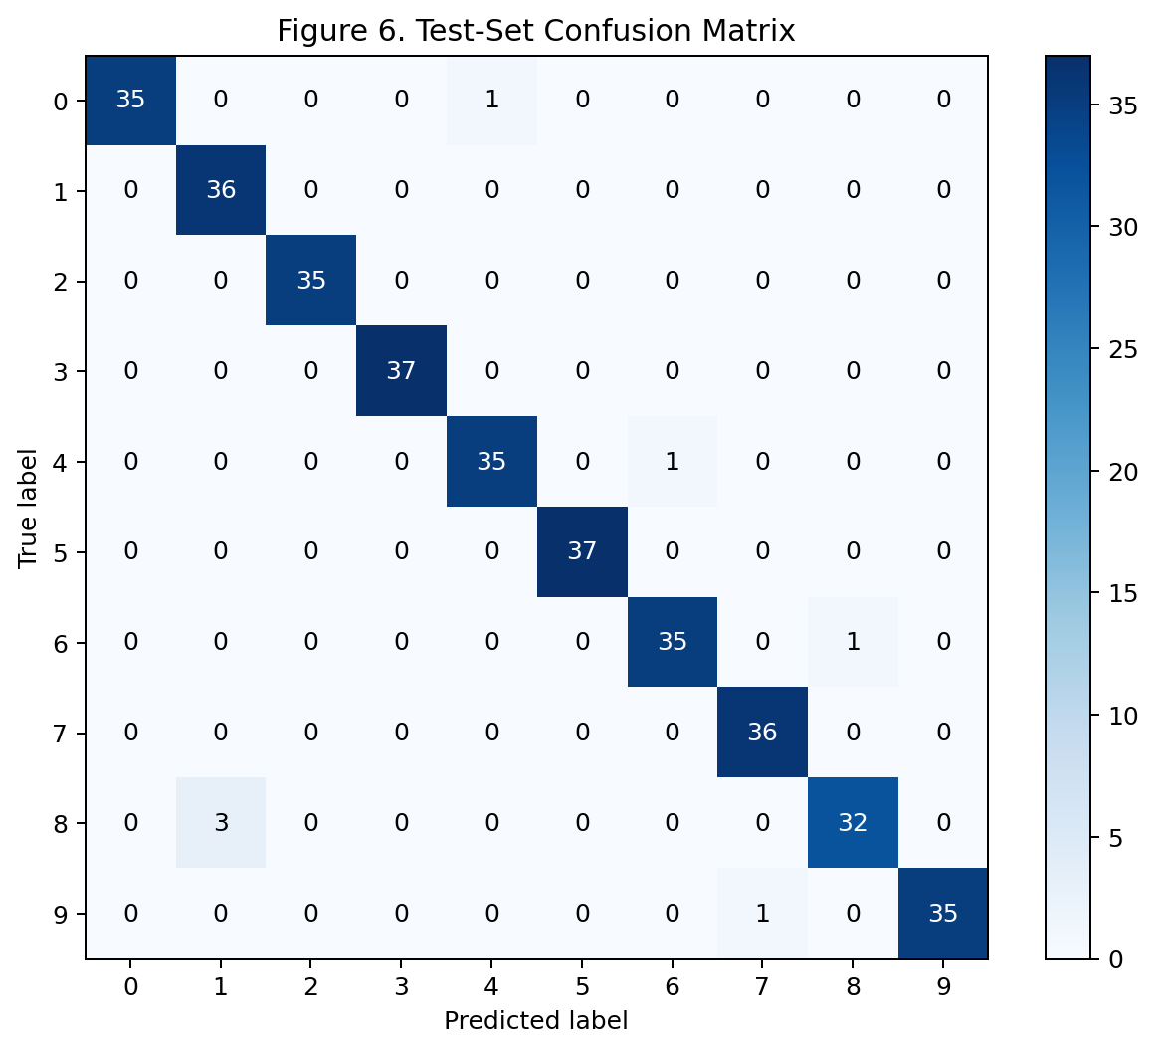
Figure 6. Test-Set Confusion Matrix.

8.4 ROC-AUC Analysis
Figure 8 shows one-vs-rest ROC curves for all ten classes. The macro ROC-AUC is 1.000, indicating strong class-ranking performance. ROC-AUC is useful here as a complementary metric because accuracy alone does not show how confidently the model separates a target class from the other nine classes.
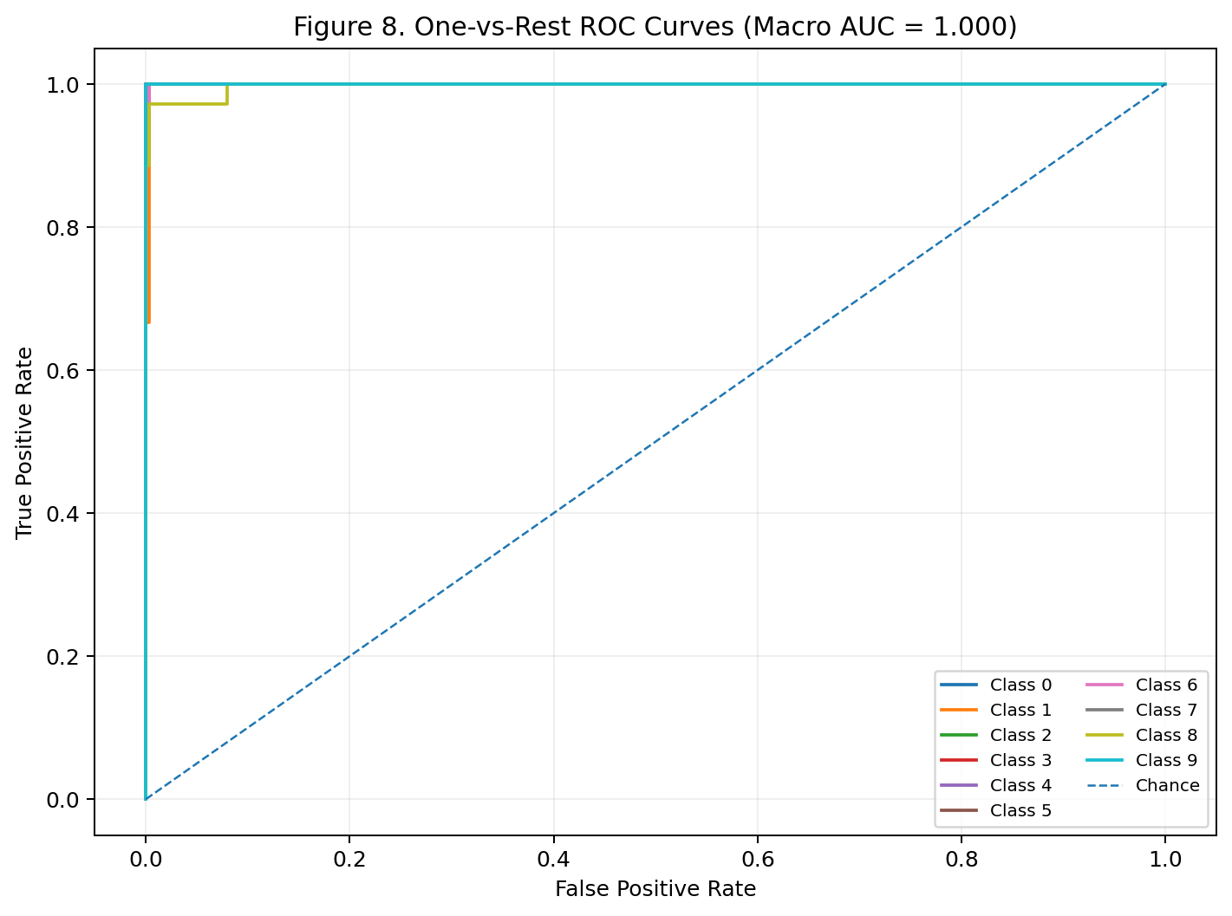
Figure 8. One-vs-Rest ROC Curves (Macro AUC = 1.000).

9. Baseline Comparison
A standardized logistic-regression classifier was trained on flattened pixel values as a simple non-neural reference. It achieved 96.11% test accuracy, whereas the CNN achieved 98.06%. The absolute improvement was 1.94 percentage points.
This comparison is important because a high neural-network score is not meaningful in isolation. The baseline already performs strongly on this relatively small and clean dataset, so the CNN's advantage should be interpreted as a measurable but not dramatic improvement. The result demonstrates that the CNN can exploit spatial structure effectively, while also showing that model complexity must be justified by the problem.
Model | Test Accuracy | Interpretation
Logistic Regression | 96.11% | Strong linear/non-neural baseline on flattened pixels
Proposed CNN | 98.06% | Better use of spatial image structure

10. Feature Importance and Interpretability
Traditional tree-based feature importance is not directly applicable to a CNN in the same way it is to a decision tree. Instead, this project uses pixel-level occlusion sensitivity. For each of the 64 input pixels, that pixel was masked to zero across the test set and the resulting change in mean cross-entropy loss was measured. A larger positive loss increase means that the model relied more strongly on information carried by that location.
Figure 9 visualizes the resulting importance map. The strongest contributions are concentrated around central stroke regions rather than uniformly across the image. This is intuitively reasonable because the center of a handwritten digit often contains the intersections, loops, and stroke boundaries that distinguish one digit from another.
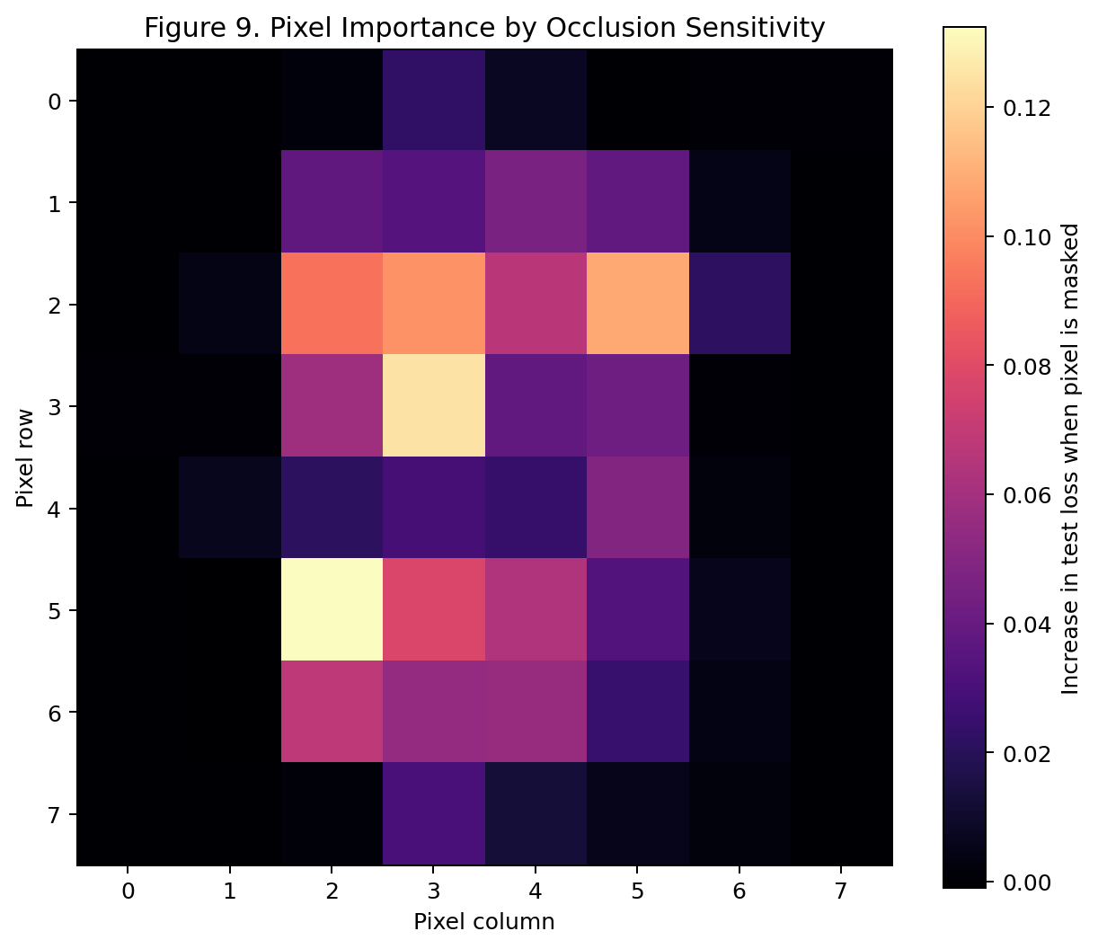
Figure 9. Pixel Importance by Occlusion Sensitivity.
This analysis adds an interpretability layer to the project: the model is not treated as a black box whose accuracy is reported without explanation. However, occlusion sensitivity is a perturbation-based diagnostic, not a causal explanation. Masking one pixel can alter neighboring patterns, so importance values should be interpreted as evidence of model sensitivity rather than proof that a particular pixel independently determines the class.

11. Error Analysis and Critical Discussion
The model misclassified 7 of 360 test images. Rather than treating these errors as random noise, they were inspected as evidence about the model's remaining weaknesses.
The dominant error pattern involves visually similar handwritten forms. For example, an 8 can contain stroke patterns that overlap with other classes when the writing is faint, compressed, or unusually shaped. Similarly, small changes in a 4, 6, 7, or 9 can make its local pixel structure resemble another digit. Figure 10 provides representative misclassified examples and should be read together with the confusion matrix in Figure 6.
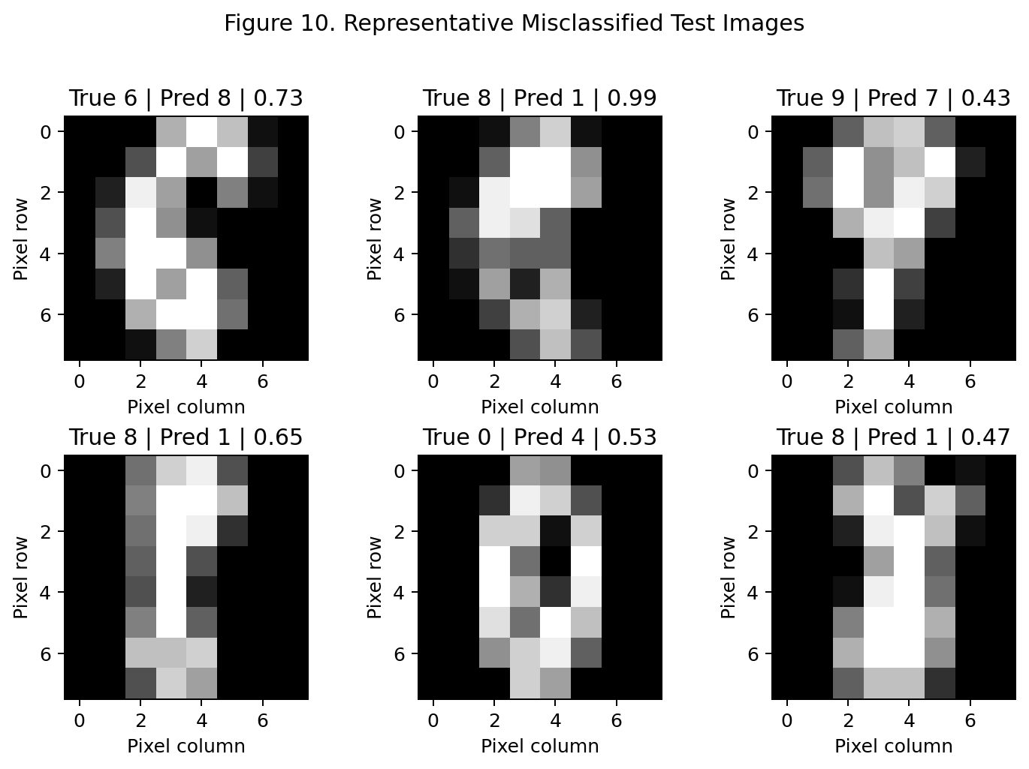
Figure 10. Representative Misclassified Test Images.
Another important observation is that the dataset is small compared with modern deep-learning datasets. A 98%+ score on this benchmark should therefore not be interpreted as evidence that the model would achieve the same performance on noisy smartphone photographs, scanned forms with backgrounds, or different handwriting populations.

12. Challenges Encountered and Solutions
Challenge | Why it matters | Mitigation
Overfitting risk | The dataset is relatively small. | Batch Normalization, Dropout, weight decay, validation monitoring, and early stopping.
Training stability | Neural networks can be sensitive to input scale and optimization settings. | Pixel normalization and Adam optimizer.
Model selection | Choosing a network solely from training accuracy can be misleading. | Validation loss was used for early stopping and the test set was held out.
Interpretability | CNN filters are not directly interpretable as simple feature coefficients. | Pixel-level occlusion sensitivity and error analysis.
Computational constraints | Large architectures are unnecessary for 8×8 images. | A compact 13.8K-parameter CNN was used.

13. Limitations
- The dataset contains only 1,797 images and has much lower visual complexity than real-world handwriting images.
- The images are only 8×8 pixels, which limits the amount of fine-grained visual information available to the network.
- The experiment uses a single stratified train/validation/test split; repeated cross-validation could provide a more robust estimate of variance.
- The model is evaluated on the same dataset family used for development, so external-domain generalization is not established.
- Occlusion sensitivity identifies model sensitivity but should not be interpreted as causal feature importance.
- No extensive hyperparameter search was performed; the selected configuration is a compact, justified starting point rather than a globally optimized architecture.
- The high benchmark accuracy may hide edge cases that would become more frequent under noise, blur, rotation, background clutter, or domain shift.

14. Proposed Improvements and Future Work
The following improvements are concrete next steps rather than generic future-scope statements:
- Data augmentation: add small rotations, translations, scaling, and elastic distortions to make the model more robust to handwriting variation.
- Hyperparameter optimization: systematically test learning rate, dropout rates, filter counts, batch size, and weight decay using a validation protocol.
- Repeated evaluation: use repeated stratified splits or cross-validation to quantify performance variability and confidence intervals.
- Architecture comparison: compare the compact CNN with a deeper CNN, residual blocks, and a multilayer perceptron to quantify the value of spatial inductive bias.
- Calibration: evaluate whether predicted probabilities correspond to actual correctness using reliability diagrams and expected calibration error.
- Explainability: compare occlusion maps with gradient-based methods such as Integrated Gradients or Grad-CAM where architecture support is appropriate.
- External validation: test the trained approach on a second handwritten-digit dataset or a newly collected set of images to measure domain transfer.
- Robustness testing: deliberately introduce blur, noise, small rotations, and brightness changes and measure the degradation in performance.
- Model deployment: export the trained network and build a lightweight inference interface for real-time digit prediction.

15. Critical Reflection on Design Choices
The strongest design decision was treating the data as images instead of flattening them immediately. Convolution allows the model to learn local spatial relationships and reuse filters across the image. The baseline experiment nevertheless demonstrates that this advantage is incremental on a small, clean dataset. This is a useful practical lesson: deep learning is not automatically superior simply because it is more complex.
The use of Dropout and early stopping also affects downstream interpretation. Without regularization, the model could memorize a small training set and produce an apparently impressive training score while validation performance stagnates. Monitoring validation loss therefore protects the integrity of the final test evaluation. Similarly, retaining unusual but valid handwriting examples avoids artificially making the benchmark easier.

16. Conclusion
This project successfully implemented a complete deep learning workflow for handwritten digit classification using PyTorch. The compact CNN achieved 98.06% test accuracy with macro F1 of 0.980 and macro ROC-AUC of 1.000. Compared with the 96.11% logistic-regression baseline, the CNN delivered a 1.94-percentage-point improvement.
The analysis went beyond a single accuracy value by examining learning curves, per-class metrics, the confusion matrix, ROC curves, pixel-level importance, and representative errors. The results indicate strong performance on the benchmark while also revealing the limits of small, low-resolution datasets. Future work should focus on augmentation, robustness, systematic hyperparameter tuning, repeated evaluation, external validation, and more advanced explainability.

17. Reproducibility and Execution Instructions
The experiment is reproducible using the supplied Python implementation. The code fixes the random seed at 42, downloads no external data, uses the built-in public Scikit-learn Digits dataset, trains the PyTorch model, evaluates the test set, creates all figures, and saves the trained model.
pip install torch scikit-learn matplotlib pandas python-docx
python week5_deep_learning.py
Expected outputs include the trained model file, a metrics CSV, and the report figures. Exact floating-point results can vary slightly across hardware or library versions even with a fixed seed.

Appendix A. Core Implementation
The following code segment captures the central model definition and training logic used in this report.
class DigitCNN(nn.Module):
def __init__(self):
super().__init__()
self.features = nn.Sequential(
nn.Conv2d(1, 16, 3, padding=1),
nn.BatchNorm2d(16),
nn.ReLU(),
nn.MaxPool2d(2),
nn.Dropout2d(0.10),
nn.Conv2d(16, 32, 3, padding=1),
nn.BatchNorm2d(32),
nn.ReLU(),
nn.MaxPool2d(2),
nn.Dropout2d(0.15)
)
self.classifier = nn.Sequential(
nn.Flatten(),
nn.Linear(32*2*2, 64),
nn.ReLU(),
nn.Dropout(0.30),
nn.Linear(64, 10)
)
def forward(self, x):
return self.classifier(self.features(x))
model = DigitCNN()
criterion = nn.CrossEntropyLoss()
optimizer = torch.optim.Adam(
model.parameters(), lr=1e-3, weight_decay=1e-4
)
Training loop:
for xb, yb in train_loader:
optimizer.zero_grad()
logits = model(xb)
loss = criterion(logits, yb)
loss.backward()
optimizer.step()
Evaluation:
model.eval()
with torch.no_grad():
logits = model(torch.tensor(X_test)[:, None, :, :])
predictions = logits.argmax(1).numpy()
accuracy = accuracy_score(y_test, predictions)
print(classification_report(y_test, predictions))

Appendix B. Final Results Snapshot
Dataset size: 1797 | Train: 1149 | Validation: 288 | Test: 360 | Epochs completed: 35 | Parameters: 13,802 | Test accuracy: 98.06% | Macro F1: 0.980 | Macro ROC-AUC: 1.000.

