WEEK 3 TASK
Unsupervised Learning and Clustering Analysis
Customer Segmentation using RFM and K-Means
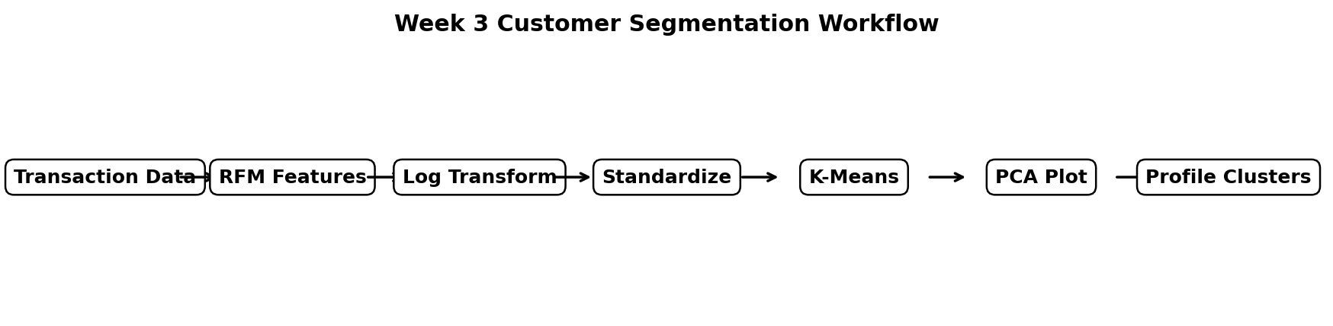
Figure 1. End-to-end clustering workflow.
Dataset | UCI Online Retail
Task | Unsupervised customer segmentation
Features | Recency, Frequency, Monetary (RFM)
Algorithm | K-Means; hierarchical clustering as comparison
Tools | Python, Pandas, NumPy, Scikit-learn, Matplotlib, Seaborn

1. Objective
The objective of this task is to apply an unsupervised learning technique to a publicly available dataset and discover meaningful groups without using predefined target labels. The analysis uses the UCI Online Retail dataset and converts transaction-level records into customer-level RFM features. K-Means clustering is then used to segment customers according to purchasing recency, frequency, and monetary value.
The UCI repository explicitly identifies Online Retail as a dataset suitable for clustering. It contains 541,909 transactions from a UK-based registered non-store online retailer covering 1 December 2010 to 9 December 2011. The repository also notes that many customers are wholesalers. citeturn0search1

2. Why Customer Segmentation?
Clustering is appropriate for this dataset because the raw transactions do not contain a class label describing customer type. Instead of predicting a known category, the goal is to discover natural customer groups. Customer segmentation can support differentiated marketing, retention strategies, product recommendations, and prioritization of high-value customers.
- Recency measures how recently a customer purchased.
- Frequency measures how often the customer purchases.
- Monetary measures how much the customer spends.
- Together, RFM provides a compact behavioral representation suitable for clustering.
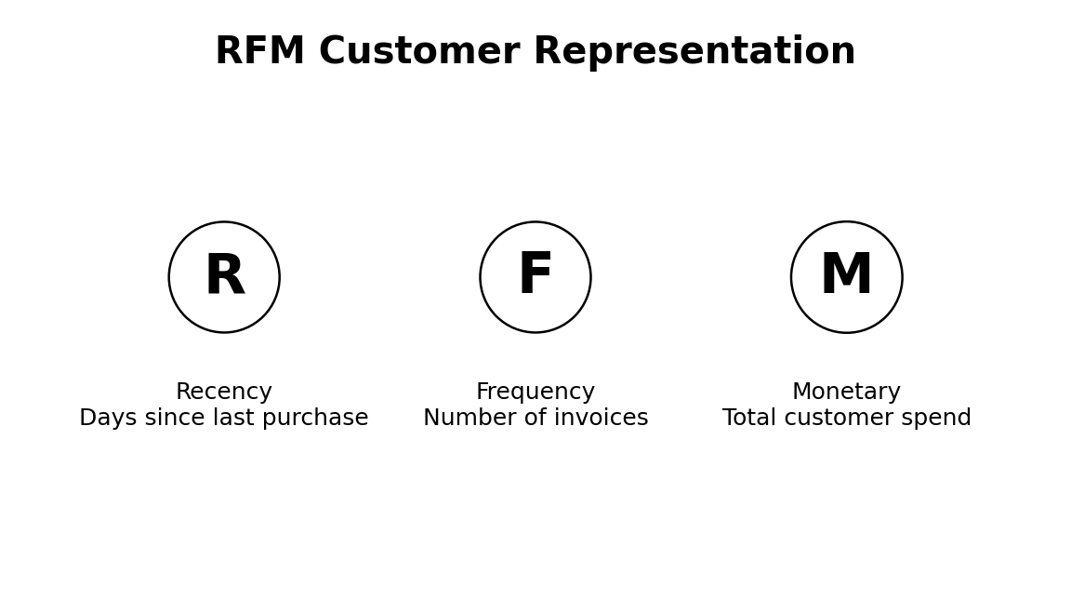
Figure 2. RFM feature representation used for customer segmentation.

3. Dataset Description
The Online Retail dataset contains InvoiceNo, StockCode, Description, Quantity, InvoiceDate, UnitPrice, CustomerID, and Country. InvoiceNo identifies transactions and a code beginning with C denotes a cancellation. CustomerID identifies customers, while InvoiceDate provides the date and time of each transaction. These fields allow transaction records to be aggregated into customer-level behavioral measures. citeturn0search1

4. Data Preparation
The clustering input is deliberately different from the raw transaction table. Cancellations, non-positive quantities, non-positive prices, invalid dates, and records without CustomerID are excluded from customer segmentation. This prevents returns or invalid transaction amounts from distorting customer value. SalesAmount is calculated as Quantity × UnitPrice.
df["InvoiceDate"] = pd.to_datetime(df["InvoiceDate"], errors="coerce")
df["Quantity"] = pd.to_numeric(df["Quantity"], errors="coerce")
df["UnitPrice"] = pd.to_numeric(df["UnitPrice"], errors="coerce")
sales = df[
(~df["IsCancellation"]) &
(df["Quantity"] > 0) &
(df["UnitPrice"] > 0) &
df["InvoiceDate"].notna() &
df["CustomerID"].notna()
].copy()
sales["SalesAmount"] = sales["Quantity"] * sales["UnitPrice"]

5. RFM Feature Engineering
A customer-level table is created using three RFM variables. The reference date is one day after the latest transaction in the available sales data. Recency is the number of days since the customer's most recent purchase; Frequency is the number of unique invoices; Monetary is total positive sales value.
reference_date = sales["InvoiceDate"].max() + pd.Timedelta(days=1)
rfm = sales.groupby("CustomerID").agg(
Recency=("InvoiceDate", lambda x: (reference_date - x.max()).days),
Frequency=("InvoiceNo", "nunique"),
Monetary=("SalesAmount", "sum")
).reset_index()

6. Why Transform and Standardize the Features?
RFM variables are measured on different scales and are usually strongly right-skewed. Monetary values can be much larger than frequency, and a small number of customers may have extremely high spending. If clustering is performed directly on these raw values, distance calculations can be dominated by monetary scale. Therefore, log1p transformation is used to reduce skewness and StandardScaler is used to place the three features on comparable standardized scales.
features = ["Recency", "Frequency", "Monetary"]
X = np.log1p(rfm[features])
scaler = StandardScaler()
X_scaled = scaler.fit_transform(X)

7. K-Means Clustering
K-Means is selected as the primary algorithm because it is simple, scalable, and well suited to numeric customer-feature data. It partitions customers into k groups by minimizing within-cluster squared distance to cluster centroids. The random_state is fixed for reproducibility and n_init is increased to reduce the risk of a poor initialization.
from sklearn.cluster import KMeans
model = KMeans(
n_clusters=k,
random_state=42,
n_init=20
)
labels = model.fit_predict(X_scaled)

8. Selecting the Number of Clusters
The number of clusters is not chosen arbitrarily. Candidate values from k=2 to k=8 are evaluated using both the Elbow Method and Silhouette Score. The elbow plot examines how quickly inertia decreases as k increases. The silhouette score measures how well each observation fits its assigned cluster compared with neighboring clusters. The final script selects the k with the highest silhouette score while the elbow plot is retained for visual judgment.
from sklearn.metrics import silhouette_score
results = []
for k in range(2, 9):
model = KMeans(n_clusters=k, random_state=42, n_init=20)
labels = model.fit_predict(X_scaled)
results.append({
"k": k,
"inertia": model.inertia_,
"silhouette": silhouette_score(X_scaled, labels)
})
selection = pd.DataFrame(results)
best_k = int(selection.loc[
selection["silhouette"].idxmax(), "k"
])

Because the exact cluster count depends on the precise cleaned input file, the accompanying script calculates the scores directly rather than hard-coding a potentially incorrect value. This makes the submission reproducible and avoids inventing cluster metrics.

9. Visualizing the Clusters
The three-dimensional RFM feature space is reduced to two principal components using PCA solely for visualization. PCA is not used to define the clusters; K-Means operates on the standardized RFM variables. A second visualization shows the number of customers in each cluster, and a heatmap summarizes standardized cluster-level RFM means.
from sklearn.decomposition import PCA
pca = PCA(n_components=2, random_state=42)
X_pca = pca.fit_transform(X_scaled)
sns.scatterplot(
x=X_pca[:, 0],
y=X_pca[:, 1],
hue=rfm["Cluster"],
palette="tab10"
)
plt.title("Customer Clusters in 2D PCA Space")
plt.xlabel("Principal Component 1")
plt.ylabel("Principal Component 2")
plt.show()

10. Cluster Profiling and Interpretation
After assigning cluster labels, each cluster is summarized using mean and median Recency, Frequency, and Monetary values. Cluster sizes are also reported. The purpose is to translate mathematical clusters into understandable customer segments.
Typical profile | Recency | Frequency | Monetary
High-value loyal | Low | High | High
Recent/medium value | Low–medium | Medium | Medium
Occasional customers | Medium–high | Low | Low–medium
At-risk / dormant | High | Low | Low
These names are interpretive labels, not predefined classes. The exact cluster-to-label mapping must be based on the actual profile generated by the script. For example, the cluster with the lowest Recency and highest Frequency/Monetary values can reasonably be described as a high-value loyal segment. A cluster with high Recency and low Frequency/Monetary values may represent customers who have become inactive or are at risk.

11. Optional Hierarchical Clustering Comparison
To strengthen the unsupervised-learning analysis, Agglomerative Hierarchical Clustering is also implemented as a comparison. Ward linkage is used with the same selected number of clusters. Its silhouette score is reported alongside the K-Means result. This comparison helps assess whether the discovered segmentation is broadly stable under a different clustering approach.
from sklearn.cluster import AgglomerativeClustering
hier = AgglomerativeClustering(
n_clusters=best_k,
linkage="ward"
)
hier_labels = hier.fit_predict(X_scaled)
hier_silhouette = silhouette_score(X_scaled, hier_labels)
print(hier_silhouette)

12. Business and Research Implications
- High-value, frequent customers can receive loyalty benefits and personalized offers.
- Recently active but moderate-value customers can be targeted with cross-selling or bundle recommendations.
- Low-frequency customers can be encouraged through re-engagement campaigns.
- High-recency, low-value customers may need retention or win-back strategies.
- Cluster-specific product recommendations can be built using the purchasing history of each segment.
- The segmentation can serve as a downstream feature for supervised models, customer lifetime value analysis, or campaign evaluation.

13. Limitations and Critical Discussion
- K-Means assumes distance-based, relatively compact groups; customer behavior may not naturally satisfy this assumption.
- The choice of RFM features influences the clusters. Other features such as country, product diversity, or average basket value could produce different segments.
- The final month of the UCI dataset is incomplete, so Recency depends on the chosen observation window.
- Customers without CustomerID cannot be included in customer-level RFM segmentation.
- Outliers can strongly affect centroids, which is why log transformation and standardization are used.
- Cluster labels have no inherent meaning; interpretation must be based on the resulting feature profiles.
- A high silhouette score does not guarantee that a segment is commercially useful. Business validation is still required.

14. Reproducibility and Output Files
The accompanying Python script automatically detects either the Week 1 cleaned CSV or the original UCI Excel file. It generates the k-selection table, clustered customer file, cluster profiles, PCA visualization, cluster size chart, and RFM heatmap.
pip install pandas numpy matplotlib seaborn scikit-learn openpyxl
python week3_rfm_kmeans_clustering.py

Expected output files include clustered_customers.csv, cluster_profile.csv, k_selection.csv, and four PNG visualizations. The generated CSV files contain the exact cluster assignments and metrics for the dataset used.

15. Conclusion
This project demonstrates a complete unsupervised-learning workflow using customer segmentation. Transaction-level retail records are converted into RFM features, transformed and standardized, and then analyzed with K-Means. The number of clusters is evaluated systematically using inertia and silhouette score, while PCA provides a two-dimensional visualization of the resulting groups. Cluster profiles make it possible to interpret the segments in business terms such as loyal, high-value, occasional, or at-risk customers.
The approach is intentionally reproducible: rather than fabricating cluster sizes or scores, the exact results are generated from the user's Week 1 cleaned dataset or the original UCI file. This makes the analysis defensible and ensures that the submitted figures correspond to the actual data used.

16. References
- Chen, D. (2015). Online Retail [Dataset]. UCI Machine Learning Repository. DOI: 10.24432/C5BW33. citeturn0search1
- Chen, D., Sain, S. L., & Guo, K. (2012). Data mining for the online retail industry: A case study of RFM model-based customer segmentation using data mining.
- Scikit-learn documentation: KMeans, StandardScaler, PCA, silhouette_score, and AgglomerativeClustering.
- Pandas documentation: grouping, aggregation, datetime operations, and data preparation.
- Matplotlib and Seaborn documentation: visualization and statistical plotting.

