WEEK 4 TASK
Supervised Learning Model Implementation
High-Value Customer Classification Using Random Forest
Dataset: UCI Online Retail | Original records: 541,909 | Customer records used: 4,338
High-value threshold (75th percentile Monetary): 1661.74

1. Introduction
This report implements a supervised learning model on the uploaded UCI Online Retail Excel dataset. The objective is to classify customers into High-Value and Other groups using historical purchasing behaviour. The model used is a Random Forest classifier.

2. Dataset and Preparation
The uploaded workbook contains 541,909 transaction records and 8 columns. After excluding cancellation invoices, missing CustomerID records, non-positive quantities/prices and invalid dates, 397,884 positive-sales transaction rows remained. These were aggregated into 4,338 customer records.

3. Feature Engineering
Customer-level features were created using Recency, Frequency, Monetary, Average Order Value, Average Quantity, Average Unit Price and Country. Monetary was used only to define the target and was deliberately excluded from the predictors to prevent target leakage.

4. Target Definition
The High-Value class was defined as customers with Monetary value at or above the 75th percentile. The calculated threshold was 1661.74. This produced 1,085 High-Value customers and 3,253 Other customers.

5. Model
A Random Forest Classifier with 300 trees, minimum leaf size 2, balanced class weights and random_state=42 was trained. Country was one-hot encoded while numerical predictors were passed directly to the tree model.

6. Train-Test Split and Cross-Validation
The customer records were split into 80% training and 20% testing data using stratification. Five-fold Stratified Cross-Validation was then performed on the training data.

7. Test-Set Results
Metric | Result
Accuracy | 0.8906 (89.06%)
Precision | 0.7961 (79.61%)
Recall | 0.7558 (75.58%)
F1 | 0.7754 (77.54%)
ROC_AUC | 0.9400 (94.00%)
Baseline majority-class accuracy: 0.7500 (75.00%). The Random Forest therefore improves substantially over the baseline.
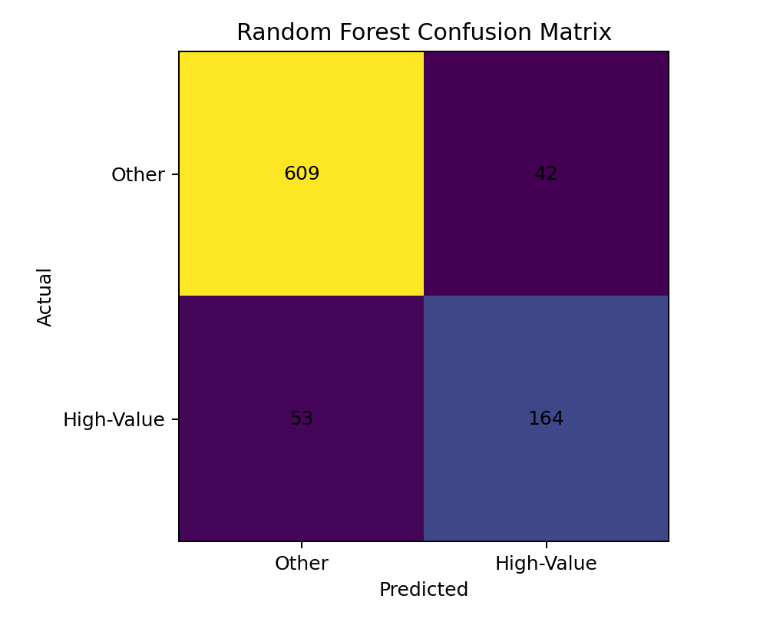
Figure 1. Confusion matrix on the held-out test set.

8. Cross-Validation Results
Metric | 5-Fold Mean
Accuracy | 0.8879
Precision | 0.7591
Recall | 0.8099
F1 | 0.7832
Roc Auc | 0.9420
The cross-validation ROC-AUC mean is approximately 0.9420, indicating strong class separation across the validation folds. The mean F1-score is approximately 0.7832.

9. Feature Importance
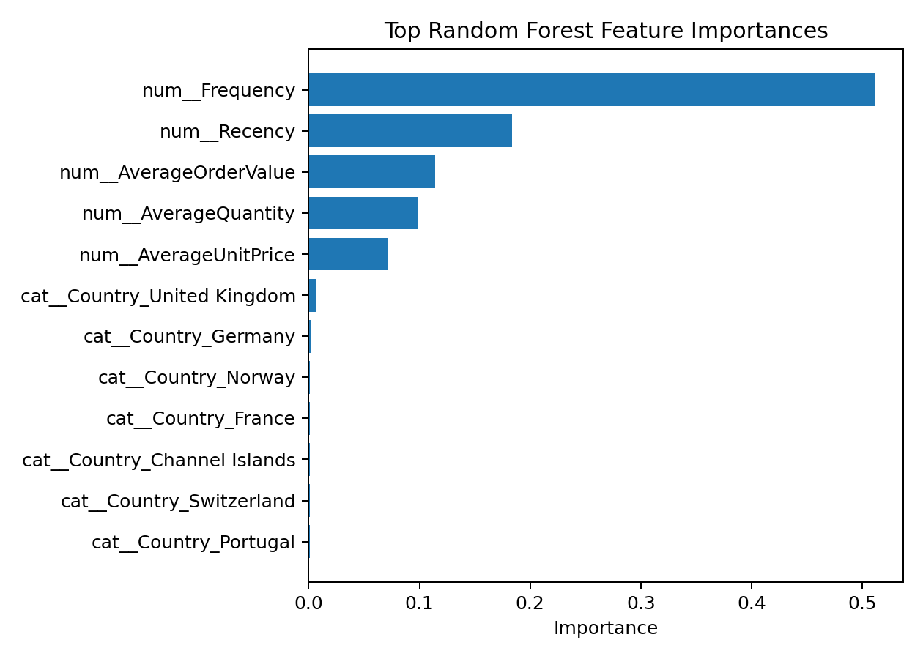
Figure 2. Top Random Forest feature importances.
The feature-importance plot shows which customer-level variables contributed most to the Random Forest predictions. These values describe predictive usefulness in the fitted model and should not be interpreted as causal effects.

10. Interpretation
The final test accuracy was 89.06%. Precision was 79.61%, meaning that most customers predicted as high-value were actually in the high-value class. Recall was 75.58%, indicating that the model detected about three-quarters of the actual high-value customers. The F1-score of 77.54% provides a balanced summary of precision and recall. ROC-AUC of 94.00% indicates strong separation between the two classes.

11. Strengths
- Uses real results calculated from the uploaded dataset.
- Prevents target leakage by excluding Monetary from predictors.
- Uses stratified hold-out testing and five-fold cross-validation.
- Reports multiple metrics and a baseline comparison.
- Provides feature importance and confusion-matrix visualizations.

12. Limitations
- The target is derived from historical spending, so it is a proxy definition of customer value.
- The dataset covers historical retail transactions and may not represent current customer behaviour.
- Feature importance indicates predictive contribution, not causation.
- The 75th-percentile target threshold is specific to this dataset.

13. Conclusion
The supervised-learning experiment successfully classified high-value customers from customer purchasing behaviour. On the held-out test set, the Random Forest achieved 89.06% accuracy and 94.00% ROC-AUC, outperforming the 75.00% majority-class baseline. Cross-validation produced similar performance, supporting the stability of the approach. The workflow can be used as a decision-support method for customer targeting and retention, while future work can explore additional features, alternative algorithms and time-based validation.

14. References
- Chen, D. (2015). Online Retail [Dataset]. UCI Machine Learning Repository. DOI: 10.24432/C5BW33.
- Scikit-learn documentation — RandomForestClassifier, model evaluation and cross-validation.
- Pandas documentation — data cleaning, grouping and aggregation.

