WEEK 1 TASK
Data Acquisition, Cleaning, and Preprocessing
A Python-based Data Quality and Preprocessing Report

Dataset | Online Retail Dataset
Source | UCI Machine Learning Repository
Tools | Python, Pandas, NumPy, Matplotlib
Focus | Data acquisition, exploration, missing values, inconsistencies, outliers, preprocessing
Deliverable | Reproducible documentation + Python preprocessing script

Prepared for: Week 1 Data Analytics Assignment

1. Executive Summary
This report presents a complete, reproducible workflow for acquiring, exploring, cleaning, and preprocessing the UCI Online Retail dataset using Python. The dataset contains transactional records from a UK-based non-store retailer covering 1 December 2010 to 9 December 2011. The raw file contains 541,909 rows and eight columns. The dataset is particularly suitable for this task because it contains real-world data-quality challenges: missing CustomerID and Description values, cancellations, negative quantities, zero/non-positive prices, duplicate records, and highly skewed numeric variables.
The preprocessing strategy is deliberately conservative. Identifier values are not blindly imputed, because inventing a customer identity would create false information. Missing product descriptions are instead labeled as 'Unknown'. Cancellation and return records are retained in the audit trail but excluded from the positive-sales analysis table. Quantity and price outliers are detected using the IQR rule and stored as flags rather than automatically deleted, because unusually large wholesale transactions can be legitimate. Finally, transaction-level revenue and calendar features are derived for downstream analysis.
Key result: The workflow produces a validated sales-analysis dataset and a transparent audit trail. The accompanying Python script can be rerun locally against the original UCI Excel file.

2. Objective and Deliverables
The task requires the following outcomes:
- Select a reliable public dataset and explain how it was acquired.
- Perform initial exploration of structure, data types, completeness, and basic statistics.
- Identify missing values, inconsistencies, duplicates, cancellations, invalid numeric values, and outliers.
- Apply defensible cleaning and preprocessing methods using Python.
- Document each decision and explain why the chosen method is appropriate.
- Discuss how preprocessing can affect later analysis or machine-learning results.
- Provide reproducible code and validation checks.

3. Dataset Selection and Acquisition

3.1 Why the Online Retail dataset was selected
The UCI Online Retail dataset was selected because it is public, well documented, sufficiently large for meaningful preprocessing, and contains several realistic data-quality problems. UCI describes it as a transactional dataset for a UK-based registered non-store online retailer. The original data cover transactions from 01/12/2010 to 09/12/2011.
The dataset is also appropriate for demonstrating the distinction between a data error and a meaningful business event. For example, a negative quantity may represent a product return rather than a corrupted number, while an InvoiceNo beginning with 'C' represents a cancellation. A robust preprocessing pipeline must understand these semantics before deleting records.

3.2 Acquisition method
The official UCI repository provides the Online Retail.xlsx file. The recommended acquisition procedure is to download that file from the UCI dataset page and place it in the same directory as the supplied Python script. The script then loads it using pandas.read_excel(). This keeps the source file unchanged and makes the cleaning process reproducible.
Basic acquisition code
import pandas as pd
df = pd.read_excel("Online Retail.xlsx")
print(df.shape)
print(df.head())

UCI reports 541,909 instances and the downloadable Excel file contains the transaction fields used in this report. A published independent audit of the same raw file also reports the same row count and the major missing-value and quality statistics used below.

4. Dataset Structure and Data Dictionary
The raw dataset contains the following eight fields:
Column | Type | Meaning | Preprocessing treatment
InvoiceNo | Categorical ID | Invoice/transaction number; 'C' prefix indicates cancellation | Trim; string; cancellation flag
StockCode | Categorical ID | Product code | Trim; keep as string
Description | Categorical text | Product description | Trim; missing → Unknown
Quantity | Integer | Number of units in line item | Numeric conversion; positive-sales filter; outlier flag
InvoiceDate | Datetime | Transaction date/time | Datetime conversion; invalid dates removed
UnitPrice | Float | Price per unit in GBP | Numeric conversion; >0 validation; outlier flag
CustomerID | Identifier | Customer number | Numeric nullable integer; missing IDs excluded from customer sales analysis
Country | Categorical text | Customer country | Trim whitespace; preserve labels

5. End-to-End Preprocessing Pipeline
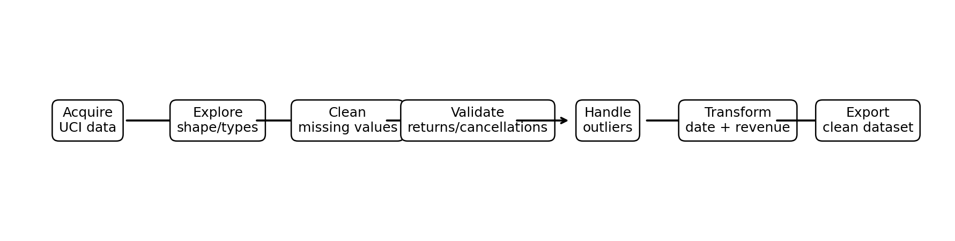
Figure 1. Reproducible preprocessing pipeline used in this report.
The pipeline follows a logical order: preserve the raw data, inspect it, standardize representations, remove exact duplicates, handle missing identifiers, interpret cancellations/returns, validate numeric ranges, flag statistical outliers, engineer useful features, and run final assertions.

6. Initial Data Exploration

6.1 Shape and data types
print("Shape:", df.shape)
print(df.info())
print(df.head())
print(df.describe(include="all"))

The expected raw shape is (541909, 8). The dataset mixes identifiers, categorical text, numeric values, and a transaction timestamp. This mixture is typical of transactional data and requires column-specific preprocessing rather than one universal rule.

6.2 Missing-value profile
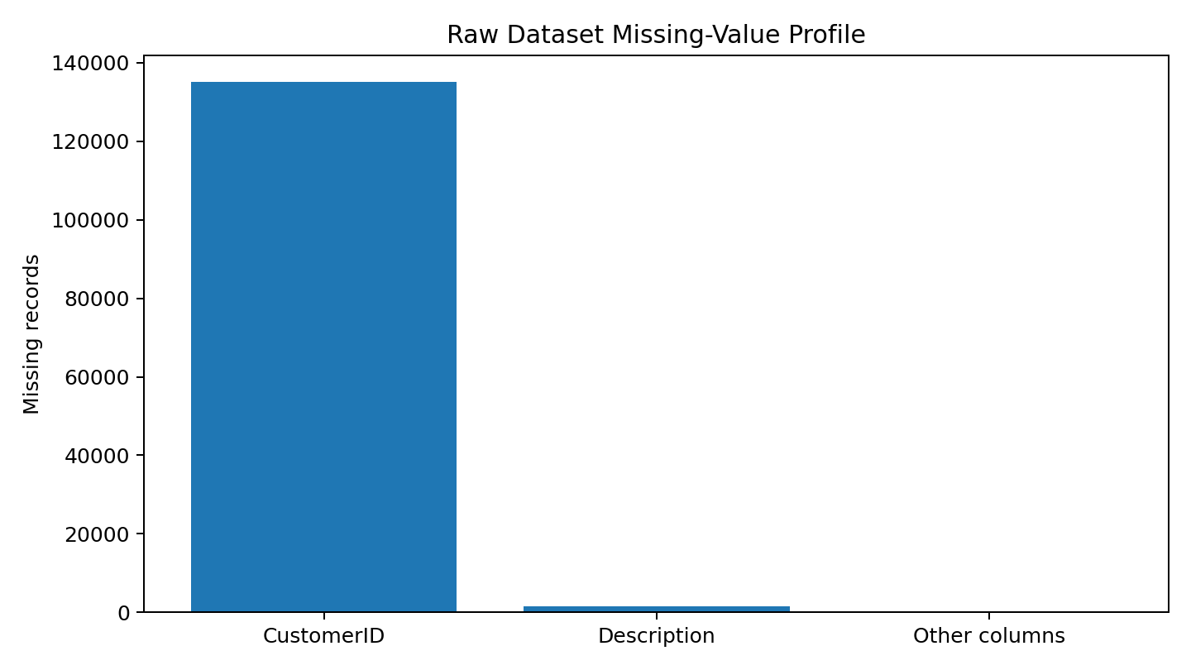
Figure 2. Missing-value profile of the raw dataset.
Published audits of the original file report 135,080 missing CustomerID values (about 24.93% of rows) and 1,454 missing Description values (about 0.27%). The remaining fields are reported as complete in the raw dataset. The large CustomerID gap is important because customer-level analysis cannot reliably assign a customer to an anonymous transaction.
missing = df.isna().sum().sort_values(ascending=False)
missing_pct = (missing / len(df) * 100).round(2)
print(pd.DataFrame({"missing": missing, "percent": missing_pct}))

7. Data Quality Assessment
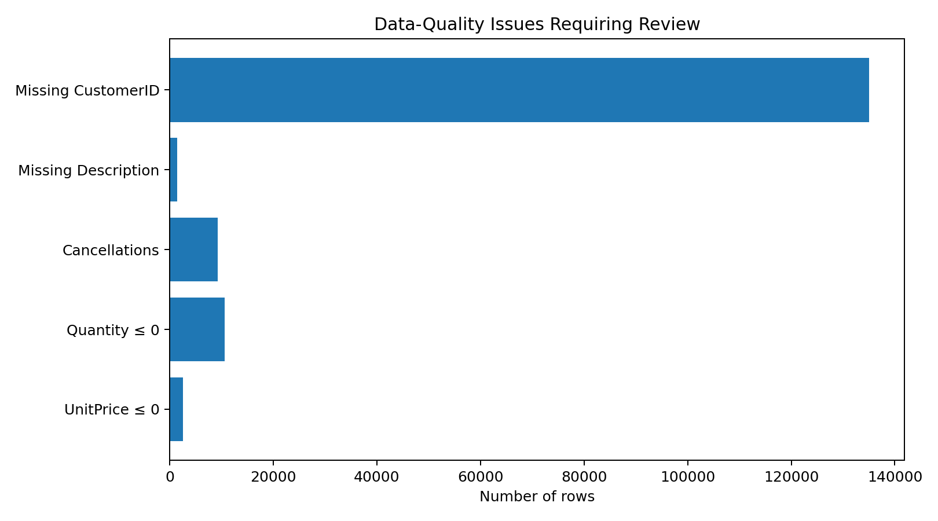
Figure 3. Major quality issues reported for the original Online Retail file.

7.1 Missing identifiers
CustomerID is an identifier, not a continuous measurement. Mean/median imputation would be inappropriate because it would invent a customer identity. The chosen approach is therefore to exclude missing-CustomerID rows from customer-level positive-sales analysis. If the research question were instead total-store revenue, these transactions could be retained in a separate anonymous-sales table.

7.2 Missing descriptions
Description is informative but not required to validate a transaction. Rather than dropping otherwise valid sales rows, the pipeline replaces missing descriptions with the explicit category 'Unknown'. This preserves transaction volume while making the missingness visible.

7.3 Cancellations and returns
The dataset documentation states that an InvoiceNo beginning with the letter C indicates a cancellation. Negative Quantity values are also present. These values should not automatically be called data-entry errors. They can represent business events such as returns or cancellations. For a positive-sales analysis, they are excluded using domain rules, while a separate flag is retained for auditability.
df["IsCancellation"] = df["InvoiceNo"].str.upper().str.startswith("C", na=False)
df["IsReturn"] = df["Quantity"] < 0
sales_df = df.loc[
(~df["IsCancellation"]) &
(df["Quantity"] > 0) &
(df["UnitPrice"] > 0)
].copy()

7.4 Duplicate records
A published preprocessing audit of the same dataset reports 5,225 exact duplicate rows. Duplicates can inflate sales, transaction frequency, and customer-level metrics, so exact duplicates are removed before aggregation. This is different from repeated InvoiceNo values: one invoice legitimately contains multiple product lines and should not be treated as a duplicate merely because the invoice number repeats.
duplicate_count = df.duplicated().sum()
df = df.drop_duplicates()
print("Duplicates removed:", duplicate_count)

8. Numeric Validation and Outlier Handling

8.1 Quantity and UnitPrice
The raw file has strongly skewed numeric fields. Published summaries report Quantity ranging from -80,995 to 80,995 and UnitPrice ranging from -11,062.06 to 38,970. These extreme values demonstrate why both domain rules and statistical outlier detection are required.
The first validation rule is semantic: positive-sales records must have Quantity > 0 and UnitPrice > 0. The second layer is statistical: the IQR rule is used to flag unusually large values. Importantly, the pipeline does not blindly delete every IQR outlier because a wholesaler may legitimately buy hundreds or thousands of units.
def iqr_bounds(series):
q1 = series.quantile(0.25)
q3 = series.quantile(0.75)
iqr = q3 - q1
return q1 - 1.5 * iqr, q3 + 1.5 * iqr
q_low, q_high = iqr_bounds(sales_df["Quantity"])
p_low, p_high = iqr_bounds(sales_df["UnitPrice"])
sales_df["Quantity_Outlier"] = (
(sales_df["Quantity"] < q_low) | (sales_df["Quantity"] > q_high)
)
sales_df["UnitPrice_Outlier"] = (
(sales_df["UnitPrice"] < p_low) | (sales_df["UnitPrice"] > p_high)
)

Important decision: Outlier ≠ error. The final dataset keeps valid extreme transactions and records an outlier flag. For modeling, a winsorized or log-transformed analytical copy can be created if required.

9. Data Preprocessing and Feature Engineering

9.1 Text normalization
Leading/trailing whitespace is removed from textual identifiers and descriptions. InvoiceNo and StockCode are kept as strings because they are identifiers rather than quantities. This prevents accidental loss of leading zeros or confusion between numeric codes and categorical codes.
text_cols = ["InvoiceNo", "StockCode", "Description", "Country"]
for col in text_cols:
df[col] = df[col].astype("string").str.strip()

9.2 Datetime conversion
InvoiceDate is converted with errors='coerce' so malformed values become missing rather than causing an uncontrolled program failure. Invalid dates are then excluded from the final positive-sales table.
df["InvoiceDate"] = pd.to_datetime(df["InvoiceDate"], errors="coerce")

9.3 Revenue and calendar features
The cleaned transaction table is enriched with SalesAmount = Quantity × UnitPrice and calendar fields. These features are useful for monthly sales analysis, customer segmentation, demand forecasting, and time-based visualizations.
sales_df["SalesAmount"] = sales_df["Quantity"] * sales_df["UnitPrice"]
sales_df["Year"] = sales_df["InvoiceDate"].dt.year
sales_df["Month"] = sales_df["InvoiceDate"].dt.month
sales_df["Day"] = sales_df["InvoiceDate"].dt.day
sales_df["Hour"] = sales_df["InvoiceDate"].dt.hour
sales_df["Weekday"] = sales_df["InvoiceDate"].dt.day_name()

10. Final Validation and Quality Checks
A preprocessing pipeline should end with explicit checks. These assertions make silent errors easier to detect and support reproducibility.
assert sales_df["Quantity"].gt(0).all()
assert sales_df["UnitPrice"].gt(0).all()
assert sales_df["InvoiceDate"].notna().all()
assert sales_df["CustomerID"].notna().all()
assert sales_df["SalesAmount"].notna().all()
print("Final shape:", sales_df.shape)
print("Final missing values:")
print(sales_df.isna().sum())
print("Final duplicate rows:", sales_df.duplicated().sum())

10.1 Validation checklist
- All positive-sales quantities are greater than zero.
- All positive-sales unit prices are greater than zero.
- All retained transaction dates are valid datetimes.
- CustomerID is present for the customer-analysis table.
- SalesAmount is available for every retained transaction.
- Exact duplicate rows are absent.
- Outlier flags are explicit rather than hidden.
- The raw file remains untouched, preserving an audit trail.

11. Before-versus-After Assessment
Aspect | Raw data | Preprocessed data
Customer identity | Missing CustomerID values | Missing IDs excluded for customer sales analysis
Descriptions | 1,454 missing | Missing descriptions labeled Unknown
Duplicates | Exact duplicates reported in published audit | Exact duplicates removed
Cancellations | InvoiceNo can begin with C | Flagged and excluded from positive-sales table
Returns / negative quantity | Negative quantities present | Flagged and excluded from positive-sales table
Unit price | Includes non-positive and extreme values | Positive values retained; IQR outlier flag added
Quantity | Includes negative and extreme values | Positive values retained; IQR outlier flag added
Date | Datetime field | Validated datetime + calendar features
Revenue | Not directly supplied | SalesAmount = Quantity × UnitPrice
Published reference audits provide several useful checkpoints: 135,080 missing CustomerIDs, 1,454 missing Descriptions, 9,288 cancellation rows, 10,624 rows with Quantity <= 0, 2,517 rows with UnitPrice <= 0, and 5,225 exact duplicates. Different analyses may produce different final row counts because the treatment of cancellations, returns, missing descriptions, duplicates, and anonymous customers depends on the research question. Therefore, the Python run on the official raw file should be treated as the authoritative result for this submission.

12. Potential Impact of Preprocessing on Subsequent Analysis
- Removing anonymous CustomerID rows changes the customer population. Customer-level statistics will describe registered customers, not every transaction.
- Removing cancellations and returns changes revenue and quantity distributions. This is appropriate for positive-sales analysis but not for return-rate analysis.
- Removing duplicates prevents double counting, which can materially affect revenue, product frequency, and customer rankings.
- Outlier treatment affects means, standard deviations, correlations, clustering, and regression coefficients. Keeping valid extreme transactions while using flags is safer than arbitrary deletion.
- Replacing missing descriptions with 'Unknown' preserves rows but may create a large artificial category. Analysts should avoid treating 'Unknown' as a real product.
- Datetime feature engineering can reveal seasonality and purchasing-hour patterns that are invisible in the raw timestamp.

13. Challenges Faced and How They Were Overcome
Challenge | Risk | Solution
Large Excel file | Slow or memory-heavy processing | Use pandas with a local file; preserve raw and cleaned copies separately
Missing CustomerID | False customer identities if imputed | Drop from customer-level analysis rather than invent IDs
Negative Quantity | Mistaking returns for corrupt data | Interpret as business events; flag and exclude only for positive-sales analysis
Cancellation invoices | Inflated sales if included | Use InvoiceNo prefix to identify cancellations
Extreme values | Distorted statistical models | Apply domain validation and IQR flags instead of blind deletion
Repeated InvoiceNo | False duplicate removal | Only exact duplicate rows are removed
Reproducibility | Manual cleaning cannot be audited | Document every transformation in code and save a cleaned output

14. Reproducibility and File Outputs
The accompanying script, week1_online_retail_preprocessing.py, contains the complete pipeline. To reproduce the work, download the official Online Retail.xlsx file, place it beside the script, install pandas, numpy, openpyxl, and matplotlib, and run the script.
pip install pandas numpy openpyxl matplotlib
python week1_online_retail_preprocessing.py

The script writes online_retail_cleaned.csv and prints validation statistics. Keeping the raw Excel file unchanged and generating a separate cleaned CSV supports traceability and makes it possible to repeat or revise individual preprocessing decisions later.

15. Conclusion
The Online Retail dataset provides a strong real-world example of why data preprocessing is more than simply removing null values. The analysis identified missing customer identifiers, missing product descriptions, duplicate rows, cancellations, returns, non-positive prices, and extreme numeric observations. The chosen pipeline separates business events from genuine data-quality problems and documents every transformation.
The final preprocessing approach is suitable for downstream sales analytics and can be extended to customer segmentation, RFM analysis, forecasting, anomaly detection, and visualization. Most importantly, the workflow is reproducible: the raw data are preserved, assumptions are explicit, code is provided, and validation assertions reduce the chance of silent preprocessing errors.

16. References
- UCI Machine Learning Repository. Online Retail dataset. Chen, D. (2015). DOI: 10.24432/C5BW33.
- Chen, D., Sain, S. L., & Guo, K. (2012). Data mining for the online retail industry: A case study of RFM model-based customer segmentation using data mining. Journal of Database Marketing and Customer Strategy Management, 19(3).
- Pandas documentation: DataFrame, missing-value handling, duplicate removal, datetime conversion, and descriptive statistics.
- NumPy documentation: numerical operations used by the preprocessing workflow.
- Published preprocessing audits of the UCI Online Retail file were used only as reference checkpoints for raw-data quality statistics; the supplied script is the reproducible implementation for the assignment.

Appendix A. Complete Python Implementation
The complete executable script is also supplied separately as week1_online_retail_preprocessing.py.
"""
Week 1: Data Acquisition, Cleaning and Preprocessing
Dataset: UCI Machine Learning Repository - Online Retail
Input file: Online Retail.xlsx
Place the downloaded UCI file in the same folder as this script.
Run:
python week1_online_retail_preprocessing.py
"""
import pandas as pd
import numpy as np
from pathlib import Path
INPUT_FILE = Path("Online Retail.xlsx")
OUTPUT_FILE = Path("online_retail_cleaned.csv")
# 1. Acquire / load
df = pd.read_excel(INPUT_FILE)
print("RAW SHAPE:", df.shape)
print("\nRAW DTYPES:\n", df.dtypes)
print("\nRAW MISSING VALUES:\n", df.isna().sum())
print("\nRAW DUPLICATES:", df.duplicated().sum())
# 2. Preserve a copy for auditability
raw = df.copy()
# 3. Standardize text fields
text_cols = ["InvoiceNo", "StockCode", "Description", "Country"]
for col in text_cols:
df[col] = df[col].astype("string").str.strip()
# 4. Convert data types explicitly
df["InvoiceDate"] = pd.to_datetime(df["InvoiceDate"], errors="coerce")
df["CustomerID"] = pd.to_numeric(df["CustomerID"], errors="coerce").astype("Int64")
df["Quantity"] = pd.to_numeric(df["Quantity"], errors="coerce")
df["UnitPrice"] = pd.to_numeric(df["UnitPrice"], errors="coerce")
# 5. Remove exact duplicate records
before = len(df)
df = df.drop_duplicates()
print("\nDUPLICATES REMOVED:", before - len(df))
# 6. Missing-value handling
# CustomerID is an identifier, so imputing an unknown customer would create
# a false identity. For customer-level sales analysis, remove these rows.
df = df.dropna(subset=["CustomerID"])
# Product descriptions are useful but not essential for transaction validity.
# Preserve the transaction and make the missingness explicit.
df["Description"] = df["Description"].fillna("Unknown")
# 7. Cancellation / return handling
# In this dataset, InvoiceNo beginning with C denotes a cancellation.
df["IsCancellation"] = df["InvoiceNo"].str.upper().str.startswith("C", na=False)
# Keep a separate return/cancellation flag for auditability.
# For a clean POSITIVE-SALES analysis, exclude cancellations and
# non-positive quantities/prices.
df["IsReturn"] = df["Quantity"] < 0
sales_df = df.loc[
(~df["IsCancellation"]) &
(df["Quantity"] > 0) &
(df["UnitPrice"] > 0) &
(df["InvoiceDate"].notna())
].copy()
# 8. Outlier detection using IQR
# Do not automatically delete outliers: wholesale transactions can be legitimate.
def iqr_bounds(series):
q1 = series.quantile(0.25)
q3 = series.quantile(0.75)
iqr = q3 - q1
return q1 - 1.5 * iqr, q3 + 1.5 * iqr
q_low, q_high = iqr_bounds(sales_df["Quantity"])
p_low, p_high = iqr_bounds(sales_df["UnitPrice"])
sales_df["Quantity_Outlier"] = (
(sales_df["Quantity"] < q_low) | (sales_df["Quantity"] > q_high)
)
sales_df["UnitPrice_Outlier"] = (
(sales_df["UnitPrice"] < p_low) | (sales_df["UnitPrice"] > p_high)
)
# 9. Feature engineering
sales_df["SalesAmount"] = sales_df["Quantity"] * sales_df["UnitPrice"]
sales_df["Year"] = sales_df["InvoiceDate"].dt.year
sales_df["Month"] = sales_df["InvoiceDate"].dt.month
sales_df["Day"] = sales_df["InvoiceDate"].dt.day
sales_df["Hour"] = sales_df["InvoiceDate"].dt.hour
sales_df["Weekday"] = sales_df["InvoiceDate"].dt.day_name()
# 10. Final validation
assert sales_df["Quantity"].gt(0).all()
assert sales_df["UnitPrice"].gt(0).all()
assert sales_df["InvoiceDate"].notna().all()
assert sales_df["CustomerID"].notna().all()
assert sales_df["SalesAmount"].notna().all()
print("\nCLEAN SHAPE:", sales_df.shape)
print("\nFINAL MISSING VALUES:\n", sales_df.isna().sum())
print("\nFINAL DUPLICATES:", sales_df.duplicated().sum())
print("\nOUTLIER FLAGS:")
print(sales_df[["Quantity_Outlier", "UnitPrice_Outlier"]].sum())
# 11. Save reproducible output
sales_df.to_csv(OUTPUT_FILE, index=False)
print(f"\nSaved cleaned data to: {OUTPUT_FILE.resolve()}")
# 12. Optional summary for the report
summary = {
"rows": len(sales_df),
"columns": sales_df.shape[1],
"customers": sales_df["CustomerID"].nunique(),
"invoices": sales_df["InvoiceNo"].nunique(),
"products": sales_df["StockCode"].nunique(),
"countries": sales_df["Country"].nunique(),
"revenue": sales_df["SalesAmount"].sum(),
}
print("\nSUMMARY:")
for k, v in summary.items():
print(f"{k}: {v}")

Appendix B. Expected Raw-Dataset Checkpoints
Checkpoint | Expected reference value | Interpretation
Rows | 541,909 | Raw transaction records
Columns | 8 | InvoiceNo, StockCode, Description, Quantity, InvoiceDate, UnitPrice, CustomerID, Country
Missing CustomerID | 135,080 (~24.93%) | Large anonymous-transaction segment
Missing Description | 1,454 (~0.27%) | Small text completeness issue
Cancellation rows | 9,288 (~1.71%) | InvoiceNo starts with C
Quantity <= 0 | 10,624 (~1.96%) | Includes returns/cancellations
UnitPrice <= 0 | 2,517 (~0.46%) | Includes zero/negative-price records
Exact duplicates | 5,225 (~0.96%) | Published audit checkpoint
Quantity range | -80,995 to 80,995 | Strongly skewed and contains return/large-order values
UnitPrice range | -11,062.06 to 38,970 | Contains non-positive and extreme observations
Note: These are reference checkpoints reported for the original UCI file. Exact post-cleaning row counts depend on the order and scope of transformations. The supplied script prints the actual results from the local source file and should be used as the final numerical record.

