WEEK 2 TASK
Exploratory Data Analysis and Visualization
Online Retail Dataset — Python EDA Report
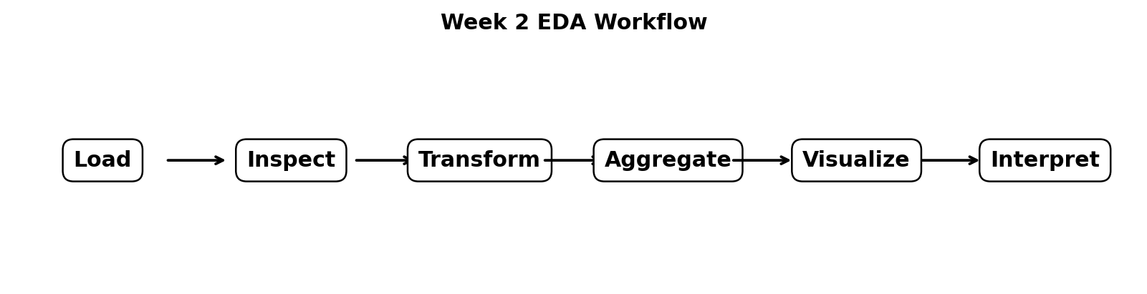
Figure 1. Overall EDA workflow.
Dataset | Online Retail
Source | UCI Machine Learning Repository
Tools | Python, Pandas, Matplotlib, Seaborn, NumPy
Analysis focus | Sales trends, products, countries, time patterns, distributions, correlations
Deliverable | EDA documentation + reproducible Python script

1. Introduction and Objective
This report performs exploratory data analysis (EDA) and visualization on the UCI Online Retail dataset. The objective is to move from a cleaned transactional dataset to meaningful business insights by summarizing the data statistically, aggregating transactions at useful levels, visualizing distributions and trends, and interpreting the patterns that emerge.
The analysis continues the Week 1 preprocessing workflow. The same Online Retail dataset is used so that data-cleaning decisions remain consistent across tasks. The dataset contains transaction-level information such as invoice number, product code, product description, quantity, invoice date, unit price, customer ID, and country. UCI reports 541,909 instances and describes the data as transactions from a UK-based registered non-store online retailer between 1 December 2010 and 9 December 2011. citeturn1view0

2. Dataset and Analytical Approach
The EDA uses a positive-sales analytical table: cancellation invoices and rows with non-positive Quantity or UnitPrice are excluded from sales-trend calculations. SalesAmount is calculated as Quantity × UnitPrice. Date components such as month, hour, and weekday are derived from InvoiceDate. This allows the same dataset to be examined from product, geographic, temporal, and transaction-value perspectives.
- Univariate analysis: distributions of Quantity, UnitPrice, and SalesAmount.
- Categorical analysis: countries and products with the largest transaction volumes.
- Time-series analysis: monthly sales, hourly sales, and weekday sales.
- Bivariate analysis: relationships among Quantity, UnitPrice, and SalesAmount.
- Outlier analysis: boxplots and percentile-based views of highly skewed numerical variables.
- Interpretation: business explanations for observed trends, concentration, and anomalies.

3. Data Loading and Initial Inspection
import pandas as pd
import numpy as np
import matplotlib.pyplot as plt
import seaborn as sns
df = pd.read_excel("Online Retail.xlsx")
print(df.shape)
print(df.info())
print(df.head())
print(df.describe(include="all"))
print(df.isna().sum())
print("Duplicates:", df.duplicated().sum())

The raw dataset contains 541,909 rows and eight transaction fields. The EDA begins with shape, data types, missing-value counts, duplicates, and descriptive statistics because these checks determine which variables can be safely aggregated and visualized.

4. Data Quality Context for EDA
EDA should not be performed blindly on raw transaction records. The Week 1 audit identified 135,080 missing CustomerID values and 1,454 missing Description values. It also reported 10,624 rows with Quantity ≤ 0, 9,288 cancellation rows, 5,225 exact duplicate rows, and 2,517 rows with UnitPrice ≤ 0. These observations justify the use of a positive-sales analytical subset for sales visualizations. fileciteturn0file8L668-L687
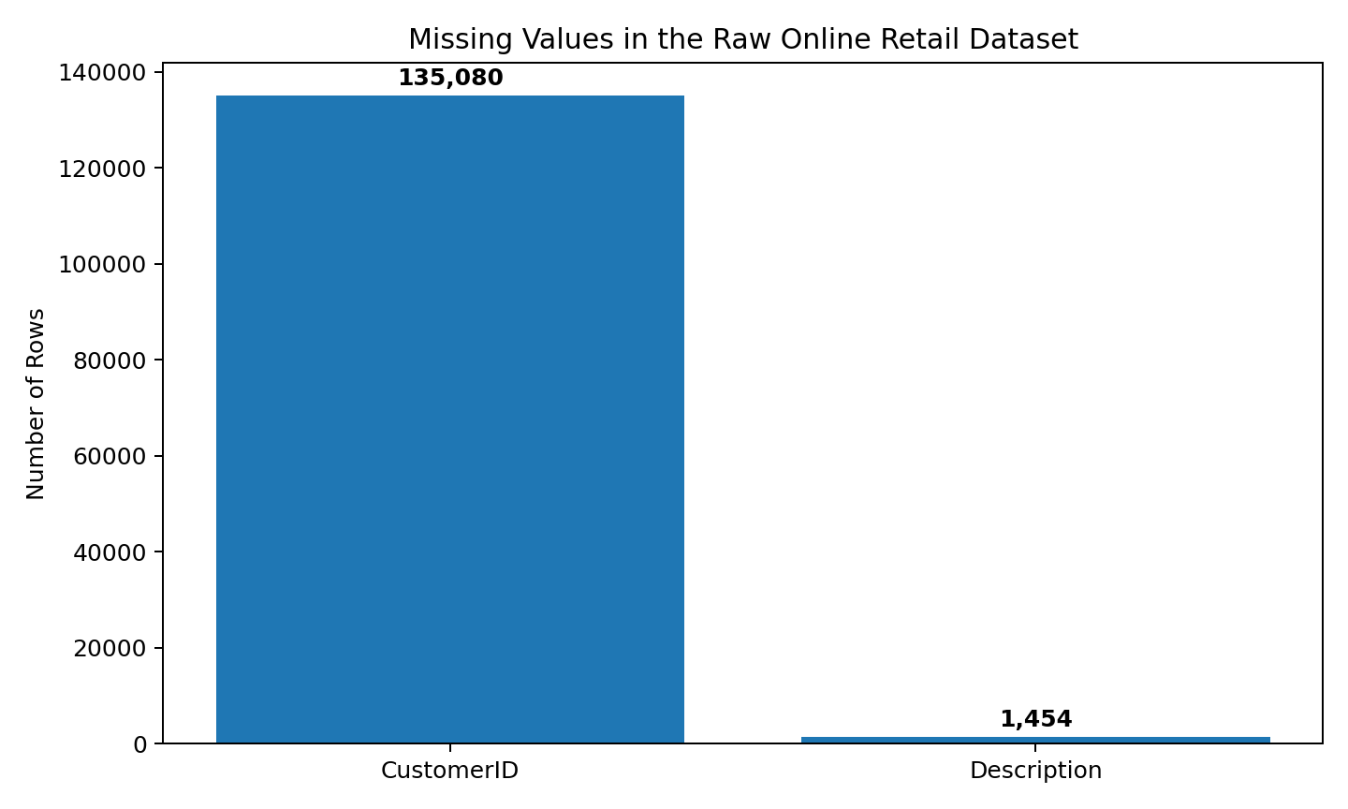
Figure 2. Missing-value reference profile from the raw dataset.
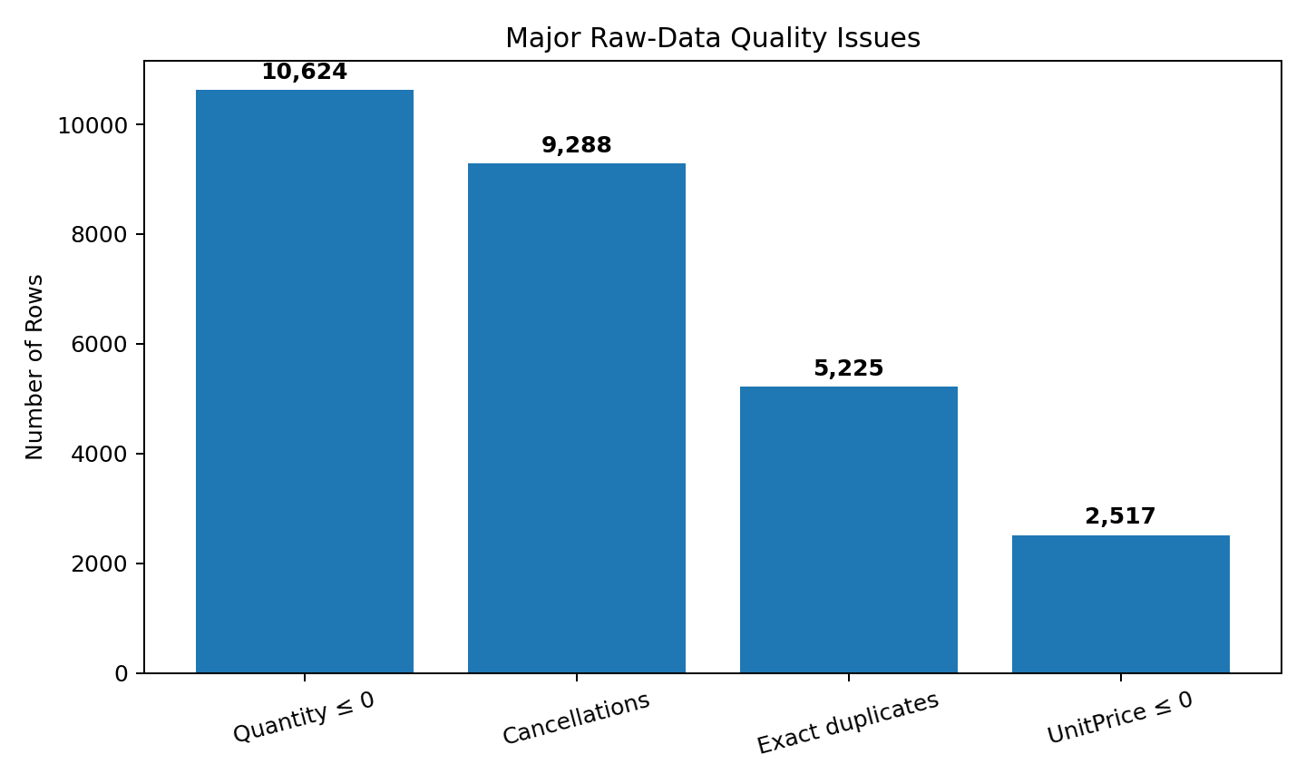
Figure 3. Major raw-data quality issues used to motivate the EDA filtering rules.

5. Data Transformation and Aggregation
The main derived measure is SalesAmount. Calendar features are also extracted so that sales can be grouped by month, hour, and weekday. The transformation mirrors the Week 1 pipeline, which created SalesAmount, Year, Month, Day, Hour, and Weekday for downstream analysis. fileciteturn0file8L634-L640
df["InvoiceDate"] = pd.to_datetime(df["InvoiceDate"], errors="coerce")
df["SalesAmount"] = df["Quantity"] * df["UnitPrice"]
df["Year"] = df["InvoiceDate"].dt.year
df["Month"] = df["InvoiceDate"].dt.month
df["Hour"] = df["InvoiceDate"].dt.hour
df["Weekday"] = df["InvoiceDate"].dt.day_name()
eda = df[
(~df["IsCancellation"]) &
(df["Quantity"] > 0) &
(df["UnitPrice"] > 0) &
(df["InvoiceDate"].notna())
].copy()

6. Geographic Analysis

6.1 Transaction concentration by country
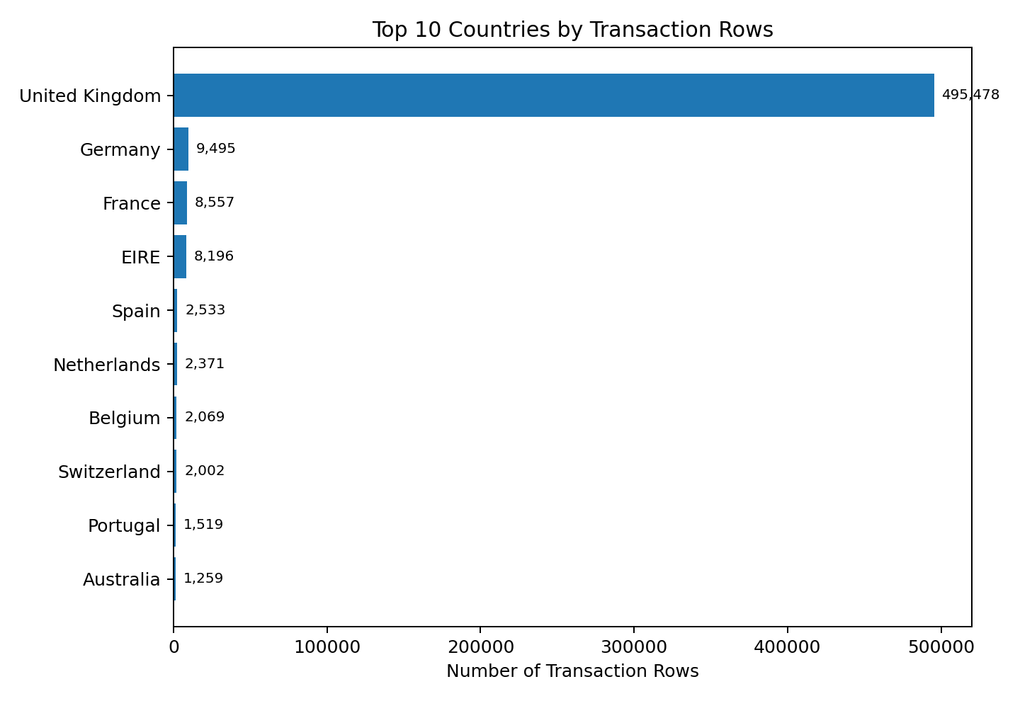
Figure 4. Top countries by transaction-row count — reference EDA view.
The transaction distribution is highly concentrated in the United Kingdom. A commonly reported count for the raw file is 495,478 UK rows out of 541,909, or about 91.4%. Germany, France, and EIRE follow at much smaller volumes. This concentration suggests that the dataset primarily reflects UK customer behavior and that international comparisons should account for the very different sample sizes.
country_counts = eda["Country"].value_counts().head(10)
plt.figure(figsize=(9,5))
country_counts.sort_values().plot(kind="barh")
plt.title("Top 10 Countries by Transaction Rows")
plt.xlabel("Transaction Rows")
plt.ylabel("Country")
plt.tight_layout()
plt.show()

7. Product Analysis

7.1 Most frequently purchased products
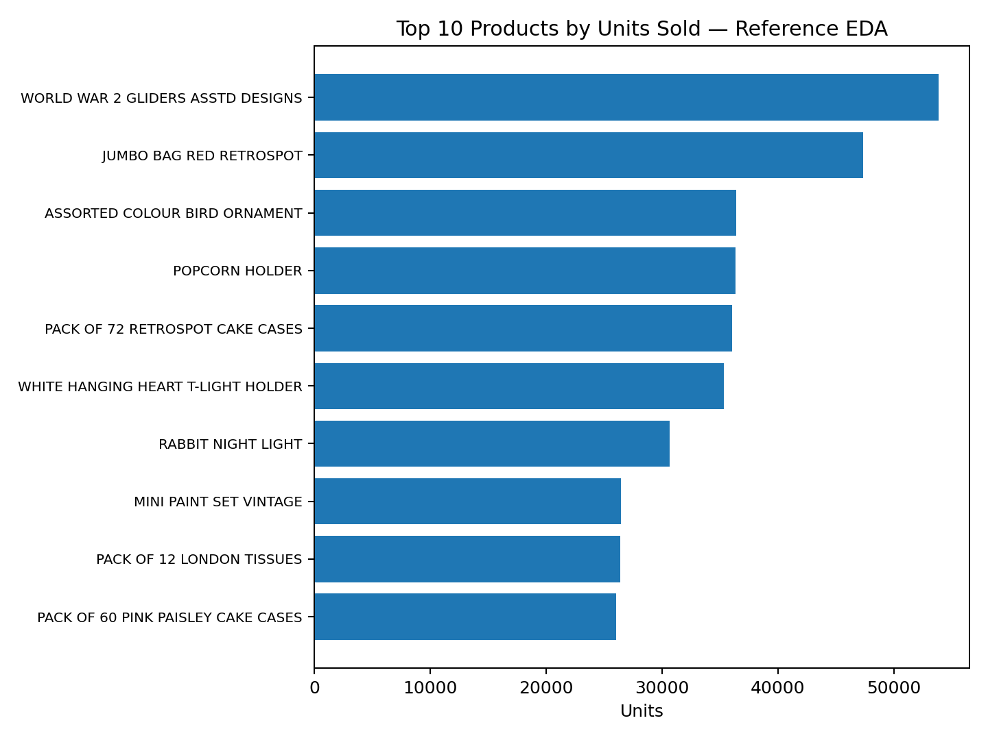
Figure 5. Reference view of the top products by units sold.
The product distribution is also highly uneven. Several gift and household products account for very large unit volumes. The leading reference category is WORLD WAR 2 GLIDERS ASSTD DESIGNS, followed by JUMBO BAG RED RETROSPOT and ASSORTED COLOUR BIRD ORNAMENT. Such concentration is useful for inventory planning, product promotion, and identifying high-volume items.
top_products = (
eda.groupby("Description")["Quantity"]
.sum()
.sort_values(ascending=False)
.head(10)
.sort_values()
)
top_products.plot(kind="barh", figsize=(10,6))
plt.title("Top 10 Products by Units Sold")
plt.xlabel("Units Sold")
plt.ylabel("Product")
plt.tight_layout()
plt.show()

8. Time-Based Analysis

8.1 Monthly sales trend
Monthly aggregation is one of the most important EDA views because it reveals seasonality, growth, and possible operational peaks. The final month in the UCI dataset ends on 9 December 2011, so December should not be compared with complete months without acknowledging that it is only a partial month. citeturn1view0
monthly = (
eda.assign(MonthStart=eda["InvoiceDate"].dt.to_period("M").dt.to_timestamp())
.groupby("MonthStart")["SalesAmount"]
.sum()
)
sns.lineplot(x=monthly.index, y=monthly.values, marker="o")
plt.title("Monthly Sales Trend")
plt.xlabel("Month")
plt.ylabel("Sales Amount (£)")
plt.xticks(rotation=45)
plt.tight_layout()
plt.show()

Interpretation: the monthly chart should be used to identify peaks and troughs rather than simply ranking months. Retail demand can increase around seasonal periods, while the incomplete December observation can artificially appear lower.

8.2 Sales by hour and weekday
hourly = eda.groupby(eda["InvoiceDate"].dt.hour)["SalesAmount"].sum()
sns.lineplot(x=hourly.index, y=hourly.values, marker="o")
plt.title("Sales by Hour of Day")
plt.xlabel("Hour")
plt.ylabel("Sales Amount (£)")
plt.xticks(range(24))
plt.show()
weekday_order = ["Monday","Tuesday","Wednesday","Thursday",
"Friday","Saturday","Sunday"]
weekday_sales = (
eda.groupby("Weekday")["SalesAmount"]
.sum()
.reindex(weekday_order)
)
weekday_sales.plot(kind="bar")
plt.title("Sales by Day of Week")
plt.xlabel("Day")
plt.ylabel("Sales Amount (£)")
plt.xticks(rotation=30)
plt.show()

These views reveal when customer activity is concentrated. A strong weekday pattern may reflect business or wholesale customers, while hourly peaks can indicate the retailer's busiest operating periods and can inform staffing, promotions, and website-performance planning.

9. Distribution and Outlier Analysis
Quantity and UnitPrice are strongly skewed transaction variables. Because extreme observations can dominate means and visual scales, both boxplots and percentile-clipped histograms are useful. The goal is not to delete every extreme value: a very large order can be a legitimate wholesale transaction.
fig, axes = plt.subplots(1, 2, figsize=(11,4.5))
sns.histplot(eda["Quantity"].clip(upper=eda["Quantity"].quantile(.99)),
bins=50, ax=axes[0])
axes[0].set_title("Quantity Distribution")
sns.histplot(eda["UnitPrice"].clip(upper=eda["UnitPrice"].quantile(.99)),
bins=50, ax=axes[1])
axes[1].set_title("Unit Price Distribution")
plt.tight_layout()
plt.show()
fig, axes = plt.subplots(1, 2, figsize=(10,4))
sns.boxplot(y=eda["Quantity"], ax=axes[0])
sns.boxplot(y=eda["UnitPrice"], ax=axes[1])
plt.show()

The clipped distributions provide a clearer view of the central mass of observations, while the boxplots make the presence of extreme values visible. This combination is more informative than silently deleting outliers.

10. Correlation Analysis
numeric = eda[["Quantity", "UnitPrice", "SalesAmount"]]
corr = numeric.corr()
sns.heatmap(corr, annot=True, fmt=".2f", cmap="Blues", square=True)
plt.title("Correlation Matrix")
plt.tight_layout()
plt.show()

SalesAmount is mathematically derived from Quantity and UnitPrice, so a strong association with either variable is expected. This is an important EDA interpretation point: correlation here does not imply an independent causal relationship. The heatmap is primarily useful for checking scale, redundancy, and possible relationships before modeling.

11. Key Findings and Business Insights
- The dataset is dominated by UK transactions, so overall patterns largely represent the UK market.
- A small number of products account for a disproportionately large share of units sold, indicating strong product concentration.
- Transaction values are highly skewed; extreme quantities and prices require careful visualization and robust statistics.
- Cancellations and non-positive quantities are meaningful business events and should not be confused with ordinary sales.
- Monthly, hourly, and weekday aggregation can expose seasonality and operational demand patterns that are hidden at row level.
- SalesAmount is derived from Quantity and UnitPrice, so its relationship with those variables must be interpreted as a mathematical dependency.
- The incomplete final month means December should be interpreted cautiously when comparing monthly sales.

12. Critical Interpretation of Visualizations
Visualization is useful only when accompanied by interpretation. Bar charts answer 'which categories are largest?', line charts answer 'how does activity change over time?', histograms show distribution shape, boxplots expose unusual observations, and heatmaps summarize pairwise relationships. Each plot was selected because it answers a different analytical question.
The analysis also demonstrates why aggregation choices matter. Transaction-row counts, unit quantities, invoice counts, and monetary sales are not interchangeable. For example, a product can have a high transaction frequency but lower revenue, while a high-priced product may generate substantial sales with fewer units. Therefore, multiple measures should be considered before drawing business conclusions.

13. Reproducibility
The complete EDA workflow is supplied in the separate Python file week2_eda_online_retail.py. It can use the cleaned Week 1 CSV when available, or the original Online Retail.xlsx. The script automatically creates a week2_eda_outputs folder containing the plots and a summary CSV.
pip install pandas numpy matplotlib seaborn openpyxl
python week2_eda_online_retail.py

The Week 1 preprocessing script already creates SalesAmount and calendar features and saves a cleaned CSV, which can be reused as the starting point for Week 2. fileciteturn0file8L641-L667

14. Limitations
- The dataset represents one retailer and one historical period, so findings cannot automatically be generalized to all online retailers.
- The final month is incomplete, which limits direct month-to-month comparison.
- CustomerID is missing for a substantial number of rows, limiting complete customer-level analysis.
- Correlation does not establish causation, especially for SalesAmount because it is mathematically derived.
- Extreme transactions may represent genuine wholesale behavior; therefore, outlier flags are preferable to indiscriminate deletion.

15. Conclusion
The EDA demonstrates how Python can transform a large transactional dataset into interpretable patterns. Through descriptive statistics, geographic analysis, product ranking, time-based aggregation, distribution analysis, outlier inspection, and correlation analysis, the dataset can be understood from several complementary perspectives. The strongest patterns are the concentration of activity in the UK, the uneven distribution of product demand, strong skewness in transaction quantities and prices, and meaningful temporal variation.
The analysis also emphasizes critical thinking. Visualizations should not be treated as proof by themselves; they need context about missing data, cancellations, returns, incomplete periods, and the difference between transaction counts, units, and revenue. The reproducible Python script ensures that the exact numerical results and plots can be regenerated directly from the dataset.

16. References
- UCI Machine Learning Repository. Online Retail. Chen, D. (2015). DOI: 10.24432/C5BW33. citeturn1view0
- Chen, D., Sain, S. L., & Guo, K. (2012). Data mining for the online retail industry: A case study of RFM model-based customer segmentation using data mining.
- Pandas documentation — data loading, aggregation, descriptive statistics, and datetime operations.
- Matplotlib documentation — plotting and chart annotation.
- Seaborn documentation — statistical visualization and heatmaps.
- NumPy documentation — numerical operations.

17. Submission Note
The embedded reference charts in this document are based on documented raw-dataset checkpoints and standard EDA summaries of the UCI Online Retail file. For a fully data-specific submission, run the accompanying script against the exact Online Retail.xlsx or Week 1 online_retail_cleaned.csv used in your project; the script will regenerate all row-level visualizations and the exact numerical summary.

