Assignment 1

Data that was used was to demonstrate basic and advanced functionality of program as well as document probable errors when program is used. Each program path is tested for to ensure that the program runs properly and without errors.

Program Testing

Main menu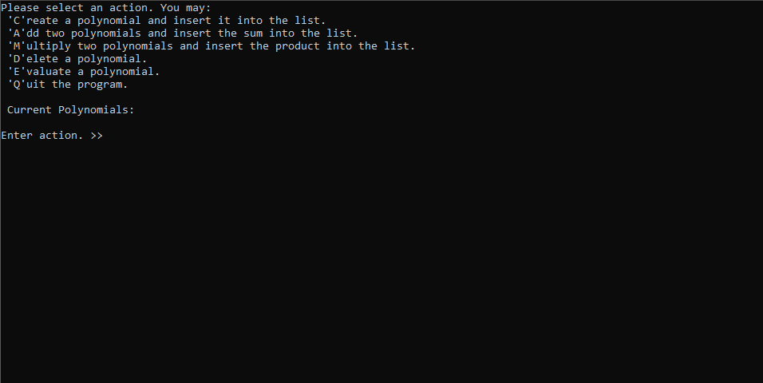

Create polynomial

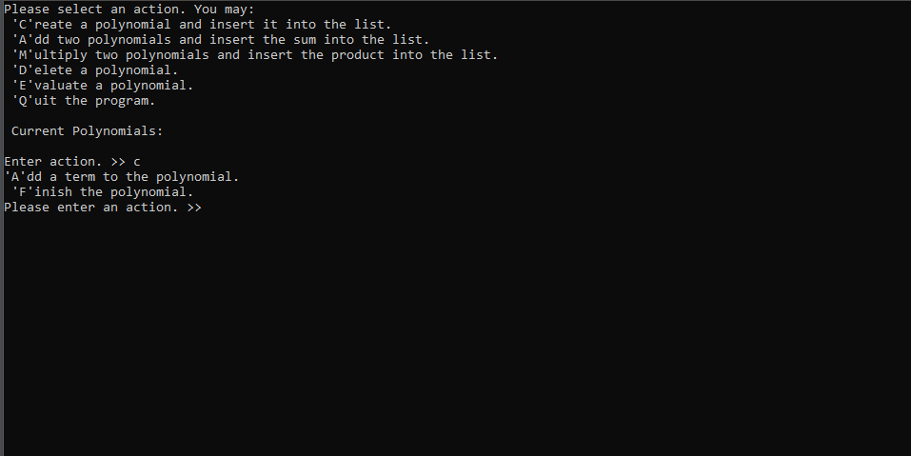

Adding a first term

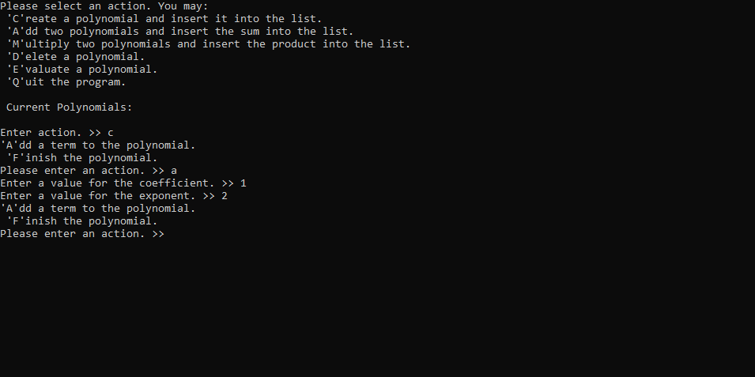

Adding a second term, and finishing polynomial

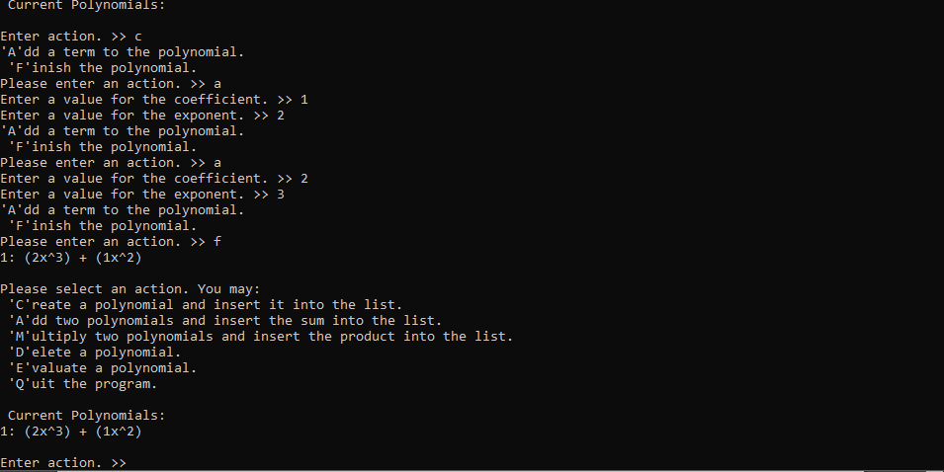

Creating extra polynomials, and printing multiple polynomials

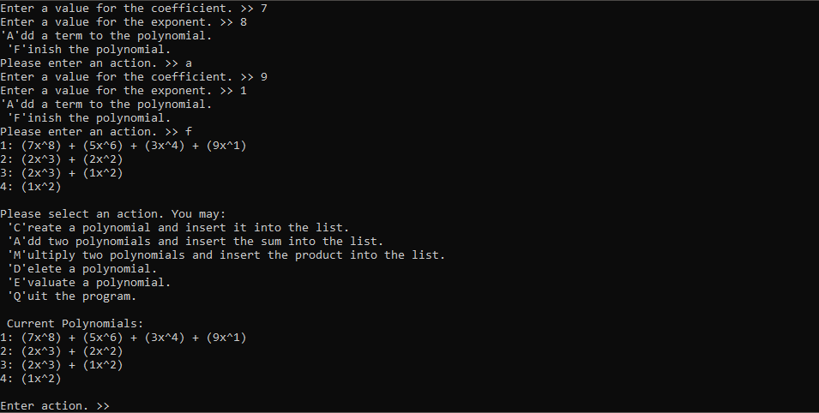

Adding 2 polynomials together

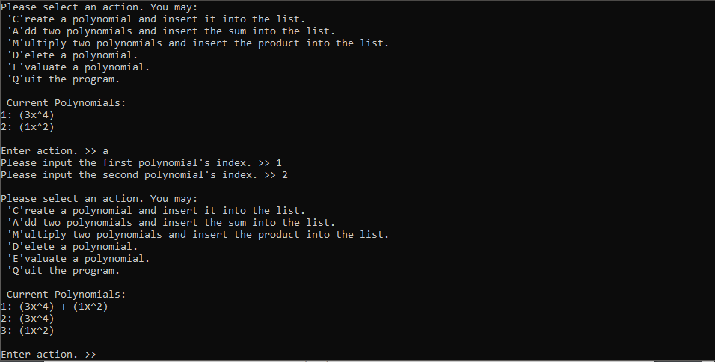

Multiply 2 polynomials

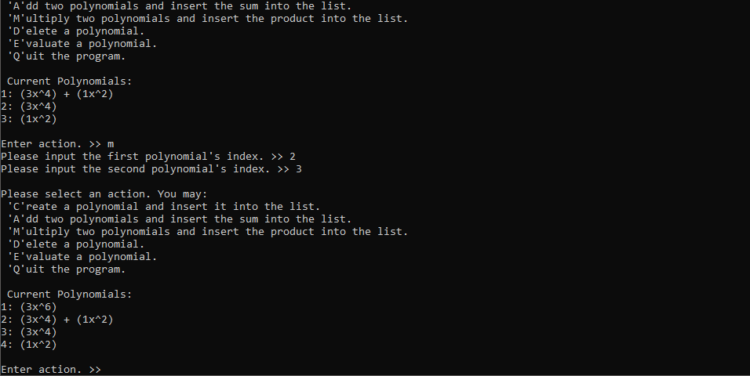

Deleting a polynomial

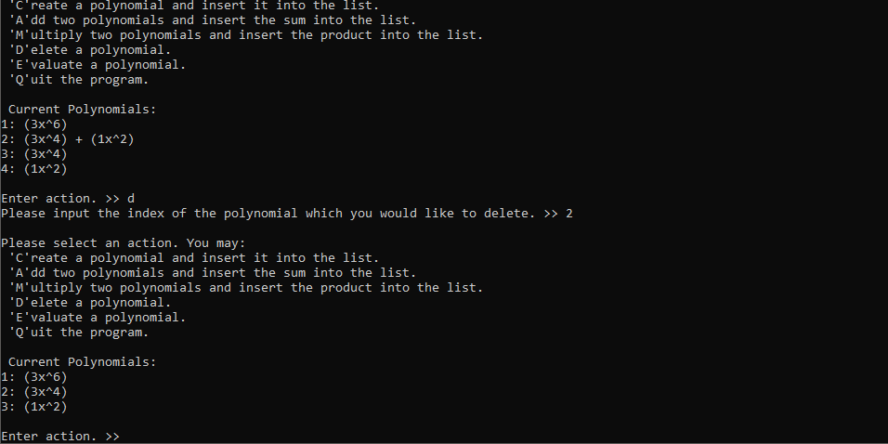

Evaluating a polynomial

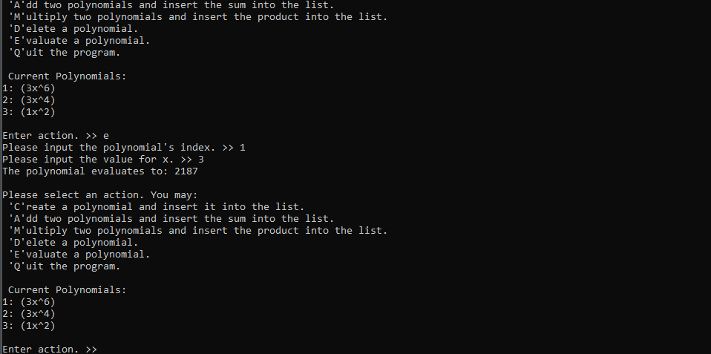

Quit program

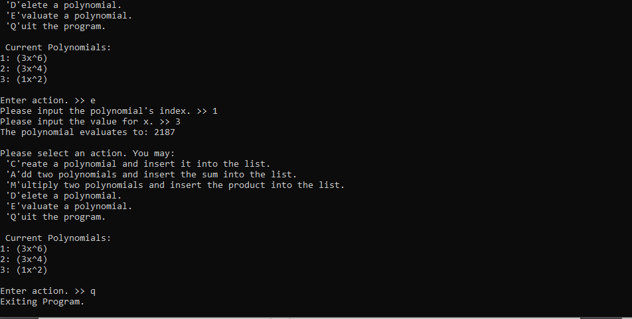

Error Handling

Main menu, invalid character

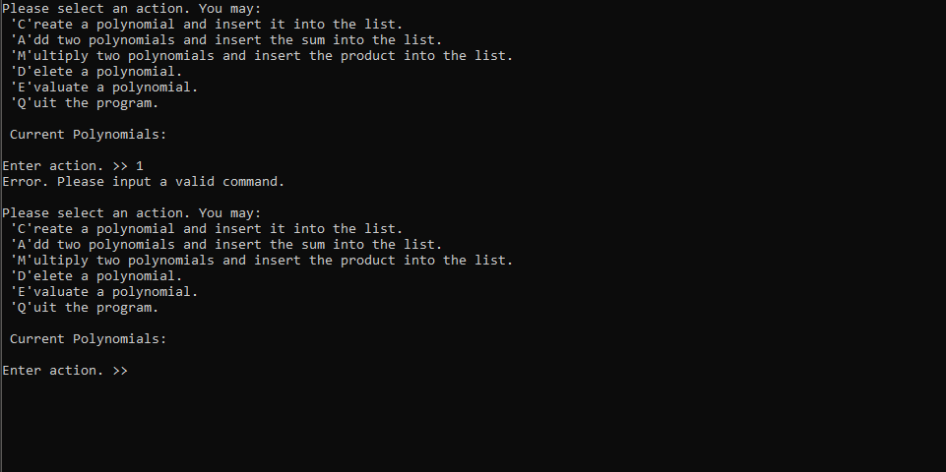

Create polynomial, invalid character

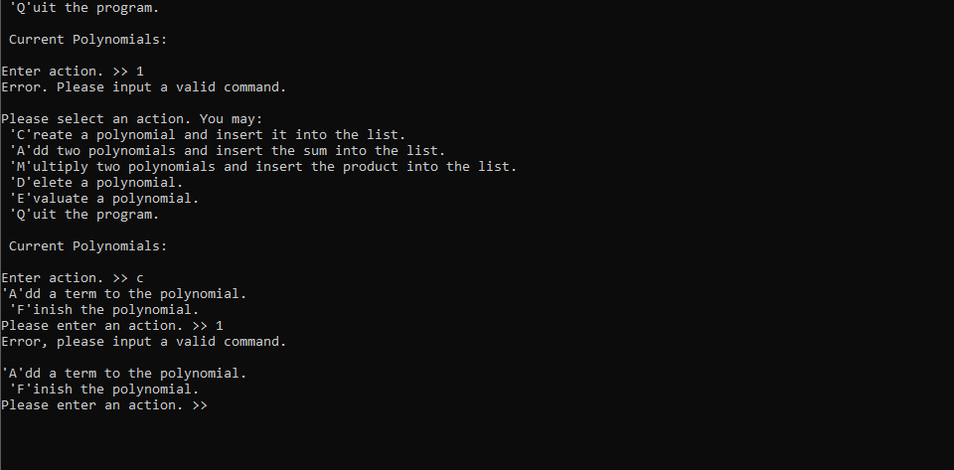

Create term, invalid character

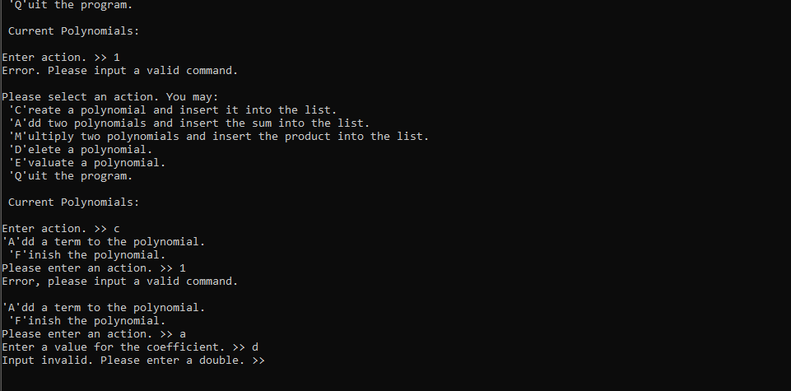

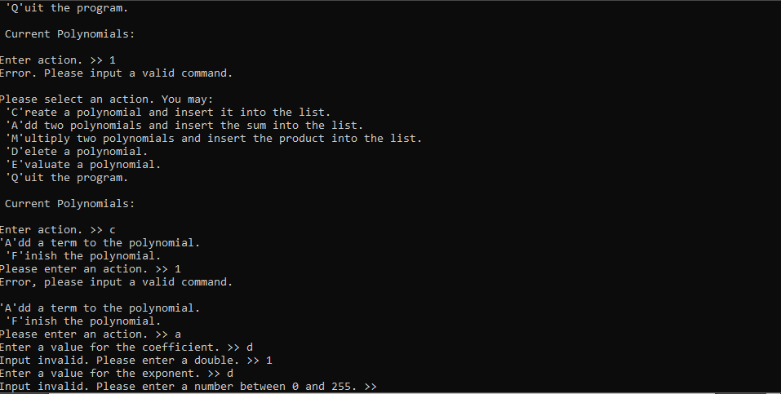

Adding polynomials, invalid character and out of bounds index

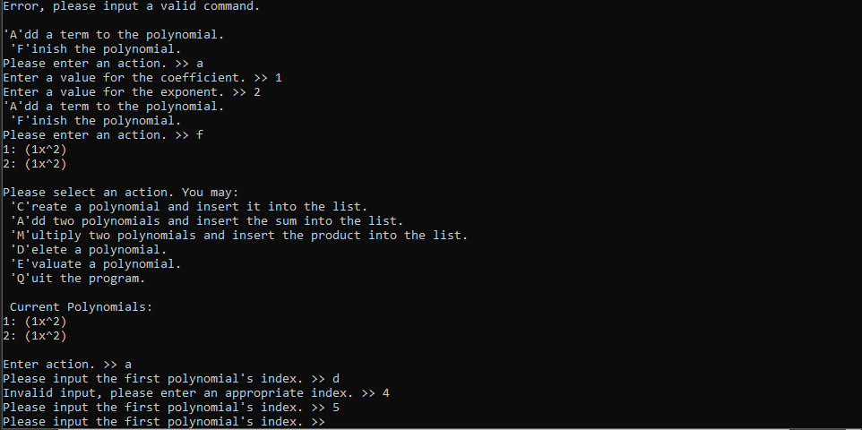

Multiply polynomials, invalid character and out of bounds index

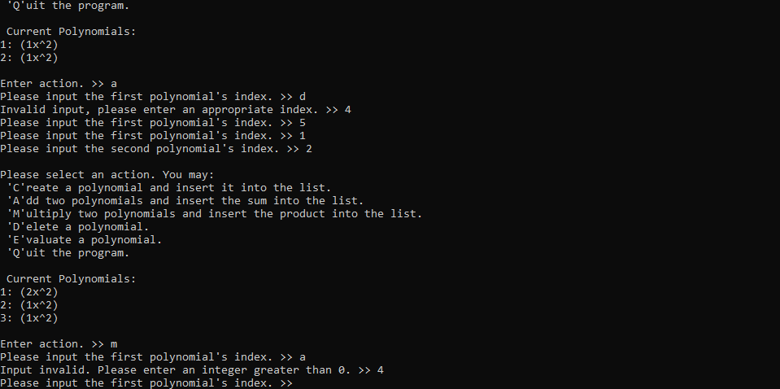

Delete polynomial, invalid character and out of bounds index

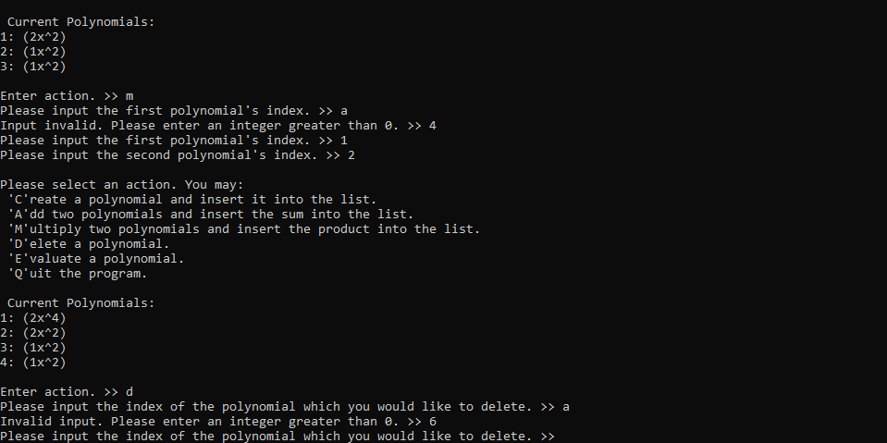

Evaluate polynomial, invalid character

