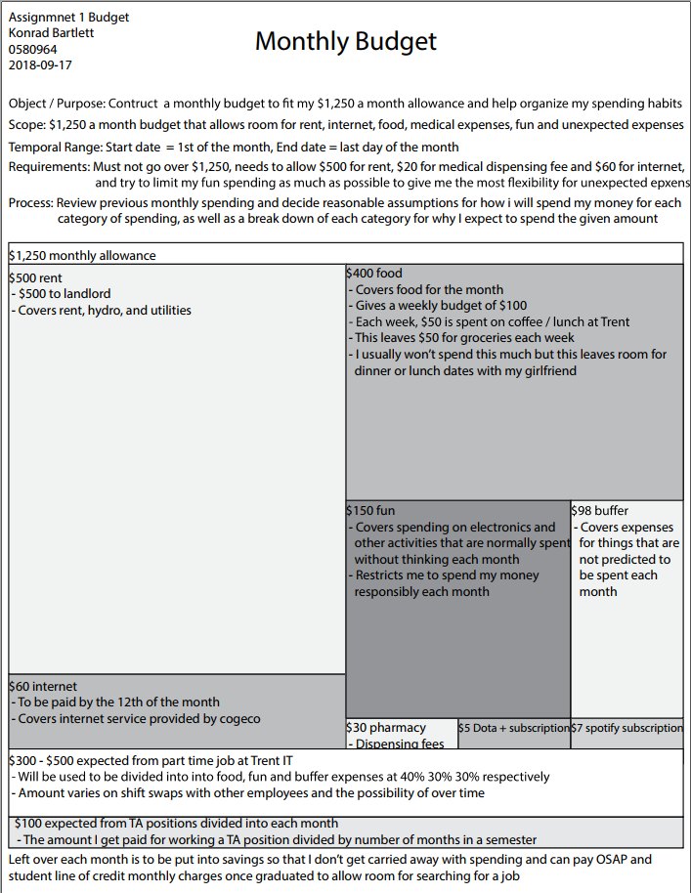

Konrad Bartlett

0580964

2018-09-17

Assignment #1 – Budget

Beginning the assignment, I started by outlining my monthly budget as what I am allowed as well as the main categories that I would plan to spend my money on: rent, internet, food, and extra for just regular spending.

I continued from there to break down the scope of the budget, and later the requirements to be met by organizing my budget, this led to me outlining spending that needs to be spent each month and won’t vary including rent, internet, and medical expenses, all of which I know I will end up spending monthly.

Specifying the temporal range was simple as it is a budget based around the amount of money that I will be allowed each month.

Later I outlined the process at which I will decide the amount to go into each category and specified that I will do a simple breakdown of what each amount will be spent on. I finished by including income amounts which I cannot guarantee I will receive so I kept them out of my main budget and included them as extra amounts at the bottom of my budget break-down.

In terms of frustrations of the budget, I didn’t have many as the amounts chosen are based on amounts spent from previous bank statements and it was just a matter of identifying which categories to include each expense in and then averaging spending habits and deciding what the hard limits of each category would/could be.

Questions which supported forward movement were centered mainly around how I would break up the flexible spending categories, food, fun, and buffer. Obviously because these are flexible they tend to vary from month to month and I opted to lower the amount which I would be willing to spend on “fun” expenses in order to seem more responsible and pretend I would actually spend that money on food, even though it’s normally the other way around. However, because the goal of this budget was to realistically set guidelines on my spending and organizing my spending habits I figured giving myself a smaller capped budget for fun expenses will let me be more responsible going forward.

Another question which arose was what I would do with my monthly income as it is an amount that varies, and I cannot guarantee any amount for my income as there could be a month where I don’t work at all. Because of this I opted to exclude the income from my main budget plan and keep it at the bottom and specify the percent that I would break it into other categories.

I started the project completely differently focusing on the budget for a custom computer build, however, because those costs are very fixed and don’t vary much it wasn’t exciting and as it was more of a process of adding prices together I felt it wasn’t good for the process as it was deciding the budget at the end rather than working within the constraints of a budget that is fixed. From there I worked through 2 prototypes of my current budget where I changed how I spent the food/fun categories, one where I broke down what I would spend my food money on each time I went to the grocery store (ex receipts, eggs, bacon, milk), but that added a lot of clutter and didn’t communicate the idea clearly so I opted to instead to keep the spending ambiguous and just an amount. My second prototype was more of a list rather than a percent based area idea, while the list is effective at specifying how each category would be broken down individually, once I got rid of the receipt specification I felt the result was fairly empty and didn’t communicate much other than just what the expenses would be. That’s why I added the area concept in order to communicate an easy way to compare categories and really give an easy way to look at the scope of each category. Included in each area is then a smaller condensed list that breaks down the obvious expenses, what they cover, and how the money will be used.

The worst experience from this assignment was realizing how irresponsible I actually am with my money and that I spend way too much on fun spending. Other than that, the task was fairly fine and I didn’t derive much hate towards it at all.

Moving forward in the course I will focus on the processes specified in the lectures even if they are named after a person and see how I can apply them to my normal life. Usually when steps are outlined in a lecture I’ll memorize them and never use them in real life but following Mary’s Steven Steps made this process very efficient and resulted in a clear and concise budget that easily communicates my goal to the user effectively.