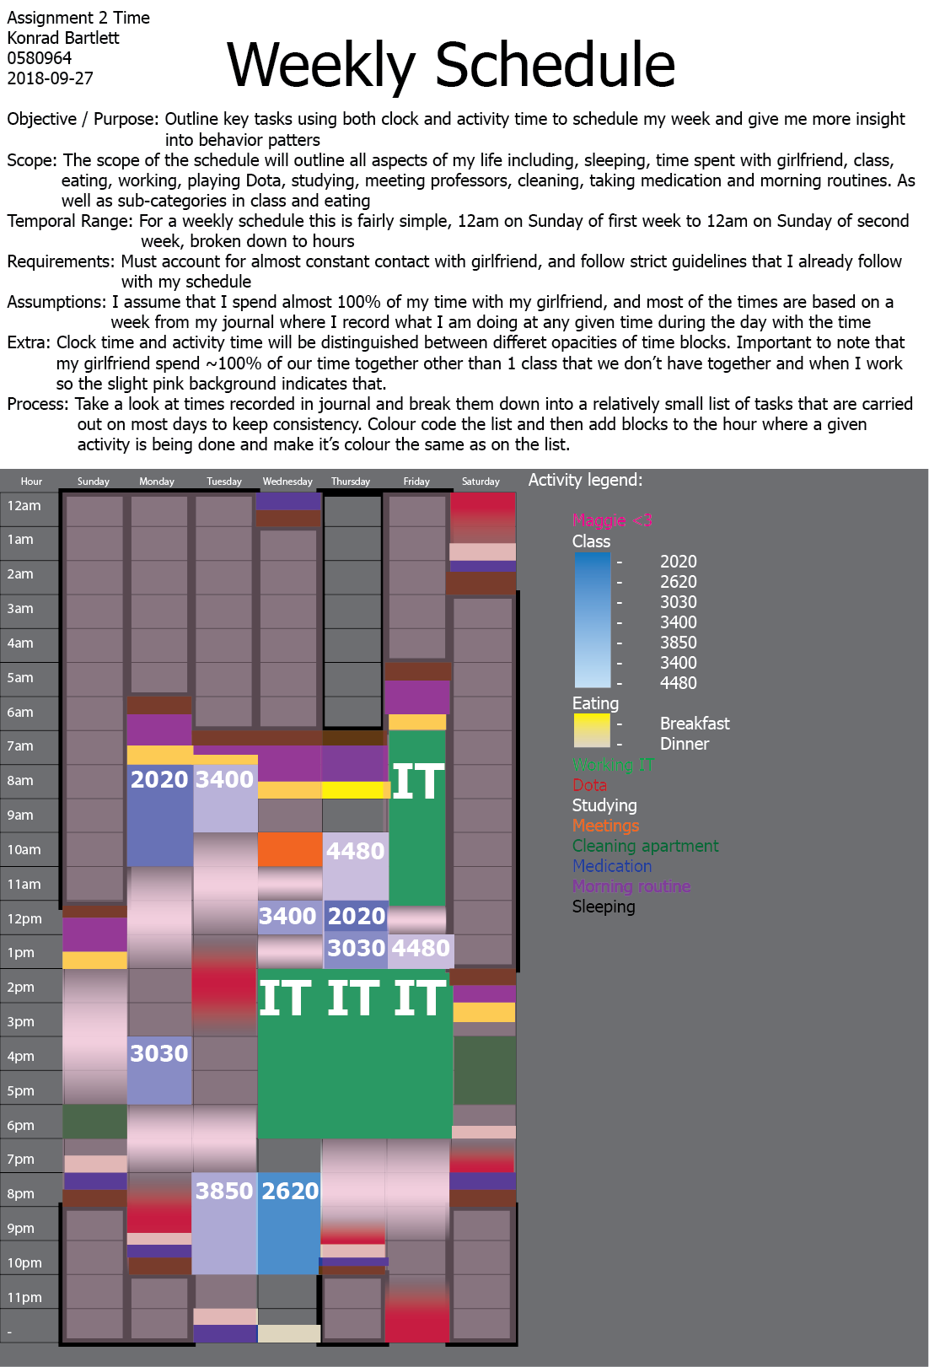

Konrad Bartlett

0580964

2018-09-27

Assignment #2 – Time

The goal of the schedule was to communicate as much information about my personal schedule, with as much detail as possible without words, while still trying to reduce clutter and present in a pleasant format.

Beginning this assignment, I am almost lucky that I have a weird personality and have a journal where I record what I am doing at any time of the day. This meant that I could just use data that already existed from my life and transform it into a viable format for this project. So, I collected my data by simply picking a recent week in my journal and then continuing to the next step. The organization already given in my journal made the design decision of how I would break up my temporal space as in my journal it was already broken down into 24 hour blocks every day for 7 days a week.

I started by creating a list of tasks that are regularly carried out during my week that also have relevance for other weeks. For example, the list started as everything I had in my journal for the week, and the I slowly clustered the activities in a hierarchical structure that can still be seen with the sub-categories under class and eating in the activity legend. An example cluster would be: Wednesday 12pm COIS 3400 lab -> COIS 3400 -> Class. This clustering gave me a condensed list of activities that are carried out consistently and gave me simple categories of tasks to then be used across the days. I then laid out schedule itself and realized that I hadn’t made a category for when I spend time with my girlfriend, mostly because my girlfriend and I have a very attached relationship and are inseparable at the hip, other than classes that we don’t have together and while I’m working we spend all of our time together. This realization gave me the good idea to add a girlfriend category and colour it pink, I then applied a pinkish haze to all the times that I would be with my girlfriend so that all those times have some pink indicating that my girlfriend is with me.

This opacity put on the pink haze gave me a good idea of how to differentiate between clock time activities and activity time activities, where I made clock time activities completely opaque, and made activity time activities have an opacity gradient that fades at the tops and bottoms of the blocks. What this communicates to the user is that there’s almost a probability for me doing that activity at a given time and that probability increases as the opacity increases. Clock time remains completely opaque because those are hard scheduled times that don’t change, so I will always be doing that activity at that time.

After colouring the girlfriend blocks and deciding about how I would go about separating clock and activity time I started to just take the colours from the list and then apply them to the corresponding blocks. Some blocks colours were very similar to other blocks colours that were close neighbors on the schedule. This lead to me adding the minimal amount of labelling required to separate for example forest green, from dark green. This is just a limitation of there only being ~10 distinct colours available for use and the need to use colours that are similar to other colours. After colouring the blocks, it was then just a matter of breaking out the ruler tool and making sure that everything aligned nicely with everything else in the schedule and adding some nice polish. Then I was finished.

There wasn’t much difficulty when developing this schedule other than the actual action of copying times over to the schedule and then deciding what colour each category should be. Time is something that I already try to do a very good time of scheduling so there were no difficulties in outlining my time. Instead however I had difficulty deciding what I was going to communicate to the client, the colour coding works only so well so some blocks have a label as to what they are, while most remain unlabelled just assuming that the client would understand the legend. I left sleep just as colour coded borders to emphasize the lack of activities being done during this time.