Konrad Bartlett

Assignment 5

COIS 2620

2018-11-02

Redesign

The apartment that I live in is extremely poorly laid out. The house is over 100 years old and it was divided into 3 separate apartments, with the bottom 2 floors being split into 2 apartments horizontally, and my apartment in the attic separated vertically. The result is that the apartment that I live in must fit within the confines of the attic that already existed, instead of having walls designed for the apartment itself. What we need to especially keep in mind is that the space within this ceiling is largely hollow leading right down to the side of the house.

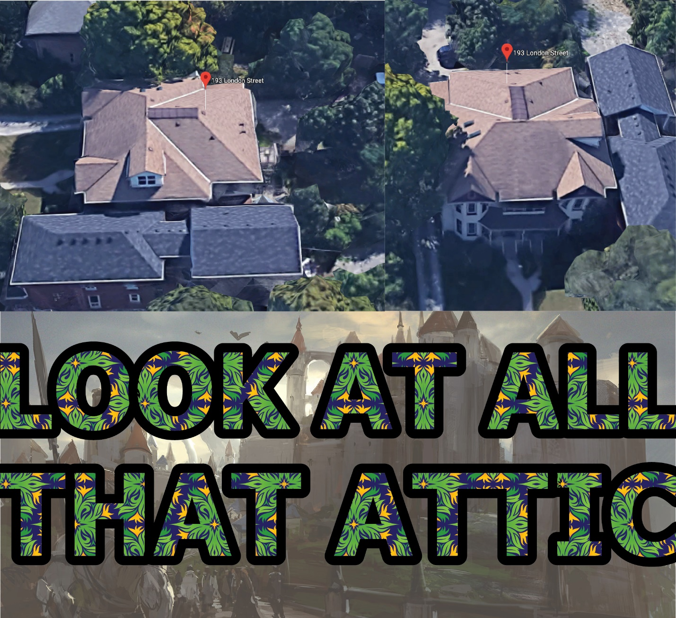

My proposal is to completely redo the 3rd floor of my apartment in order to create a new modern design much in line with the current trends of tiny houses. A house on top of the other house. This redesign would require a complete reconstruction of a section high section of the house and would require many hundreds of thousands of dollars which is why I am relying on my landlord to cover construction fees.

I began by identifying the two key areas of the house that were my biggest issues, the wall layout, and the staircase on the back of the house.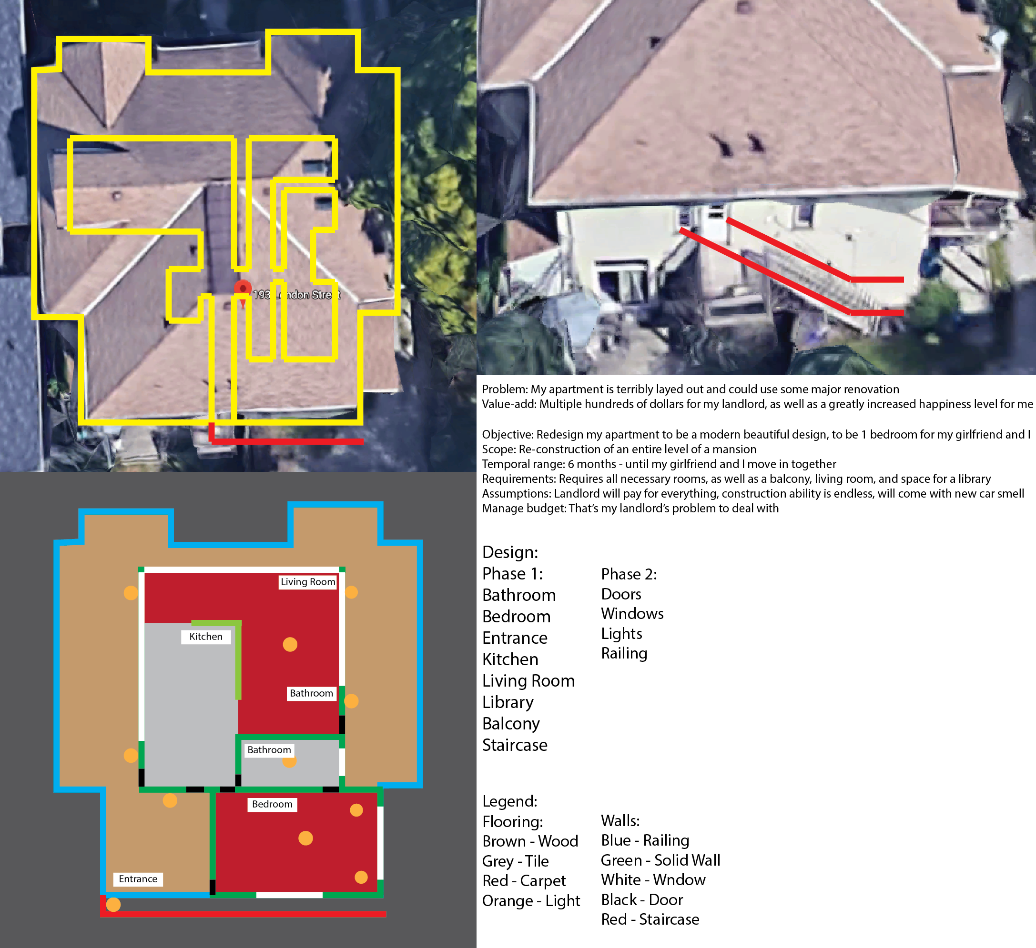

I mapped the current interior layout of the apartment based on window placement, and ceiling contours, to communicate the extent of the misuse of space. From there I traced the perimeter of the apartment and took that as my foundation of the new space. Built on top of the already existing house will now be a modern tiny home in the center surrounded by a terrace like balcony that wraps around majority of the building.

The design needed to be very modern and so I went for a design that would allow for an open concept, with large rooms, but still privacy for the bedroom and bathroom. This resulted in the bedroom and bathroom being walled off from the rest of the house, and placed towards the back to maximize on the amount of privacy that would be provided, apart from that though the kitchen, living room, library were all placed together in 1 open space room, that would be wrapped around with windows for walls to ensure maximum brightness and modern design. I left the entrance as a wooded deck area though I would expect there to be some sort of overhang above the extended staircase and entrance area to prevent the problem of my steps icing over in the winter time.

I then moved on to working on the re-working the staircase as it would have to be extended to reach the top of the roof.

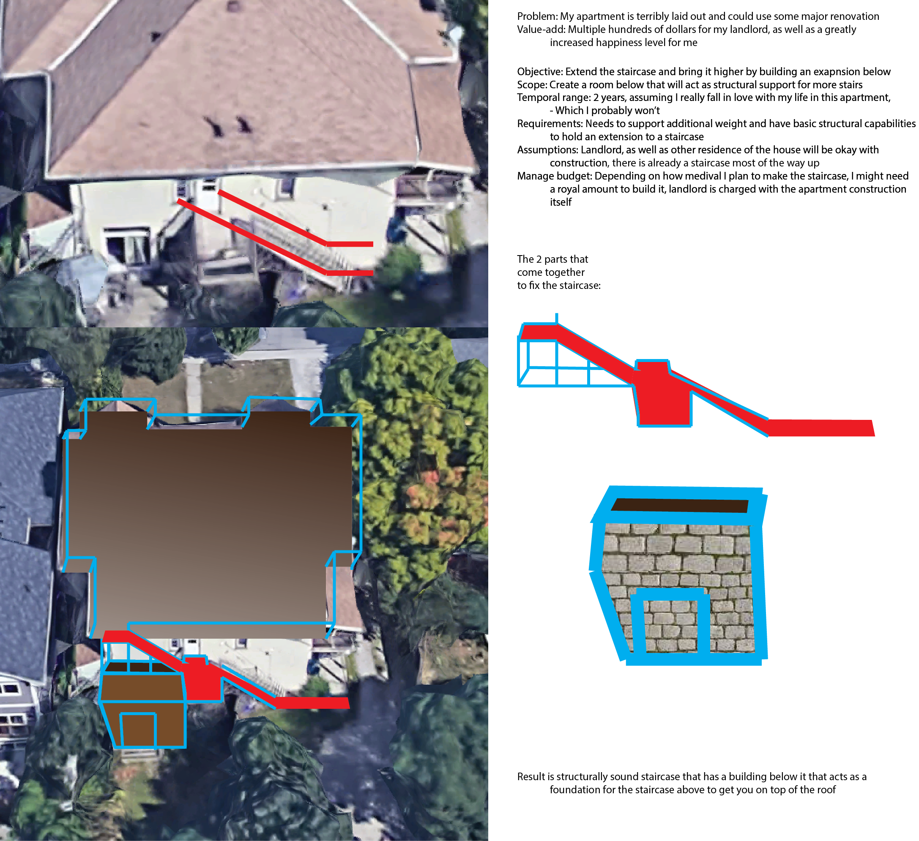

I drew over top of the image, first tracing the staircase, then continuing to define what would need to be added to support the extension of the staircase. This is where I came up with the idea of also extending the apartment downstairs outward to provide a more solid support rather than having to worry about a structural beam system. This is an easy and more elegant solution that also improves the value-add of other apartments that exist in the building.

Reflection:

The goal of the redesign was to firstly communicate how poorly the apartment is currently laid out, while also providing a reasonable fix that is well within the grasp of reality.

In beginning the assignment, I spent the first few days simply thinking about what I could redesign. Software, hardware, road layouts, and then settled on my apartment after having a revelation about how much better it could be designed. This was a relatively easy thing to come across as my apartment is a major cumbrance in my daily life, and usually gets in the way of everyday activities. For example my kitchen is currently about 6m2 and consists of a tiny hallway, which makes it very difficult to cook anything, layer on top of there my lack of toaster, microwave, and oven and things get really interesting in the kitchen. Stuff like this can be seen in the redesign however where you’ll notice that the kitchen in the redesign takes up about half of the entire floor space of the building itself.

After deciding on redesigning my apartment I worked out just how to layout the new apartment itself. I knew that I was going to completely chop off the roof of the apartment to make room, but the space of each room needed to be carefully measured and designated. I started by laying out the rooms themselves and deciding optimal placements for access to things such as the washroom, the staircase, and the balcony. I then moved on to place doorways, windows, and lights focusing on privacy near the back of the house and clarity around the front of the house. At this point I largely had the redesign of the apartment itself done so it was just a matter of shuffling things around a few times before I settled on a layout that I was happy with.

After the design on the roof was done I moved on to figuring out how we would get a staircase up there. The result turned out to be pretty simple. Because I am on top of such a high place the only real way to go higher is to just build higher. So that’s what I designated to be done, but just extending the staircase until it reached there the new foundation of the apartment was going to be. Underneath the staircase there needed to be some sort of support so I added a room to the apartment below just beneath where the staircase was going to be put so that the support beams for the staircase wouldn’t get too long.

Overall in this assignment I didn’t find there was much difficulty. The hardest part really was picking a subject to redesign, with an assignment specification so open to interpretation it can be difficult to decide what it was that I wanted to focus on. After that however the most difficult part was when I showed it to my girlfriend and she said she didn’t like the idea, so I had to take that input to heart and then ignore it which was difficult. Even now she teases me by saying, “I just wouldn’t live there…”, when I was reading over this reflection to her.