Sinking Ship Studios

Konrad Bartlett

COIS 2620 A7

2018-11-28

Contents

Executive Summary 3

Objective 4

Draft proposed design by tenant: 4

Statement of Need 5

Scope / Temporal Range 5

Requirements 5

Project Activity, Methodology 6

Evaluation and Outcomes 6

Assumptions 6

Budget and Funding 7

Invoice 8

# Executive Summary

The following project pitch outlines a proposal for the redesign of apartment 3 at 193 London St. The current tenant of 1 year is unhappy with the quality of living provided by the current floor layout of the house. He has pitched the idea to Sinking Ship Studios to help him design, develop, and construct a new building in place of his current apartment.

Sinking Ship Studios provides clients with reliable, high-quality services in the industry and ensure that costumers receive products that exceed expectations. We are a company dedicated to satisfying our customers in order to keep them coming back. Out commitment to quality and service makes us a valid and worthwhile investment.

Quality Parts emphasizes development of the most popular parts with the highest need. Our supply philosophy allows us to meet the needs of the widest range of customers, creating a great supply for a high demand.

At Sinking Ship Studios, the client comes first. By meeting the needs of every customer that walks through our doors, we create a word-of-mouth marketing model that allows us to expand dramatically within our industry.

|  |  |
| --- | --- |
| **Problem** | **Solution** |
| There are animals in the walls | Replace walls with large glass panes, and create walls that do not allow small animals to get in. |
| The building is not eco friendly | Get glass that is currently involved in activist groups that protest climate change, and utilize materials that are environmentally conscious. |
| The apartment is currently susceptible to ninjas | Ninja proof the building with booby-traps, as well as make the exterior of the building more difficult to traverse and climb. |

# Objective

Sinking Ship Studios is proposing a redesign to the 3rd apartment located at 193 London St. in Peterborough Ontario. The purpose of this redesign is to improve the quality of life for the tenant living on site, as well as to improve the longevity of the apartment to ensure that the landlord will have a house that is an attractive option for future tenants to rent.

The project is to be conceptualized by the current tenant, Mr. Konrad Bartlett, and then handed to an architect to create drafts of a layout to make sure it reaches requirements for safety and structural stability. From there it will be passed to a series of interior designers and building planners to create a beautiful aesthetic as well as fill in documentation regarding the wiring and plumbing of the proposed building. The tenant shall then move out, and the project will be passed to a team of construction experts who will complete the task of building the new structure, after which the tenant will move back in.

# Draft proposed design by tenant:

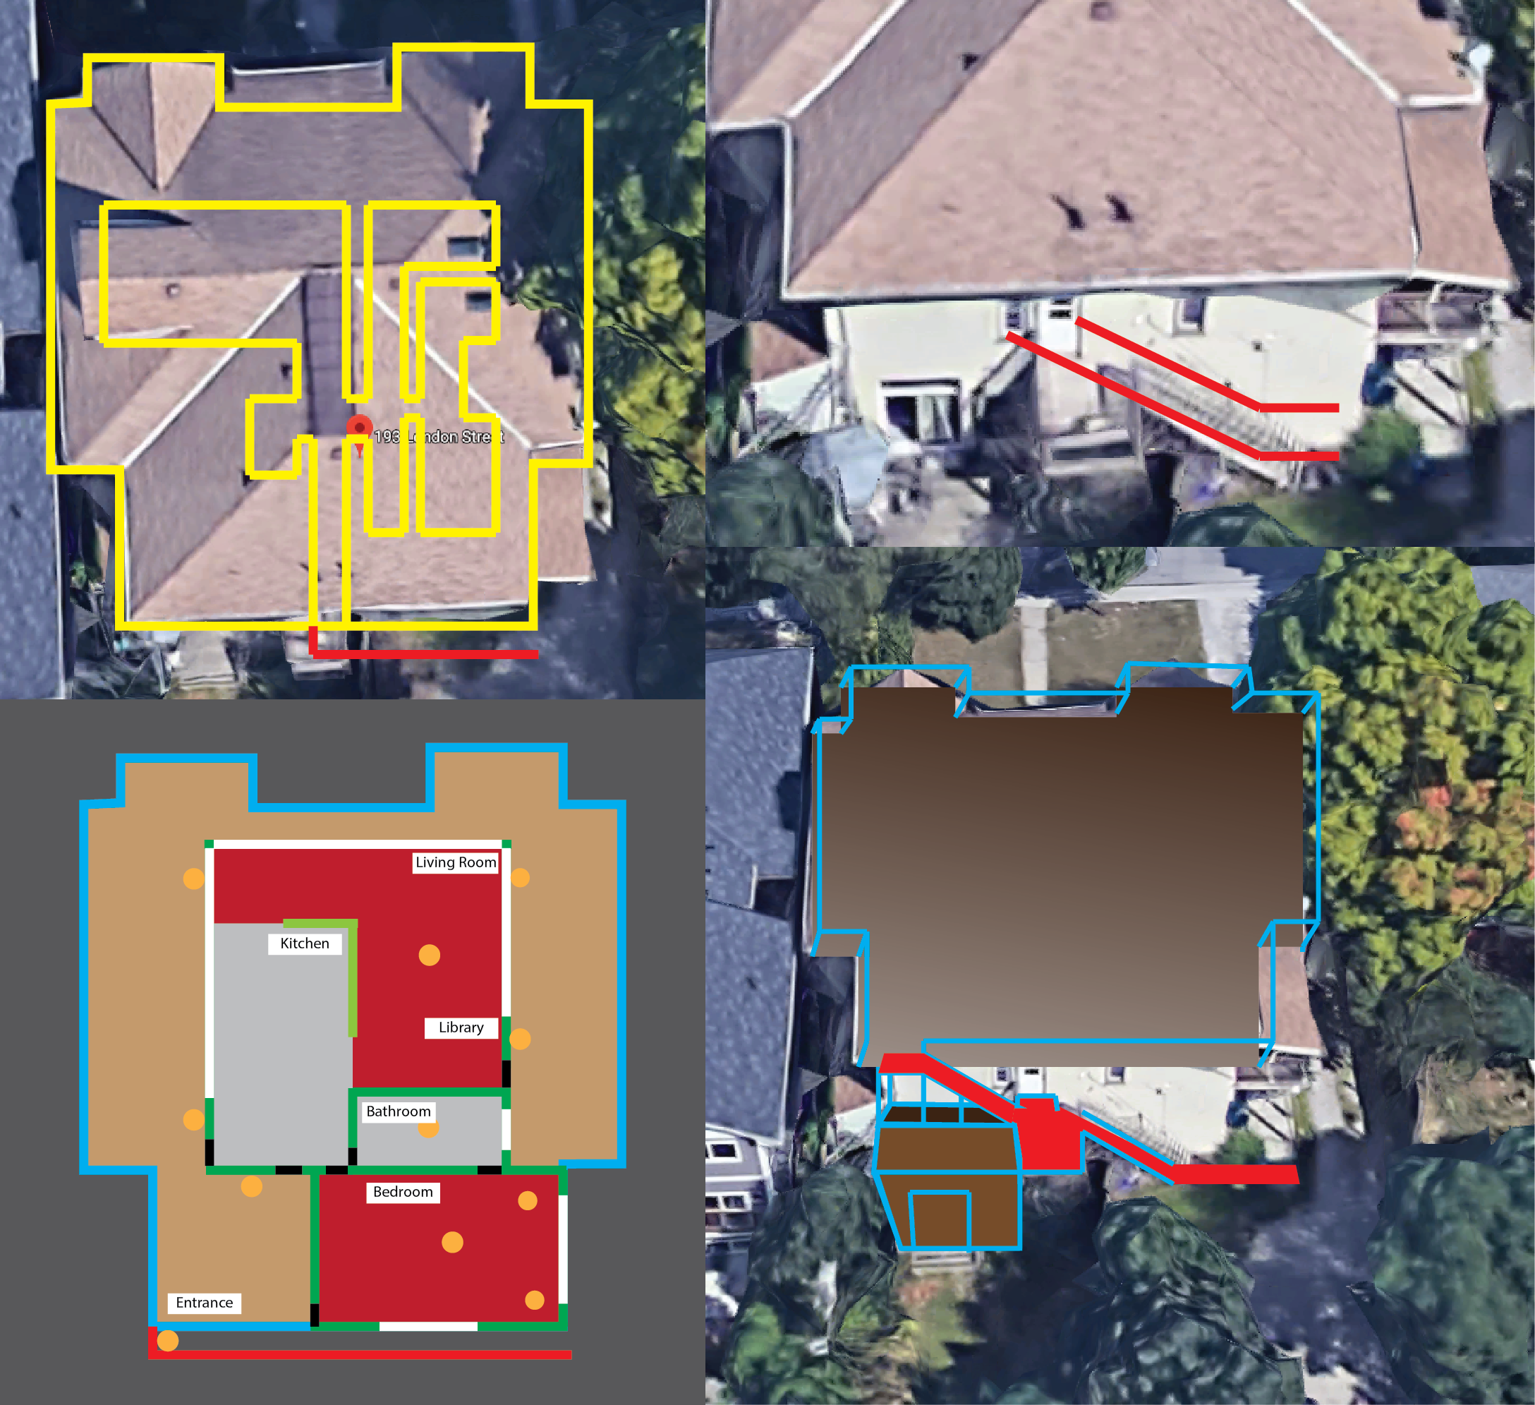

# Statement of Need

The current design of the apartment wasted a tremendous amount of room by not utilizing the entire space under the entire roof. On top of that there is a non-functioning fridge, animals in the walls, and an unintuitive design that just overall doesn’t make sense. On top of this the current entry point has a very real possibility of being breached by ninjas. A reworking of the apartment is necessary in order to facilitate the current tenant who is becoming increasingly irritated at the current state of the apartment. There is also incentive for the landlord who will benefit from the increased property value and be able to charge a higher monthly rent to tenants.

# Scope / Temporal Range

The project covers the entire redesign of 1/3rd of a century home, requiring the project meet bylaw codes as well as satisfy the tenant’s desires for a new apartment. In the scope of the project is the demolition of a 3rd floor apartment, as well as the blueprinting and design of a new apartment to take its place, construction is to take place by a separate team but is also included in the scope of this project.

This project is to be taken place over the course of a maximum of 10 months, with 2 months being dedicated to project management and planning, and then other 8 hours dedicated to construction as well as final touch ups.

# Requirements

* The final design of the apartment is to meet the satisfaction of the current tenant
* Must be approved by homeowner
* Must be completely structurally sound, and include all electrical and plumbing
* Must meet all construction codes for the city of Peterborough
* Permits are to be acquired before construction of building
* Must include ninja proofing features
* Must use eco friendly products, and have activist windows
* Design must repel animals while still caring for them
* Construction and design budget must be within $100,000

# Project Activity, Methodology

The project is being pitched as a complete redesign of the building due to the overall quality of the building currently being very low. The tenant currently does not see any purpose in doing simple adjustments to the inside of the building and working within the confines of the roof doesn’t allow for much room. The landlord has also agreed that a redesign is necessary over a reworking due to the age of the building and the desire to charge more for rent.

The project will be broken into 3 phases:

1. Development which will cover the design, drafting, and blueprinting of a new apartment building.
2. Construction which will include the actual building of the apartment itself.
3. Review which will provide the tenant and landlord the flexibility and comfort of knowing that they will have the ability to adjust the building after initial construction is complete.

# Evaluation and Outcomes

Progress for design will be measured and reported bi-weekly and shall include the following in reports:

* Current phase of project
* Tasks completed this term
* Outstanding tasks
* Difficulty in completing certain tasks
* Suggestions for changes to the project given new circumstances

The Construction team will report building reports that include:

* The current progress of the building
* Completed tasks
* Roadblocks preventing further construction in a given area

The deliverables are in order:

* A project charter documenting funding as well as stakeholders
* A floor plan and design blueprint for both a new apartment as well as a stair extension
* A constructed apartment for the current tenant to live in.

# Assumptions

* The landlord has assumed all costs required to undertake the project
* The project goal is achievable in approximately 8 months
* The tenant will sublet off premise during the stages of construction
* The landlord will not collect rent during construction process to allow tenant to afford to sublet
* The developed house will be structurally sound and meet tenant’s expectations
* The building is to be eco friendly, animal free, and repel ninjas
* The tenants living below are okay with construction occurring on their building
* All permits will be granted

# Budget and Funding

|  |  |  |
| --- | --- | --- |
| **Category** | **Amount** | **Description** |
| Materials | $14,400 | Covers cost for construction materials, including specialized slip ‘n’ slides |
| Construction | $60,000 | Wages for construction workers, as well as permits |
| Design | $19,500 | Cost of architectural design and building assessments |
| Living Expenses | $600 * 8 | Cost of current tenants sublet rent |
| Extra | $1,300 | Covers cost of donuts and coffe |

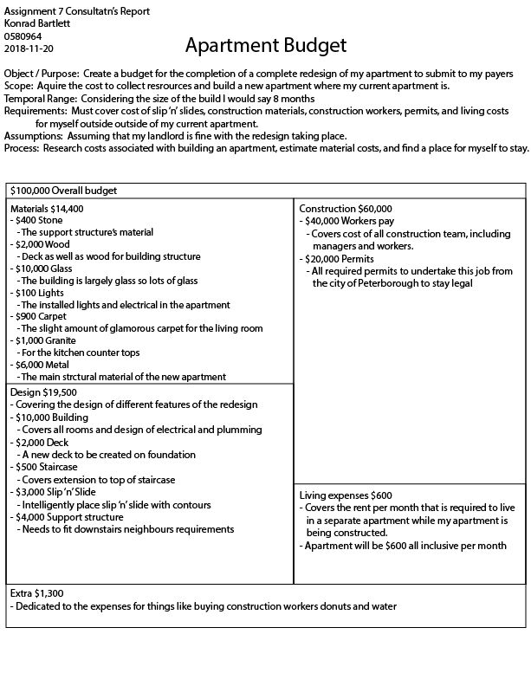

# Invoice

Sinking Ship Studios

Project #: 009085

Client: Konrad Bartlett

Phone: (123) 456 – 7890

Location: 193 London St. Peterborough Ontario

Date: November 28, 2018

|  |  |
| --- | --- |
| **Expense** | **Cost** |
| Build Cost | $100,000 |
| Sinking Ship Studios Fee ($25 / hr) | $40,000 |
| Taxes (13%) | $18,200 |
| Permits | $1,800 |
|  | $160,000 |

To be paid monthly at the cost of $20,000 / month for the duration of 8 (+ - 2) months

Client Name: Konrad Bartlett__

Client Signature: Konrad Bartlett ___ Date: 2018, 11 – 27

Witness Name: Maggie Kikkert___

Witness Signature: Maggie Kikkert ___ Date: 2018, 11 – 27