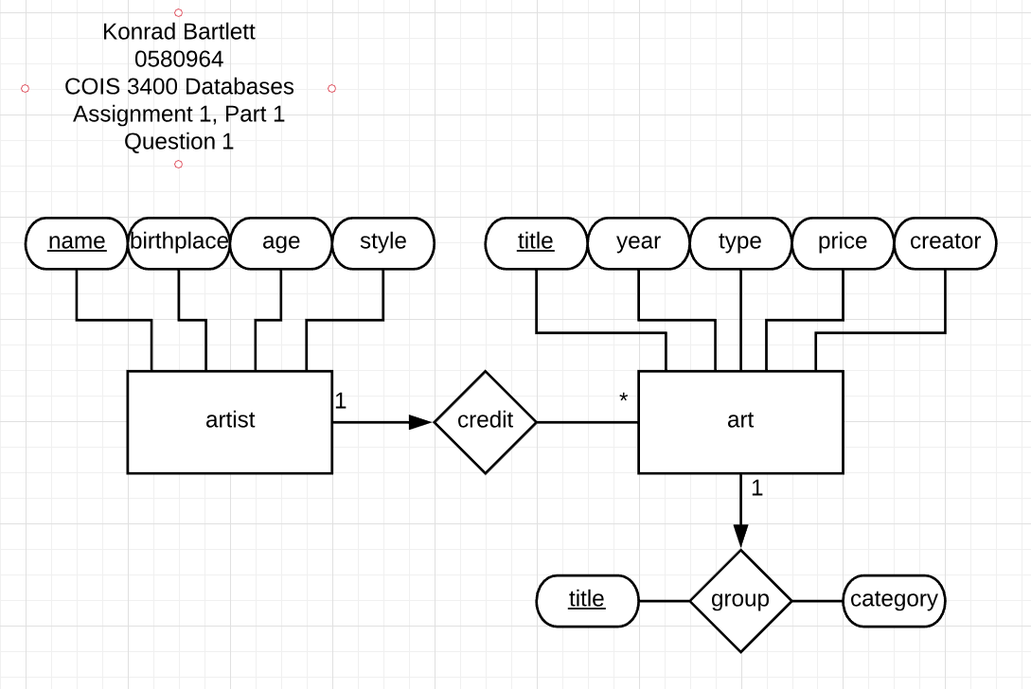

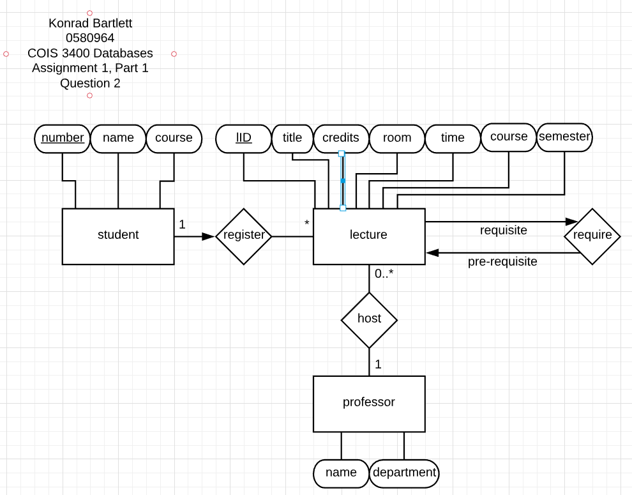

Assignment1, Part 2 Question: 1.

[SELECT](http://localhost/phpmyadmin/url.php?url=https://dev.mysql.com/doc/refman/5.5/en/select.html) * FROM `table 1` ORDER BY `table 1`.`first_name` ASC;

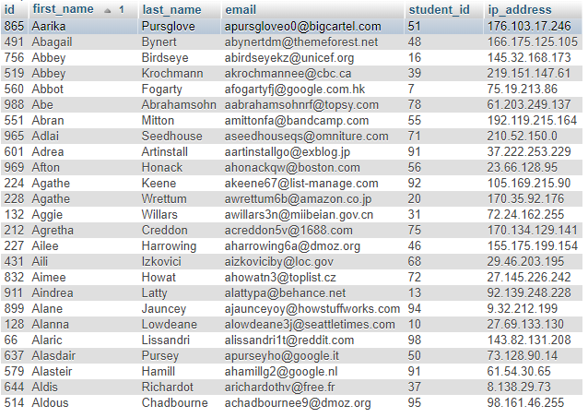

Assignment1, Part 2 Question: 2.

[SELECT](http://localhost/phpmyadmin/url.php?url=https://dev.mysql.com/doc/refman/5.5/en/select.html) `first_name` FROM `table 1` WHERE `first_name` [LIKE](http://localhost/phpmyadmin/url.php?url=https://dev.mysql.com/doc/refman/5.5/en/string-comparison-functions.html#operator_like) 'A%';

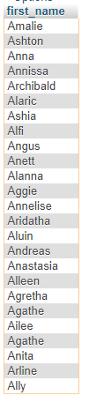

Assignment1, Part 2 Question: 3.

[SELECT](http://localhost/phpmyadmin/url.php?url=https://dev.mysql.com/doc/refman/5.5/en/select.html) * FROM `table 1` WHERE `first_name` LIKE '%ch%' [OR](http://localhost/phpmyadmin/url.php?url=https://dev.mysql.com/doc/refman/5.5/en/logical-operators.html#operator_or) `last_name` [LIKE](http://localhost/phpmyadmin/url.php?url=https://dev.mysql.com/doc/refman/5.5/en/string-comparison-functions.html#operator_like) '%ch%';

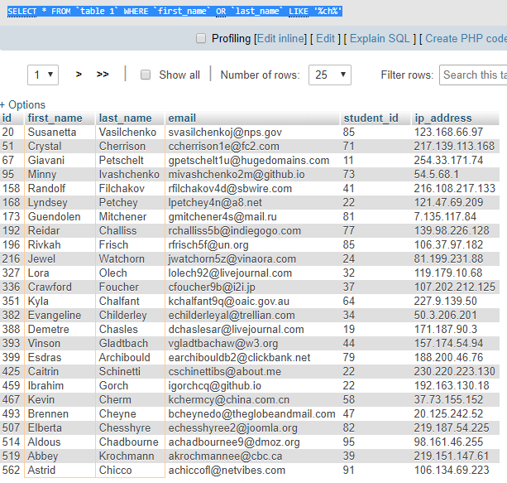

Assignment1, Part 2 Question: 4.

[SELECT](http://localhost/phpmyadmin/url.php?url=https://dev.mysql.com/doc/refman/5.5/en/select.html) `first_name`, `last_name`, `ip_address` FROM `table 1` WHERE [LEFT](http://localhost/phpmyadmin/url.php?url=https://dev.mysql.com/doc/refman/5.5/en/string-functions.html#function_left)(`ip_address`, 3) <= 100;

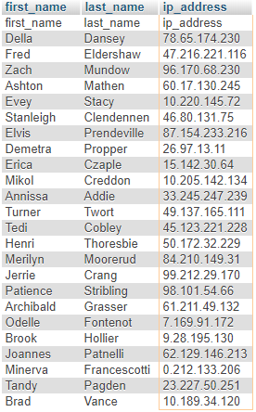

Assignment1, Part 2 Question: 5.

[SELECT](http://localhost/phpmyadmin/url.php?url=https://dev.mysql.com/doc/refman/5.5/en/select.html) * FROM `table 1` WHERE `email` [LIKE](http://localhost/phpmyadmin/url.php?url=https://dev.mysql.com/doc/refman/5.5/en/string-comparison-functions.html#operator_like) '%@reddit.com';

