Part 1:

1 - Construct an SQL query that will show the assignedID, professorName, and the professor’s home department for each professor that teaches a 2000 level course (all course codes that begin with a two). (2 points)

[SELECT](http://localhost/phpmyadmin/url.php?url=https://dev.mysql.com/doc/refman/5.5/en/select.html) prof.assignedID, prof.name, prof.dept, prof.gender, course.course FROM prof [RIGHT](http://localhost/phpmyadmin/url.php?url=https://dev.mysql.com/doc/refman/5.5/en/string-functions.html#function_right) JOIN course ON prof.assignedID=course.IID WHERE course.course [LIKE](http://localhost/phpmyadmin/url.php?url=https://dev.mysql.com/doc/refman/5.5/en/string-comparison-functions.html#operator_like) '2%'

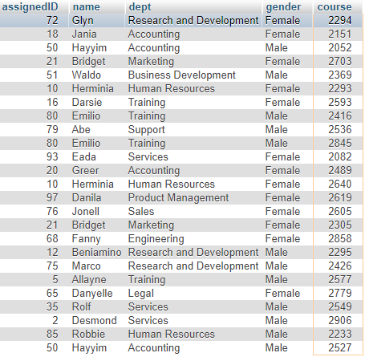

2 - Construct an SQL query that will show all the course IDs, lectureTimes, and Lecture durations for the Engineering department. (2 points)

[SELECT](http://localhost/phpmyadmin/url.php?url=https://dev.mysql.com/doc/refman/5.5/en/select.html) dept, course, `time`, length FROM course WHERE (dept = 'Engineering')

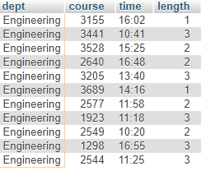

3 - Business Development 3332 is no longer being taught by George (assignedID = 77), it is being taught by Royall (assignedID = 88). Update the course table to reflect this change. (3 points)

[UPDATE](http://localhost/phpmyadmin/url.php?url=https://dev.mysql.com/doc/refman/5.5/en/update.html) course [SET](http://localhost/phpmyadmin/url.php?url=https://dev.mysql.com/doc/refman/5.5/en/set.html) IID = 88 WHERE course = 3332

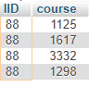

4 - In this imaginary university, they have a rule that states any professor cannot lecture for more than 6 hours per week. Construct an SQL query that will find any professor that is lecturing for more than 6 hours per week (please note the result set may be empty). (3 points)

[SELECT](http://localhost/phpmyadmin/url.php?url=https://dev.mysql.com/doc/refman/5.5/en/select.html) prof.name FROM (course [RIGHT](http://localhost/phpmyadmin/url.php?url=https://dev.mysql.com/doc/refman/5.5/en/string-functions.html#function_right) JOIN prof ON prof.assignedID=course.IID) GROUP BY name HAVING [SUM](http://localhost/phpmyadmin/url.php?url=https://dev.mysql.com/doc/refman/5.5/en/group-by-functions.html#function_sum)(length) > 6



5 Bonus: write a PHP or Python DB-API script with an HTML5 frontend that will add a professor to the professors table. (2 points)

<html>

<body>

<center>

<H1> Add a professor </H1> <br>

<form action="index.php" method="post">

Professor's name: <input type="text" name="name"> <br> <br>

</center>

</form>

</body>

</html>

<?php // PHP tag

$name = $_POST['name']; // Collect input

echo($name); // Debug input

$conn = mysqli_connect("localhost","root","","assignment2"); // Connect to a2 database

// Check for connection failures

if (mysqli_connect_errno($conn)){

echo " Failed to connect: ".mysqli_connect_error();

} else {

echo " Connected successfully\n";

}

$sql = "INSERT INTO prof(`name`) VALUES ('$name')"; // SQL statement to insert name

// Check for query failures

if ($conn->query($sql) === TRUE) {

echo "New entry";

} else {

echo "Error " . $sql . $conn->error;

}

mysqli_close($conn); // Close connection

?>

Example:



[SELECT](http://localhost/phpmyadmin/url.php?url=https://dev.mysql.com/doc/refman/5.5/en/select.html) * FROM `prof` ORDER BY `name` ASC



Part 2

1 - Normalize the following DB schema up until 3rd normal form: Employee(eid, first name, middle name, last name, date_of_birth, home_address, national_insurance_number, first_day_of_employment). Remember you need to show your steps starting with 1NF, 2NF, until 3NF. (5 points)

