COIS 3400

Assignment 3

Konrad Bartlett

2018-11-24

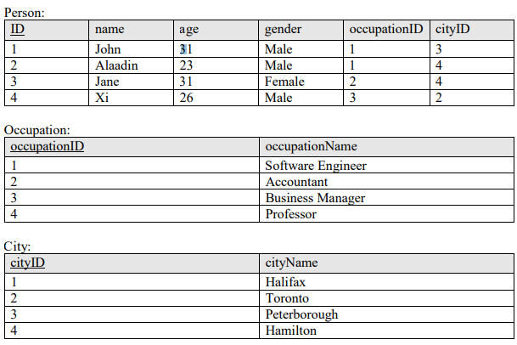

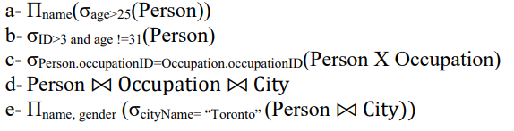

1- Show the output for the following relational algebra expressions using the relational instances above (5 points):

1. Πname(σage>25(Person))

Person:

|  |
| --- |
| **Name** |
| John |
| Jane |
| Xi |

1. σID>3 and age !=31(Person)

Person:

|  |  |  |  |  |  |
| --- | --- | --- | --- | --- | --- |
| **ID** | **name** | **age** | **gender** | **occupationID** | **cityID** |
| 4 | XI | 26 | Male | 3 | 2 |

1. σPerson.occupationID=Occupation.occupationID(Person X Occupation)

Person:

|  |  |  |  |  |  |  |
| --- | --- | --- | --- | --- | --- | --- |
| **ID** | **name** | **age** | **gender** | **occupationID** | **cityID** | **occupationName** |
| 1 | John | 31 | Male | 1 | 3 | Software Engineer |
| 2 | Alaadin | 23 | Male | 1 | 4 | Software Engineer |
| 3 | Jane | 31 | Female | 2 | 4 | Accountant |
| 4 | Xi | 26 | Male | 3 | 2 | Business Manager |

1. Person ⨝ Occupation ⨝ City

Person:

|  |  |  |  |  |  |  |  |
| --- | --- | --- | --- | --- | --- | --- | --- |
| **ID** | **name** | **age** | **gender** | **occupationID** | **cityID** | **occupationName** | **cityName** |
| 1 | John | 31 | Male | 1 | 3 | Software Engineer | Peterborough |
| 2 | Alaadin | 23 | Male | 1 | 4 | Software Engineer | Hamilton |
| 3 | Jane | 31 | Female | 2 | 4 | Accountant | Hamilton |
| 4 | Xi | 26 | Male | 3 | 2 | Business Manager | Toronto |

1. Πname, gender (σcityName= “Toronto” (Person ⨝ City))

Person:

|  |  |
| --- | --- |
| **name** | **gender** |
| Xi | Male |

2- Write the equivalent SQL statements for the relational algebra expressions in question 1 (5 points).

1. Πname(σage>25(Person))

SELECT ‘name’

FROM Person

WHERE (age > 25);

1. σID>3 and age !=31(Person)

SELECT Person.*, Occupation.*

FROM Person

WHERE (ID > 3) AND (age <> 31);

1. σPerson.occupationID=Occupation.occupationID(Person X Occupation)

SELECT *

FROM Person

INNER JOIN Occupation

ON Person.occupationID = Occupation.occupdationID;

1. Person ⨝ Occupation ⨝ City

SELECT Person.*, Occupation.*, City.*

FROM Person

INNER JOIN Occupation

ON Person.occupationID = Occupation.occupationID

INNERJOIN City

ON Person.cityID = City.cityID;

1. Πname, gender (σcityName= “Toronto” (Person ⨝ City))

SELECT Person.name, Person.gender

FROM PERSON

INNER JOIN City

ON Person.cityID = City.cityID

WHERE (City.cityName = “Toronto”);

3- Briefly comment and provide a rationale as to which NF the database above is in currently (2 points).

1NF: Rows are uniquely identified

Each cell only has 1 value

Table layout is organized well

2NF: Is in 1NF

Each non-key attribute relies fully on the primary key value

3NF: Is in 2NF

No transitive dependency

No derived data

BCNF: Is in 3NF

No overlapping candidate keys

Therefore by following the checklist of rules that define each step, I can assume that the tables are in Boyce-Codd normal form as they meet every requirement.