University of Juba
School of Computing
Department of Computer Science



Philosophy of Computer Science (PCS)
For the First-Year Students of CS, IT & CYS
Introduction to Computer Programming using Java

Mr. Macuei Mathiang Ring

May 1, 2023

Core Java Review
- Getting Set up: Setting up development environment for Computer Programming using Java
- JDK: Java Development Kit ➔ why? uses to develop Java programs
- JRE: Java Runtime Environment ➔ why? To run/execute java programs
- IDE: Integrated Development Environment ➔ why? Helps in writing, compiling, and running java applications. Examples of IDE are Dr.Java, Eclipse, NetBeans & others.
- JVM: Java virtual Machine➔ why? JVM helps in translating bytecode/Class File into binary language/machine code 0s & 1s of specific processor/CPU (Windows (32bits/63bits), Mac OS (32bits/63bits), Unix/Linux, )
- JVM It converts Java bytecode into machines language
- Java Virtual Machine (or JVM) allows a computer to interpret or run Java programs. It acts as a compiler for generating machine code
- Similar to virtual machines, the JVM creates an isolated space on a host machine.
Required Tools:
- JDK v19 or v20 download and install in your computer (Windows/Mac)
- IDE ➔ Dr.Java OR VS Code But it will requires Java Extensions to be install.
- Intro to Computers:
- How does computer works?
- Is a programmable device that accepts instructions/commands/program, processing them, and either store information or generate outputs.
- 3 parts are inputs, processing, outputs
- Computer is 2 parts, hardware and software
Talking to the Machine:
- Human: natural language like English, Arabic & others
- Computer: ONLY understands Binary Language/Machine Code (MC)
- In our case of Java Developer: To pass our message to the computer, we first have follow these steps:
- Write Java Source Code: HelloWorld.java
- Compile Java Source Code using Compiler to generate Java Bytecode/Java Class File: HelloWorld.class
- Run/Execute : pass the Java Class file to JVM to help in translating it into binary language of specific CPU/computer architecture (32bit/64bits)

How Java Program Compile and Run?
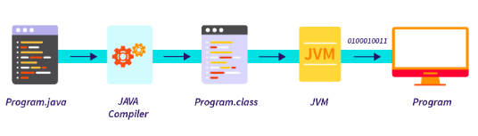

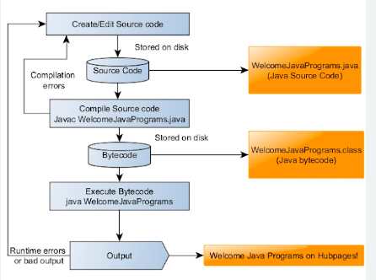
- Identifiers:
- An identifier is a name for a variable, parameter, constant, user-defined method or user-defined class.
- An identifier is any sequence of letters, digits, and the underscore character.
- May not begin with digit
- Is case-sensitive which means the uppercase and lowercase letters are treated different.

➔ When naming Java identifiers (variables, methods, classes), we use camel notation: HelloWorld.java
- Naming Variable Identifiers
- Naming Method identifiers
- Naming Class Identifiers

Q1. How to declare Variable in Java?
How to tell a computer that you want to name a variable of specific data & store specific value on it?
1st Recall your high school algebra: when given the following mathematic values perform the below computing:
Math:
X = 3;
Y = 2;
Z = X + Y;
You can easily find the value of Z to be 5 by X + Y contained values.

Computing:
Int x = 3;
Int y = 2;
Int z = x + y;
System.out.println(z);
Output ➔ an integer 5

- Working with a Hello World Program

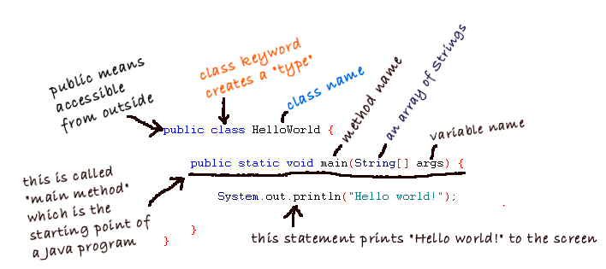
- Static: is a reversed Java keyword that means this method (main method) is owned by this class in which it is defined but we don’t have to create an instance of this class to use it.
- Void: is a return data type means that return nothing.
- “;”: is a semi-colon symbol that must be at the ending of each complete Java statement.
- Basics of Java
- Variables and Primitive Data Types
- Input and Output
- Creating Variables
- Packages and Classes
The 3 types of Java Comments are:
- Javadoc Comments:
/**
* Comments go here
*/

- Single comment or the end of the line comment: // only 1 comment goes here.
- Multiple line comments:
/*
* comment go here
* comment
*/

- Java Data Types:
- Java Data Types: in Java there are two data types primitive types & reference type or :
- Primitive Data Types/built-in types: 8 int, byte, short, char, Boolean, long, double, float
- References/objects/class Types: Array, String, and classes.

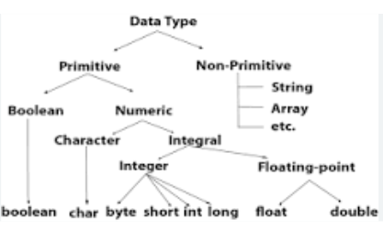

//8 Primitive Data Types
// 1. Boolean type
Boolean isStudent = true;
if(isStudent){
System.out.println(“He is student”)
}

// 2. Byte type
Byte range = 124;
//3. Short type
Short temperature = -200;

//4. Int type
Int indexNum = 1023;

//5. Long type
Long range = -4334342888949L;

//6. Double type
Double number = -42.3;

//7.float type
Float number = -42.3f;

//8. Char type
Char grade =’A’;

II). Reference or Object Data Types
- String
//String
String className = “Philosophy of Computer Science”;

- Operators:
- Arithmetic Operators
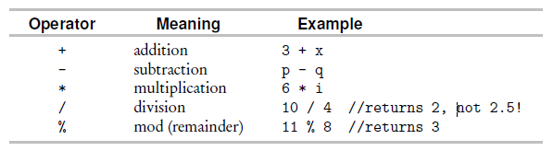
.
- Relational Operators
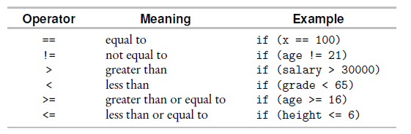

- Logical Operators
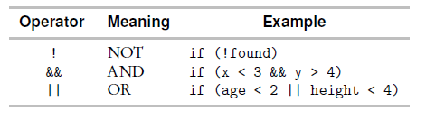
- Assignment operators
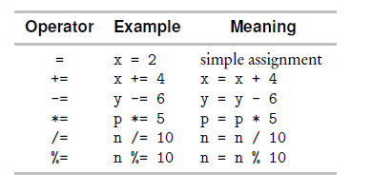
- Increment and Decrement operators
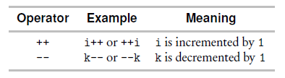

- Operator Precedence
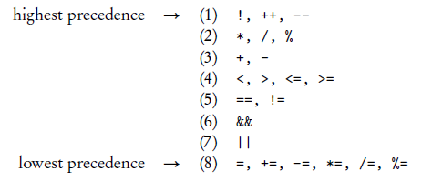

- Inputs/Output
- Input
- Output
- Escape sequence: An escape sequence is a backslash followed by a single character. It is used to print special characters.

Examples of Escape Sequences:
Here are some examples:
System.out.println("Welcome to\na new line");

prints
Welcome to
a new line

The statement
System.out.println("He is known as \"Hothead Harry\".");

prints
He is known as "Hothead Harry".
The statement
System.out.println("The file path is d:\\myFiles\\..");

prints
The file path is d:\myFiles\..

- Control Structures in Java

Control structures are the mechanism by which you make the statements of a program
run in a non-sequential order. There are two general types: decision making and
iteration.
What is a control structure?
- A control structure are statements that support repetition and conditional execution
- Way of non-sequential execution order
- Decision making (if)/selection statements
- Iteration (while and for)

Before:
- All programs that we have been building are executing line-by-line or in sequence or linear executions.
- But, with control structures are ways for non-sequential executions where repetition and conditional statement are supported.
- Conditional Execution: means that some statements might not execute based on certain Boolean conditions.
- Repetition statement/loop: means that some Java statements can be executed repeatedly based on some Boolean conditions.
- Selection Statements for decision making Statements:
- The if Statement
- The if-else Statement
- The Nested if statement
- The Extended if statement
- The Switch case statement

- Iteration or Loop Statements:
- The for-loop Statement
- The For-each Loop/Enhanced for-loop Statement
- The While Loop Statement
- The Do-while Loop Statement

Decision Making Control Structures:
Selection Statements types:

- The if Statement:

if(Boolean Expression ) {
Statement (s)
}

The statement will only execute if the Boolean expression evaluates to true, otherwise it will do nothing or move to the next line of code execution if any addition Java statements after this if-block statement.
Ex.
int x =5;
if(x > 2){
System.out.println(“X is greater than 2”);

}
Output: the above Java code will print on the console “X is greater than 2”, because the Boolean expression test will evaluate to true, because the value of x is equals 5 which is an integer that is greater than 2.
However, if an integer x value was equals to less than or equal to 2, the program will not print out anything at point but will exit because the Boolean expression test evaluated to false.

- The If-Else Statements

if (Boolean Expression Test) {
Statement #1 (s) // only execute if the above Boolean test evaluate to true
}
else {
Statement #2 (s) // only executes if the above test evaluate to false
}
Example for if-else statement:
int x =5;
if(x < 2){
System.out.println(“x is less 2”);
} else {
System.out.println(“x is greater or equals 2”);
}
Output: The above program will ignore the block statement #1 because the 1st Boolean expression test evaluated to false and print out the 2nd statement#2 on the console “x is less 2”.

The Big Number Program Built using the If-Else Statement:

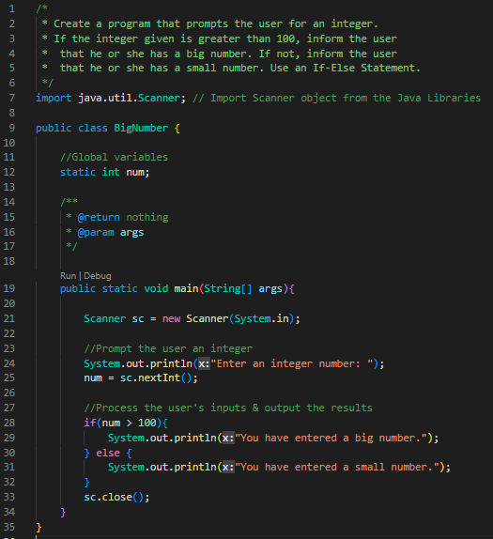

- Nested If Statement
The Nested if-statement means you can use one if or else if statement inside another if or else if statement.
if (boolean expr1)
if (Boolean exprs2)
Statement;

This equivalent to:
if (Boolean expr 1 && Boolean expr2)

Example for Nested if-Statement:
boolean isStudent = true;
String major = “CS”;

if(isStudent){
if(major.equals(“CS”)){
System.out.println(“You are student majoring in Computer Science (CS)”);
}
}

Outputs: the above program will display message on the console “You are student majoring in Computer Science (CS)” because both Boolean expression tests evaluated to true, the variable isStudent is sets to true, and major is assigned CS of type String.

- Extended if Statement

String grade = IO.readString(); //read user input
if (grade.equals("A"))
System.out.println("Excellent!");
else if (grade.equals("B"))
System.out.println("Good");
else if (grade.equals("C") || grade.equals("D"))
System.out.println("Poor");
else if (grade.equals("F"))
System.out.println("Egregious!");
else
System.out.println("Invalid grade");
// The statement after else executes if the all Boolean expressions above evaluate to false.

Example of extended if-else statement:
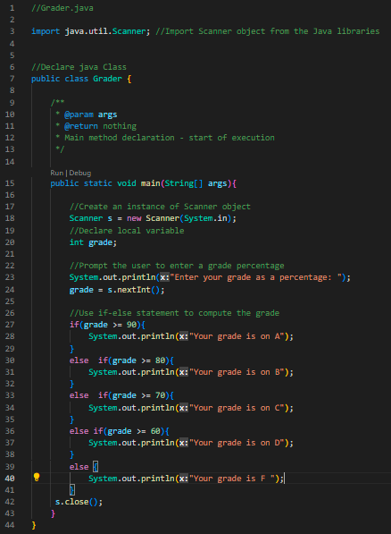

- The Switch Case Statement In Java
- The Java Switch Statement executes one statement from multiple conditions.
- It is like if-else-if ladder statement
- The switch statement works with byte, short, int, long, enum, String, & some wrapper type like Byte, Short, Integer, and Long.
Syntax:
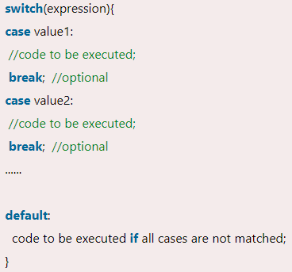
The Day Name Program using Switch Case Statement:

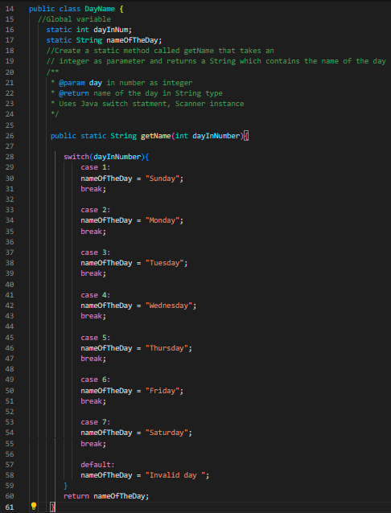

Iteration/ Loop Statements in Java
- Java has four different control structures that allow the computer to perform iterative tasks: the for loop, the for-each loop/the Enhanced For-loop, while loop, and do...while loop.
- Loops can execute a block of code as long as a specified condition is reached.
- Loops are useful because they save time, reduce errors, and they make code more readable.

- The For-Loop Statement
- The For-Each Loop or The Enhanced For-Loop
- The While-Loop Statement
- The Do-While-Loop Statement

- The For-Loop Statement
The general syntax of the for loop statement:
for (Initialization; Termination condition; Update statement++/--)
{
Statements //body of loop statements to be executed
}

The termination condition is tested at the top of the loop; the update statement is performed at the bottom.

// Print 2 line of code to print integers from 1 to 100

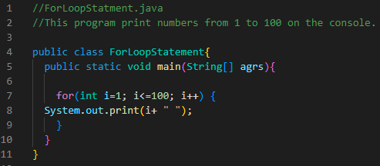

Example 2
//outputs 20 19 18 17 16 15
for (k = 20; k >= 15; k--) {
System.out.print(k + " ");
}

- The For-Each Loop or The Enhanced For-Loop
- For-Each loop is another array traversing technique like for loop, while loop,or do-while loop introduced in Java 5.
- For-Each Loop is used exclusively to loop through elements in an array and collection (ArrayList). It is also called the Enhanced For-Loop Statement.
Syntax:
for (type variableName : arrayName) {
// code block to be executed
}

The For-Each Statement Used in Building The Bag of Marbles Program:
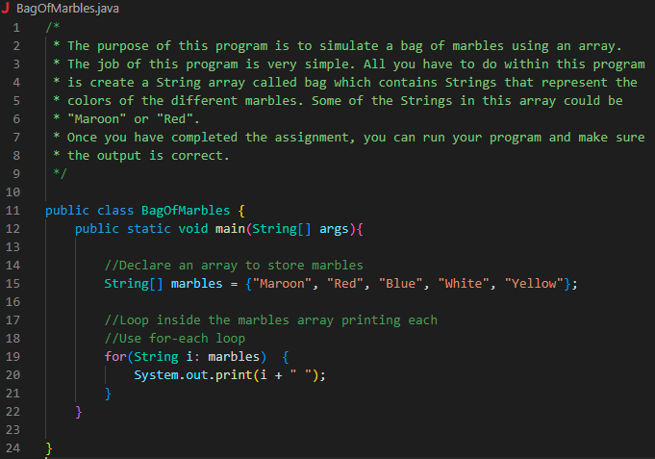

- The While-Loop Statement:
- The While-Loop loops through a block of code as long as a specified condition is true.
- Syntax:
While (condition){
//Code block to be executed.

}

The blow program will keep printing value of number x, increment it by 1, until 99999

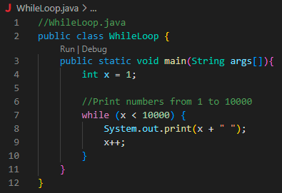

- Compute Average Program using the while-loop statement
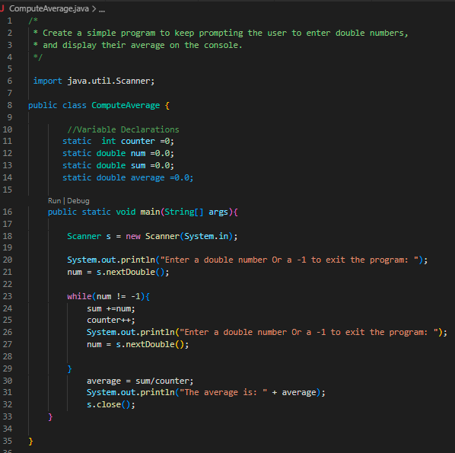

- The Do-While Loop
- Used to iterate a part of the program repeatedly until the specified condition is true.
- If the number of iteration is not fixed and you must have to execute the loop at least once.
- Java d-while loop is also called an exit control loop, the do-while loop check the condition at the end of loop body.
- The Java do-while loop is executed at least once because condition is checked after loop body.

Syntax:
do{
//Code to be executed /loop body
//update statement
while(condition);

This program will keep greeting the website visitors/users until specific condition is met/evaluate to true.

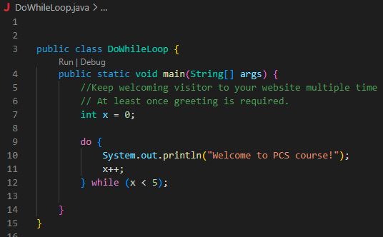

Part II: Methods and Classes

Q2. How to declare methods in Java
How can you tell the computer that you want to create a method to perform specific task and call many times as you wish?
What is a method in Java?
- A method is a block of code which only runs when it is called.
- You can pass data known as parameters, into a method
- Methods are used to perform certain actions, and they are also known as functions in other High level programming languages like C++ or Matlab
Why use methods?
- To reuse code: define the code once and use it many times.
- How to create a Java Method?
- How to call/invoke the defined/created Java method?

- A method must be declared within a class and defined with the name of the method followed by parentheses ().
- We can also use Java pre-defined method like System.out.println(), but we can create/define our own methods to perform certain actions.
Example:
Create a static method that do not have return type or parameter and display Hello World on the screen.

//Declare Class
public class HelloWorld{
//Declare a static method that take not argument, no return type, but display Hello World //on the screen twice.
public static void greet(){
System.out.println(“Hello World!”);
}
//Declare a method using Java Built-in method or pre-defined main method
public static void main(String[] args){
//Call or invoke the greet() multiple times
// To call a method, we use its name and parameters if any
greet();
greet();
}
}

Example 2: Create or define/declare a static method that takes two integers, sum both numbers and return their sum to its caller.
- Method declaration
- Method call the defined method from the main method
Solution implementation:
public class ComputeSum{
//variable declaration & initialization
static int sum = 0;

//Define the method
public static int sum(int x, int y){
sum = x + y;
return sum;
}

public static void main(String[] args){
//Call the computeSum() method
System.out.println( “The sum of the two numbers is: ” + computeSum(4, 2)); //6 is the sum
}

}

Pass Fail Program with method declaration and calling:
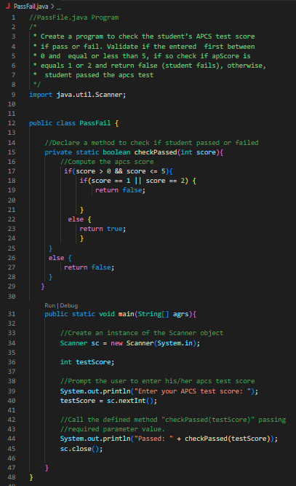

3) Class Declaration and Object instantiations
How to tell the computer that you want to create a Java Class?
How to tell the computer that you want to create an instance objects from defined/declared class?

- Class:
- A class is user-defined blueprint or prototype form which objects are created.
- A class is defined as a template/blueprint that describes the behavior/state that the object of its types supports.
- A class is simply a blue print for an object.
- Object:
- An object is an instance of a class
- an object is an instance of a Java class, meaning it is a copy of a specific class. Java objects have three primary characteristics: identity, state, and behavior.
- An object has states and behaviors.
- An object stores its state in fields (variables in some programming languages) and exposes its behavior through methods (functions in some programming languages).
- We use a keyword “new” to create an object/an instance of a particular class for example: Scanner s = new Scanner(System.in);
OR
Customer john = new Customer(“John”, “Dau”, 2386534, 675.00);

- Remember there are two type of class, pre-defined class or built-in class coming with Java libraries like String, Scanner, lang and user-defined class like the onces we define. Example you can defined class for your banking application like Customer class, Account class, CheckingAccount Class, & SavingAccount Class. Then within Checking account you can create three methods, one to withdraw fund called withdraw() method, despite() method, & checkBalance() method.
- Inside the main method, we can create an instance of Customer class label that object reference with unique name like John who has two accounts with Ivory Bank, CheckingAccount and SavingAccount.
- The two accounts will inherit all generic attributes and method of Account Class which they extended. In Addition to having their own unique methods, they will the three defined methods, withdraw, despite and view the balance/balance inquiry.

Class Definition and its Test class with main method

- Class declaration or definition in one file ex. Customer.java
- Test Class with main declaration for ex. CustomerTest.java
On the provided Video of Week 7: decoding AP computer Science contents, it shows you have to declare Course class (Course.java) and CourseTest.java Class.
Steps for Declaring Course Class & its Course Test Class:
- Create a class called Course inside file named Course.java and declare the following:
- Declare a class: public class Course{}
- Declare a private instance variable so it can only be accessed by this class public methods. Ex. private String name;
- Create two constructors: one without parameter and other with parameters.
- No Parameter constructor: has the same name as class, not return type, and take not parameter at all. If the user don’t define it, still the complier generated by default and assign all its variable to their default values.
The below inner variable is assigned to empty string as default value for String type.
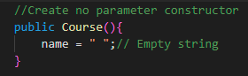
- Create constructor with parameters: takes String argument
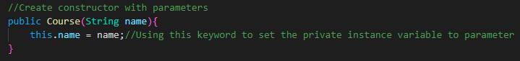

- Constructors are also types of methods and having more than two constructors with same name, return type and different parameter is called Method Overloading
- Define setter and getter methods:
- Getter methods: getters are the methods that retrieve the data stored in the fields of an object of a class. Or getter reads the value of a variable & its name starts with “get” word.
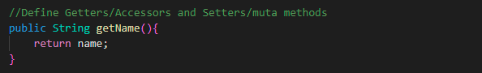

- Setter methods: a setter updates the value of a variable/ allows us to change the object value & it starts with “set”word.
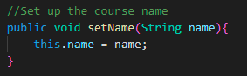

- Override toString method to print out contents of Course Class, by default any Java class is coming with toStrig() method that needed to be override based on class contents to be print.
toString() Methhods:
- The toString() method of the Object class returns the string representation of an object in Java.
- If we print any object, the Java Compiler internally invokes the toString() method on that object. The value returned by the toString() method is then printed.
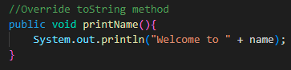
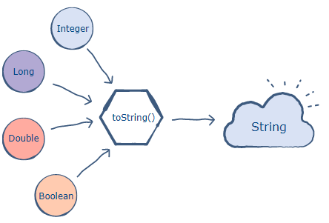
- Any object that this method is applied on, will then be returned a string object.

The Course Class Implementation
- Create two files, Course.java and CourseTest.java

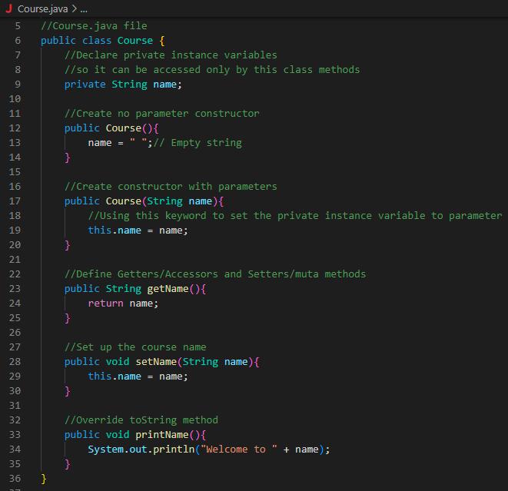

2) CourseTest.java file
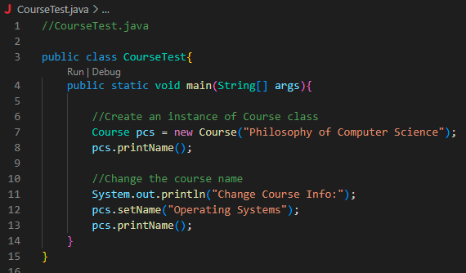

Warning ➔ Don’t run Course.java Class file it does not have any main method, you can only run CourseTest.java.

The Polygon Program: implementation
- Following the same approach, implement the polygon Program by creating two classes, Polygon.java and PolygonTest.java as below.

Problem Statement:
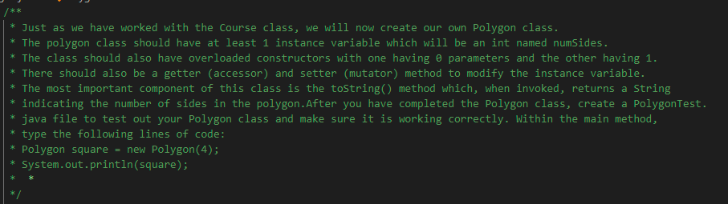

- Polygon Class (Polygon.java):
- Class declaration
- Private instance variables declaration
- Two constructors method declarations: one with no parameter and other with parameters
- Getter and setter methods
- Override to String method

- Polygon Test with main method (PolygonTest.java):
- PolygonTest class declaration
- Main method declaration
- Create an instance of Polygon class using constructor with parameter passing a number 4, and call it square.
- Use the override toString() method of the Polygon.java class.
Hint: the main method body code was provided in the problem statement instruction, you just have to copy it and paste it without any modification/changes.
