**MGSC 675 – Assignment 1**

Adv Topics in Mgmt Science

Konstantin Volodin – 261083570

Table of Contents

1. Introduction 1

2. Data Review 1

3. Network Architecture 1

4. Final Model Results 2

## Introduction

The objective of this project is to create a convolutional neural network (CNN) capable of accurately categorizing images. Our approach involves employing a comprehensive machine learning pipeline, encompassing data exploration, model development using PyTorch Lightning, and rigorous model evaluation.

## Data Review

The project utilizes the CIFAR-10 dataset, a widely recognized benchmark dataset for image classification, comprising 60,000 32x32 color images. With 10 distinct target classes, each class contains 6,000 images. This translates to a total of (32*32*3) inputs and 10 outputs.

Data preprocessing is conducted to enhance model generalizability. Random transformations, including horizontal flipping and image cropping, are applied to the images. Additionally, the data is standardized using normal scaling. To ensure comprehensive evaluation, the dataset is partitioned into two subsets: 50,000 data points for training, 10,000 data points for validation.

## Network Architecture

In this project, we leverage existing model architectures with pretrained weights to avoid unnecessary duplication of efforts. Four architectures, namely ResNet18, ResNet34, EfficientNetS, and EfficientNetM are explored. The final layer of each model is modified to accommodate 10 output classes. Training is conducted for 20 epochs per model, and the architecture yielding the highest validation accuracy is chosen for further training.

Based on experimentation results (refer to Figure 1), EfficientNetS exhibits the most promising performance, achieving the highest validation accuracy of 86.6% within 20 epochs. It also seems less prone to overfitting compared to ResNet models, given the smaller gap between train and validation sets. Thus, this model is selected for extended training, spanning 250 epochs. The trained model will be evaluated using the final validation set.

## Final Model Results

The final model was trained over a course of 250 epochs, utilizing a training dataset consisting of 45,000 points. It achieved the highest validation accuracy of 92.05% at epoch 242, indicating its strong performance on the validation set (refer to figure 2). While this value does not surpass the state-of-the-art benchmark of 99.7% accuracy, it does signify a solid starting point and demonstrate the model's capability to make accurate predictions across multiple classes.

It's important to keep in mind that achieving better performance may require further tweaks, like fine-tuning the model's settings, using a different architecture, or trying techniques like ensemble learning or data augmentation. In our case, it seems like the model needs stronger regularization because there's a noticeable difference between the training and validation losses. Still, the results we obtained show that we successfully implemented the convolutional neural network for image classification.

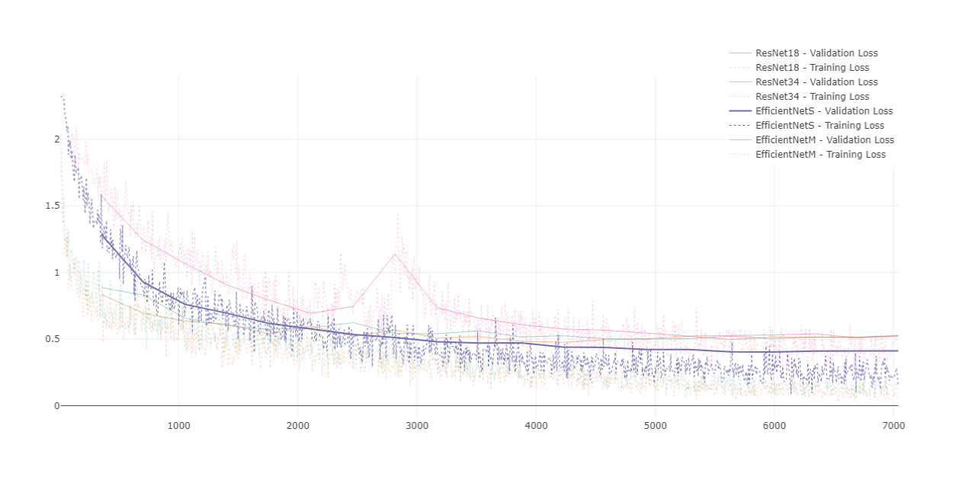

Figure 1: Train vs Validation loss of tested models

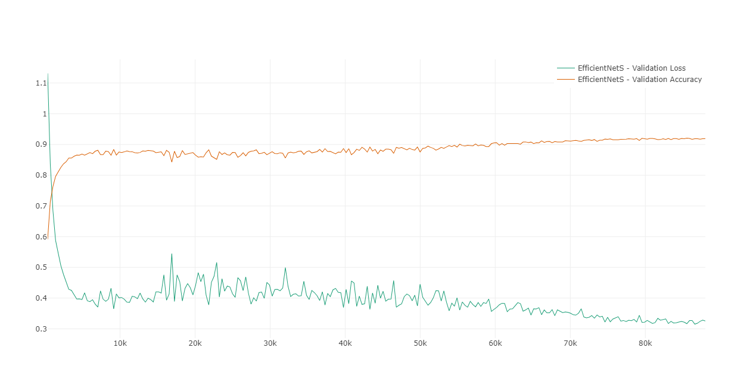

Figure 2: Final Model Performance over Time