# Inputs Parameters

This is for the “smaller instance” of the problem

Simulation parameters: 30 replications, 3000 weeks duration, 1000 weeks warm up.

Arrival Rate:

It was set to be 90% of the capacity, however due to transitions, the resource usage should be higher than 90%

|  |  |  |  |
| --- | --- | --- | --- |
| **Surgery** | **Complexity** | **Priority** | **Arrival per week**  **(poisson)** |
| 1. SPINE POSTERIOR DECOMPRESSION/LAMINECTOMY LUMBAR | Complexity 1 | No Priority | 1.0375 |
| 1. SPINE POSTERIOR DECOMPRESSION/LAMINECTOMY LUMBAR | Complexity 1 | Priority | 0.2594 |
| 1. SPINE POSTERIOR DECOMPRESSION/LAMINECTOMY LUMBAR | Complexity 2 | No Priority | 0.5187 |
| 1. SPINE POSTERIOR DECOMPRESSION/LAMINECTOMY LUMBAR | Complexity 2 | Priority | 0.1297 |
| 4. SPINE POST CERV DECOMPRESSION AND FUSION W INSTR | Complexity 1 | No Priority | 0.0865 |
| 4. SPINE POST CERV DECOMPRESSION AND FUSION W INSTR | Complexity 1 | Priority | 0.0648 |
| 4. SPINE POST CERV DECOMPRESSION AND FUSION W INSTR | Complexity 2 | No Priority | 0.0648 |
| 4. SPINE POST CERV DECOMPRESSION AND FUSION W INSTR | Complexity 2 | Priority | 0.0432 |
| 6. SPINE POSTERIOR DISCECTOMY LUMBAR | Complexity 1 | No Priority | 1.0375 |
| 6. SPINE POSTERIOR DISCECTOMY LUMBAR | Complexity 1 | Priority | 0.2594 |
| 6. SPINE POSTERIOR DISCECTOMY LUMBAR | Complexity 2 | No Priority | 0.5187 |
| 6. SPINE POSTERIOR DISCECTOMY LUMBAR | Complexity 2 | Priority | 0.1297 |

PPE Usage:

|  |  |  |  |
| --- | --- | --- | --- |
| **Surgery** | **Complexity** | **Resource** | **Usage** |
| 1. SPINE POSTERIOR DECOMPRESSION/LAMINECTOMY LUMBAR | Complexity 1 | Admissions | 0 |
| 1. SPINE POSTERIOR DECOMPRESSION/LAMINECTOMY LUMBAR | Complexity 1 | OR_Time | 3 |
| 1. SPINE POSTERIOR DECOMPRESSION/LAMINECTOMY LUMBAR | Complexity 2 | Admissions | 1 |
| 1. SPINE POSTERIOR DECOMPRESSION/LAMINECTOMY LUMBAR | Complexity 2 | OR_Time | 4 |
| 4. SPINE POST CERV DECOMPRESSION AND FUSION W INSTR | Complexity 1 | Admissions | 1 |
| 4. SPINE POST CERV DECOMPRESSION AND FUSION W INSTR | Complexity 1 | OR_Time | 4 |
| 4. SPINE POST CERV DECOMPRESSION AND FUSION W INSTR | Complexity 2 | Admissions | 1 |
| 4. SPINE POST CERV DECOMPRESSION AND FUSION W INSTR | Complexity 2 | OR_Time | 5.5 |
| 6. SPINE POSTERIOR DISCECTOMY LUMBAR | Complexity 1 | Admissions | 0 |
| 6. SPINE POSTERIOR DISCECTOMY LUMBAR | Complexity 1 | OR_Time | 1.5 |
| 6. SPINE POSTERIOR DISCECTOMY LUMBAR | Complexity 2 | Admissions | 0 |
| 6. SPINE POSTERIOR DISCECTOMY LUMBAR | Complexity 2 | OR_Time | 2.5 |

PPE Capacity:

|  |  |
| --- | --- |
| **Resource** | **Capacity per week** |
| Admissions | 1.5 |
| OR Time | 11.25 |

# Description of the Policy (MDP):

The policy description is based on the following graphs.

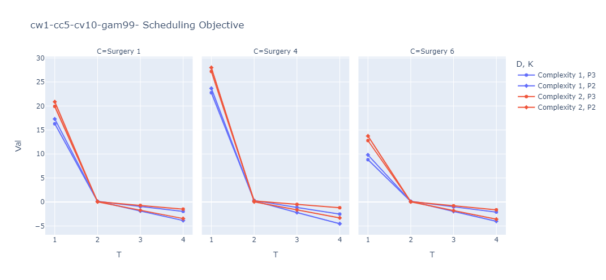This graph shows the benefit of scheduling a patient. If it is above 0, it is better to schedule a patient than to let a patient wait. The highest points on the graph should be scheduled first. (FYI, this is for wait time after transition starts, it is generally slightly lower for patients where transition hasn’t kicked in)

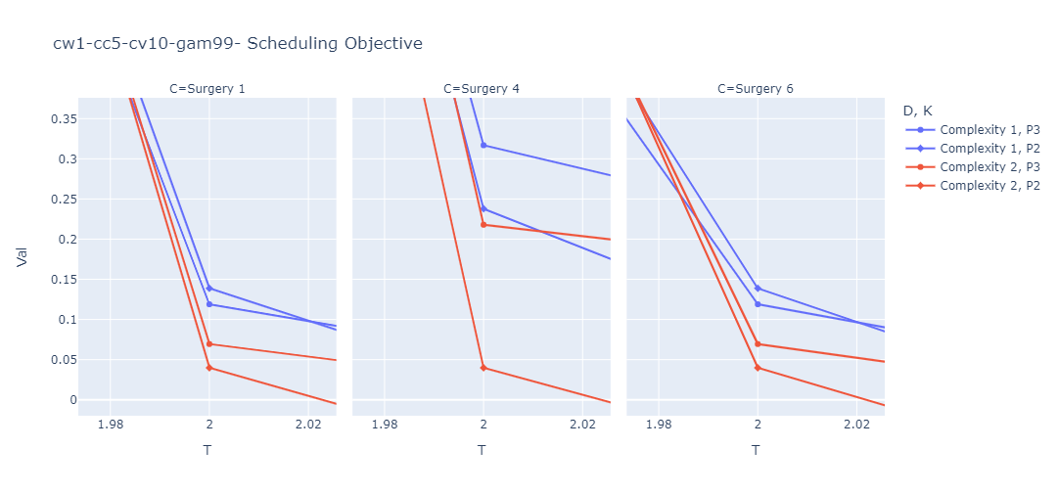For day 2 the graph is shown below

* This plot shows that the policy would only schedule on day 1 and 2. (For all days after it is below 0).
* First the policy would attempt to fill day 1, then it attempts to fill day 2
  + On day 1 the following decisions are made (in the order below):
    1. The policy chooses a surgery to schedule completely (Surgery 4, Surgery 1, Surgery 6 – in that order)
    2. Then the policy attempts to schedule all higher complexities of patients
    3. Next the policy tries to schedule patients with priority first
  + On day 2 the following decisions are made (in the order below):
    - Surgery 4 again has the highest priority
    - However now lower complexity is scheduled 1st
    - Patients with no priority are also scheduled 1st
    - After everyone on surgery 4 (except complexity 2, high priority) are scheduled – the order changes
    - Complexity 1, high priority is scheduled based on resource usage next
    - Complexity 1, low priority is scheduled next
    - Complexity 2 low priority is scheduled 2
    - And finally Complexity 2, high priority are scheduled

# Result Tables

**Wait Times** in weeks (mean +- 95% margin of error):

Surgeries:

* 1. SPINE POSTERIOR DECOMPRESSION/LAMINECTOMY LUMBAR
* 4. SPINE POST CERV DECOMPRESSION AND FUSION W INSTR
* 6. SPINE POSTERIOR DISCECTOMY LUMBAR

|  |  |  |  |  |  |  |  |  |
| --- | --- | --- | --- | --- | --- | --- | --- | --- |
|  | Overall | Surgery | | | Complexity | | Priority | |
|  |  | Surgery 1 | Surgery 4 | Surgery 6 | Complexity 1 | Complexity 2 | No Priority | Priority |
| MDP | 3.66 +- 8.39 | 4.73 +- 7.81 | 18.4 +- 25 | 0.628 +- 0.278 | 1.60 +- 5.12 | 7.66 +- 12.4 | 2.02 +- 4.11 | 9.69 +- 16.2 |
| Myopic | 23.2 +- 41.0 | 25.0 +- 36.5 | 170 +- 116 | 1.67 +- 0.620 | 12.7 +- 31.8 | 43.5 +- 53.7 | 4.51 +- 9.45 | 92 +- 81.9 |

**Wait List Size** in number of patients (mean +- 95% margin of error):

Surgeries:

* 1. SPINE POSTERIOR DECOMPRESSION/LAMINECTOMY LUMBAR
* 4. SPINE POST CERV DECOMPRESSION AND FUSION W INSTR
* 6. SPINE POSTERIOR DISCECTOMY LUMBAR

|  |  |  |  |  |  |  |  |  |
| --- | --- | --- | --- | --- | --- | --- | --- | --- |
|  | Overall | Surgery | | | Complexity | | Priority | |
|  |  | Surgery 1 | Surgery 4 | Surgery 6 | Complexity 1 | Complexity 2 | No Priority | Priority |
| MDP | 24.9 +- 9.99 | 13.7 +- 5.68 | 9.43 +- 4.79 | 1.73 +- 0.701 | 8.62 +- 3.47 | 16.2 +- 6.95 | 7.92 +- 2.34 | 16.9 +- 8.49 |
| Myopic | 78.2 +- 20.6 | 39.4 +- 10.9 | 35.8 +- 10.9 | 3.01 +- 0.794 | 28.6 +- 7.35 | 49.6 +- 13.8 | 13.1 +- 2.45 | 65.1 +- 19.4 |

**Utilization** (mean +- 95% margin of error):

|  |  |  |
| --- | --- | --- |
|  | Admissions | OR Time |
| MDP | 0.6 +- 0.148 | 0.963 +- 0.0837 |
| Myopic | 0.616 +- 0.116 | 0.953 +- 0.0705 |

**Reschedules per week** (mean +- 95% margin of error):

|  |  |  |  |  |  |  |  |  |
| --- | --- | --- | --- | --- | --- | --- | --- | --- |
|  | Overall | Surgery | | | Complexity | | Priority | |
|  |  | Surgery 1 | Surgery 4 | Surgery 6 | Complexity 1 | Complexity 2 | No Priority | Priority |
| MDP | 0.112 +- 0.118 | 0.0856 +- 0.104 | 0.0410 +- 0.0739 | 0.0155 +- 0.0461 | 0.0434 +- 0.0760 | 0.0762 +- 0.099 | 0.113 +- 0.118 | 0.000274 +- 0.00617 |
| Myopic | 0.429 +- 0.203 | 0.332 +- 0.187 | 0.101 +- 0.113 | 0.0807 +- 0.104 | 0.176 +- 0.147 | 0.284 +- 0.177 | 0.430 +- 0.203 | 0.00842 +- 0.0341 |

# Some Graphs:

