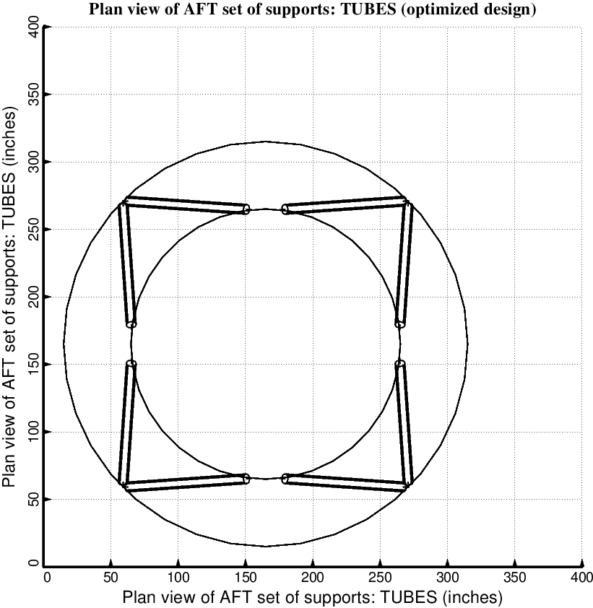

Fig. 10 (old) Optimized design of the short propellant tank with one set of struts, called “aft”, with 4 pairs of struts in this one set. Compare with the starting configuration shown in Fig. 8.

