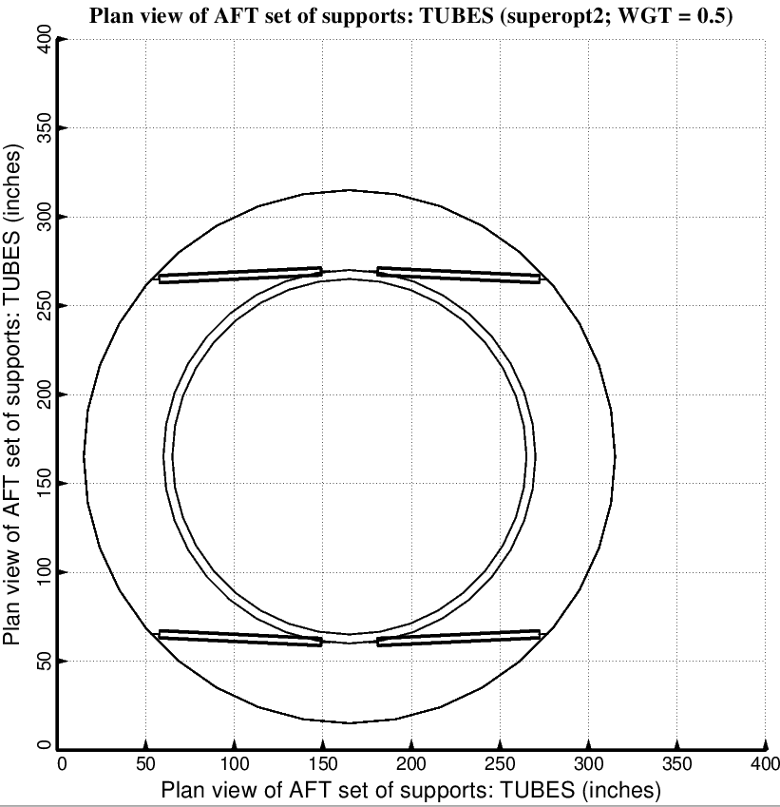

Fig. 11 (old) Optimized design of the long propellant tank with two sets of struts, aft and forward, with 2 pairs of struts in each of these two sets.

