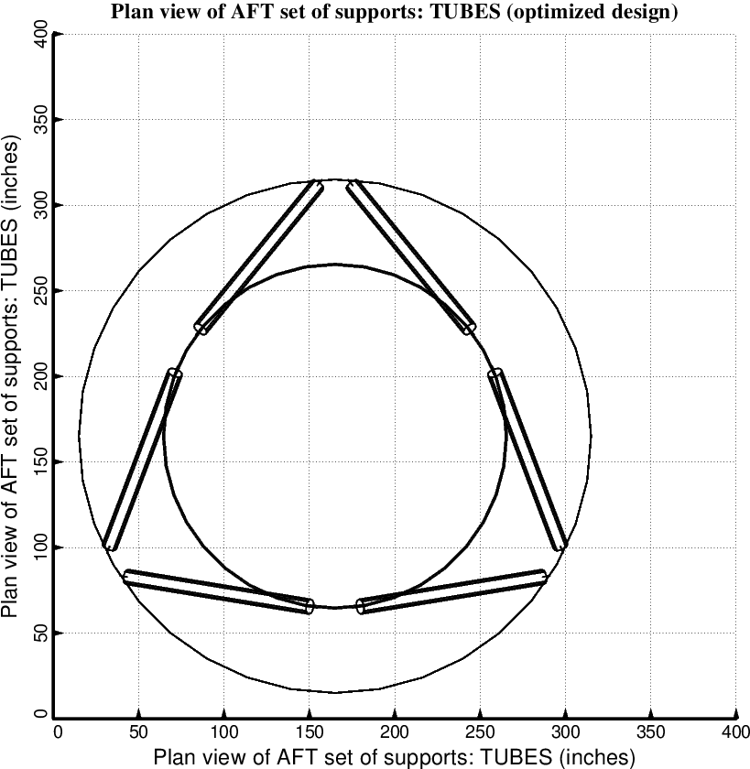

Fig. 12 (old) Optimized design of the long propellant tank with two sets of struts, aft and forward, with 3 pairs of struts in each of these two sets. Notice that there is a small clearance problem at the end of the struts attached to the propellant tank. In the work reported here no constraint was introduced to avoid clearance problems of this type.

