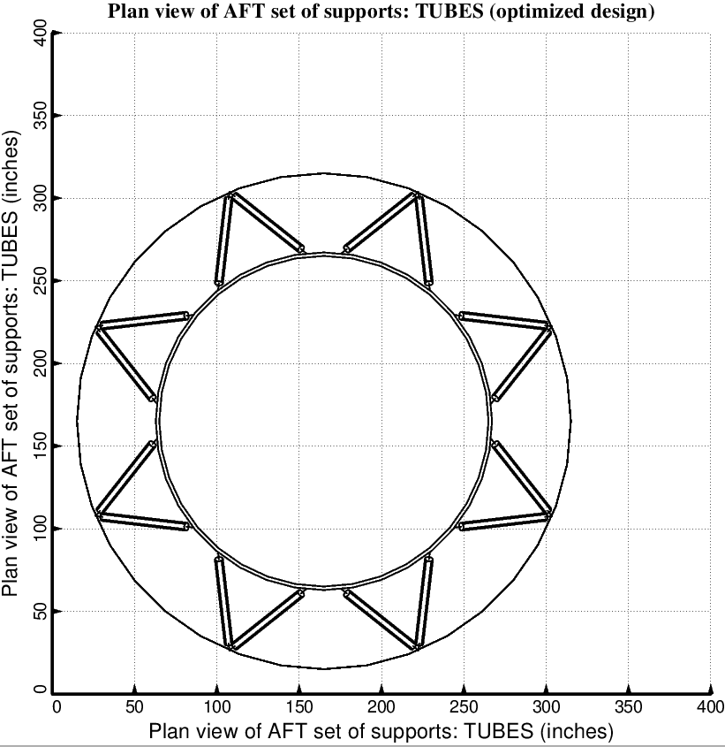

Fig. 16 (old) Optimized design of the long propellant tank with two sets of struts, aft and forward, with 8 pairs of struts in each of these two sets.

