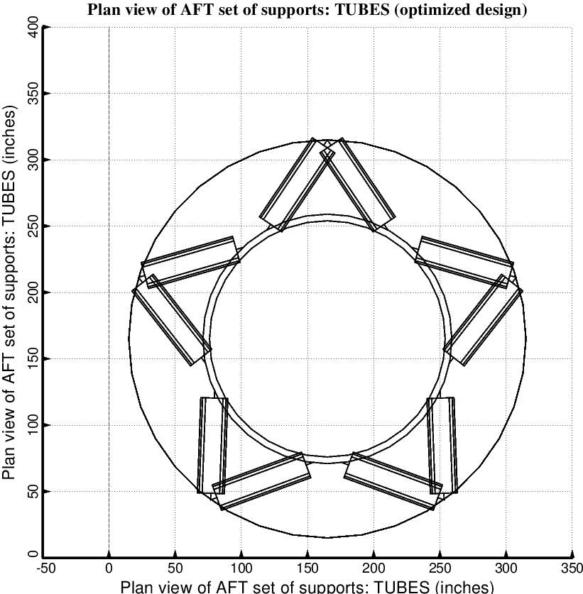

Fig. 17 (old) Optimized design of the long propellant tank with two sets of struts, aft and forward, with 5 pairs of struts in each of these two sets. The ends of the struts attached to the propellant tank are attached within the end domes, not at the junctions between the domes and the cylindrical part of the tank. This is a poor design: corresponding to high values of the empty tank mass and the total conductance.

