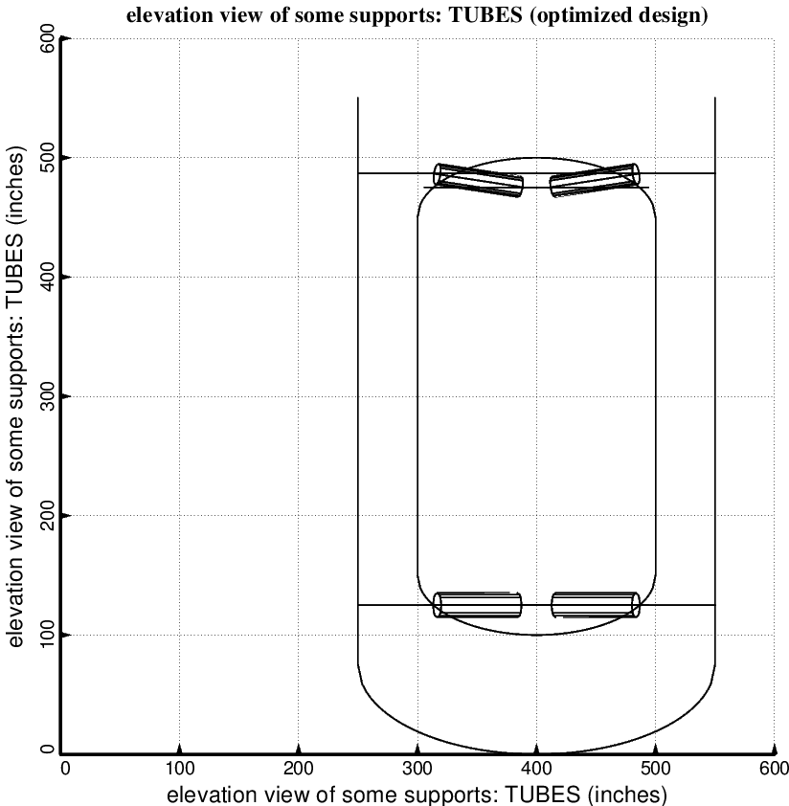

Fig. 18 (old) Optimum design of the long propellant tank with two sets of struts, aft and forward, with 5 pairs of struts in each of these two sets (NOTE: In this elevation view only one of the five pairs of struts is displayed) This is a poor design because the tank-ends of the struts are attached within the domes, not at the junctions between the domes and the cylindrical part of the tank.

