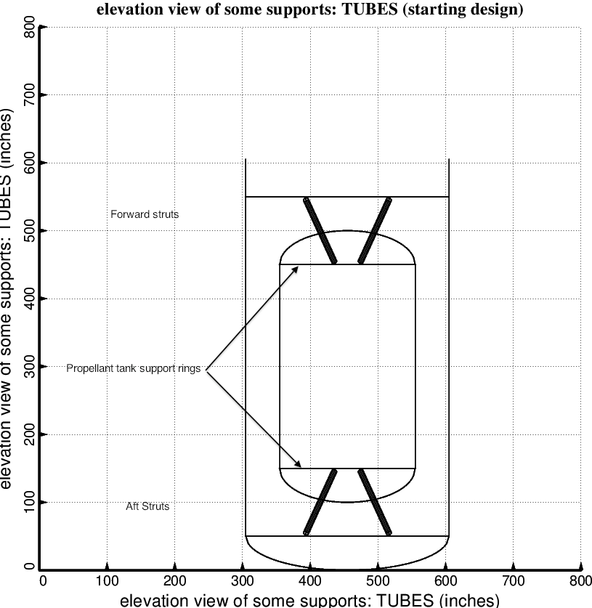

Fig. 1 (old) Starting design of the long propellant tank with two sets of struts, aft and forward, with 4 pairs of struts in each of these two sets. Compare with the optimized configuration shown in Fig. 4. (NOTE: In this elevation view only one of the four pairs of struts is displayed)

