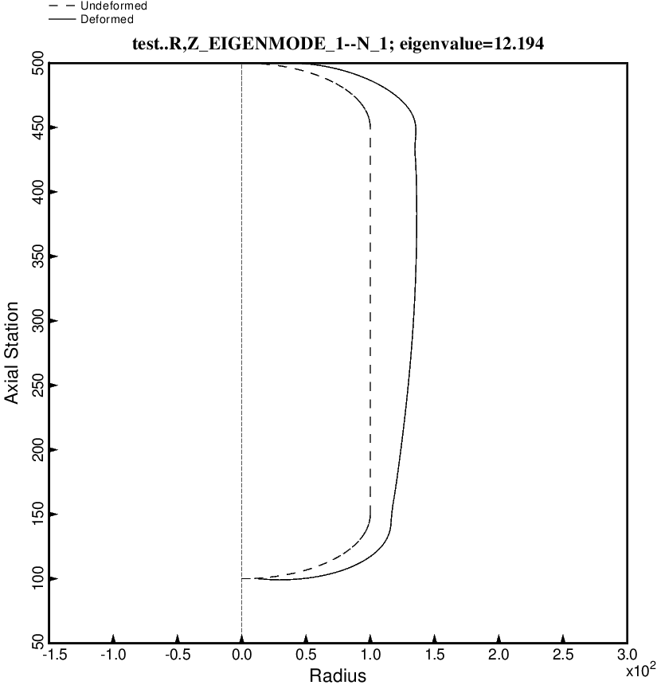

Fig. 21 (new) Free vibration mode of the optimized tank/strut system for the long propellant tank with aft and forward sets of struts, 4 strut pairs in each set, Load Case 2 (test.BEHX12). The struts are present in the BIGBOSOR4 model but are not plotted here because BIGBOSOR4 does not yet have the capability to plot springs. This mode corresponds to the first lateral/pitching mode, mostly pure lateral motion here because the tank/strut system is fairly symmetric. This optimum design was found with use of the “permanent” (constant density) versions of bosdec (bosdec.tank) and addbosor4 (addbosor4.tank).

