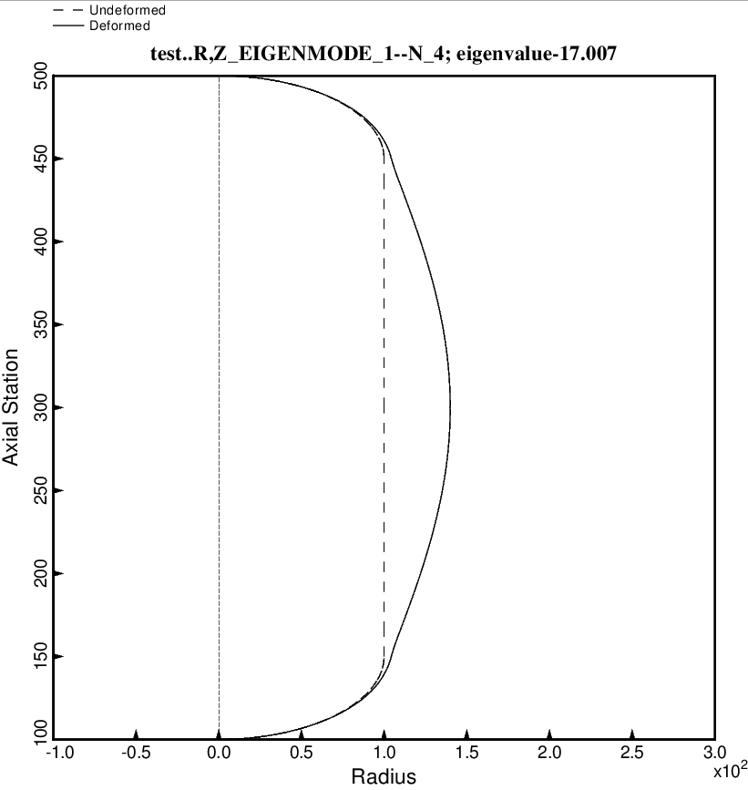
Fig. 22d (new) Free vibration mode of the optimized tank/strut system for the long propellant tank with aft and forward sets of struts, 4 strut pairs in each set, Load Case 2 (test.BEHX12). The struts are present in the BIGBOSOR4 model but are not plotted here because BIGBOSOR4 does not yet have the capability to plot springs. This mode corresponds to N = 4 circumferential waves. This is a “shell” vibration mode the frequency of which is not sensitive to the type of propellant “lumping” model: constant density or varying density, because most of the motion occurs in the cylindrical portion of the propellant tank in which the “lumped” propellant density does not depend on the location along the cylindrical shell. This optimum design was found with use of the “permanent” (constant density) versions of bosdec (bosdec.tank) and addbosor4 (addbosor4.tank).

