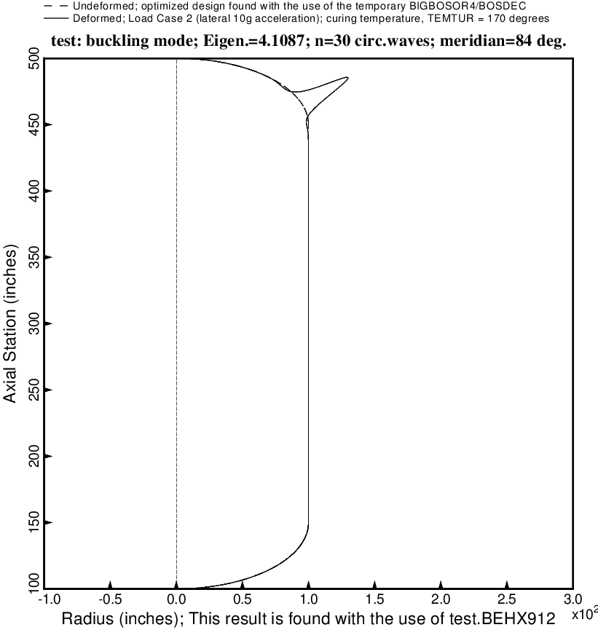

Fig. 24 (old) Buckling of the long optimized tank with aft and forward sets of struts, 4 strut pairs in each set. The loading is Load Case 2: lateral acceleration = 10 g, 25 psi ullage pressure, 200 deg. tank cool-down. Buckling in the forward 2:1 ellipsoidal dome is caused partly by the narrow band of hoop compression in the dome knuckle region and partly from concentrated compression caused by the struts “poking” into the tank.

