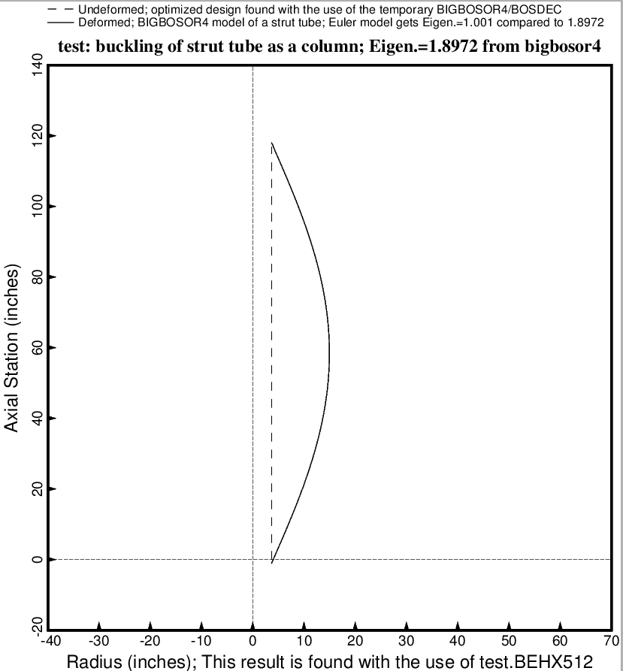

Fig. 25 (old) Buckling of the most highly compressed strut as a column from the BIGBOSOR4 model. The BIGBOSOR4 model does not include the “softening” effect of the tank flexibility on the effective axial stiffness of the struts.

