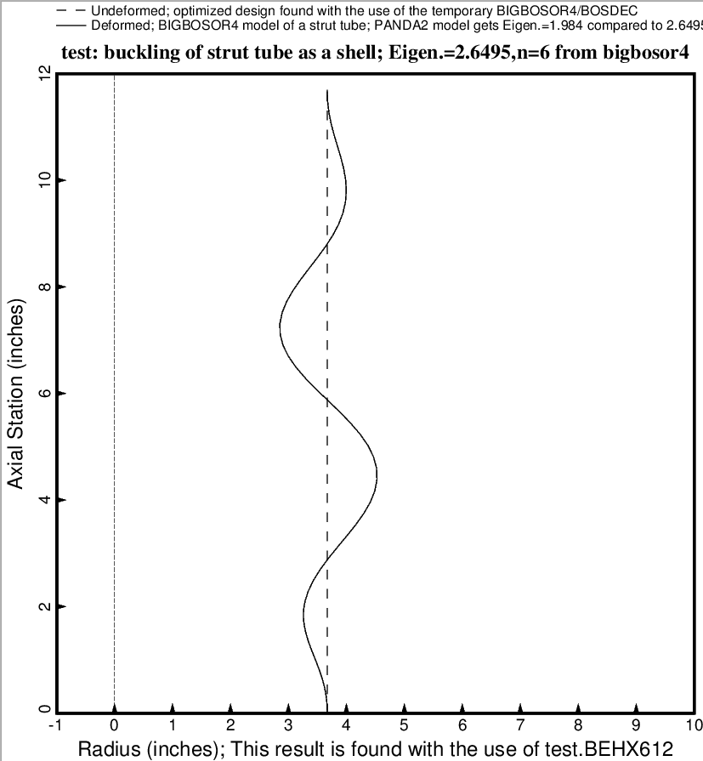

Fig. 26 (old) Buckling of the most highly compressed strut as a thin axially compressed cylindrical shell from the BIGBOSOR4 model. Only part of the total strut length is included in this BIGBOSOR4 model. The BIGBOSOR4 model does not include the effects of anisotropy or transverse shear deformation, and therefore overestimates the shell buckling load factor. However, a PANDA model of shell buckling is also included in the GENOPT model reported here. The PANDA model includes anisotropy and transverse shear deformation. Therefore, it yields a lower shell buckling load factor than the BIGBOSOR4 model. A factor of safety of 2.0 is used for the shell buckling behavior in order to account for the effect of unavoidable initial imperfections in the cylindrical shape of the laminated composite strut tube.

