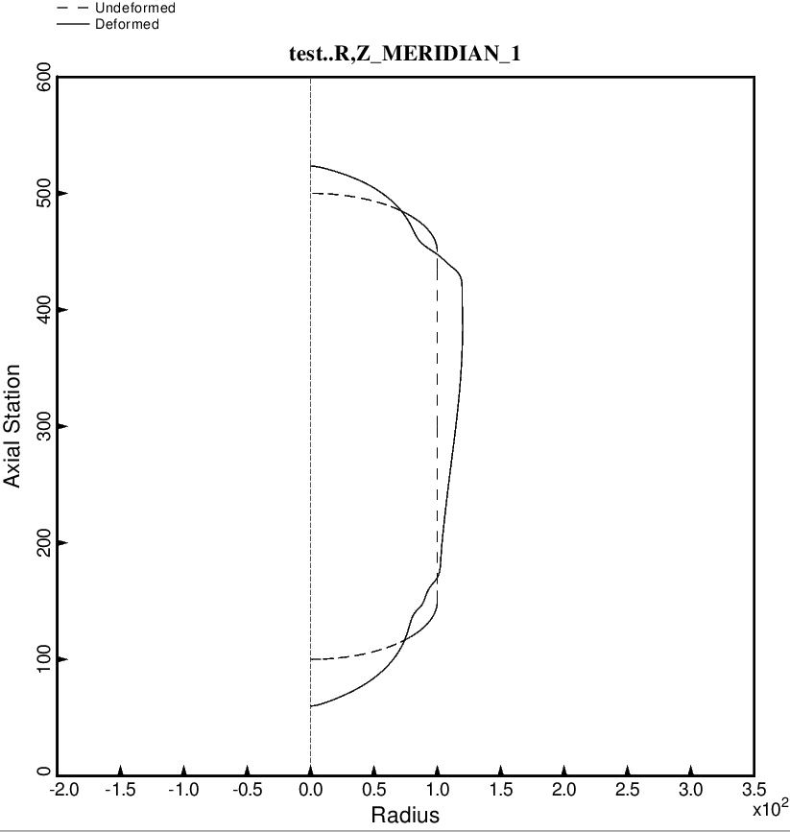
Fig. 27a (new) Load Case 1 (10 g axial acceleration, 25 psi ullage pressure, 200 deg. tank cool-down): Deformation along the meridian at zero degrees of the long propellant tank with aft and forward struts, 4 strut pairs in each set of struts. In this BIGBOSOR4 model, from which the maximum stresses in the propellant tank are computed, the struts (springs) are replaced by the concentrated loads that these springs apply to the tank. The concentrated loads are represented in the BIGBOSOR4 model as Fourier series expansions of circumferential line loads. The non-axisymmetric linear equilibrium state is obtained by superposition of the displacements and stresses from each Fourier component. This optimum design was found with use of the “temporary” (varying density) versions of bosdec (bosdec.density.var) and addbosor4 (addbosor4.density.var).

