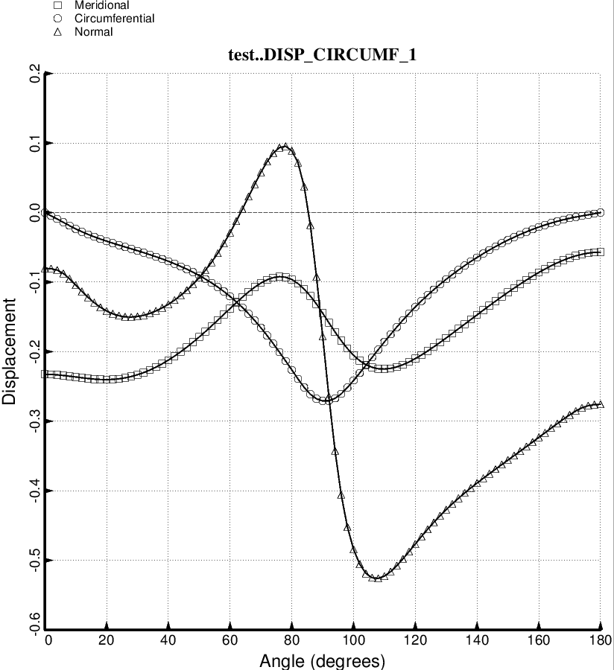

Fig. 28e (new) Load Case 2 (10 g lateral acceleration, 25 psi ullage pressure, 200 deg. tank cool-down): Deformation along 180 degrees of the circumference at the forward dome/cylinder junction of the long propellant tank with aft and forward struts, 4 strut pairs in each set of struts. This optimum design was found with use of the “temporary” (varying density) versions of bosdec (bosdec.density.var) and addbosor4 (addbosor4.density.var).

