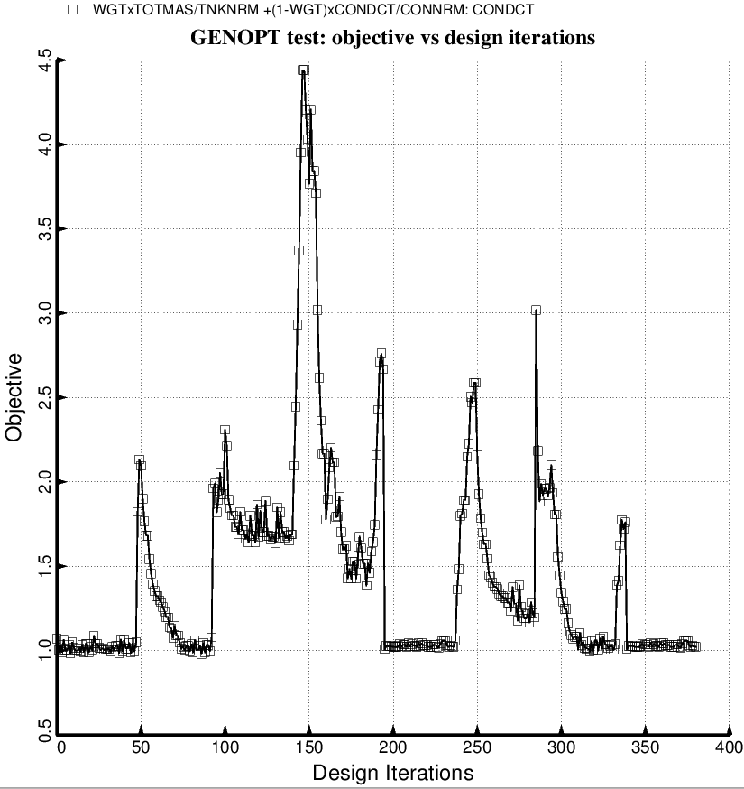

Fig. 29a (new) Evolution of the objective during a partial execution of the GENOPT processor, SUPEROPT, for the long tank/strut system with aft and forward sets of struts. This optimum design was found with use of the “temporary” (varying density) versions of bosdec (bosdec.density.var) and addbosor4 (addbosor4.density.var).

