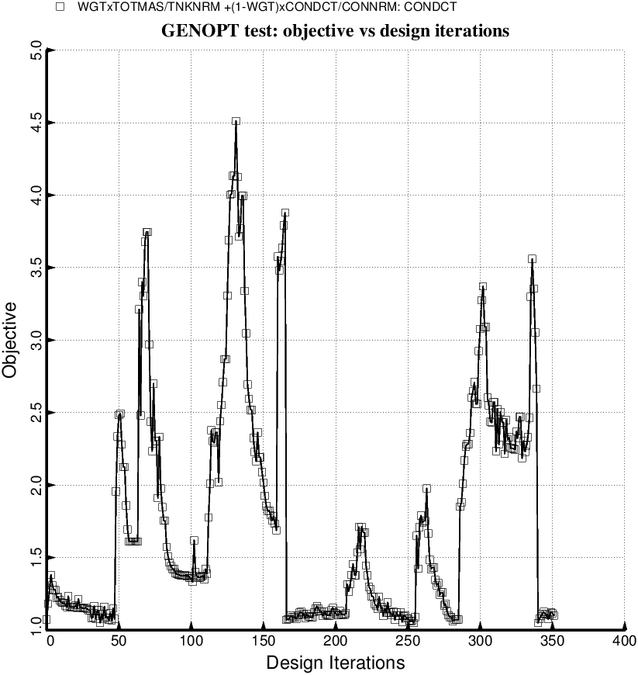

Fig. 29b (new) Evolution of the objective during a partial execution of the GENOPT processor, SUPEROPT, for the long tank/strut system with aft and forward sets of struts. This optimum design was found with use of the “permanent” (constant density) versions of bosdec (bosdec.tank) and addbosor4 (addbosor4.regular). Notice that during the long SUPEROPT process the objective converges to more than one local minimum. This behavior makes it difficult to find a “global” optimum design.

