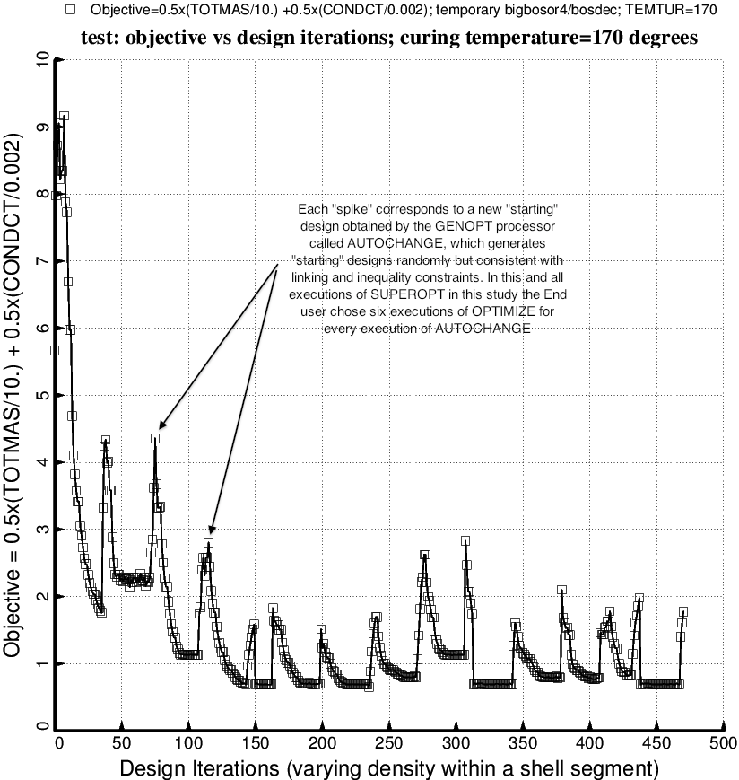

Fig. 29 (old) Evolution of the objective during the first execution of the GENOPT processor, SUPEROPT, for the long tank/strut system with aft and forward sets of struts. Notice that during the long SUPEROPT process (24 hours of computer time on the writer’s very fast computer) the objective converges to more than one local minimum. This behavior makes it difficult to find a “global” optimum design.

