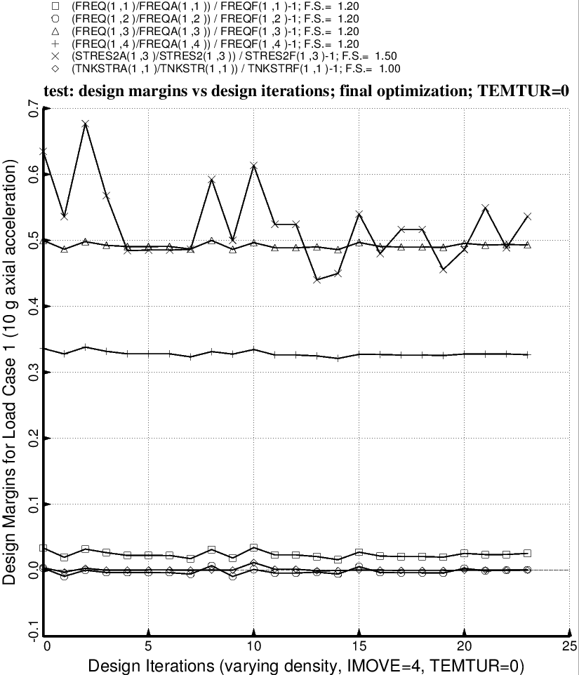

Fig. 30 (old) Load Case 1 = 10g axial acceleration, 25 psi ullage pressure, 200 degrees propellant tank cool-down. Shown here are the most critical margins as a function of design iterations for a partial execution of the GENOPT processor, SUPEROPT. (The index, IMOVE, governs how large a change in the design is permitted by the ADS optimizer at each optimization cycle. IMOVE = 4 is quite restrictive.)

